STEM faculty Community of Practice in Equity and Privilege
Meeting 12-9-15
Abstract submitted to DTA
The alarming gap in achievement between students of different backgrounds is persistent against an outpouring of resources and initiatives. These initiatives focused primarily on assimilating low-income and under-represented groups into the academic culture without examining the systemic patterns within the culture that work together to create inequity. Faculty are the stewards of the academic culture and the core of students’ learning and experience. We propose here to create a faculty community of practice to examine hidden values and models within the STEM culture that may perpetuate inequity. We seek a faculty development process using expertise from different colleges at Purdue.
Presentation to DTA:
- The Wicked Problem of Diversity and Inequity in STEM Higher Education
  - Why do we continue to miss our targets related to diversity?
  - National aspirations
  - Public and Private Funding
  - Continuous monitoring and reporting
  - Overwhelming recognition of importance and urgency

- The system is not broken …
Ongoing Hypothesis: Systemic patterns are a problem that needs to be fixed, with the primary attempts to fixing this problem being at the level of fixing and helping the students, developing the “right” teaching materials and teaching methods.
Alternative Hypothesis: The persistence of systemic inequity, non-diversity is an unintended consequence of the system functioning perfectly as designed by its primary architects: the faculty.
- Proposed Approach
- Grow a Collaborative Community of Reflection and Participatory Action Research where the faculty are the locus of intervention.
- Create the space and resources for reflection, development, and emergent design and action.
- Partner with similarly-motivated groups on campus and beyond to leverage resources and broaden impact.
- Process Outcomes
- A diversity of designs and experiments generated from common coherent aspirations and values
- Evidence-generation of alternative approaches and impact of mental models and culture
- Articulation of an equity and diversity competency for (STEM) faculty

Part of IUSE proposal
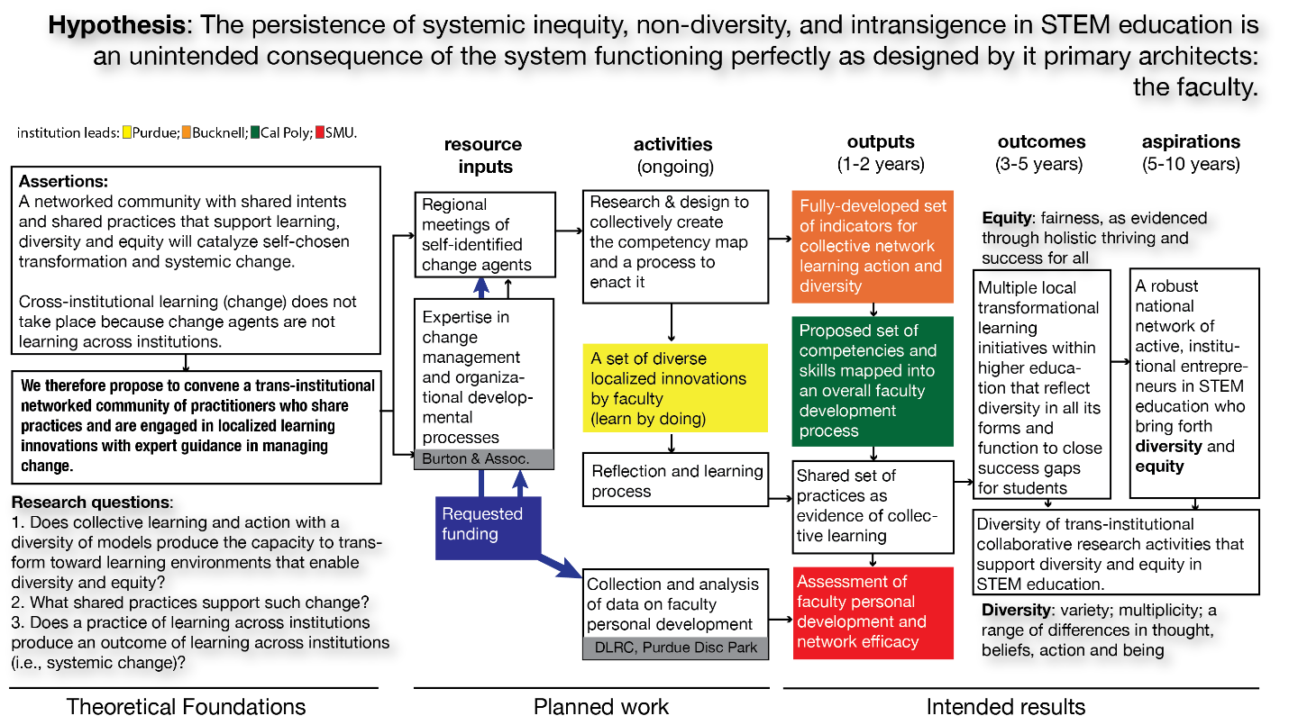

The Purdue team’s objectives are threefold: 1. Understanding the role we as faculty play in inequity and deconstructing mental models and assumptions underlying this systemic effect. 2. Undertaking a personal consciousness awareness and transformation around the themes of privilege, power, and success, especially in the STEM educational realm. 3. Designing and running experiments with the goal of generating evidence on mechanisms by which inequity is perpetuated and ways in which it can be countered. The activities are targeted at moving faculty’s social identity along the five stages identified in (Jackson & Hardiman, 1994) (naive, acceptance, resistance, redefinition, internalization.) The process used is akin to one that the Purdue team used recently in a similar project (Mili, 2015). The team will be created through a process of self-selection; most will be in the resistance or redefinition stage on the Jackson and Hardiman scale. They will engage in a communal learning and personal development process autonomously and with external facilitators. Together they will seek a deconstruction of inequity through common readings and discussions (e.g. Promoting Diversity and Social Justice: Educating People from Privileged Groups by Diane Goodman and Equity and Excellence in American Higher Education by Bowen et al.), by inviting speakers (e.g. Dr. Dorinda Carter Andrews from Michigan State University to discuss her work on the consciousness gap in higher education and how to address it), and by visiting institutions that have succeeded in closing the gap (e.g. High Tech High in San Diego; the Finnish educational system). After a first phase of building the community and establishing a climate of trust, support, and a base of common understanding, the faculty will start the entrepreneurial phase of designing experiments and approaches. This will have the purpose of gaining a deeper understanding of the systemic issue of inequity and mechanisms by which it can be brought to light and countered.

Agenda for this meeting
- Discussion of level of endorsement/commitment to the premises of the project
  - It is a journey.
  - We need to agree on the general direction we are moving
  - We do not need to be in lockstep
  - Diversity of paths and paces can be an asset
- Who? What core of faculty should we start with? What criteria do we want our initial group to meet, e.g. what size? what diversity? what level of commitment and availability, etc.?
  - Who else should we invite?
- Pillar activities
  - Outside speakers
    - Dr. Dorinda Carter Andrews from Michigan State University February 3rd, talk on the 4th (see The Consciousness Gap In Education - An Equity Imperative: Dorinda Carter Andrews At TEDxLansingED http://video.vidiw.com/watch.php?vid=bd838b352)
    - Alford A. Young, University of Michigan on safe discussion of “challenging issues” in academia (have not contacted him yet). He is co-editor of book below; also see WEPAN panel or https://www.youtube.com/watch?v=w283ZX0atIs
    - Purdue speakers?
    - Other external?
  - Reading club
    - Promoting Diversity and Social Justice: Educating People from Privileged Groups by Diane Goodman
    - Equity and Excellence in American Higher Education by Bowen et al.
    - Faculty Identities and the Challenge of Diversity edited by Mark Chesler, Alford A. Young
  - Learning with and from others (internal and external partners and role models)
  - Targeted activity --- research in action (designs, experiments, a common one? Several? )
- What do we start now?
- Next meeting

