Purdue University
Sponsored Program Services, Pre-Award

Our Mission
Pre-Award supports the University community in proposal development through value-added, high-quality service and professional partnerships with Principal Investigators (PIs) in order to facilitate world-changing research.

Our proposal specialists work collaboratively with PIs and the Office of Research Proposal Development team to prepare grant applications, serving as a dedicated central resource in all matters related to University and sponsor policies for proposal development and submission. Pre-Award Specialists provide the following services in support of PIs:

- Review sponsor guidelines, identify key requirements
- Assist with budget preparation, related documentation and proposal submission forms
- Prepare required sponsor administrative forms
- Ensure that all Purdue information included within the proposal is accurate and complete
- Contact and collaborate with partner institutions to secure all necessary subcontract documentation
- Assure all regulatory requirements and export control issues are identified
- Review the final proposal package to ensure all administrative requirements have been met
- Obtain academic approvals and provide institutional approval for the proposal
- Complete the final submission package, upload final documents and forms, and submit to the sponsor

Proposal Deadline Policy (Effective September 15, 2023)
Sufficient time is required to assemble, review, and submit grant applications to meet sponsor requirements. With the growing number of faculty at Purdue that are submitting proposals and the increased sponsor complexities this policy will allow Pre-Award time to adequately support preparation of applications and to thoroughly review applications for compliance requirements.

Proposal Deadline Stages | Due to Pre-Award
- Initiation Stage | 3 weeks (15 business days) in advance
- Admin Stage (Non-Scientific Documents) | 1 week (5 business days) in advance
- Science Stage (Scientific Documents) | 2 business days (16 hours) in advance

Anything received after the stated number of days prior to the sponsor deadline or desired submission date will require completion and approval of an exception form in order to be able to submit. Any sponsor deadline after 5:00pm should be considered due at 5:00pm.

Once a Principal Investigator has decided to submit a proposal, the PI should create a Funding Proposal in PERA. https://pera.research.purdue.edu/ A Funding Proposal Quick Start Guide is available. Once the Pre-Award team receives this information you will be contacted by a team member.

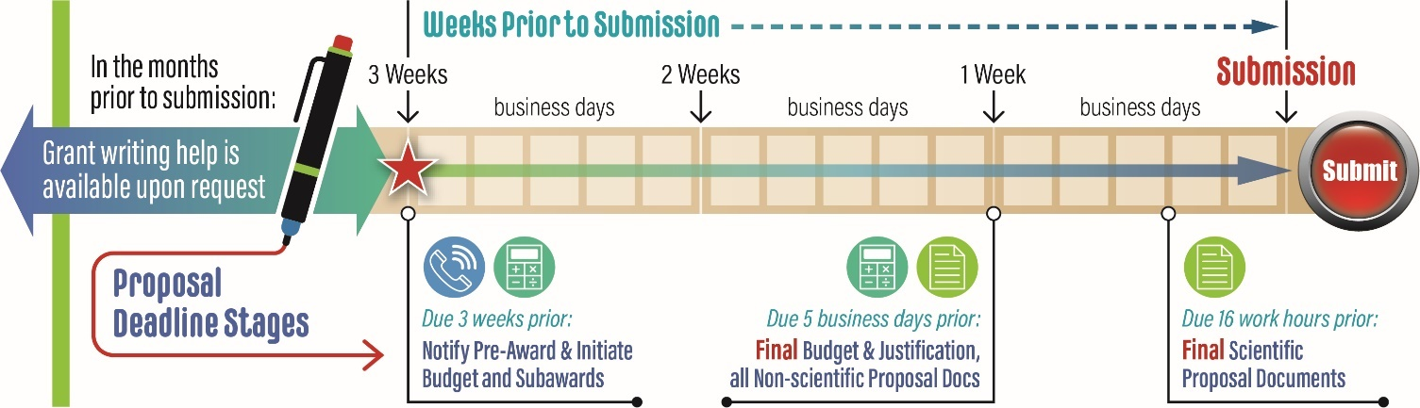
Contact Pre-Award (ALL staff are REMOTE):
College of Agriculture: agpreaward@purdue.edu  College of Education: centralpreaward@purdue.edu  College of Engineering: coepreaward@purdue.edu  College of Health and Human Sciences:  chhspreaward@purdue.edu  College of Liberal Arts: centralpreaward@purdue.edu | College of Pharmacy: coppreaward@purdue.edu  College of Science: cospreaward@purdue.edu  College of Veterinary Medicine: vetpreaward@purdue.edu  Daniels School of Business: centralpreaward@purdue.edu  Purdue Polytechnic Institute: centralpreaward@purdue.edu  Discovery Park District: spsdpark@purdue.edu
-----------------------------------------------------------------------------------------------------------------------------------
Leadership:
Hamaker, Amanda Director 6-9647 ahamaker@purdue.edu

Peabody, Lindsey Assistant Director 6-2393 lindseyp@purdue.edu
- Affiliated Organizations: PII, PARI, Purdue Global, Regional Campuses
Clayton, Ryan Senior Manager 6-9650 rcclayto@purdue.edu
- College of Science/College of Pharmacy/ College of Health and Human Sciences
Cleveland, Heather Senior Manager 6-7121 hclevela@purdue.edu
- Strategic Interdisciplinary Research
Claxton, Matt Senior Manager 6-1464 mclaxto@purdue.edu
- Purdue Polytechnic Institute/College of Education/College of Liberal Arts/Krannert School of Management)/Discovery Park District
Martin, Amanda Senior Manager 4-6117 mart196@purdue.edu
- College of Agriculture/College of Veterinary Medicine
Martin, Melissa Senior Manager 4-7881 martin89@purdue.edu
- College of Engineering
Scott, Bryan Senior Manager 4-8366 scott1@purdue.edu
- Industrial Partnerships

Pre-Award Specialists
Brown, Tara | 4-5604 | tmfinley@purdue.edu
Bryant, Renda | 4-5367 | rlbryant@purdue.edu
Bullins, Paige | 4-4596 | pbullins@purdue.edu
Burgess, Carissa | 6-8754 | burgescm@purdue.edu
Carey, Marla | 4-4113 | careym@purdue.edu
Clodfelter, Joley | 6-2198 | jclodfe@purdue.edu
Estby, Malinda | 4-6487 | mestby@purdue.edu
Evans, Kathryn  Frantz, Nicole  Garrity, Susan | 6-2781  6-5348  6-1797 | weiss44@purdue.edu  nmfrantz@purdue.edu  sgarrit@purdue.edu
Glidden, Amanda | 4-5796 | glidden1@purdue.edu
Gretencord-Steiner,  Jessica | 6-3627 | gretencj@purdue.edu
Huang-LaRoche,  Lovell | 4-1916 | lhuangla@purdue.edu
Huffield, Jessica | 6-2782 | jhuffiel@purdue.edu
Johnson, Clinton | 6-9649 | johns272@purdue.edu
Killian-Alenduff,  Rose | 6-0347 | killianr@purdue.edu

Kitchen, Lauren | 6-8225 | kitchenl@purdue.edu
Kizer, Amber | 6-3654 | aakizer@purdue.edu
McNeal, Selena | 4-4416 | mcneals@purdue.edu
Powers, Kim | 6-0159 | powersk@purdue.edu
Saldivar, Barbara | 4-7916 | blsaldiv@purdue.edu
Sandquist, Heidi | 6-3566 | hsandqui@purdue.edu
Scheffee, Gretchen | 6-9649 | ghurst@purdue.edu
Schluttenhofer,  Brandee | 6-6167 | bhudspet@purdue.edu
Skidmore, Cathy | 4-9316 | cskidmor@purdue.edu
Springer, Mike | 6-3707 | mrspring@purdue.edu
Williams, Jessica | 6-8758 | will1286@purdue.edu
Whitcraft, Hailey | 4-5750 | wrigh398@purdue.edu
Wright, Samantha | 6-7879 | wrigh815@purdue.edu

