NIH Commons: Just In Time Submission Procedures
(only to be submitted if requested by NIH)
Just In Time (JIT) information may now be submitted through the NIH Commons using the Status module. Since the PI can directly upload his/her documents in to the system and SPS submits the JIT information directly to NIH through the Commons, hard copy submission of such documents is not required to be routed to SPS for administrative signature.
The PI is responsible for the initiation of the JIT submission by uploading the documents and notifying SPS that the documents are ready for submission.

Instructions:
- Log in to Commons
If you do not have log in access, please see your department business manager or contact Jenny Siemers (46367) or Allison Harris (41066) in SPS.
- Select Status in the menu bar at the top of the page. If logged in using a PI account, all of the individuals NIH applications will appear. If using an AO account, you must enter the PI’s last name and any other desired information to complete the search for the specific PI.
- Select the JIT on the right side of the screen corresponding to the application which information is being submitted for. (Shown on screen 1)
- Upload Other Support.
- If Human or Animal Subjects are being used in the project:
5a. Enter the most recent IRB or PACUC approval date in the text box provided. ** will only show up if required**
5b. For projects involving human subjects, enter completed training for all key personnel (Including third party subcontractors & consultants) involved with the human subjects portion of the project.
Note: This letter can be copied and pasted in to the text box.
- Click Save at the bottom of the screen and select View Just In Time Report and print for your records. (Shown on screens 2 & 3)
- Send email to spsdhhs@purdue.edu with the following heading and body:
Email Heading
JIT Documents Ready in Commons [complete NIH application number/SPS Institution number]
Email Body
This is to notify you that the JIT documents for [complete NIH application number] are ready to be submitted in the NIH Commons.
Sincerely,
[PI Name]
- SPS will then review the information and upon approval, route electronically to NIH. An email will be automatically generated from the Commons and sent to the PI and SPS indicating receipt of the JIT documents.

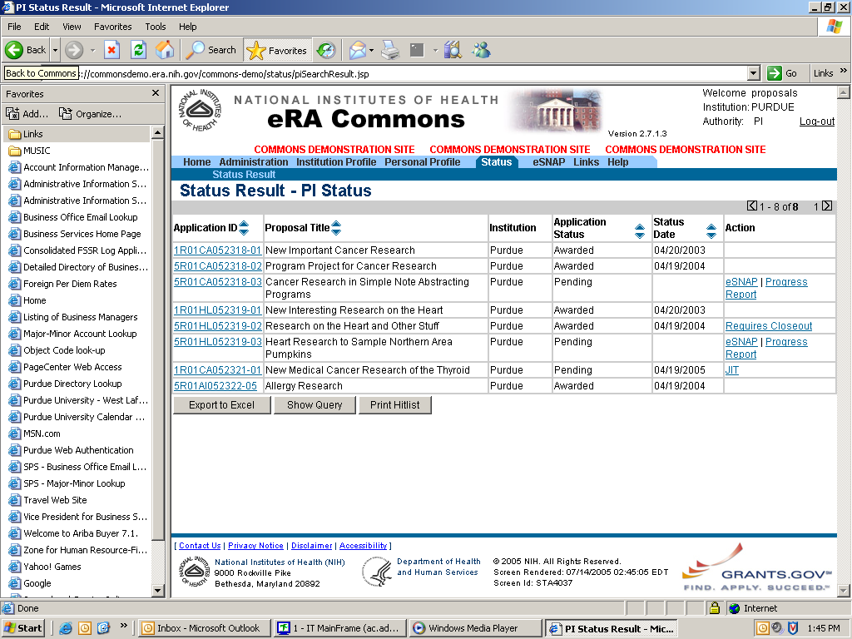
Screen 1
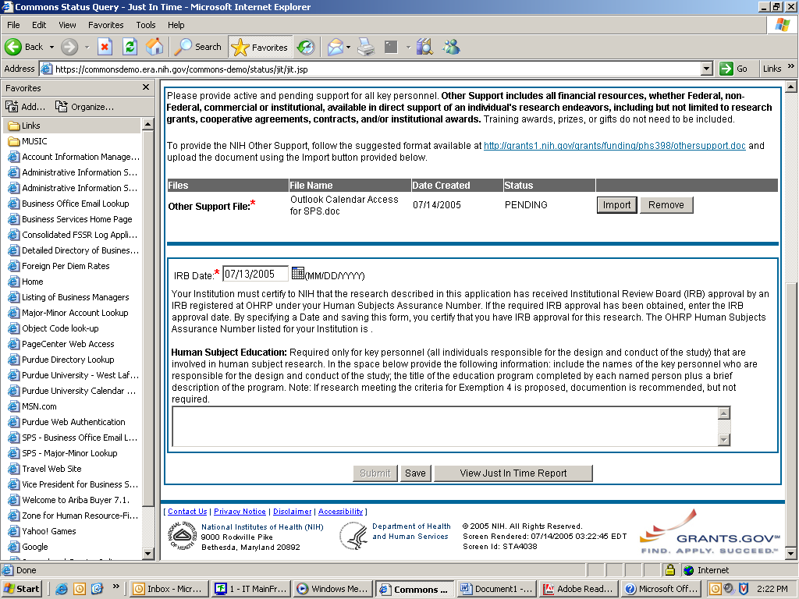
Screen 2
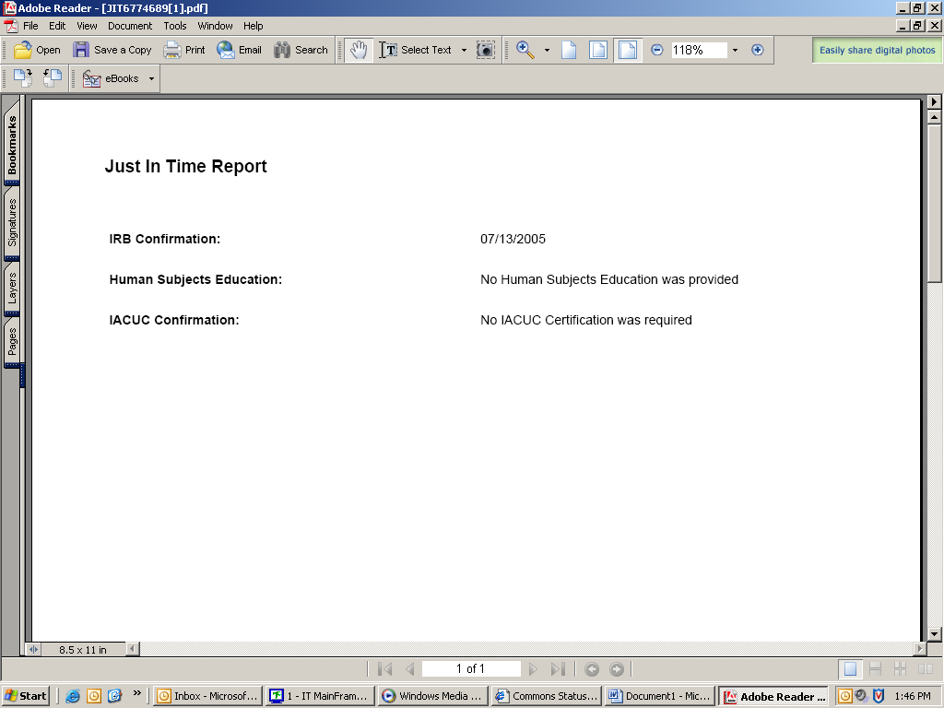
Screen 3

