Research Administration Project Updates

The Offices of the Executive Vice President for Research and Partnerships and the CFO/Treasurer are presently engaged in two significant activities aimed at improving research administration related processes, procedures, and systems. Below is a summary of each:

Integrated Research Administration Study (IRAS)
- An Integrated Research Administration Study (IRAS) began in April 2022 and is scheduled to conclude in December 2022. Fischer and Associates is conducting the review. IRAS is a comprehensive review of research administration processes with the goal of improving efficiencies and recommending critical enhancements to drive research productivity. Periodic updates will be provided.

Three Phases have been completed:
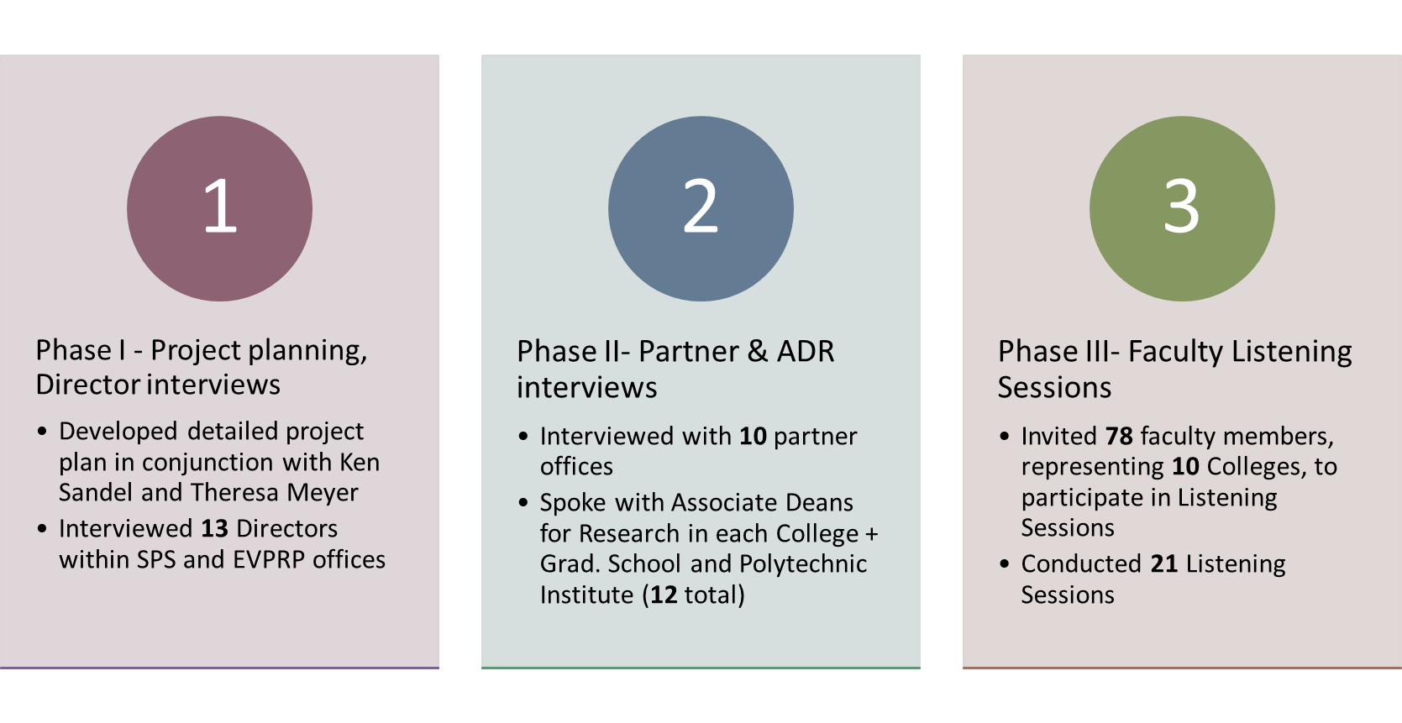
Next steps include:

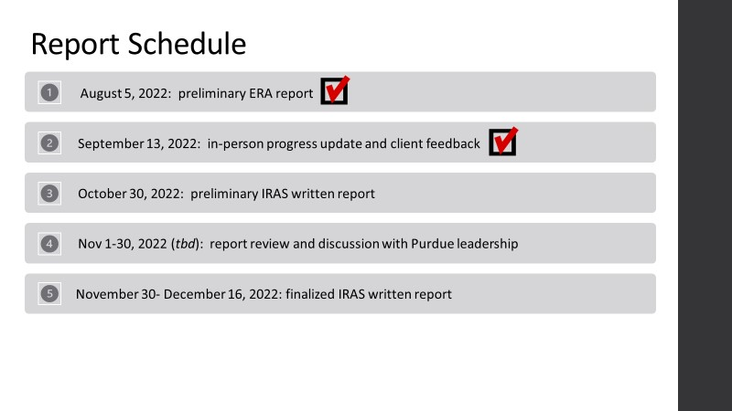

Electronic Research Administration Systems Replacement Request for Proposal (RFP)
- The search for a new Electronic Research Administration system began earlier this year. Purdue released an RFP for the integration of current multiple/electronic systems. This RFP is a joint effort of Sponsored Program Services, the CFO, the Office of the Executive Vice President of Research, and Information Technology (ITaP). Proposal requests were sent to fourteen vendors and six responses were received. Four on-campus vendor demos were held, and two vendors will visit campus in October and November for additional on-campus demonstrations to show the capabilities of each system. The goal of this process is to identify the replacement for several internal current electronic Research Administration (eRA) systems The anticipated implementation to begin transition to a new eRA system is Spring 2023.

The functionality the new eRA system includes, but is not limited to the processing, management, and oversight of:
- Proposal processing (e.g., proposal submission, award establishment)
- Negotiation/Agreement management
- Award tracking and monitoring
- Human Research Protections and IRB submissions
- Institutional Animal Care and Use Committee protocol submissions
- Institutional Biosafety Committee (IBC) protocols
- Conflicts of Commitment, Outside Activities
- Financial Conflicts of Interest
- Export Controls

Typical features of an eRA system include:
  - Automation of research administration business processes
    - Submission of proposals
    - Budget development
    - Regulatory protocol development and review
  - Authentication control and single data entry point
  - Automation of workflow, routing, approvals and communication
  - Personal Dashboard/Inbox to consolidate all “to-do” activities
  - Email notification with direct link to the system
  - Storage of electronic data and exchange of information
  - Reporting/analysis/compliance monitoring

The working group/RFP team will be inviting Purdue faculty and staff who utilize the current systems to attend the upcoming vendor demos.

Anyone in the Purdue community who is interested in attending the vendor demonstrations or who have general questions about the process should contact Kim Gascho, Lead IT Business Analyst, Sponsored Program Services (kgascho@purdue.edu). Once dates are finalized, the group will extend an invite for attendees to join in-person or by virtual means.

