Questionable Transactions
SWITCHING DEFAULT LAYOUT
First step is to switch user default layout so background job will display in correct format. Go to transaction S_PLN_16000269
Enter the following parameters, grant = 100150 posting dates 1/1/2011 – 1/31/2011. Click the execute icon . This will return results, we are not interested in the results, we just want to switch your default layout. Next click the select layout icon shown below.
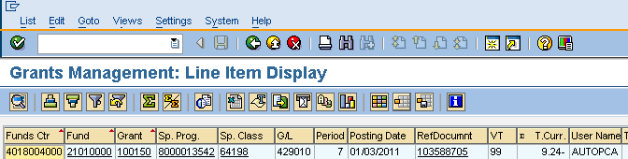
The following bow will appear. The first time you do this, scroll down and select the layout named /QUESTION
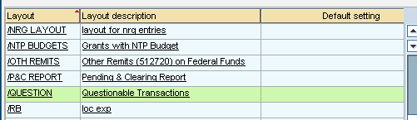
This will return you to report output, but now the data will be in a different layout. Now we need to save this variant as your user default. Click the Save Layout Icon .
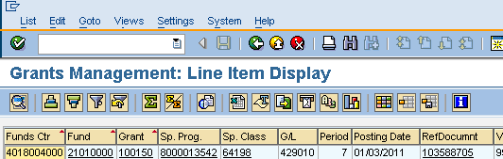

The following screen will appear. In the Save Layout Field, type Z/QUESTION
Also check the boxes marked User-Specific and Default Setting. Click the green check mark
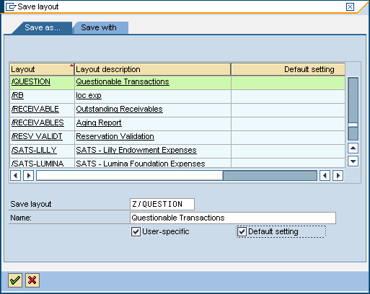
Now we are ready to run the Questionable Transaction Report

To run the Questionable Transaction Report, follow the steps below.
- Run the t-code S_PLN_16000269 (Grants Management: Line Item Display)
- Select Goto>Variants>Get as shown below
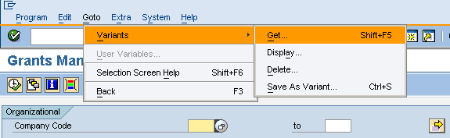
The following box will appear. Your name may default in the Created by field. If so, clear out the field so everything is empty.
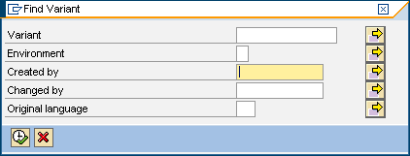
- Click the execute icon.
- The following screen will appear.
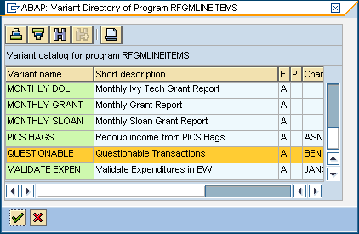
- Scroll down and select Questionable. Click the green check mark.

- The following screen will appear.

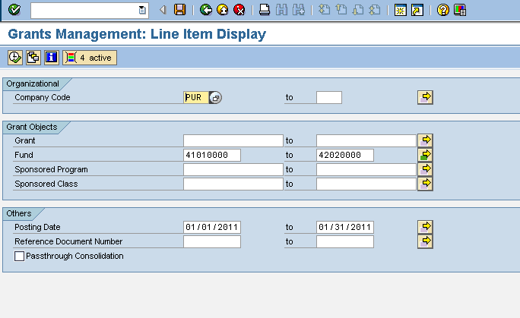

- Review the dates in the Others/Posting Date section. Enter the dates for the previous month. Click on the Dynamic Selection Icon. The following box will appear. Enter your fund center(s) below on the fund center line. IMPORTANT NOTE: DO NOT CHANGE ANY CRITERIA IN THE STAT. INDICATOR or G/L ACCOUNT FIELDS. Once fund center(s) are entered click the save icon
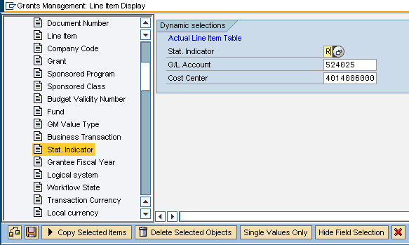

- This will take you back to the initial selection screen. Next, click Progam>Execute in Background as shown below

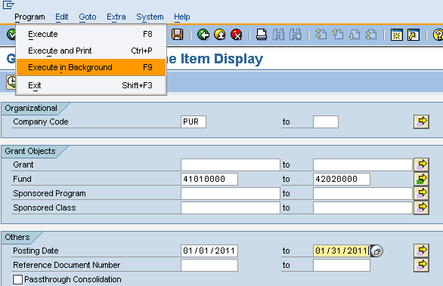

- The following screen will appear. Verify that the Output Device says OnePurdue Default and click the green check mark. You will most likely have a different printer in the Windows printer field, this is not an issue.
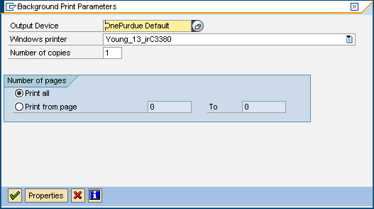
- The following screen will appear, click the icon labeled Immediate. Then click the save icon
Important Note: Do not check the Periodic job.

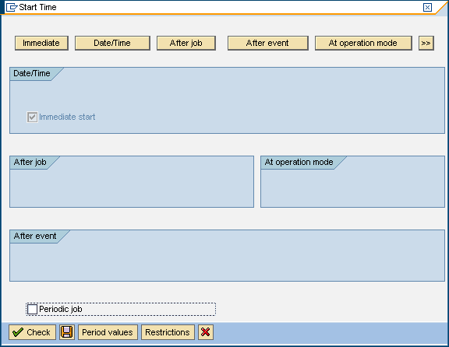

- This will take you back to the transaction screen, at the bottom of the screen you should see the note stating the Background job has been scheduled.
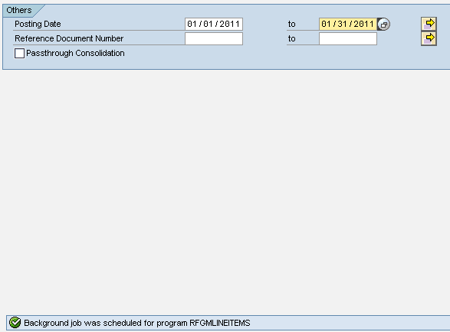
- Next exit out of the transaction and return to the SAP main screen. From here select System>Own Jobs as shown below
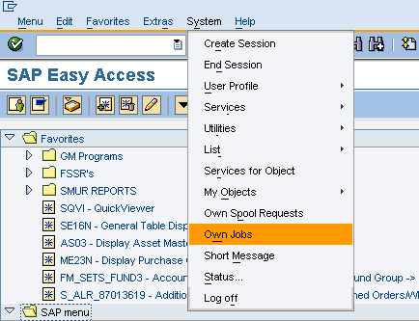
- This will take you to the following screen. This screen contains all background jobs you have run or are running. It stores jobs for eight days. All jobs pertaining to the Questionable Transaction Report should be named RFGMLINEITEMS in the Job column. If your status is active as shown below it means the job is still processing. You can see the number of seconds the job has run for under the duration column
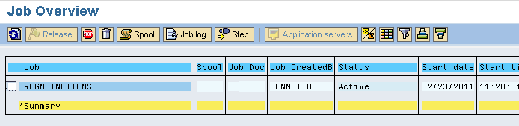

- . Once complete the status will switch to Finished, click the spool icon

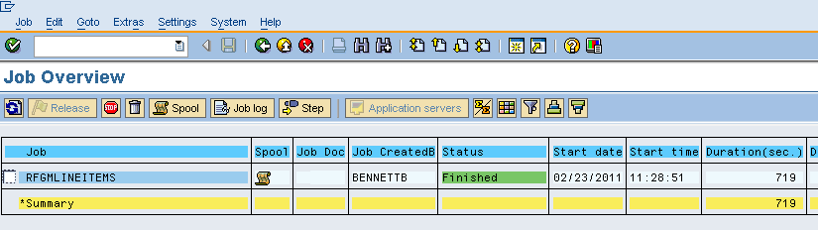

The following screen will appear, click the icon . This will take you to the results.

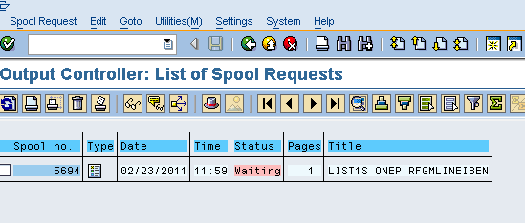

Results are shown below. Notice how the screen above lists the number of pages; in this case we only had 1 page. The output will initially only show the first 10 pages. If your job has more than ten pages we have to change a setting to see all the results.

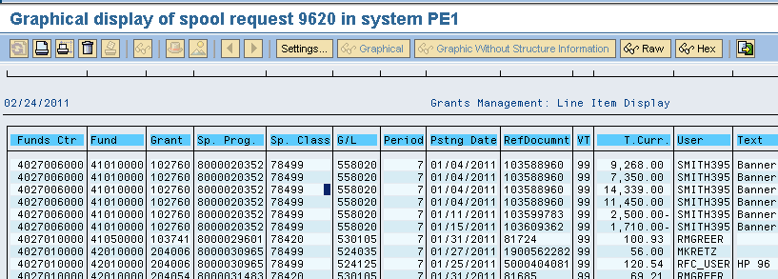

To see more than 10 pages click the settings button and the following screen will appear. See how the Display Are has from page 1 to page 10. You would need to change the To page field to the number of pages listed above and click the green check mark.

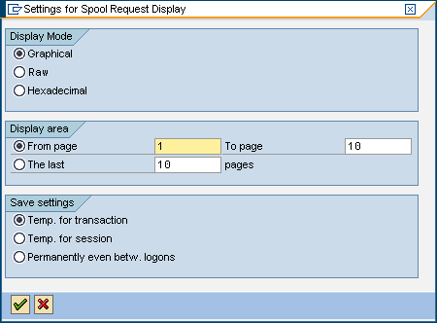

Once you have all the data you can either print directly or export to excel. To export to excel click the icon
The following screen will appear. You can select either unconverted or Spreadsheet and then click the green check mark
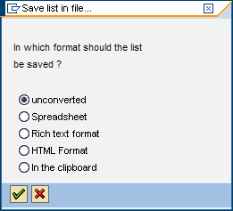

The following screen will appear, from here you can indicate where to save the file. After selecting you location click the generate icon and the file we be exported



