Process: This job aid describes how to use Perceptive Experience

WebNow
Website | https://cm.itap.purdue.edu/
Requirements | Perceptive Experience only requires access to the Purdue VPN  Please Note – All VPN networks should work to access Perceptive Experience. If you are unable to launch Perceptive Experience please try the VPN: webvpn2.purdue.edu
Viewer Role Requirement | The below security roles are necessary to view documents within Perceptive Experience. Requests for these roles should be done through Success Factors.  BI150_000_FI_DATA_LEVEL_1 – Will give access to the Finance Viewer along with PARS and CD01 Viewer  GM800_000_DISPLAY – Will give access to the Post-Award Viewer
Login | To login you will need to enter your Purdue User ID and BoilerKey  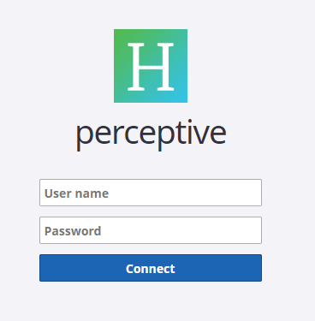
Navigation | When first logging in you will see 5 different options to select. Currently, only “Documents” is usable. All other options will become functional during later enhancements of the system
Document Views | Depending on the SAP roles granted through SuccessFactors you will see a number of different view options. Most staff in Business Services will only see the Post-Award Viewer and Finance related views, while SPS staff may see additional views.  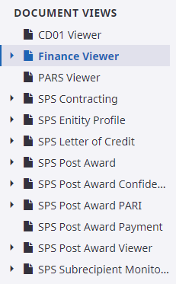
Searching – Finance Viewer | When searching in the Finance Viewer you will be asked to provide a “Constraint” or a field of information like “Document Number”.  Once a document number is added click enter on your keyboard or the “Search” button in upper right corner of screen. This will load appropriate document if it has been imaged.
Search – Post Award Viewer | Similar to searching in the finance viewer the user would select a constraint like “Grant Number” or “Proposal Number”. This will bring in all documents related to either or both of the requested searched. In addition, a number of public filters have been added to allow a prompt to occur where you can enter the data without selecting the constraint  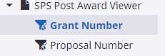  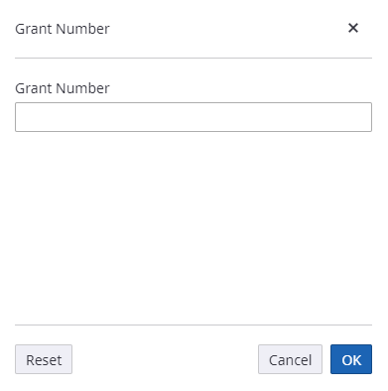
Advanced Searching | Users can add multiple constraints to a search if a user wishes to narrow search results on grants or other searches that may load a large amount of data. Follow the below steps to include multiple constraints in a search. Using the SPS Post Award Viewer this will show you had to narrow searches.  - Add your first constraint to the search functionality  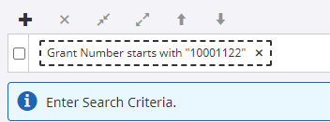  - Click the Plus sign to add another level.  - Add your second constraint  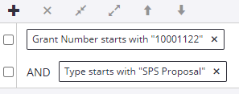
Private Filtering | Users can create private filters for their own personal use. To do so click the “Create New Filter” button at top right of screen  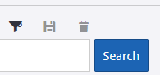  You will be required to name the filter. From there you can add different constraints and save the filter for future use.

