SPS Awarded the Golden Stopwatch Award

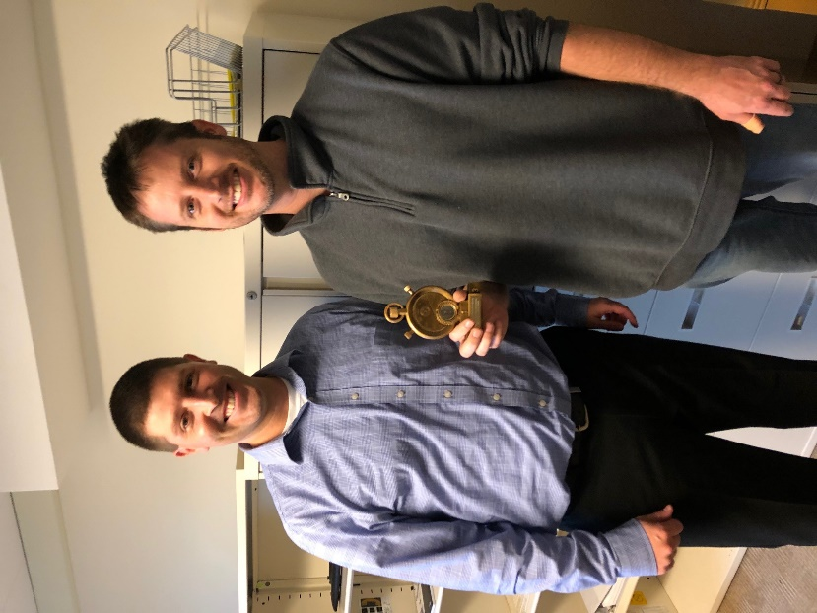
Sponsored Program Services would like to recognize the efforts of the entire Contracting and Support teams and especially Nate Bowers, Contract Analyst (pictured along with Kyle Wargo, Contracting Director) for receiving the Golden Stopwatch Award.

This recognition came from Addgene, a nonprofit plasmid repository, and is awarded to organizations with outstanding Material Transfer Agreement turnaround times.

Congratulations Nate and the Contracting and Support Teams!

