Process: This job aid describes procedures for reviewing a grant in GR55 and what issues to check. This is part of the closing process.
GR55 – Execute Group Report
SAP Easy Access | Enter the transaction code GR55  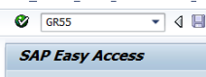
Execute Report Group | Report Group = Z500  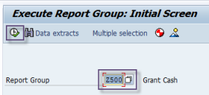  Click Execute
Grant Cash: Selection | Enter grant number in Or value(s) field  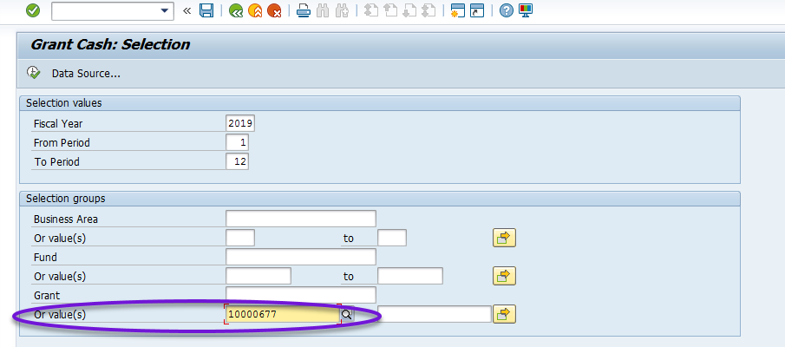  Click Execute
Example No.1 | Grant 10000677: In this example Unearned Revenue is out of balance. Currently all inv=come received is sitting on GL 204700. These issues normally are corrected overnight via a nightly SAP process if income matches expenses. If issues continue please notify your supervisor.  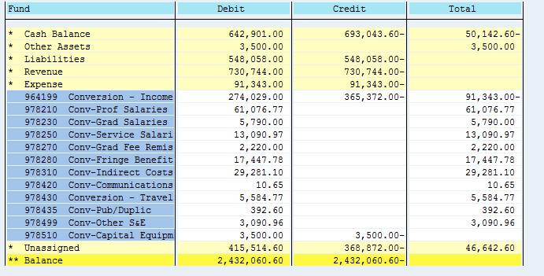
Example No.2 | Grant 10001053: Currently there are 4 liability issues outstanding. The Vendor Reconciliation and GR/IR should be handled through the business office. SUA Vendor Pay Clearing is a “Single-Use Account” Clearing account. This is an electronic credit card based payment solution that has additional controls. Accounts Payable handles these types of transcactions but it is still recommended you work with the business offices to resolve before contacting them directly.  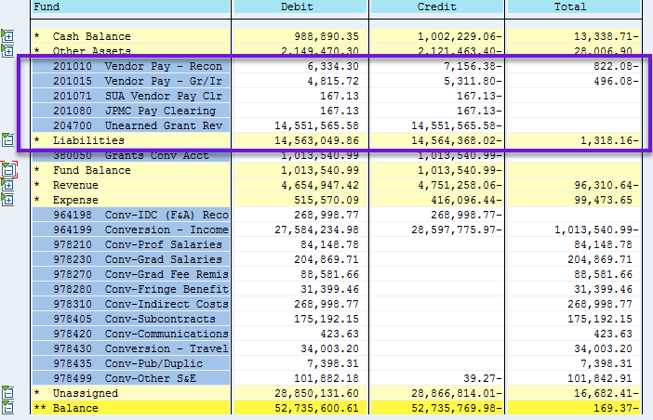
Example No. 3 | Grant 40001443: Part of the F&A process tehre are 2 entries that post to the grant on GL 429010 and 429011. 429010 is our SPS-IDC Recovery GL. It offsets to the F&A expense that posts to the grant. This offset should always use the same sponsored program as the expense. 429011 is our GL hat reverses F&A on the sponsored program using an unrestricted fund and moves the entry to the appropriate F&A revovery pool.  In all cases 429010 and 429011 should offset each other. In this case they don’t. A manual JV will be needed to correct these errors.  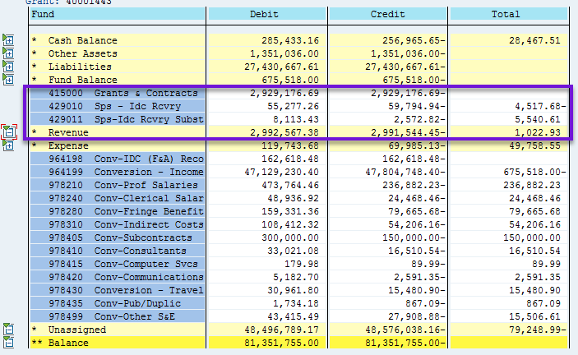
Example No. 4 | Grant 21000135: In this case, the grant has more than one business area associated with it. There are accounts for both the College of Engineering and College of Sciense. It is important to not only look at the grant as a whole to validate that everything is correct but it is necessary to also evaluate that each business area has a $0.00 cash balance. Only when all busuiness areas are balanced is the grant ready to close.  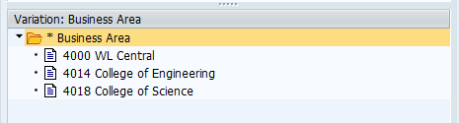
Additional Definitions | Cash Balance: Balance of cash on the grant (FI) (Statistical entry which nets all activity posted to the grant on 4, 5, asset, liability)  Other Assets: Purchase Price of equipment or outstanding invoice (A/R). If there is an A/R reconciliation outstanding this should be resolved before closing.  Liabilities: Recon – This is the vendor payable. Purdue received an invoice for a vendor that is due, but not paid. Gr/Ir – Goods have been received and expenses posted, but haven’t received the invoice which is why it is in GR/IR, or received the invoice, but it was for a difference from what was ordered.  Fund Balance: The life to date revenue – expense. Assets and Liabilities are also included.  Revenue: Amount of Income posted during the current Fiscal Year  Expense: Amount of Expenses posted during the current Fiscal Year
 | The T-Code GR55, Z500 is a Year-to-Date accounting report which can be run by grant. While this report is primarily used in closing it can be used to obtain additional information for reports during the current fiscal year.
 | When closing a grant all sub-accounts in GR55 must balance. Out of balance issues will particularly show up in the cases of Unearned Revenue. Similar to cost share if any balance adjustments are made on the grant you must wait until the next day to close out the grant to allow SAP to adjust cash.

