This job aid describes information regarding master data fields of a created grant. This document can be referenced when trying to determine where data fields exist and what they are used for within grants management.

GMGRANT
SAP Easy Access | Enter the transaction code GMGRANTD
General DataTab
Basic Data | 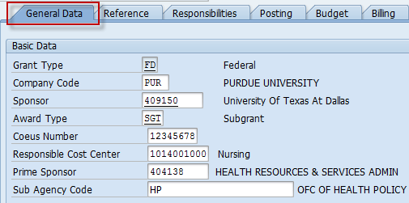Grant Type field:  Grant Type Grant Type Display  Fed - NASA FN - Fed - NASA  Federal (Old) FD - Federal (Old)  Fed - Dept. of Interior FI - Fed - Dept. of Interior  Fed - Dept. of Transportation FT - Fed - Dept. of Transportation  Fed - DHHS FH - Fed - DHHS  Fed - Dept of Education FU - Fed - Dept of Education  Fed - Dept. of Defense FF - Fed - Dept. of Defense  Fed - Dept. of Homeland Sec. FL - Fed - Dept. of Homeland Sec.  Fed - Dept. of Agriculture FG - Fed - Dept. of Agriculture  Fed - Dept. of Energy FE - Fed - Dept. of Energy  Fed - EPA FP - Fed - EPA  Fed - Other FO - Fed - Other  Fed - Natl. Science Foundation FS - Fed - Natl. Science Foundation  Fed - Agency for Intl. Dev. FA - Fed - Agency for Intl. Dev.  Fed - Dept. of Commerce FC - Fed - Dept. of Commerce  State and Local Governments ST - State and Local Governments  Joint Transport. Research Proj JT - Joint Transport. Research Proj  Grad School Fellowships - PRF GR - Grad School Fellowships - PRF  Foreign Governments OF - Foreign Governments  Purdue Research Foundation PR - Purdue Research Foundation  Voluntary Support VO - Voluntary Support  Voluntary Support (Old) VS - Voluntary Support (Old)  Grad School Fellowships (Old) GS - Grad School Fellowships (Old)  Foundations ND - Foundations  Industrials IN - Industrials  Non-Federal (Old) NF - Non-Federal (Old)  Company Code field: Always PUR  Sponsor field: Entity or organization providing funding  Award type field:  - This field is used for reporting purposes and should reflect the agreement type:  - CAG – Cooperative Agreement  - CON – Contract  - CSA – Cooperative Subagreement  - ECA – Equipment Cooperative Agreement  - EPC – Equipment Fixed Price Contract  - EQC – Equipment Contract  - EQG – Equipment Grant  - FPC – Fixed Price Contract  - FPS – Fixed Price Subagreement  - GRT - Grant  - SCT – Subcontract  - SGT – Subgrant  Coeus Number field: Institute Proposal record number for this first increment of funding received on grant  Responsible Cost Center field: Area responsible for the overall management of the award  Prime Sponsor field: Entity or organization providing funding to the sponsor, if applicable (i.e. Sponsor = University of Texas at Dallas, Prime Sponsor = HRSA)  Sub Agency Code field: If known, this is field is used to further identify federal projects in reporting (i.e. NIH)  - If the grant is not federally funded, field will be blank  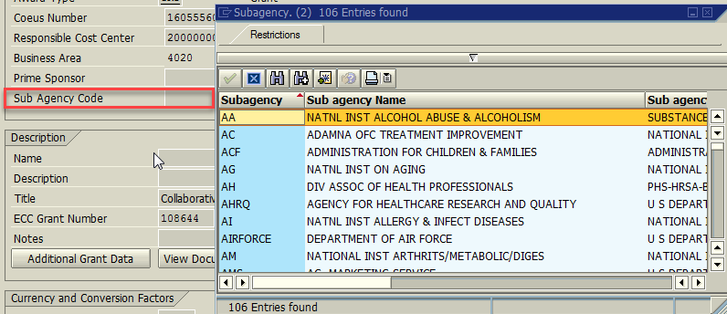
Description – Title of project | 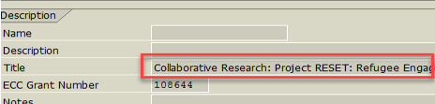
Currency and Conversion Factors | Grant Value field: displays the total amount awarded for the project  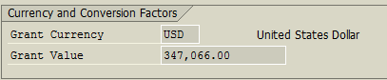  - Note: This is the total amount funded of the grant, and it is commonly maintained (that is, raised and lowered) during the life of a grant master record.)
Grant Validity | Valid from Date and Valid to Date fields: reprecent the time in which expenditures are allowed on the project.  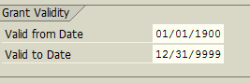  - Note: The Valid to Date field is, like the Grant Value field, a common object of grant master record maintenance
Reference Tab
Reference | Go to the Reference tab.  External Reference field: sponsor's award, agreement or contract number (from the award document) in the field or If an agreement number is not provided, the COEUS IP number is reflected  CFDA field: Code for any assistance program that is administered by federal agencies in the (Catalog of Federal Domestic Assistance)  - A few Federal programs do not assign a CFDA # enter 00.001  - Federal pass-through assign CFDA # included in the subagreement from the sponsor  - Federal contracts and purchase orders assign CFDA # NA.000  - If you can’t locate the CFDA # assign 00.FIN. The actual CFDA # should be assigned within 30 days.  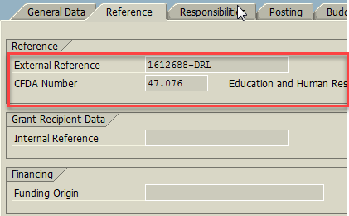
Responsibilities Tab
Responsibilities | Click the Responsibilities tab.  Several parties play a role in the management of a grant, such as the principal investigators and account clerks. In some cases, these parties are employees of the University; in others, they are positions that were created for the roles but not yet filled by a person; and in others, they are org units that oversee some aspect of the grant.  For each responsible person or position or org unit, the following will appear:  - Responsibility type column:  The options include:  - PI – Principal Investigator  - PI2 – Principal Investigator 2  - MGR – Responsible SPS Account Manager  - CLK – Responsible SPS Account Clerk  - OFC – Responsible SPS Office  - AIMS – AIMS Access  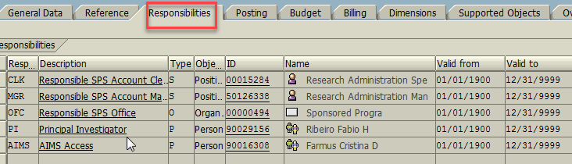
Budget Tab
Budget | Click the Budget tab.  If the sponsor allows pre-award costs, the budget validity from date will be adjusted to the sponsor approved date and the valid to date will be the project end date plus 1 year
Billing Tab
Billing | Click the Billing tab.  Billing Rule field:  - 3 (RRB Non voluntary support expense monthly) when it is non-voluntary support monthly cost reimbursement  - 4 (RRB Voluntary support expenses) when it is voluntary-support cost reimbursement  - 5 (RRB Non voluntary support expense quarterly) when it is non-voluntary support quarterly cost reimbursement  - 6 (RRB Non voluntary support expense semi-annual) when it is non-voluntary support semi-annual cost reimbursement  - 7 (Manual) when no billing plan is set up  - 8 (Milestone) when the billing plan is based on project milestones  - 9 (RRB Non voluntary support expense annual) when it is non-voluntary support annual cost reimbursement  - 11, 12, 13 or 14 (Periodic Monthly, Quarterly, Semi-Annual or Yearly) when a monthly, quarterly, semi-annual or yearly billing plan is set up  - 15 (Periodic After fact) when a billing plan is set up after the project expires  - 16 (Periodic Other) when a billing plan other than the above choices is set up  If the grant is being established as part of a Letter of Credit (LOC), select the appropriate account from the dropdown menu in the LOC field.  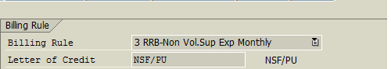  Back-up Type – This drives metrics and indicates if dual review is required.  Submission Method, Forms, Memo Match – indicates the required billing attachment and type of submissions and if there is memo match on the award to be included with invoice.  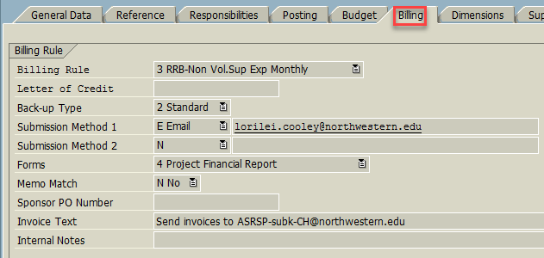  Internal Notes will not print on invoice. This is for our records.
Dimensions Tab
Financing Sources (header) | Click the Dimensions tab.  The grant master record requires data on at least one funding source, along with any internal or cost-sharing sources. External funds represent the Sponsor’s award amount. Grants can only have one external funding source. Internal funds should always be marked as IDC recovery or Cost Sharing, or program income. If F&A will be charged, then 21010000 (general operating fund) must always be entered and marked as IDC Recovery.  External fund listing: 46010000  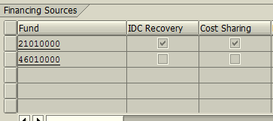
Sponsored Programs (middle) | Sponsored Programs table: represents all sponsored programs associated with the grant  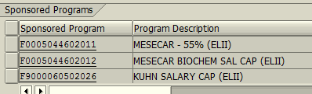
Sponsored Classes (footer) | Sponsored Classes represent the sponsor’s expense and revenue classification. In order for budget and actuals to be allowed on a grant there must be at least one sponsored class.  The selection box for IDC Relevant will be marked if the grant as eligible for indirect cost recovery. Note: IDC chargeability is driven by base & g/l.  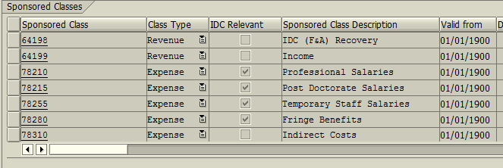
Overhead Costs
Overhead Costs | Click the Overhead Costs tab.  IDC (Indirect Cost) Base field field identifies the base for calculating the F&A costs.  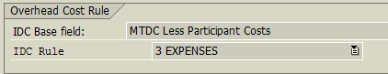  The Overhead Cost table displays a list of the sponsored program/class combos that were marked as IDC relevant on the Dimensions tab.  - Valid from Date and Valid to Date will populate based upon the dates entered on the General Data Tab (should be 01/01/1900 – 12/31/9999)  - Enter the appropriate indirect rate for any sponsored program/class combination in the Indirect Rate column. This rate, which is negotiated by the sponsor and the University, is used to recover overhead costs that cannot be charged directly to the grant  It is possible to have different rates on multiple sponsored programs.  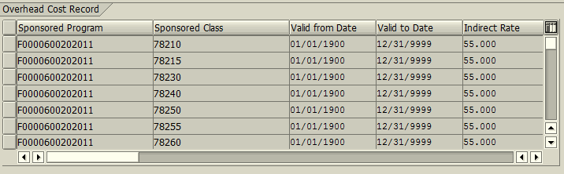
Additional Grant Data
Additional Grant Data | Click the General Data tab.  Click the Additional Grant Data button. This will launch a browser which holds additional grant data.  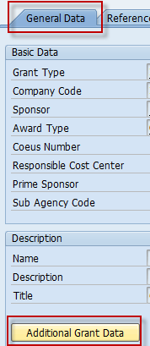
Additional Grant Data
Basic Data | The Originating Sponsor and Prime Award # if applicable.  Preaward Costs field indicates if they are allowable on the award.  FAIN – provided for federal projects.  If Grant is a continuation, the prior grant number will be in Previous Grant field.  Notes related to the award are put in the Notes field or Internal Invoice Notes for notes related to invoicing  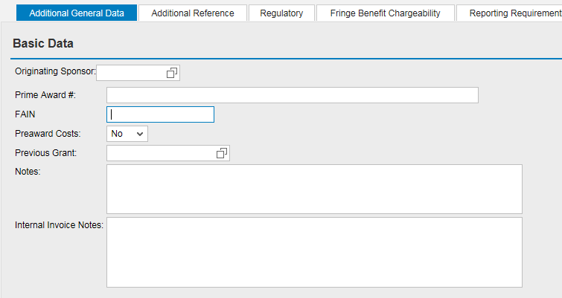
Notice to Proceed | The NTP Liability field will indicate whether the Department or the University is backing the NTP.  The period approved for the NTP will appear in the NTP Begin Date and NTP End Date fields.  NTP Value field states NTP amount authorized for expenditure.  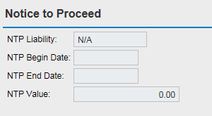
Currency and Conversion Factors | Grant Value pulls from General Data tab.  Total Project Award Amount captures the total award that the sponsor identifies in the award document. This amount could be the same as the Grant Value or greater.  The Total Project Period is the full expected project period of the project (not just the current budget funded).  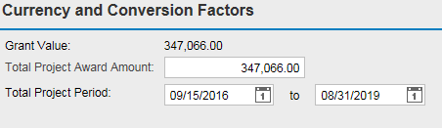
International Activity | Will display the appropriate Country Code for any project that is international in scope if:  - any portion of the project is performed overseas,  - the sponsor is located in a foreign country,  - collaboration with investigators includes overseas personnel, facilities, or ideas (including intellectual property and/or affiliation agreements with foreign universities),  - projects that bring international individuals to Purdue University,  - international travel (other than for conference presentation) is required, or  - project is matched by overseas peers applying to their own funding sources.  This includes projects across all university missions, funded with either domestic or international sources of funding, and regardless of whether Purdue is the lead institution or a subcontracting entity.  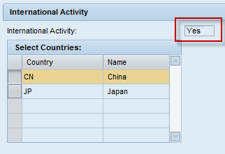
Additional Reference
Review Proposal Information | Displays information entered in coeus record during the original submission process  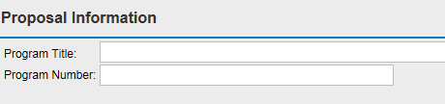
Equipment Information | Equipment Ownership field designates the owner of equipment purchased:  - Purdue Universtiy  - Sponsor  - Prime Sponsor  - Purchase of Equipment Not Authorized  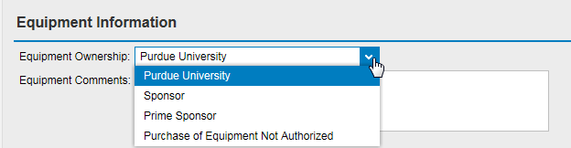
Travel | Travel Restricted field indicates any restrictions to travel charged to the grant:  - Foreign  - Domestic  - Foreign & Domestic  - None  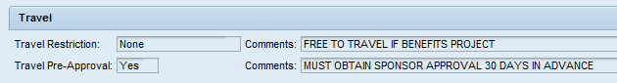  Travel Pre-Approval field indicates if sponsor approval is required in advance of a trip and any applicable comments.
Interest Earned | Calculate Interest Earned field indicates if the project funds earn interest and where the interest is applied. The options are:  - 1 Distribute to Grant: that is, return to project  - 2 Return to Sponsor  - 3 Not Applicable  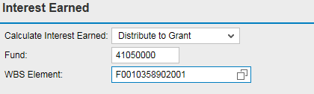
Miscellaneous Data | A variety of flags will indicate if the designated items are applicable to the project:  - Subcontract Plan, if the project has a subcontract with any of the following entities: Women, Minority, Small Business, Women & Minority, Minority & Small Business, Women & Small Business, or Women, Minority, & Small Business. If none, select N/A.  - Direct Cost Restriction, to indicate if there ia a limitation of spending of directs  - F&A Restriction, to indicate if there is an indirect cost limitation.  - Seed/Center Grant, use to indicate if grant funding will issue seed projects.  - Salary Cap, use for NIH grants where salary cap is in effect.  - Multiple IDC Base, use for grants with multiple IDC bases.  - SBIR, use for flow-through received associated with SBIR program.  - STTR, use for flow-through received associated with STTR program.  - COPA, use for grants in which COPA can be applied.  - LVA Tracker – Low Value Asset – equipment that has a value greater than $500 but less than $5,000 (Typically State of Indiana)  - Confidential – use if the project is confidential and all documents should be maintained as such (i.e. confidential drawer in Perceptive Content)  - IP fee – use if there are intellectual property fees  - IP Terms – use if there are intellectual property terms  - Carry Forward, use for agreements that allow for automatic CF  - EVERIFY, use for contracts covered under E-Verify.  - FDP – use if agreements subject to Federal Demonstration Partnership  - Stewardship Comm, Identifies ownership of communication Fly America – use if project is under the Fly America Act  - Buy America – use if project abides by Buy America Regulations  - Faculty Owned Business- use if the sponsor faculty owned  - Publicize, use to indicate if the reciept and/or information about the award can be publicized. Yes = can Publicize and No = Can’t Publicize; add a note if you can’t publicize  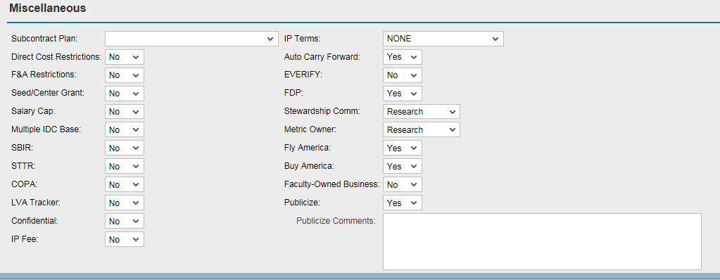  Date to Storage and Date to Destroy fields are used to define the dates when the project files are placed into archival storage and destroyed (HOOKS). These fields are populated during SPS’s boxing process.  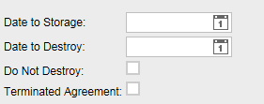
Regulatory
Regulatory | If regulotory items are required for the project, they will be identified on this tab with helpful comments.  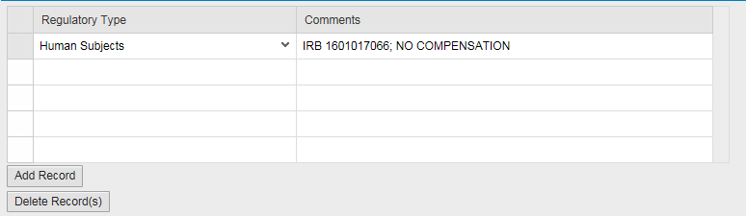  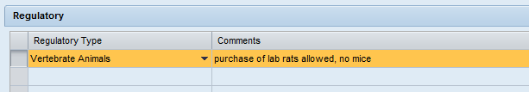
If award requires Responsible Conduct of Research Training be completed , it will be indicated as such and associated comments will be provided.

If award has Foreign National Restrictions, such will be indicated will applicable comments.
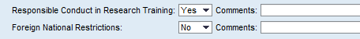
Fringe Benefit Chargeability
Fringe Benefits | The Fringe Benefit Chargeability tab is the controller of fringe benefit expenses. If a fringe benefit expense is not allowable on the grant, the entry on this tab will redirect the expense from the sponsored programs to the pool fund.  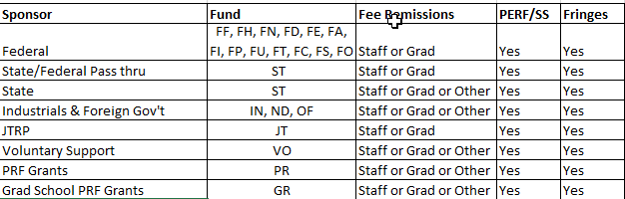  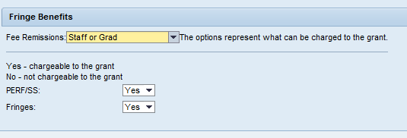
Reporting Requirements
Reporting Requirements | The reporting requirements tab provides a list of all reports required to be submitted to the sponsor per the terms and conditions of the award agreement.  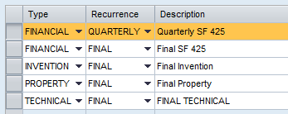  To view the due dates of a report you need to select the line of the report and click on the Dates and Addresses button.  The due dates and report submission method is shown on this screen.  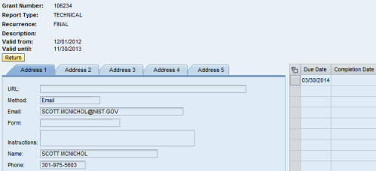
Cost Sharing
Cost Sharing | VCS Flag indicates if voluntary cost sharing is applicable. Voluntary Cost Sharing refers to situations where a PI’s effort is expended on a grant but no salary is charged to the grant.  Total Cost Share Value, the total requirement to be met for the award.  Cost Share Commitment Type, how the sponsor defines the match:  - By Dollar, sponsor requires Purdue to meet a specific dollar amount  - By Percentage, Purdue must meet a specific percentage per award amount/amount expensed  - N/A  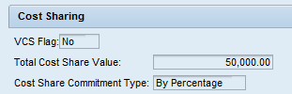  The Cost Share Type, Soruce, Committed Amount, Expended Amount, and Match Type for all cost share commitments on the project will be tracked in this table.  Memo Match – Subrecipient: cost share provided by a subreicpient; source should reflect the subrecipient name  Memo Match – Third Party: not currently being utilized  Memo Match – In Kind: utilized for equipment, space or other SPS extenral account; source should reflect the company providing the equipment/space or the IO/SP number from the SPS external account  Purdue University: this is the C/S for the IO established on the grant  Contributed F&A: all F&A contibuted or unrecovered on the project ; ‘F&A’ should be listed as the source  None: selected if no cost share is required on the project  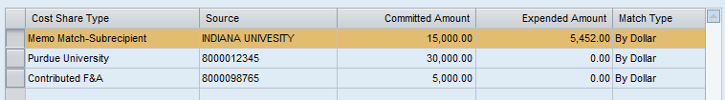
Award Data
Award Data | This tab is used to ensure that all award data is included in award reporting. SAP interfaces with COEUS nightly to mark COEUS records as awarded to prevent a proposal from being used more than once.  COEUS IP#:recored being awarded  Award Date: date SPS enters award transaction  Award Amount: amount funded for that action  Date of Award Letter Received: date award notification was received by the Universty (will be used for post-award metrics)  Notice to Proceed Date: date account was placed on NTP if applicable (will be used for post-award metrics)  Award Type:  - New: indicates first increment of funding recieved  - Increase/Decrease: all subsequesnt award transactions  - Converted: will be noted for all items established in SAP prior to the implementation of the GM Ehancement project on 3/29/13
Non-Financial Award Actions | Negotiaton #: Coeus record assocaited with the transaction  Description:  - No Cost Extenstion: time extension with no additional funding recieved  - Administrative Change: alteration to agreement with no impact to amount or period, i.e. change in financial officer  - PI Change: a new PI was appointed to the project  Post Award Received Date: date award document was received in post-award (will be used for post-award metrics)  Award Action Date: date SPS enters transaction (will be used for post-award metrics)  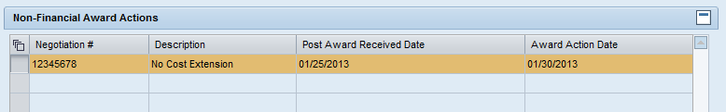
Carry Forward / Interest Earned | Date: date SPS enters transaction  Amount: dollar associated with the action  Action:  - To: used when moving excess (carry forward) funds to new grant  - From: used when receiving excess (carry forward) funds from previous grant  - Interest Earned: used when grant has generated interest as outlined by the sponsor and it is being added to the amount avaliable for expenditure  Grant: reflects grant in which the carry forward funds are moving to or from; will remain blank for interest earned entries