Process: This job aid describes the steps involved in running the Closing Check List Reports.

Go to Cognos login to run the Post Award Closing – Initial Closing Check List Reports
https://www.purdue.edu/bicc/
You will select Initial Closing Check List Reports
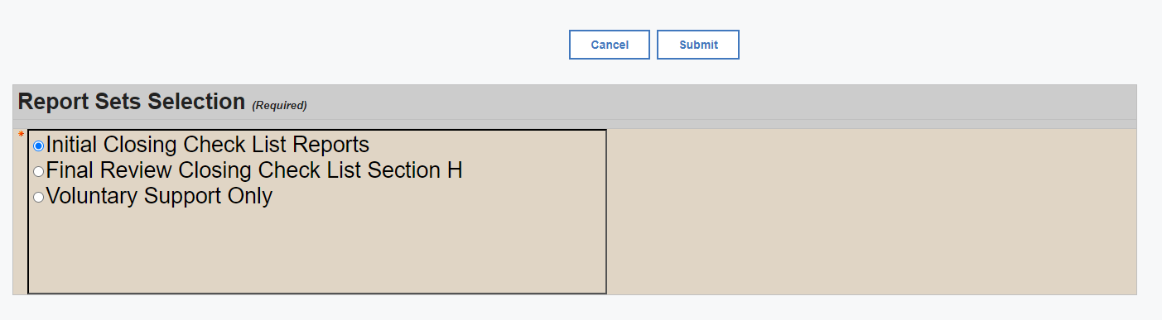
You will enter the grant number, then click insert and then submit
The report will then generate the closing checklist which should be exported to excel

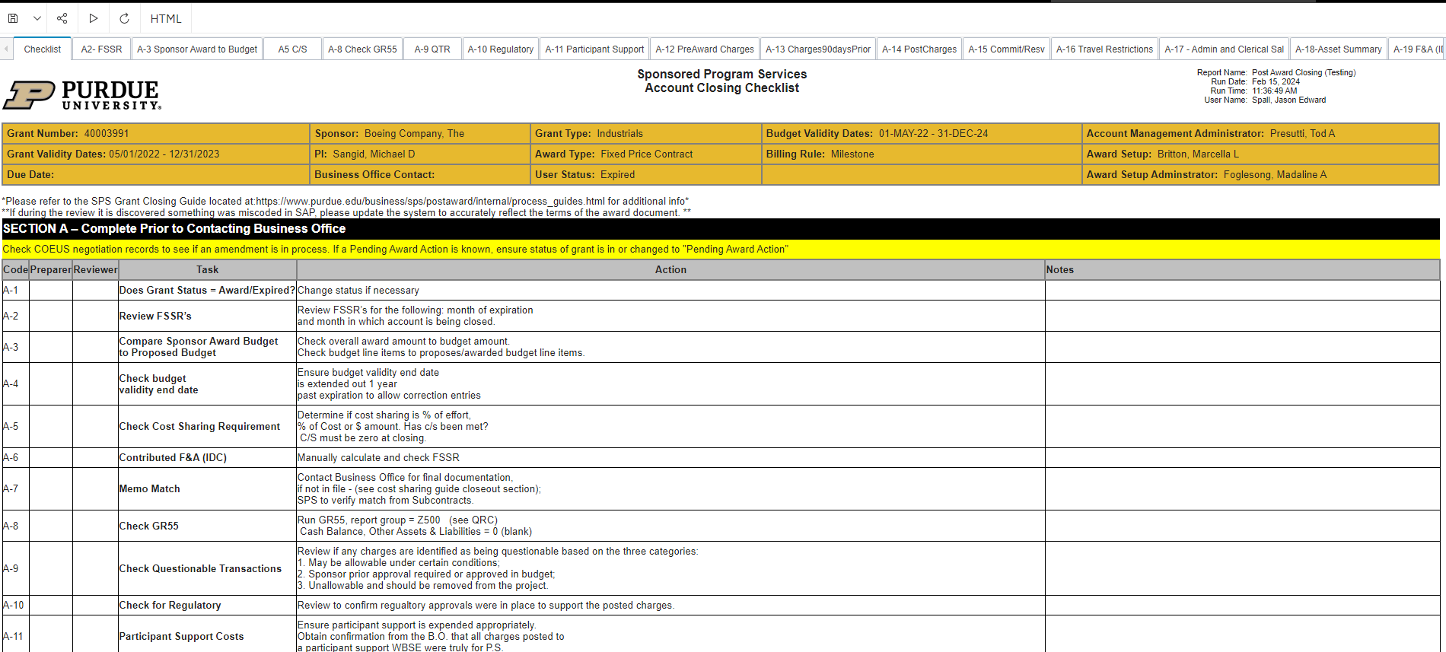

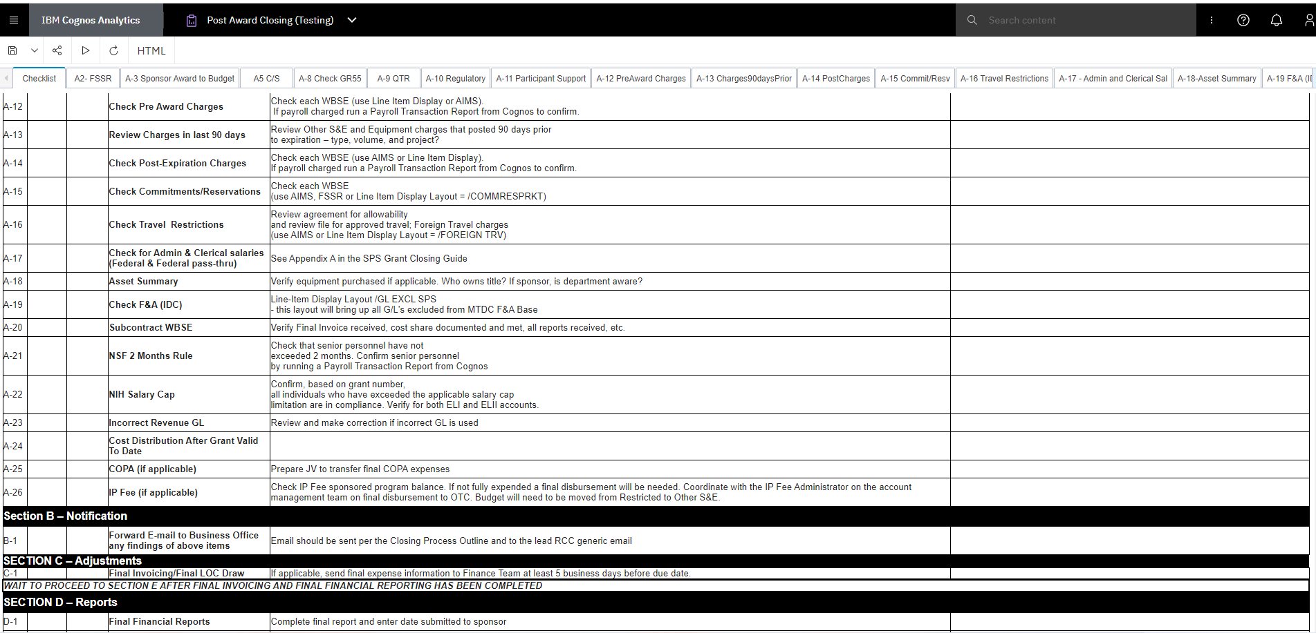

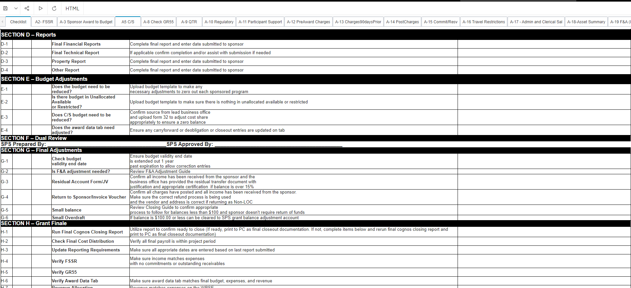

Excel document of Closing Checklist
Each row of the checklist will have a tab in the excel document. The data has been pulled for the grant you are closing out. You will review the data per the SPS Grant Closing Guide.
The Funding Administrator will work through the Closing Checklist section A and then contact the department as instructed. Refer to the SPS Grant Closing Guide and Closing Process Outline for further guidance on steps for closeout.
The SPS Grant Closing Checklist will be uploaded to Perceptive Content and routed to the reviewer.
Go to Cognos login to run the Post Award Closing – Final Review Closing Check List Section H
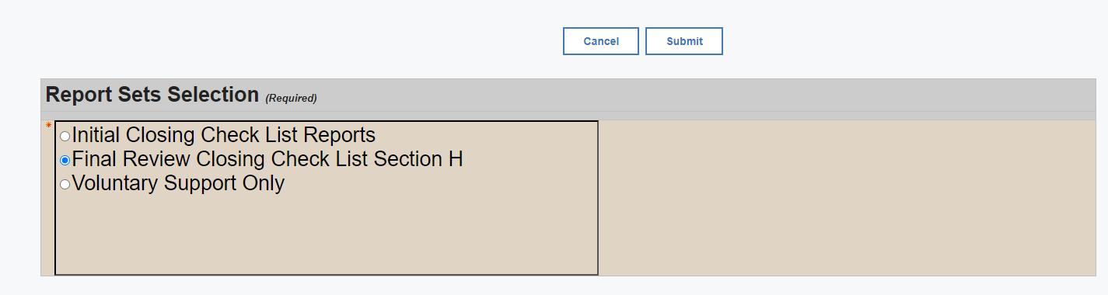
You will enter the grant number, then click insert and then submit. This report will run data for section H of the closing checklist.
The report generated should be exported to excel for final closeout review. Once determined grant is ready to close the Checklist is routed to the reviewer in Perceptive Content for final approval and the grant is marked Closed in SAP.

