Searching in Coeus
- Accessing a Search Box
Just about every task in Coeus involves searching for something, but those searches are initiated in a number of different ways. Usually the first place you’ll encounter a search box is when you open a module, such as Proposal Development. When you open a module, Coeus presents you with a search box automatically so you can jump directly to the record you want.
Once you’ve opened a record (such as a development proposal), you may have to search again to populate some information. Items such as sponsors and investigators are all populated with a search. You initiate these searches using either a Find button or a magnifying glass icon.
- Search Boxes
The method to access the search boxes may vary, but fortunately almost every search box in Coeus follows the same rules and format. As an example, here is a search box in the Proposal Development module:
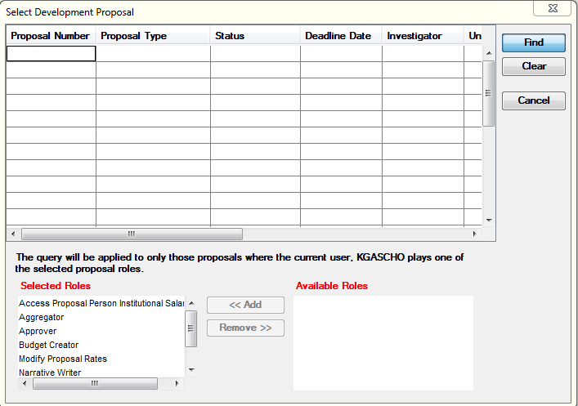
Search boxes have this same format of rows and columns, but the fields in the search box will change based on what area of Coeus you are currently searching. Every column in the search box is a field you may use in your search.
The row/column format is important for more complex searches. See the section on advanced searching below for more information.

- The “Widcard” Character
If you do not know (or want to type) the exact value in the field you are searching, you may use the * symbol, or the special “wildcard” character. This tells Coeus to replace that symbol for anything and any number of characters that may be in its place. There are effectively four ways to use this.
- Ending-Text Search: If you are looking for something and know how the value ends, use the *data search. For example, if you are looking for a development proposal ending with 217 then type *217 in the Proposal Number field. This will bring back any proposal with 217 in the last three digits of the proposal number.
- Beginning-Text Search: If you know how the data begins, use the data* search. For example, if you are looking for all of Dr. Johnson’s proposals, type john* in the PI Name field. (Keep in mind that PI Name in the proposal development is stored as “Last, First, M”.) This search will return all proposals where the PI’s last name starts with “John”.
- Enclosed-Text Search: If you know a portion of the data that is not the beginning or end, use the *data* search. For example, if you are searching for a sponsor with the name of Natural Resource Conservation Service you can enter *resource conservation*. This will return all sponsors that have “Resource Conservation” in their name.
- All records: If you want to see a list of all records available in a module, simply enter * in any field. Be advised that some modules contain many, many records and this search may take a long time to run. In fact, a search on all records is often not allowed by the system – see the section on search limitations below for more information.

- Advanced Searching: The Logical “AND” and “OR”
If you want to narrow your search beyond a single value in a single field, you can take advantage of the search box’s row and column layout. The columns all refer to different fields. The rows offer more flexibility:
- Logical “AND”: If you search in several columns on the same row, you are using a logical “AND” search. For example, if you want to find a proposal where James Kirk is the PI, and the lead unit is 41406000, and the title is Forest Service, you would use the three relevant columns in one row.
- Logical “OR”: If you use multiple rows, you are using a logical “OR” search. For example, if you want to find all proposals where James Kirk is the PI, or the lead unit is 41406000, or the title is Forest Service, you would use the three columns across three rows, like this:
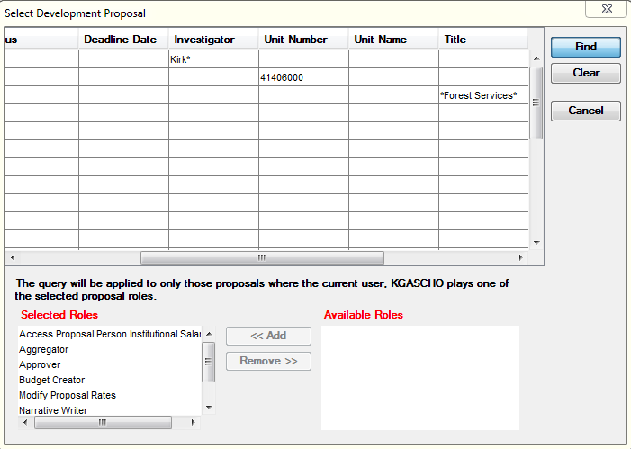

- Search Limitations
To keep the system running efficiently for everyone, there are some restrictions in place on how many records a search is allowed to return. If you run a search where the results exceed this limit, you will be given a message to that effect. The actual limits vary by module, but it is usually on the order of 1,500 records.
Don’t panic if you notice a search is taking an unexpectedly long time to run! This limitation prevents you from accidentally hanging anything up by running a search that is too wide. Coeus can handle any search volume up to these limits, even if it seems to take a while.
- Search Results and Searching Again
Depending on what started your search, you will get results in either a full results list in the module window, or a results tab of the search pop-up box. In either case, you can sort the results by clicking on the column header.

