Process: this job aid describes the steps to perform a key word search on select document types within Perceptive Content

Content Search
Document Types | The following are the Document Types that have been identified as searchable:  - SPS Amendment  - SPS Award Notification  - SPS Form 90  - SPS Proposal – Budget Justification  - SPS Proposal – Project Summary  SPS Proposal – Statement of Work
Navigate to the SPS Content Search within the SPS Post Award section under Documents.
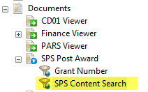
Content | Enter the key word you would like to search for in the Content box and hit enter.  
Results | All searchable document types with that word will be returned. The Details column will indicate how many times that word appears within the document.  Locate the desired document and double click to view.  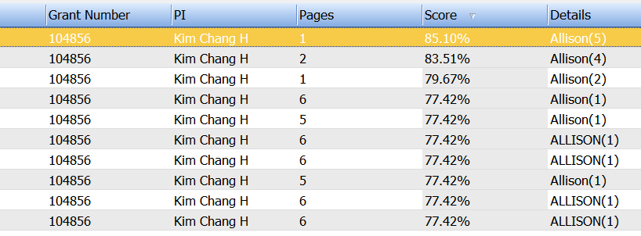
Add Conditions | If the search should be limited to a specific grant, document type, or a combination this can be done by adding conditions within the search box.  
Add the condition(s) that should be applied by selecting from the Field and Value dropdowns one at a time.
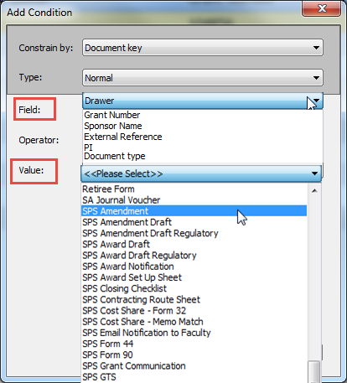
All conditions will appear in the Search field.
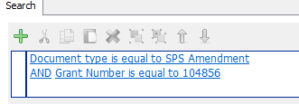
Execute | Once all desired conditions have been entered, hit the  button.
Results | All searchable document types with selected will be returned. The Details column will indicate how many times that word appears within the document.  Locate the desired document and double click to view.  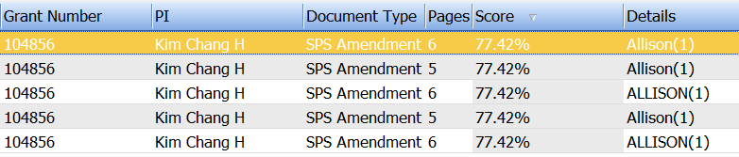
Wild Card | Wild Card searches can be completed as well.  