This QRG outlines the process for faculty to approve a sub-contractor payment request via My Inbox in SAP.

Access My Inbox
Logging into the SAP Finance Launchpad requires two-factor authentication using BoilerKey. | BoilerKey is Purdue’s version of two-factor authentication, which is an extra layer of security that requires your login, a type of password or PIN, and something that can only be accessed by the user, such as a smartphone or physical token.  BoilerKey adds another layer of protection for employees and for the University’s data. For example, the employee portal contains sensitive information, such as bank account numbers, W-2s, and personal addresses. Should an employee’s password be compromised, all of that information could be stolen.  Go to www.purdue.edu/boilerkey to sign up today!
Access the OneCampus Portal (one.purdue.edu)  Click Finance Launchpad to launch SAP Fiori  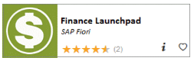  Log in using your BoilerKey | 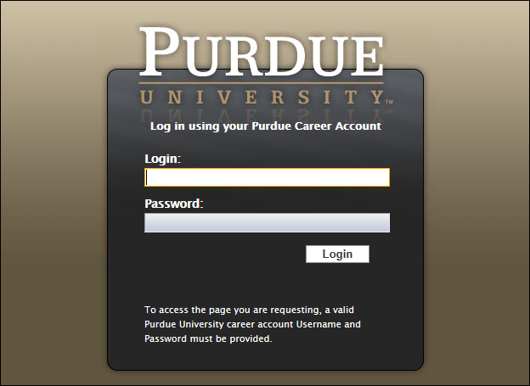
Click Purdue User Group > My Inbox to open pending approval requests.  Note: The number of current requests requiring action is displayed on the My Inbox tile. | 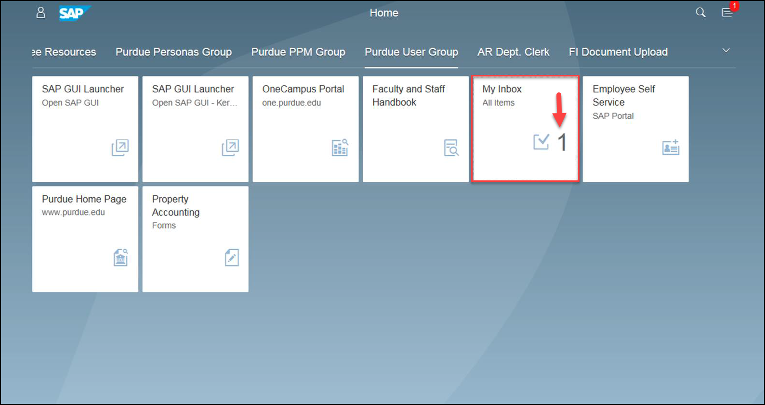

My Inbox Navigation
The Inbox displays. There are several sections within My Inbox to take note of:  - Items: The left side of the screen displays a list of pending tasks. The selected task is highlighted in light blue.  - Information: Information and resources related to the task can be accessed here.  - Actions: Several options for taking action on the selected item can be found at the bottom of My Inbox. | 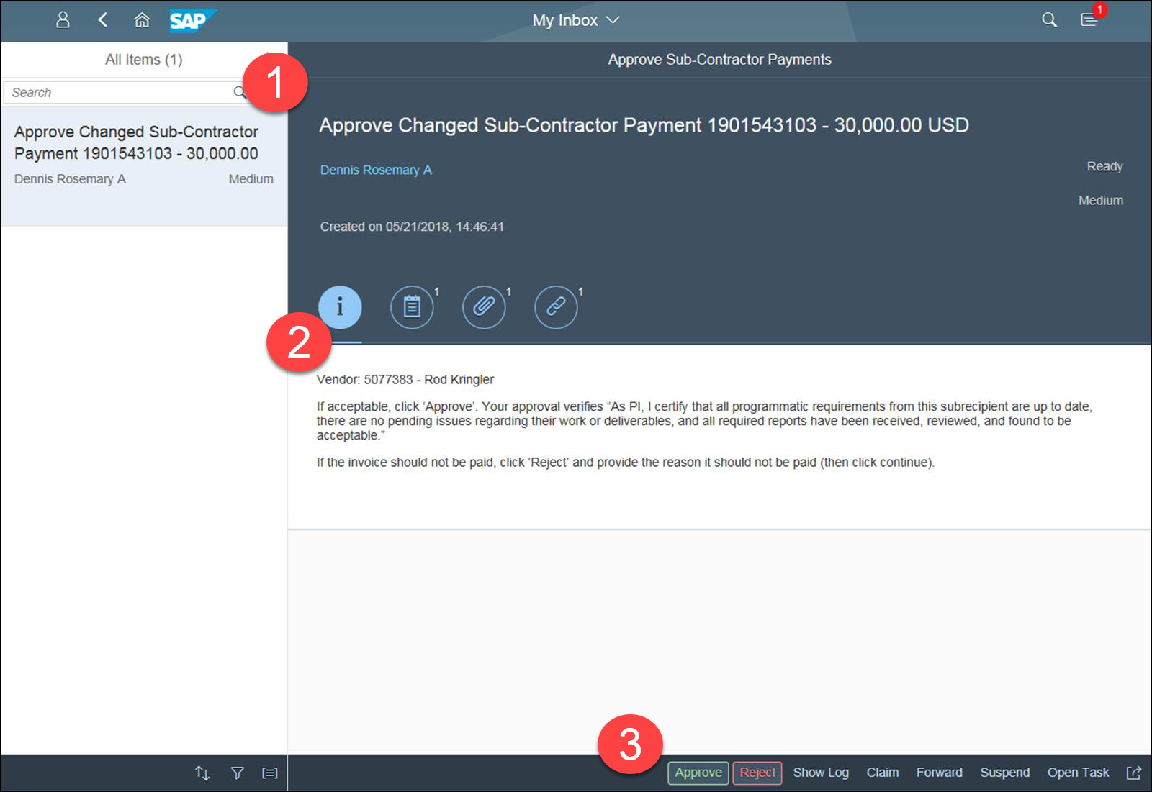
Information items include:  - A summary of the task and potential actions.  - Comments related to the task.  - Attachments related to the approval request.  - Links to documents within SAP related to the approval request. | 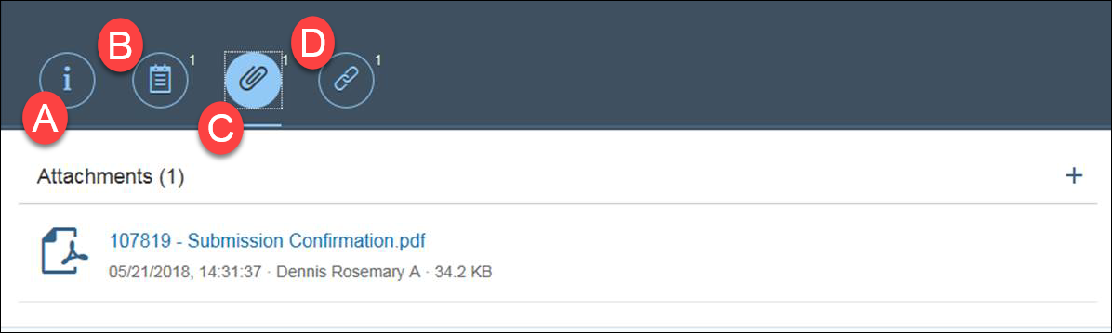
Potentials actions to take include:  - Click Approve to approve the payment request.  - Click Reject to reject the payment request.  - Click Show Log to view any actions already taken on this request.  - Click Forward to send this request to another approver, if appropriate. | 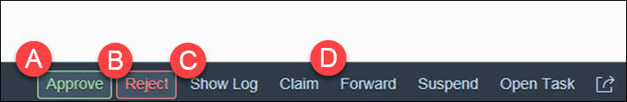
Upon clicking an action, a confirmation dialog box will display requesting confirmation of the decision. Enter comments into the text box, if desired, and click Submit. | 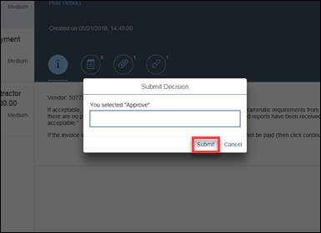
The approval decision is communicated to Sponsored Program Services and the task is now removed from My Inbox.

