Brightspace Basics

The web URL for D2L Brightspace is purdue.brightspace.com. For additional information on D2L Brightspace, please visit https://www.purdue.edu/brightspace/.

Table of Contents
Brightspace Basics 1
Course Content 2
Access Your Content 2
Add Your Syllabus 3
Create A Course Module 4
Assignments 6
Create An Assignment 6
Assignment Visibility 9
Add An Assignment To A Course Module 10
Grade An Assignment 10
Grade Work Completed Outside of Brightspace 13
Create A Grade Item From The Gradebook 13
Enter Grades From The Gradebook 13
Quizzes 15
Create A Quiz 15
Properties Tab 15
Restrictions Tab 17
Assessment Tab 18
Submission Views Tab 19
Add A Quiz To A Course Module 20
Other Things to Know 21
Add TAs, Graders, Or Other Instructors To Your Course 21
Make Your Course Available To Students 24
Modify The Start Date Or End Date Of Your Course 25
Copy Content From One Course To Another 27
Create A Grade Category 29
Email An Announcement To Your Class 30

Course Content
The content area of your course is where you can post reading materials, multimedia, web links, and other resources for your students. Additionally, you can link to assignments, quizzes, and discussion boards within Brightspace, as well as, link to External Learning Tools like publisher content and Gradescope.

Access Your Content
- From your main dashboard, click the course you would like to work in from the My Courses section near the center of the page. If you do not see your course, be sure you are searching in the tab of the correct term (i.e. WL Spring 2021). Alternatively, click the Course Selector near the top-right and select your course from the drop-down.

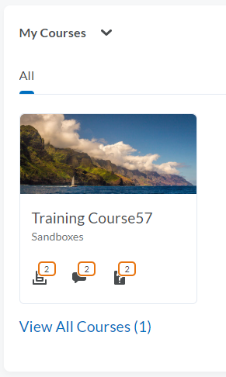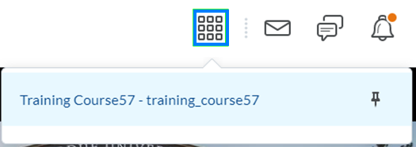

- From the course navigation bar, click Content.

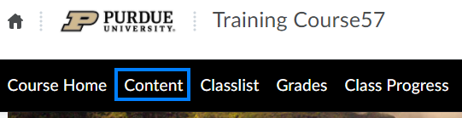

Add Your Syllabus
- From the menu on the left, select Syllabus.

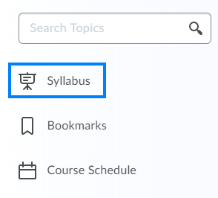

- Sample content may exist. To remove it and replace it with your own, click anywhere within the text to open the text editor, select all of the text, press the Delete key, optionally enter in your own text, and click the Update when finished.

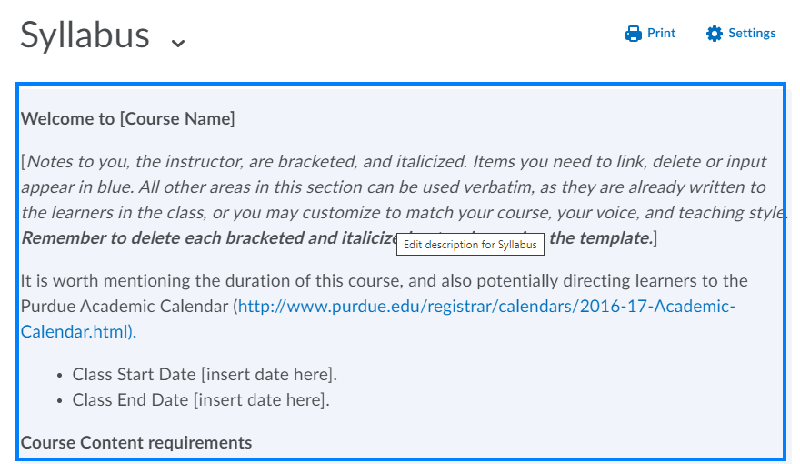

- Click the drop-down icon to the right of the Syllabus header. Select Remove attachment from the drop-down to remove the sample file now and upload your syllabus later. Alternatively, select Change the Attachment if you are ready to upload your syllabus now, in place of the sample provided.

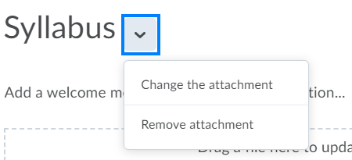

Create A Course Module
Brightspace uses the terms module, sub-module, and topic to describe the organizational structure of the content area. Modules and sub-modules can be thought of like folders. Topics are the actual files, links, videos, assignments, quizzes, etc.

- From the menu on the left, click within the Add a module… textbox, enter the name of your module, and press the Enter key. You will be brought into the module you just created.

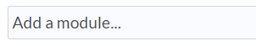

- Under the name of your module are the options to add dates and restrictions if the module should only be available to students after a specific day/time or if the module should only be available to students after they have complete a certain task (release conditions).

You can use the description are to provide an overview or additional details to students. The eye at the far right enables you to manually hide the module until you are ready to make it visible to students.

- Click the Upload/Create button. From this menu, you can add new files, links, SCORM packages, assignments, etc.

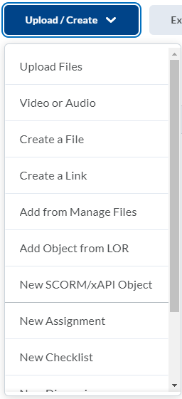

- Click the Existing Activities button. From here you can add Kaltura videos; links to assignments, discussions, and quizzes you have already created; and link to external learning tools like publishers, Gradescope, Circuit, and more.

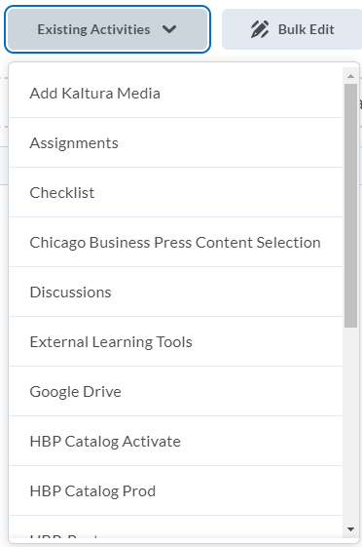

PLEASE NOTE: We recommend utilizing Kaltura for uploading and inserting video content into your Brightspace course, both to preserve storage space in your Brightspace course and to enhance the viewing experience for your students. More information on Kaltura is available here.

- Once several items have been added, you can click the 8 dots to the left of any topic and drag it up or down to reorder the topics.

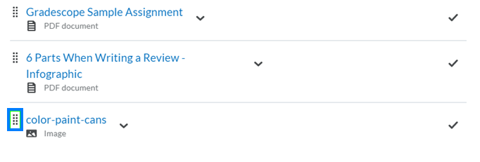

Assignments
The Assignments feature in Brightspace enables you to create a space for students to submit their work as files, text, video, etc. while providing instructors with a convenient way to score and provide feedback to students.

Create An Assignment
- From the course navigation bar, click Course Tools and select Assignments from the drop-down.

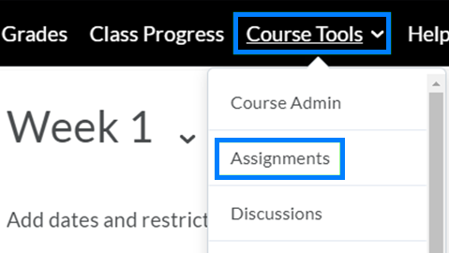
- Click the New Assignment button.

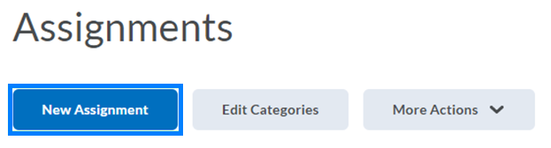

- Enter a name for the assignment.

- If the assignment will be graded, click within the Score Out Of text box and enter the point value of the assignment. In Grades will then appear, indicating a grade item will be created for this assignment in the gradebook.

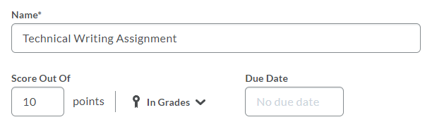

- Optionally, click the In Grades drop-down and select:
- Choose from Grades to create a new grade item and select the grade category to which it belongs. Or to link the assignment to an existing grade item.
- Remove from Grades to create an assignment with a point value, but that will not be included in the gradebook.
- Reset to Ungraded to remove all scoring.

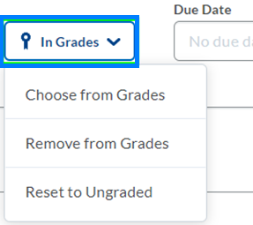

- Click within the Due Date field to establish a due date for the assignment.

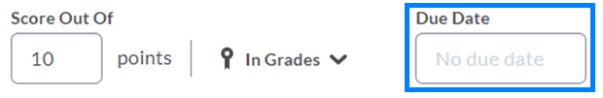

- Add any instructions and/or attach any supplemental files needed.

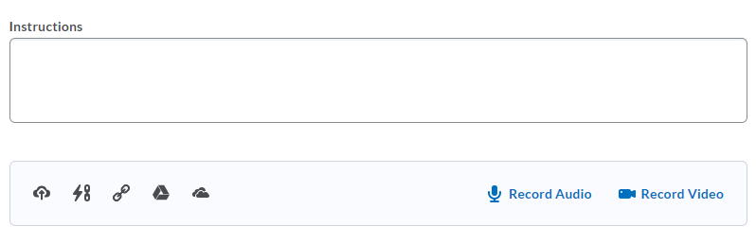
- From the Availability Dates & Conditions tab, a Start Date and End Date for the assignment can be set.

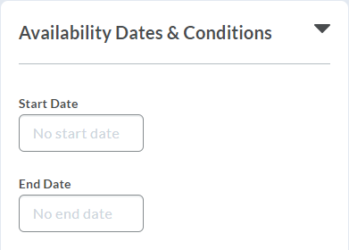

PLEASE NOTE: Students are able to submit after the established Due Date. The submission will be marked late. The End Date serves as the date and time after which a student can no longer submit.

- From the Submission & Completion tab, you can set whether the assignment:
  - Is an individual or group assignment
  - Is a File Submission, Text Submission, an On Paper Submission, or an Observed in Person assignment
  - Should be limited to one file or unlimited files per submission
  - Should keep all submissions, keep only one submission, keep only the most recent submission

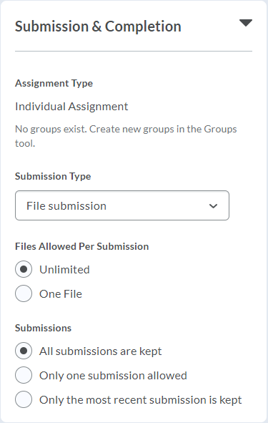

- From the Evaluation & Feedback tab, you can add a rubric by creating a new rubric or selecting an existing one. You can also determine whether you would like the annotation tools to be available to you when reviewing learner submissions, whether you would like learners to be anonymous to you while grading, and whether this assignment should utilize Turnitin.

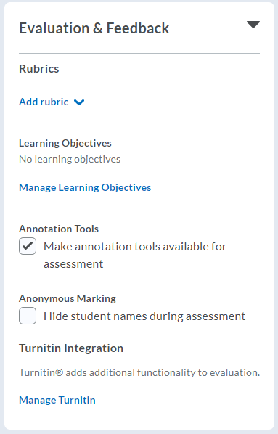

Assignment Visibility
- If you would not yet like the assignment to be visible to learners, click the Visibility option to make the assignment hidden.

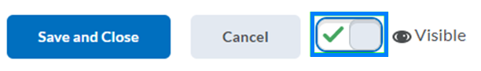

PLEASE NOTE: The difference between this visibility setting and the availability dates is that with availability dates, learners will see the assignment exists, but they will not be able to click on it. With the visibility setting, the assignment is hidden from learners until you return and change it to be visible. An assignment must be visible for the availability dates to take effect.

- Click Save and Close when you have finished creating the assignment.

Add An Assignment To A Course Module
The Assignments area under Course Tools lists all of the assignments in the course. You can insert them into any Content module to list them with related content.

- From the course navigation bar, click Content and navigate to the module location where the assignment should reside.

- Click Existing Activities and select Assignments from the drop-down.

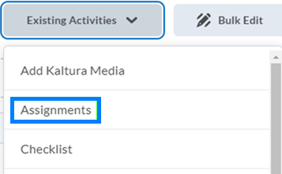

- Locate and click the assignment you would like to insert.

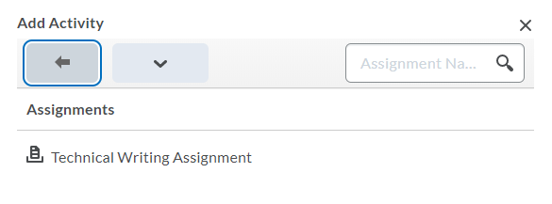

Grade An Assignment
When it comes time to grade an assignment students have submitted their work to, there are a variety of ways this can be done. These include the ‘Quick Eval’ tool on the homepage when you first log into Brightspace, adding grades and feedback directly to the gradebook, or utilizing the features of the assignment submission interface. This section will work through the assignment submission interface.

- From the course navigation bar, click Course Tools and select Assignments from the drop-down.

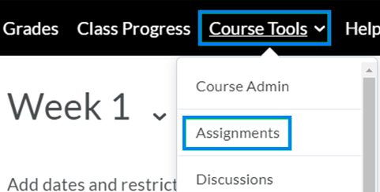
- Click the drop-down icon to the right of the assignment name and select View Submissions from the drop-down.

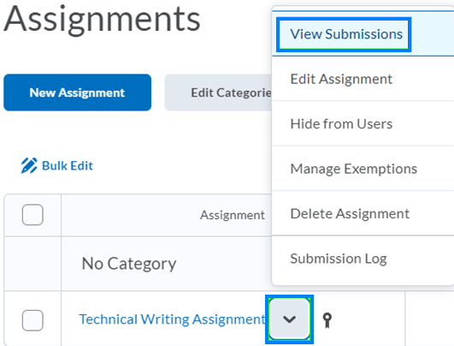

- Click the file name beneath the name of the first student you would like to evaluate.

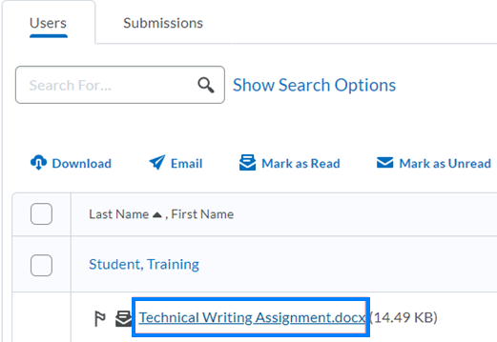

- On the right will be the panel where you can provide feedback and enter a score. If you have set up the assignment with a rubric, that will appear here as well.

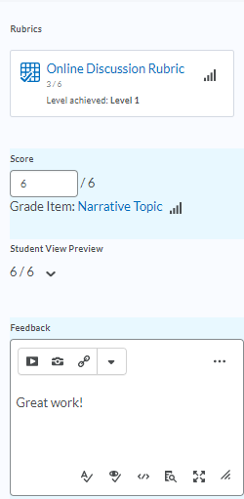

- Within the content viewer are annotation tools. Depending on the size of your screen, you may need to click the pencil and paper icon to open the annotation tools. These will allow you to write, draw, or type notes onto the student’s file submission.

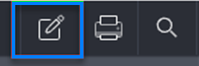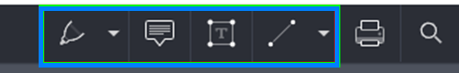

- When you are finished, click Publish or Save Draft as appropriate. Publish will release the scores and feedback to the student immediately. Save Draft will allow you to publish the scores and feedback at a later time - and for the class as a whole, if desired. You can then advance to the next student using the arrows near the top-right.

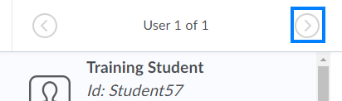

Grade Work Completed Outside of Brightspace
Grade items (columns) can also be created to score work students complete outside of Brightspace.

Create A Grade Item From The Gradebook
- From the course navigation bar, click Grades.

- From the gradebook navigation bar, click Manage Grades, click New, and select Item from the drop-down.

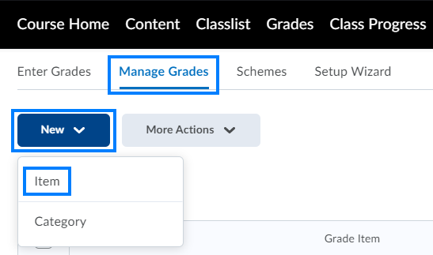

- The New Item screen will appear. Here, you can choose what type of grade item you want to create:
- Numeric grades are point-based
- Selectbox allows you to grade based on level of achievement
- Pass/Fail uses a simple pass/fail grade schemes
- Formula allows you to grade based on an Excel-like formula
- Calculated grades sum achievements across multiple grade items
- Text allows you to enter text-only comments

Enter Grades From The Gradebook
- From the gradebook navigation bar, click Enter Grades.

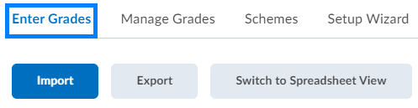

- Click the drop-down icon to the right of the column name and select Enter Grades from the drop-down.

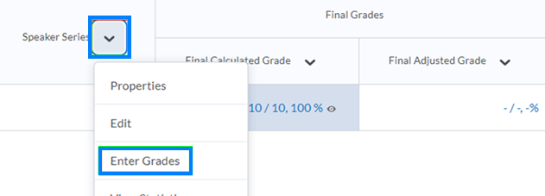

- Click within the grade box corresponding to the student and enter a grade value. When more than one student is enrolled, you can press enter to move to the next student and enter grades in succession.

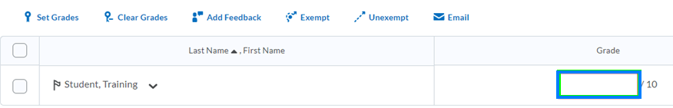

- To enter feedback for a student, click the pencil icon within the feedback box. In the Grade Feedback window, enter your comments. You can also add Private Comments for other graders. Click Save when finished.

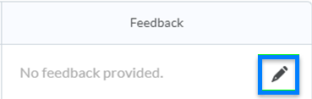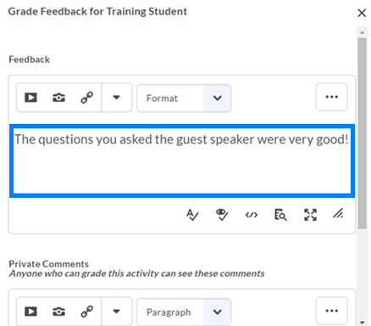

- When you are finished entering grades and feedback, click Save and Close. Select Yes when prompted to save changes and continue.

Quizzes
In Brightspace, “Quizzes” enable you to conduct quizzes, tests, and exams online. Some question types, such as multiple choice and true/false, can be auto-graded by Brightspace.

Create A Quiz
- From the course navigation bar, click Course Tools and select Quizzes from the drop-down.

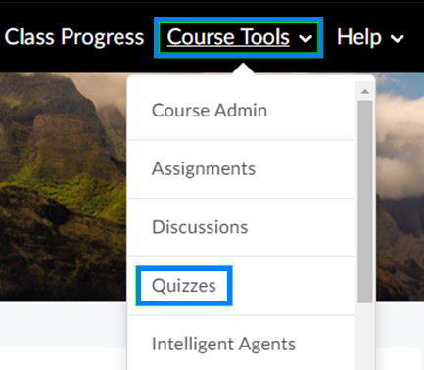

- Click New Quiz near the top-left of the screen.

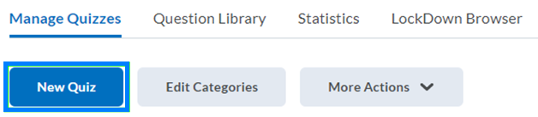

Properties Tab
- From the Properties tab, enter a name for the quiz and, optionally, select a category if you use Quiz categories to organize/group related quizzes.

- Click the Add/Edit Questions button to begin adding questions to the assessment.

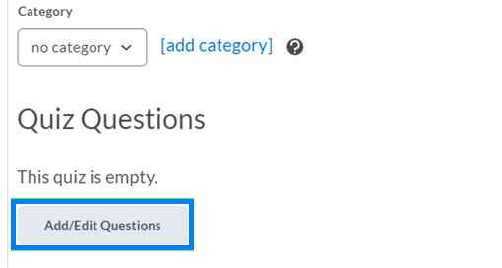
- Click the Add button and select New Question to choose the format of the question you would like to create. Click the Import option if your questions were migrated or are in a Brightspace ready file format.

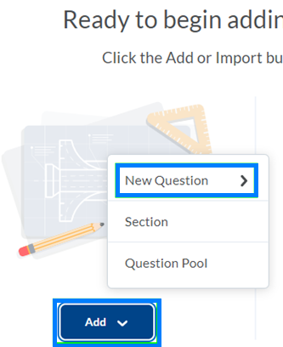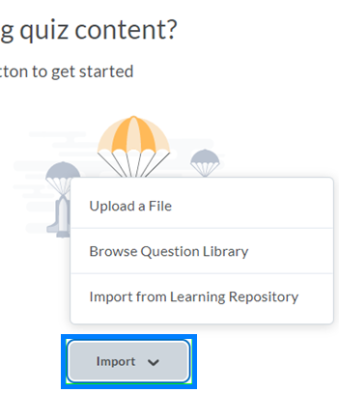
- After creating your questions, click Back to Settings for test.

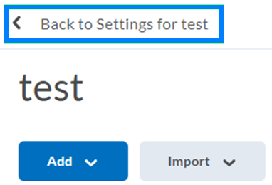

Restrictions Tab
- From the Restrictions tab, you can set the availability of the quiz. By default the quiz is set to be unavailable/hidden from students. To make it available, uncheck Hide from Users. Checking the box next to the ‘Has Start Date’ and ‘Has End Date’ options will enable you to make the quiz available for students to complete only between the days and times you establish. You can also set a Due Date if appropriate.

PLEASE NOTE: The Hide from Users setting must be unchecked for the quiz to be available to students during the timeframe you establish.

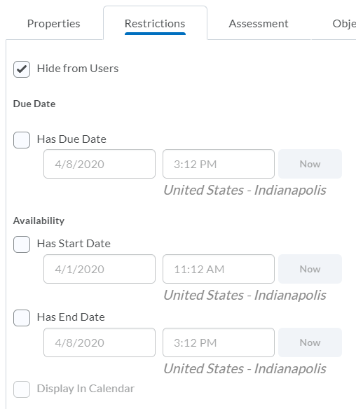

- The Timing feature enables you to set how long students have to complete the quiz. A ‘Recommended Time Limit’ is a general guideline for students as to how long the quiz should take. An ‘Enforced Time Limit’ will flag a quiz as late if it was submitted after the grace period. You can then select what action you would like to happen after the grace period ends. The grace period is time in addition to what you enter as the Enforced Time Limit.

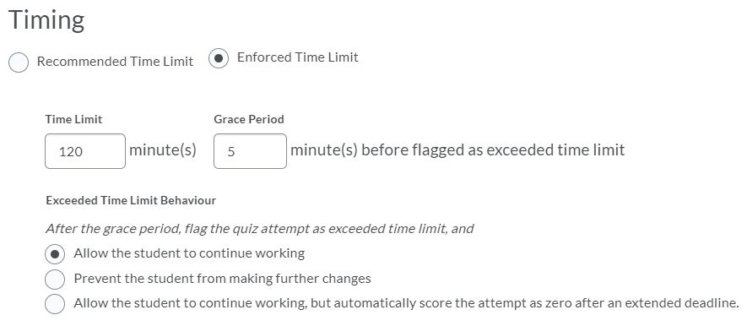
- Special Access settings enable you to extend time/availability for specific students. This is often used to meet accommodation needs. View the Brightspace video Grant Special Access to a User for a Quiz for steps to provide Special Access.

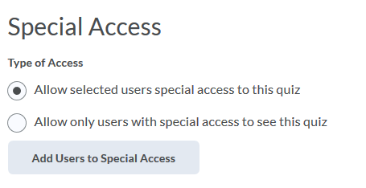

Assessment Tab
- From the Assessment tab, you will find settings for how the quiz should be graded, selecting or creating the grade item (column), the number of attempts allowed, and how the overall grade should be calculated.

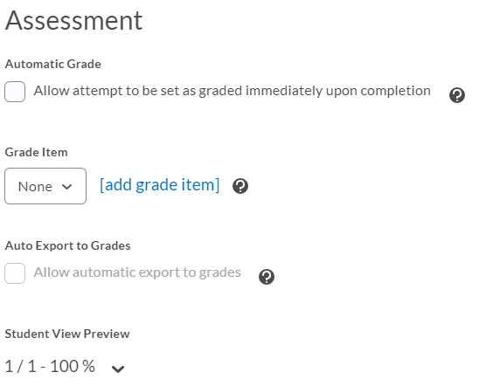

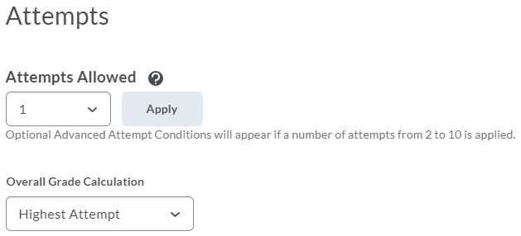

- After you have finished setting up your quiz, click Save and Close.

Submission Views Tab
Submission Views are used to customize what students see upon submitting their quiz attempt. The default will be that students do not see quiz answers upon completion.

- If your quiz contains primarily auto-gradable question types (i.e. multiple choice, true/false, etc.) and you would like students to see the quiz answers immediately upon submitting their quiz, click Default View. If you would like students to see the quiz answers at a certain date and time (i.e. after the quiz has ended or after all students have taken the quiz), click Add Additional View.

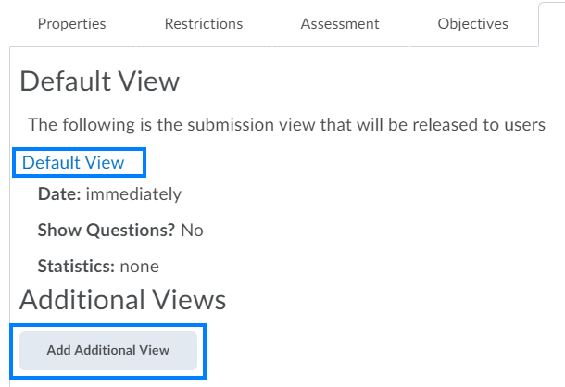

- On the subsequent page, customize the level of question detail that should be visible to students. If you chose Add Additional View, name the submission view and enter the date and time at which the answers should become available to students. Click Save when finished.

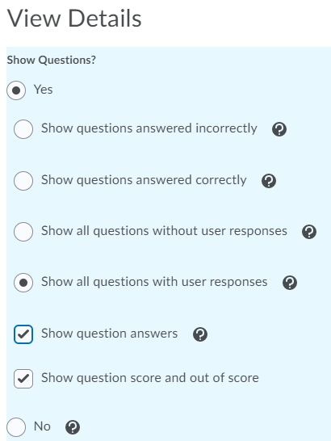

- Submission Views will not take effect until quiz scores have been published. If you would like that publish to occur automatically, click the Assessment tab. Ensure the Automatic Grade setting is checked; that a grade item has been established; and that the Auto Export to Grades setting is checked.

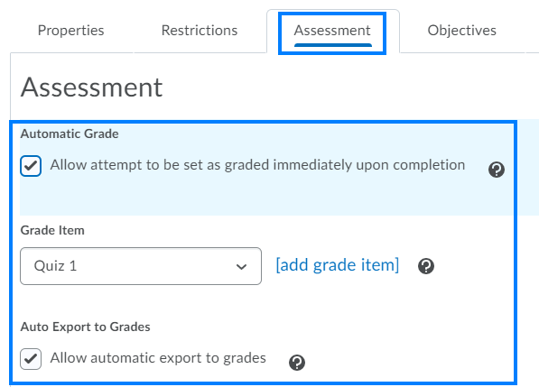

- Click Save and Close when finished.

PLEASE NOTE: Students will be able to view the quiz answers and feedback by going to Course Tools > Quizzes. These details will not be available to them from the gradebook.

Add A Quiz To A Course Module
The Quizzes area under Course Tools lists all of the quizzes within the course. You can insert them into a Content module in order to list them with related content.

- From the course navigation bar, click Content and navigate to the module location where the quiz should reside.

- Click Existing Activities and select Quizzes from the drop-down.

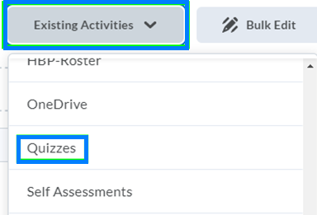

- Locate and click the quiz you would like to insert.

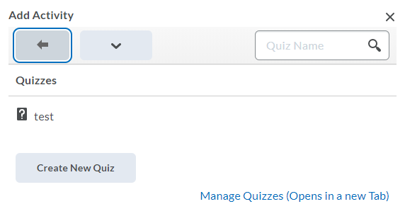

Other Things to Know

Add TAs, Graders, Or Other Instructors To Your Course
PLEASE NOTE: The people you add to your D2L Brightspace course must have completed FERPA certification.

- Login to D2L Brightspace, click Tools from the black navigation bar, and select Enrollment Manager from the drop-down.

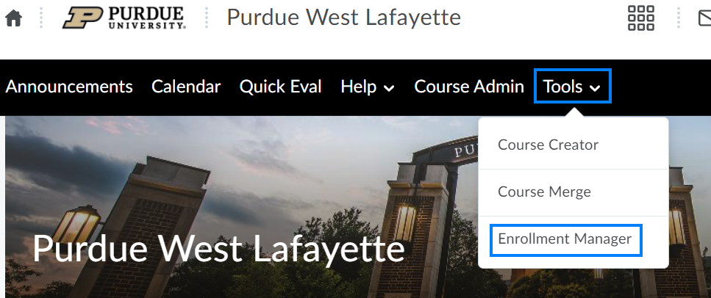

- Check the Select academic courses by campus, term, or year box and apply filters as needed. Then click Populate Courses.

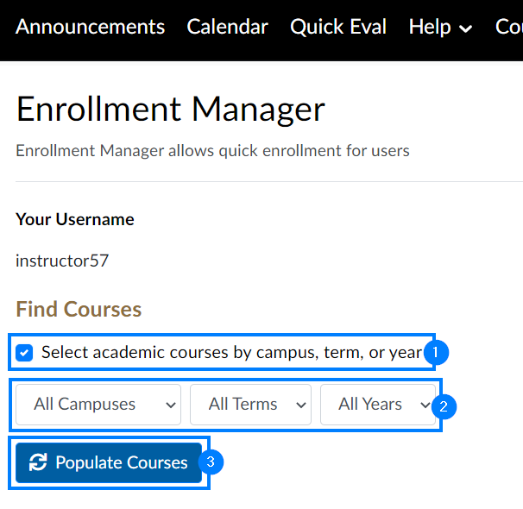

- Select the course(s) you would like to add instructors, TAs, graders, etc. to. Then click Populate Enrollments.

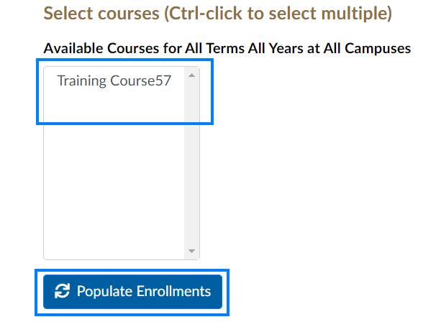

- Enter the username of the individual you would like to enroll. Click the Course drop-down and select the course you would like to enroll them in. Click the Role drop-down and select the role you would like to grant this individual.

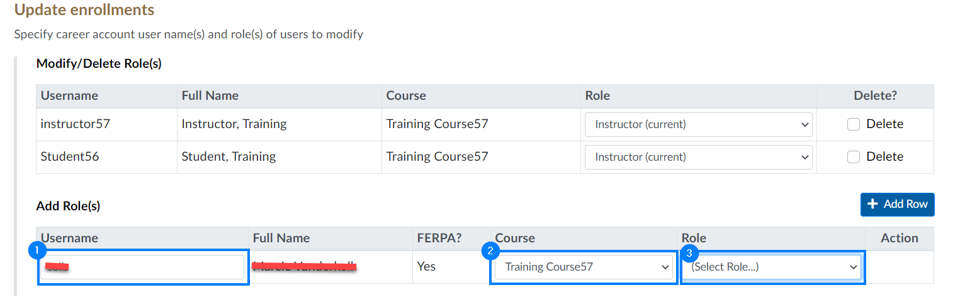

PLEASE NOTE: If the FERPA status appears as Yes, you can proceed with the enrollment process. If the FERPA status appears as No, you will be unable to enroll the individual until they complete FERPA certification here.

- Click Add Row if you would like to enroll additional individuals.

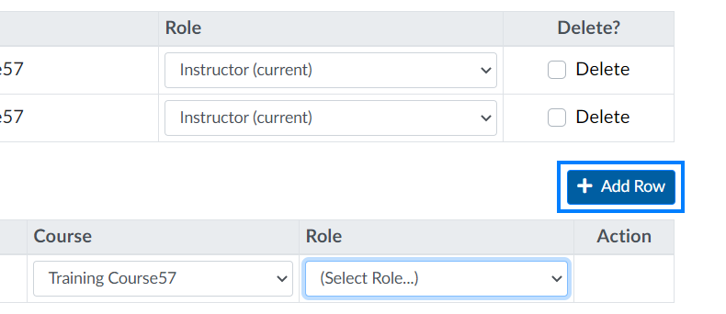

- Click Save Changes when finished.

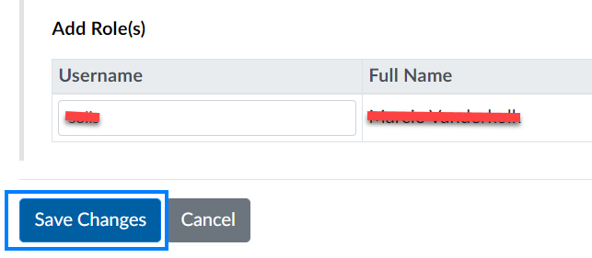

PLEASE NOTE: You can return to this tool at any time to remove previously added individuals. After locating the course and individual, check the Delete box to the right of their name and click Save Changes.

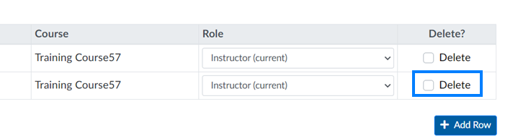

Make Your Course Available To Students
Official sections in D2L Brightspace will be inactive and unavailable to students by default. Instructors can make their course active and available for students at anytime by following the steps below:

- Login to Brightspace and open the course you would like to make available.

- From the course navigation bar, click Course Tools and select Course Admin from the drop-down.

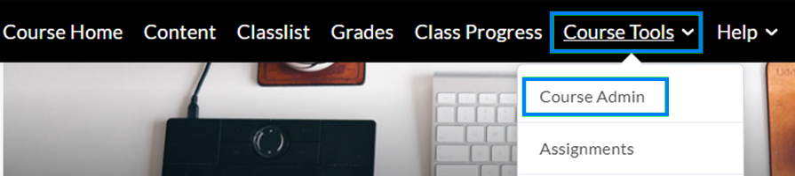

- Under Site Setup, click Course Offering Information.

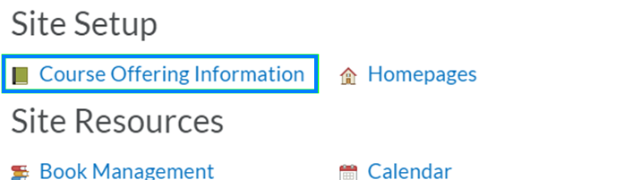

- Scroll down and check the Course is active option. Then click Save.

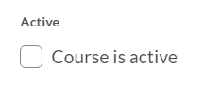
PLEASE NOTE: If the Start Date field is checked, this does not mean the course will automatically be made available to students at this date and time. Instructors must complete the above steps and check the ‘Course is Active’ option. Once checked, the course will be made visible to students after the Start Date passes.

Modify The Start Date Or End Date Of Your Course
Brightspace allows you to adjust the default start and end dates for your course. If the course end date is not changed and left to the default (the last day of the semester), students may not have a chance to review their grades, scores, and/or feedback.

PLEASE NOTE: Changing the course start and end dates in Brightspace does not impact the course dates on record with the Registrar. Changing the end date does not change when grades are due.

- Login to Brightspace and open the course you would like to change the course start or end date for.
- From the course navigation bar, click Course Tools and select Course Admin from the drop-down.
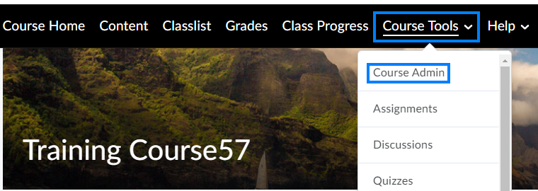

- Click Course Offering Information.
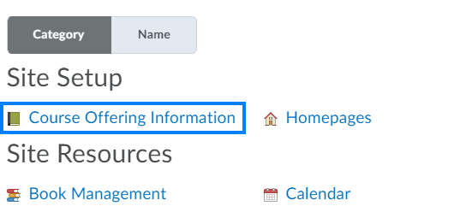

- Scroll down to the Start Date or End Date field. Click the date field and select a different date, or manually enter the date.
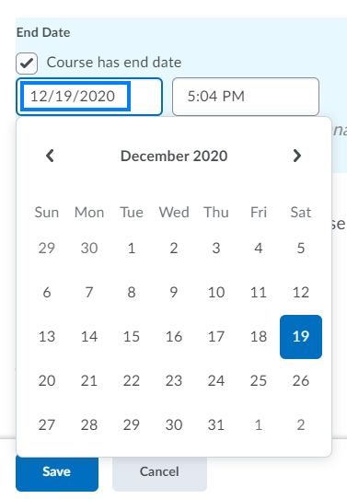
- To change the time, click the time picker and select the time from the drop-down, or manually enter the time.
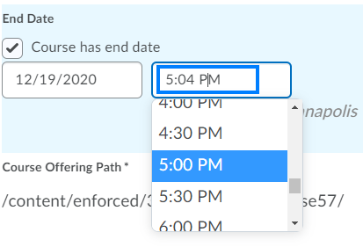

PLEASE NOTE: If you want the course to become active right away, uncheck the Course has start date box. If you do not want your course to close from student access, uncheck the Course has end date checkbox.
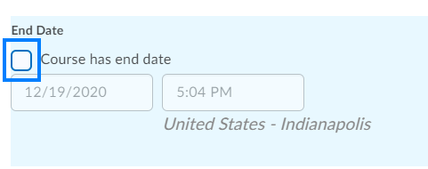
- Click Save at the bottom of the page to save your changes.

Copy Content From One Course To Another
PLEASE NOTE: Contrary to Blackboard, the course copy process in Brightspace is a “pull” process. Be sure to open the destination course where the developed course will be copied to. For example, if you would like to copy a DEV course to an actual course with student enrollment, open the actual course with student enrollment.

- Login to D2L Brightspace course and click the destination course you would like to copy an existing course to.

- Click the Settings icon near the top-right of the screen and select Import/Export/Copy Components from the drop-down.

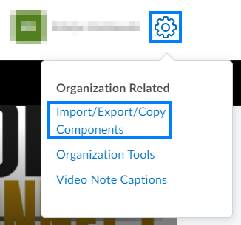

- Under Copy Components from another Org Unit, click Search for offering.

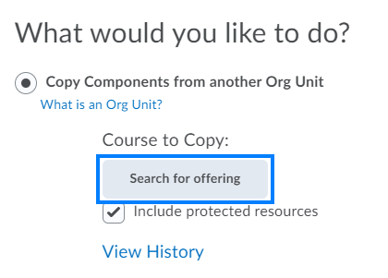

- Enter the course ID or course name of the developed course and click the Search icon.

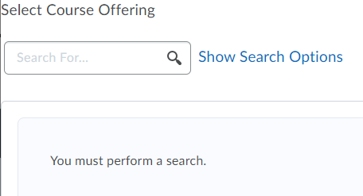

- Select the radio button to the left of the appropriate course and click Add Selected.

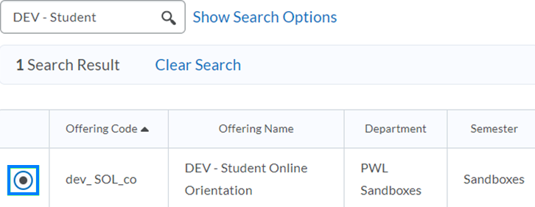

- If you would like to copy the entire course as it is, click Copy All Components. If you would like to copy only specific elements of the course, click Select Components, check the components you would like to copy, and click Continue.

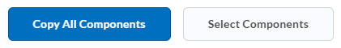

- After the copy has completed, click Course Home to view your course.

Create A Grade Category
Grade categories enable you to group assignments and other activities together; drop the lowest grade in a specific category; and, if you are using a weighted grading system, apply weights to categories.

- Click Grades on the course navigation bar.

- From the gradebook navigation bar, click Manage Grades.

- On the Manage Grades page, click the New button. Then select Category from the drop-down.

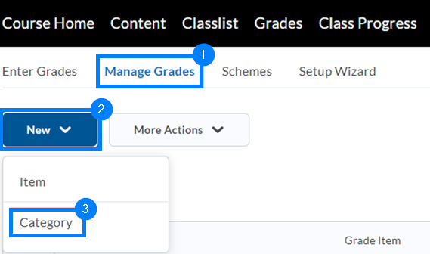

- On the New Category page, click within the Name textbox and enter a name for the category.

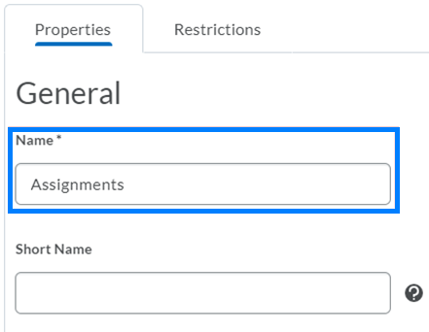

- Determine the appropriate settings for how you would like the Category to work. Options on this screen will vary depending on the Grading System chosen for the course.

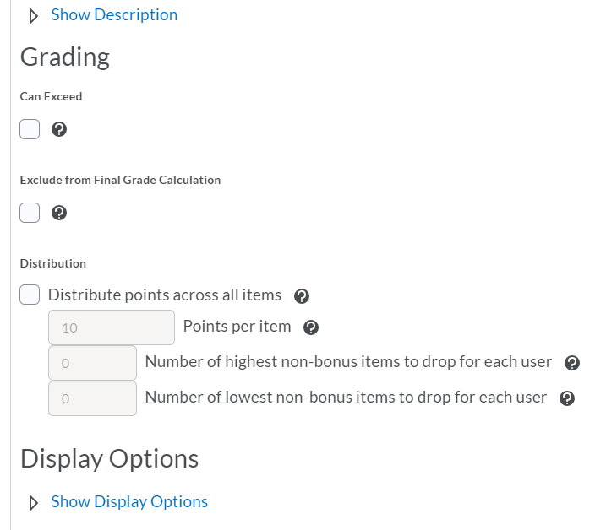

- When finished, click Save and Close.

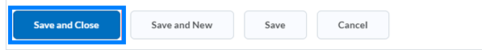

Email An Announcement To Your Class
Announcements allow you to post important course information (updates, changes, etc.) to students directly in Brightspace. Students will see announcements when they log into Brightspace and access the course. These announcements are specific to the LMS and are not emailed to students. To communicate a course announcement to your entire class via email, you can email them from Classlist.

- Login to Brightspace and open the course you would like to email an announcement for.

- From the course navigation bar, click Classlist.

- Click the Email Classlist button near the top.

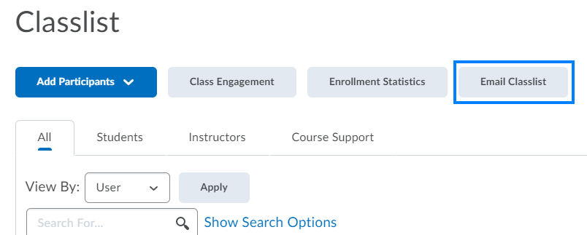

- Click Send Email near the bottom-left.

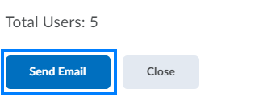

- Compose your email and click Send when you are ready for the email to go out to students.

