Student Notes and Note Guidelines

Creating Notes
- The Types of Notes
- Entering Notes
  - Double Checking That the Note Has Been Saved
  - Copy and Paste an Outlook Email in to a Note in BoilerConnect
- Entering the Advising Report Summary
  - Using the Advising Queue to Enter the Report Summary
  - Entering the Report at the Time of the Appointment
  - Entering the Report at a Later Date
  - Using a Kiosk Check-in to Enter the Report Summary
  - Editing an Existing Report Summary
  - Entering the Report Summary on the Fly
  - Editing an Existing Report Summary
  - Viewing Your Saved Report Summaries

Creating Notes

Notes are part of the student’s educational record, and students can request a copy of their record at any time, so it is important that you review the Notes Guidelines at: https://www.purdue.edu/boilerconnect. Select Training Resources and log in.

The notes feature allows you to keep track of any information about the student that may be outside of an advising appointment. You can attach files, such as a PDF, to a note, you can select whether you want to share a note with a student, and you can create a note from your Advisor Home dashboard or through the use of the Search tab.

The Types of Notes

- The first type of note is a communication that you send to a student. Generally this type of note is not related to the actual advising session discussion, and could include something related to having the student bring a form to the appointment, a notification regarding an upcoming workshop/presentation, or to remember to do something prior to their scheduled appointment.

You can create this type of note from your Advisor Home dashboard.
- The location is from the Actions menu where the list of your assigned students appears.
The second location is after you have selected a student.
- While on the Student screen, the Staff Alerts menu on the right side of the screen is where you can select Add a Note on this Student.

Both locations will take you to the same screen to enter your notes.

Keep in mind that once this type of note is entered into BoilerConnect, it cannot be edited or deleted. You will have the option of making these notes viewable to all, to the advisor only, to the student only, or to the student and advisor.

- The second type of note is a report called the Advising Report Appointment Summary. This type of summary report should be entered during the advising session, and will not be visible to the student. However, unlike the Note to a student, this report can be edited. The report can also be entered Ad Hoc for students that have shown up without an appointment.

Breadcrumb: Advisor Home>Students>My Assigned Students for XXXXX

Entering Student Notes
- On your Advisor Home dashboard, check the box alongside the student’s name in the My Assigned Students section:

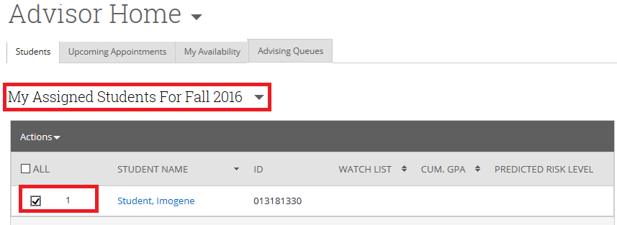

- From the Actions drop down box, click on Note.

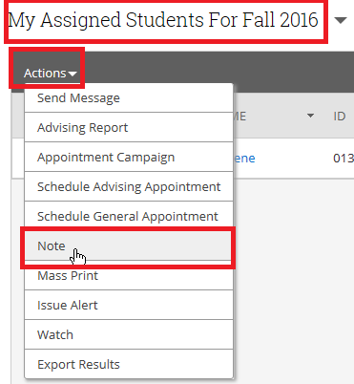

Breadcrumb: Advisor Home>Students>My Assigned Students for XXXXX>Add a Note to XXXXX
- In the Add a Note to text box, enter the text of the note.

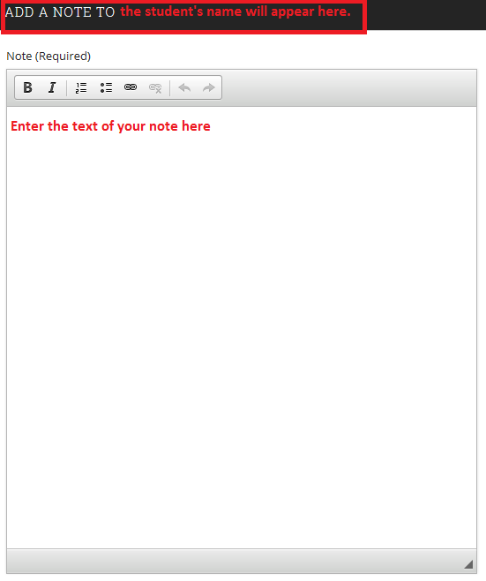

- From the right side of the screen, under the Relations section, click inside the Note Reason box and select the reason for the note that most closely relates to your note. These options are used in order to categorize your notes for future reporting.

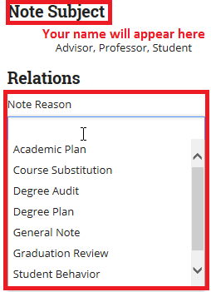

- You can ignore the use of the Note URL text box that will appear directly below the Note Reason. However, if you have a document that will be available online that you want to link to, you can use this option.

- Next, select how you want the notes to be displayed. Not checking the Advisor only checkbox will allow any advisor to see this note. You can select more than one option.

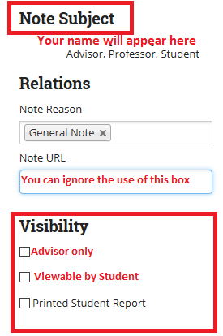

  - Here you are able to attach any type of file by clicking on the paper Attach File link, browse to the location where your file is stored to add the file as an attachment. Select Save Note when completed.

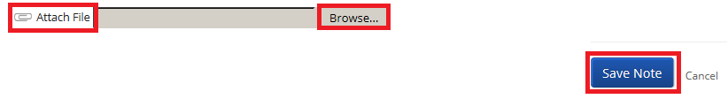

Breadcrumb: Advisor Home

To Double Check That the Note Has Been Saved
  - From your Advisor Home dashboard, click on the student’s name to bring up the Student Home page.

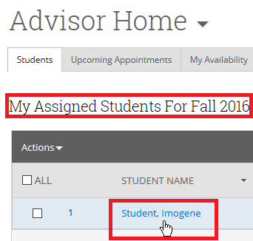

  - On the Student Home page click on the Reports/Notes tab
  - Your note should appear under the section. Click on the note to review the text.

Cut and Paste an Outlook Email in to a Note in BoilerConnect

You may have a need to do a cut and paste in to a note in BoilerConnect when a student contacts you without having used BoilerConnect to do so. They may have used Hotmail or Yahoo as a way to contact you. A simple cut and paste from Outlook in to a Note will result in the hidden HTML tags being included along with the text. So, there are two ways to include the text of an email in the Notes text box in BoilerConnect.

- The first way is to highlight the text in the email you received and use the Copy option so that you can save the text to another location.

- Open Notepad on your workstation. (It may be located in a different location on your workstation than in the example below.) Then select Paste to insert the text on to the screen.

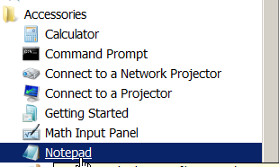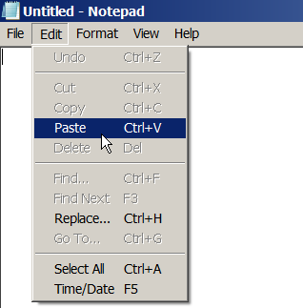

By using Notepad your copied text will be able to be pasted in to the text box without including all of the HTML code hidden behind the text when you copied it from Outlook.

- Now, Copy the text you just pasted in to Notepad by clicking on Select All from the Edit option in Notepad.

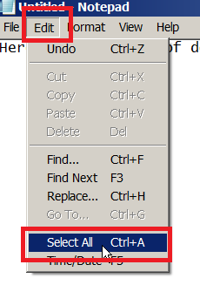

- Right click on the text on the Notepad screen, and select Copy

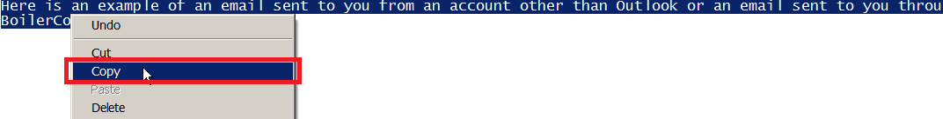

- Now, return to BoilerConnect and from the Student’s home page, select Add a Note on this Student from the list of options in the Staff Alerts menu on the right side of the screen.

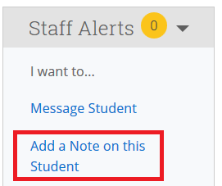

- On the Add a Note screen, place your cursor in the text box and from your keyboard hold down the Ctrl key and press the “V” key to paste in the text.

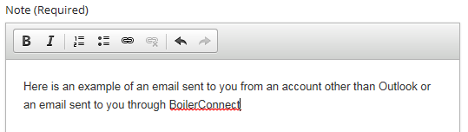

- Click on the Save Note button at the bottom right side of the screen.

Entering the Advising Report Summary

The Advising Report can be entered at the time of a scheduled appointment, at a later date, or as an ad hoc entry in the case where a student has dropped in to your office and you want to record a summary of the discussion.

Using Advising Queue to Enter the Advising Report Summary

During the times you are available for appointments, you should click on the Advising Queues tab at the top of your Advisor Home dashboard.

- When the student checks in at your reception desk, you will receive a notification by email, text or a “ding” depending on how you structured your notification of students arriving for appointments to be sent.

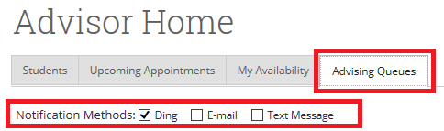

- If you aren’t on the Advising Queues tab and you are on your Advisor Home dashboard, you will know that someone has arrived for an appointment by seeing a red circle with a number on the Appointment Queue icon, and receiving your selected notification type (email, text, ding).

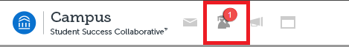

- An Email notification sent to you will look something like this:

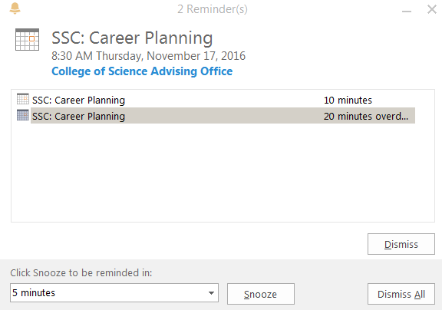

Entering the Advising Report at the Time of the Appointment
- Once you have opened the Advisor queue and clicked on the Start Appointment link, you will required to do the following if entering the summary notes at the time of the appointment.

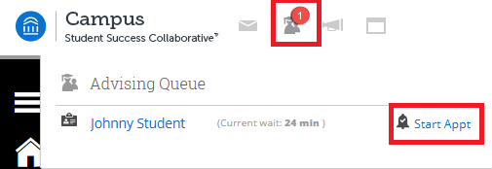

Your Advising Report screen will look like this:

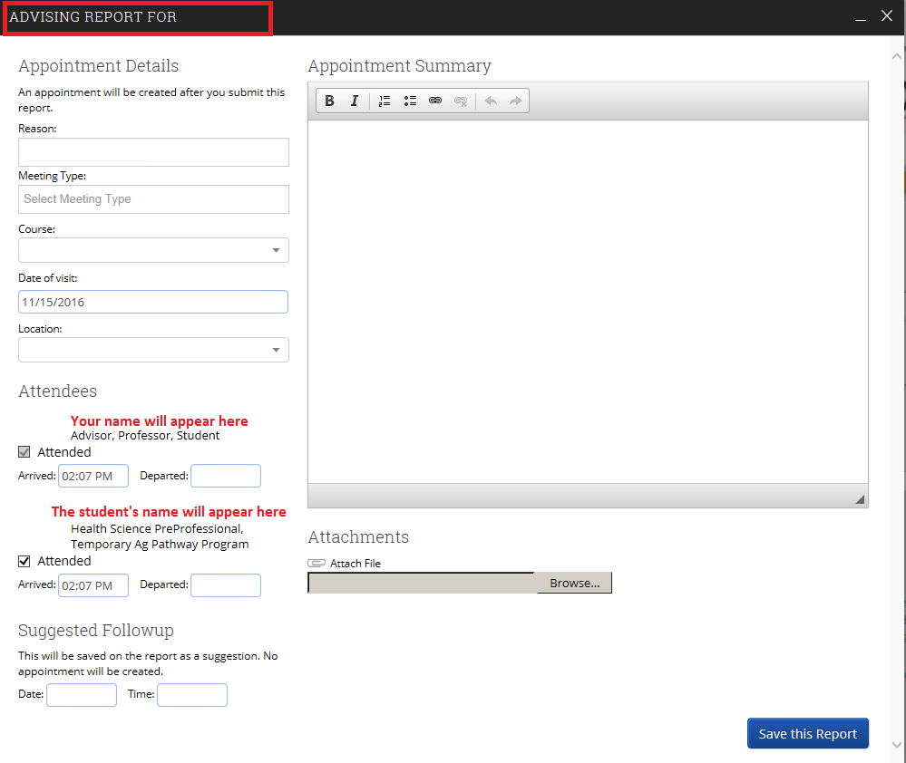

On this screen, the Location box will automatically populate with your office grouping location since the student checked in at your location. If, however, you are creating this report ad hoc, you will need to select the location in the drop down box.

On the Advising Report screen
- From the Reason drop down box, select the reason for the appointment. You may select more than one reason. This field is important in that it will allow you to determine which services are used most frequently, and will allow you to create reports on any of the reasons. Note: There could be a reason already populating this box, so make sure you remove any reasons that are not a part of the appointment you are entering notes for.
- The Meeting Type drop down box does not need to be selected as part of this process. You will not be able to enter or select any values in this field.

- The Course drop down box is optional. It would be used if the discussion is related to a specific course.

- The Date of visit box should be auto populated with the date of your meeting.

- The Location box should auto populate with your office grouping.

- Under the Attendees section, you will see two sets of fields.

  - The first set will be your Advisor Arrived and Departed boxes. It is not necessary for you to indicate a departure time after the student leaves your office. This field will be auto populated when you click on Save this Report.
  - The second set will be the fields for the student. Again, it is not necessary for you to indicate when the student leaves your office. The field will be auto populated when you click on Save this Report.

- If you have Suggested Followup with this student, you can enter the date and time information in those boxes, although these are not required.

- You can attach any file format with these notes by clicking on the Browse button, locating the file to upload, then clicking on the Save this Report button to complete the process.

If you are NOT entering the report information at this time, you must still click on the Save this Report button in order to move on to the next student appointment in your queue.

Breadcrumb: Advisor Home

Entering the Advising Report at a Later Date

If you have seen a student previously, but have not entered a summary of your advising appointment, you can do so from your Advisor Home dashboard.

  - At the bottom of the screen under the Recent Advising Appointments section, you will see the names of students that you have met with recently, and the status of their appointment reports. Click the checkbox alongside a student that has Not Yet in the Report Filed column.

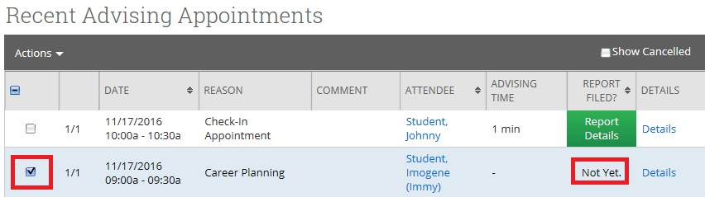

  - Click on the down arrow alongside the Actions menu, and select Add Advising Report.

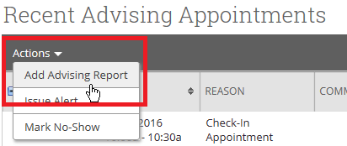

  - You will be taken to the original report you opted not to enter information for, and saved when you clicked on the Save this Report at the end of the appointment session with this student.
  - From here, all you need to do is to enter the information and click Save this Report.

Breadcrumb: Advisor Home>Toolbar
Using a Kiosk Check-in to Enter the Report Summary

Not all advising offices have a front desk check-in process. In this case, you will still be able to create an advising report for the student that swiped in using the card reader.

Since there will be no front desk check-in process for these students, you can create the report by clicking on the Red Circle at the top of your screen where you will be taken to your Appointment Queue. There, you can click on the Start Appt link.

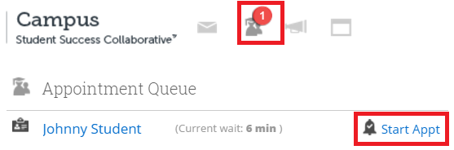

At this point, if you are entering the notes at the time of the appointment, follow these instructions:

If you are entering notes at a later date, follow these instructions:

Entering an Advising Report Appointment Summary on The Fly
- Click on the student’s name in your list of Assigned Students, or do a Quick Search by entering the student’s name in the Search box at the top of the screen:

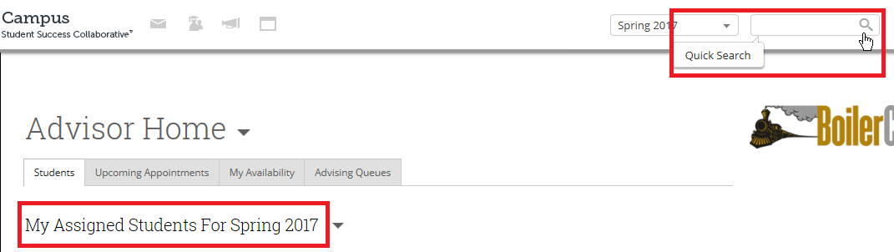

- Under the Staff Alerts section, click on Report on Advising

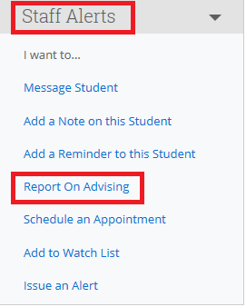

- You will be taken to the Advising Report form where you can summarize the meeting. You will be able to attach files. Make sure you click on the Save report link. You will not need to complete the “ending” time as it is automatically filled in when you close the report. Since this report is editable, you can always go back and change any of the information that is associated with the report.

Breadcrumb: Advisor Home

Editing an Existing Advising Report
If there was information entered in to an existing report, and you need to update the information contained in the report, you can edit and re-save the report.

- At the bottom of the Advisor Home screen under the Recent Advising Appointments section, you will see the names of students that you have met with recently, and the status of their appointment reports. Click the checkbox alongside a student that has Report Details in the Report Filed column. It will appear in a green box. Then, click on the green Report Details link.

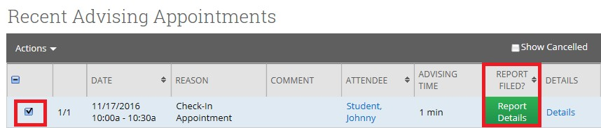

- You will be taken to your Advising Report for this student. At the bottom right hand side of the screen, alongside Report Information, click on the Edit Report button.

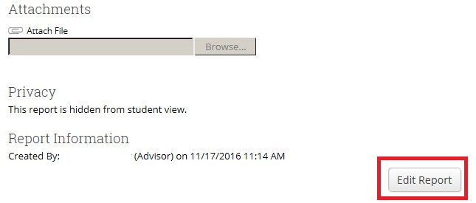

Once you have finished editing the report, click on the blue Save this Report button.

Viewing Your Saved Reports
After saving your report, you can view it on your Advisor Home screen. Go to the bottom of the screen and under the Advisor Reporting section, click on the Recent Reports You Created tab.

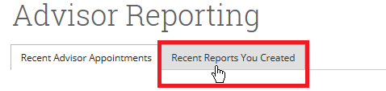

You can then click on the Details link to the far right side of the screen to view the details of your meeting.

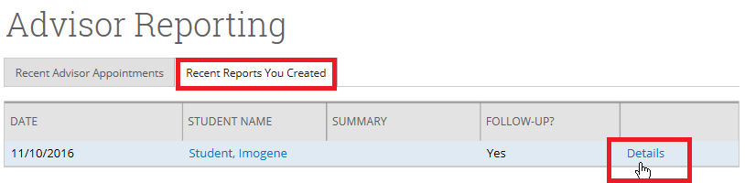

It can also be viewed on the Student Home screen. Click on the Reports/Notes tab, and then slide down the screen to the Notes About Student section. Roll across any note in the note column and you will be able to view the text. For more detail, click on the View link.
