Getting Acquainted With the Student Profile
The Student Profile Tabs
  - The Overview Tab Details
    - The 30 Second Gut-Check
    - Repeated Courses
    - Major and Major History
    - Most Recent Term
    - Categories and Tags
  - The Student Progress Tab Detail: Reviewing Student Success Markers
    - Success Markers
    - GPA Trends by Term
    - Credit Trends by Term
  - Reviewing Reports/Notes Tab Details
  - Reviewing the Students Class Information
    - The Unofficial Transcript
    - Reviewing the Pre-College Information
  - Using the Major Explorer
    - Predicted Risk Level
    - Search for Majors and Careers
  - The More Tab Details
    - Reviewing the Student’s Calendar
    - Study Hall
    - Student Appointments
    - Conversations with a Specific Student

- Viewing Your Conversations With All Students

Getting Acquainted with the Student Profile
The Student Profile page gives you a quick overview of a student’s academic standing. This page is also referred to as the 30 second gut-check as it has details similar to what appears in Banner pulled together on one page.
The information here focuses on proactively identifying students at risk of not graduating in their major, and providing you with tools to support the student.

Breadcrumb: Advisor Home>Selected Student Name
The Student Profile Tabs
The Advisor Home dashboard will provide you with information related to the student and their academic performance. There will be tabs across the top of the screen just below the student’s name:

- Overview Tab: This is often referred to as the 30 second gut check. It will provide you with a basic summary of a student’s academic progress, and will allow you to click on the arrows alongside a selected category to display more detail regarding that item.
- Success Progress: This tab will provide you with the information on the success markers the student has completed, missed, or those that are upcoming. These markers are important courses in the student’s current major that indicate their progress towards graduation in their major. It will also provide you with charts to see GPA and credit trends along with a table of data points.
- Reports/Notes: This tab displays any reminders that you have set up in BoilerConnect that will need to be followed up on with the student. It will also provide information on the appointments the student has had with you or any other advisors/offices on campus along with any notes or reports filed.
- Class Info: This tab provides information on the classes that the student is currently enrolled in, as well as the transcript information for the students that shows semester by semester enrollment. Their High School and pre-Purdue information will appear at the bottom of the screen.
- Major Explorer: This tab will provide you with information on additional majors at Purdue that are based on the student’s predicted risk score.
- More: Calendar, Study Hall, Appointments and Conversations. The Calendar will display the student’s calendar. Study Hall is assigned to student athletes so not all students will have this information in BoilerConnect. The Appointments link will display the status of all appointments across campus for this student. Conversations will display all of the types of contact made with the student.

Breadcrumb: Advisor Home>Select a Student Name>Overview
Overview Tab Detail

NOTE: The display of Course Grade D/F, Repeated Courses, and Withdrawn Courses will display the first ten courses only. Repeated courses will display the most recent time the course was taken. If you want to see the complete history of courses for this student, you will need to select the Class Info tab so you can view the unofficial transcript information.

- To view a basic summary of a student’s academic progress, use the 30 second gut check section.

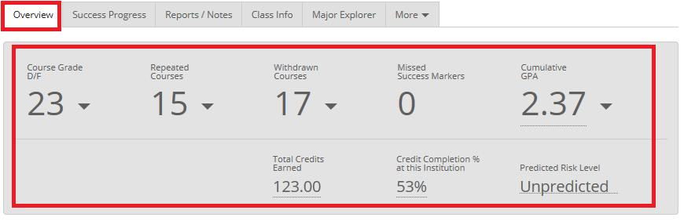

NOTE: The Cumulative GPA is the student’s institutional GPA. It will be the same as the Overall GPA if there are no Transfer credits received from IUPUI.

You can click on an arrow alongside the numbers present in the display to provide additional information. Each item will give you a list associated with the grouping, but the information does not include active links. It provides summary information only and will display the first ten records only:

For categories below this section, you can roll across each category to display more detail. Keep in mind that, the Predicted Risk Level information is incomplete. Also, the Predicted Risk Level does not guarantee success or failure in the major.

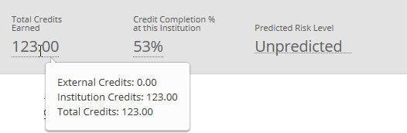

Breadcrumb: Advisor Home>Select a Student Name>Overview
To view the Major and Major History, click on the down arrow alongside the Major History text to display the details about the history of majors for a student. Additional enrollment information will appear to the right side of the Major History.

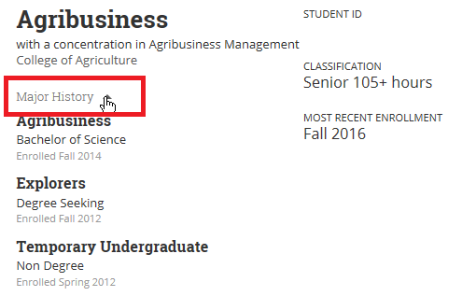

Breadcrumb: Advisor Home>Select a Student Name>Overview
- Advisor and Tutor information will appear in the lower portion of the screen. Advisor information is auto-populated based on the student’s college/major(s) affiliation. Tutors will appear as blank as this information has not been included in BoilerConnect.

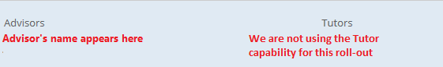

- Categories include students such as athletes. Think of categories as being Cohort groups. You cannot create a category as these refer to a university-wide grouping. If you think a category needs to be added, send an email to BoilerConnect.
- Tags are similar to a category, but they allow groupings of similar students as a result of some type of common affiliation. They include things such as Women’s Basketball, Football, Purduettes, etc. You will be able to request tags to be added, but you will not be able to add it on your own..

You can use a tag grouping to send messages to all individuals in that grouping.

The Enrollment Status information is displayed in the Pilot rollout, but will be replaced with other information at the system-wide roll out.

If a student has requested a Confidentiality flag in Banner, it will display under the Enrollment Goal.

Below the student’s picture, you will see a drop down arrow alongside Student Info. This will provide you with additional contact information.

During the appointment session, you may want to show the student this summary screen, but you would want to hide the predicted risk level information. To do this, just below the student’s picture, move the Student View slider to the right. This will also hide the Staff Alerts box:

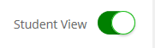

Breadcrumb: Advisor Home>Selected Student>Success Progress
The Student Progress Tab Detail
The Student Progress tab will allow you the opportunity to customize risk for a student. Courses that are used to identify the success with a major are determined by that major.

Students trigger a marker when they don’t earn the recommended grade in a specific course, or when they have not taken the course within the recommended timeframe.

- Information on the Success Markers will appear in the upper portion of the screen. Click on the Success Progress tab:

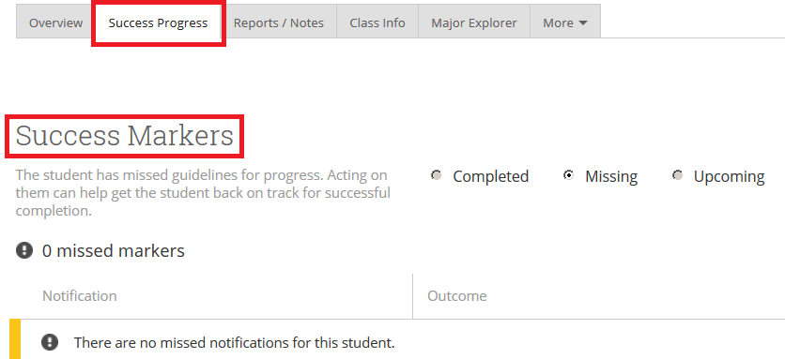

Breadcrumb: Advisor Home>Selected Student>Success Progress
- The GPA Trends by Term graph will show you trends in both the cumulative and term GPA over time. You can roll across the line graph to display details about the GPA for that term.

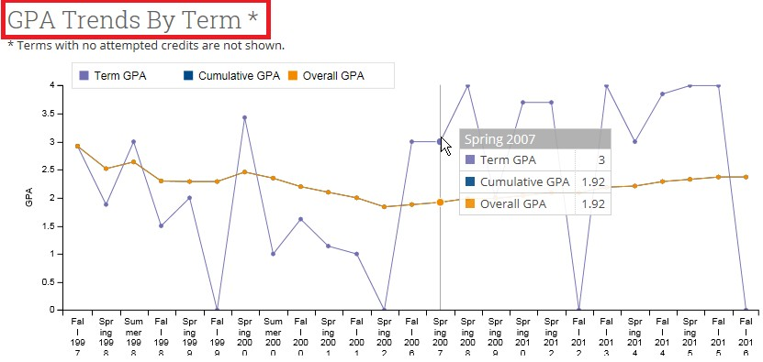

Breadcrumb: Advisor Home>Selected Student>Success Progress
- The Credit Trends by Term graph will provide you with information on the trending in the student’s credit accumulation over time. You can roll across the information in the graph to display additional information for the individual terms.

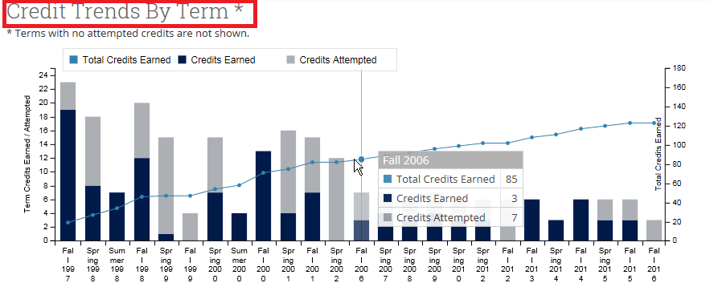

This term-by-term chart should be read with the axis on the left, and the cumulative credit accumulation line graph read with the axis on the right. You can hover over each bar to see breakdown of credits earned vs attempted vs total credits.

Breadcrumb: Advisor Home>Selected Student>History
The Reports/Notes Tab Details
This function will allow you to view any Reminders regarding this student. These are reminders sent to you, not to the student.

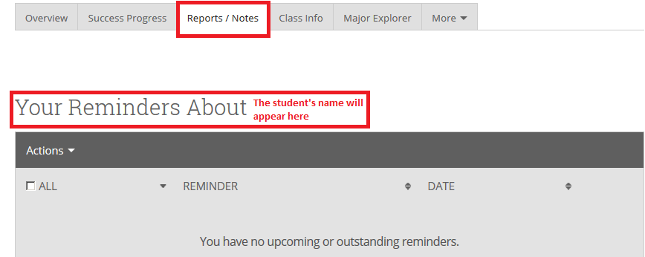

The Notes About Student section will provide you with a list of all Notes associated with this student. There are two ways to view the details related to these notes. First, in the Note column, just roll across the description of the note and it will give you a pop-up display of the entire text. The other way, is to click on the View link to the far right side of the screen to view the details of the note.

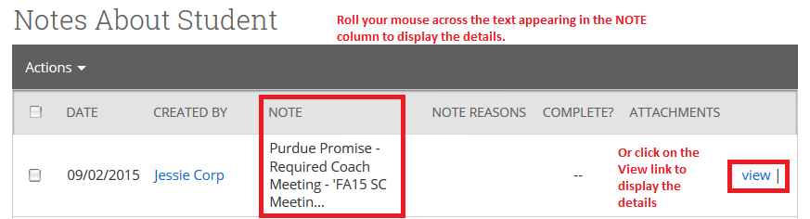

Breadcrumb: Advisor Home>Selected Student>Class Info
The Student’s Class Info Tab Detail
This function provides information on the classes the student registered for the Current Term at the top of the screen. Once fully operational, the mid-term and final grades should be populated on this screen. The Take Action field is not operational.

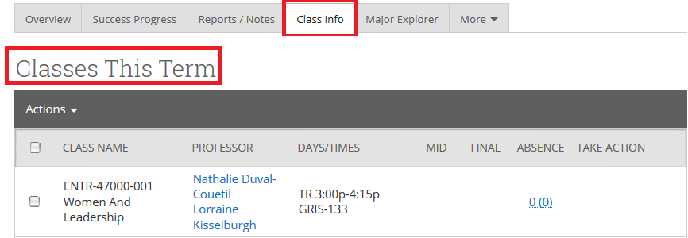

The Term Details, an unofficial transcript, are provided in the lower portion of the screen, and are listed by the most current term first. By clicking on the grey diamond alongside the Term, you will see information on the Term GPA, Cumulative GPA, Credits Attempted, Credits Earned, and the Completion Percentage.

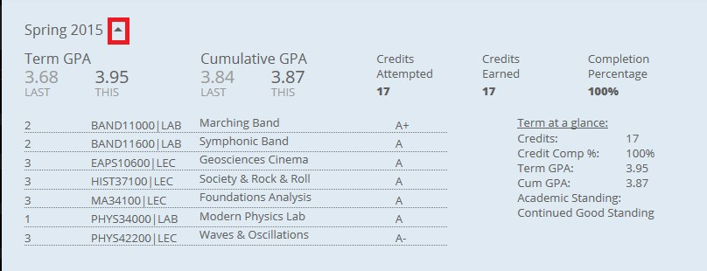

The bottom portion of the screen will provide the HighSchool/Pre-College information.

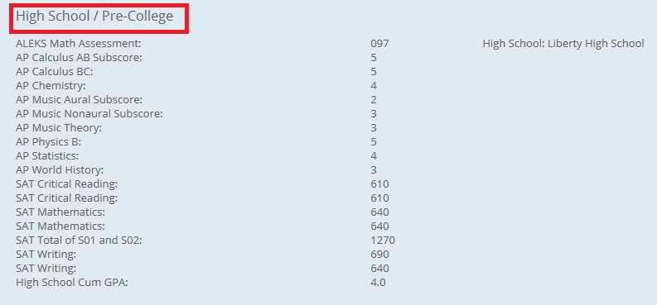

Breadcrumb: Advisor Home>Selected Student>Major Explorer
The Major Explorer Tab Details

Once fully functional, this will display the predicted risk level in all majors on campus. It will also provide career information that matches the major. It is useful for discussing CODOs as well as pathways towards the student’s future career.

Keep in mind that the Predicted Risk level is not a guarantee success or failure in the major.

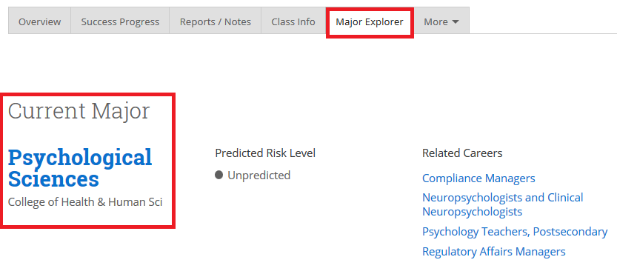

This function uses Purdue’s predictive algorithm to generate this information. The overall risk is mitigated when the student’s strengths create a high match with the skills needed to continue advancement in the major.
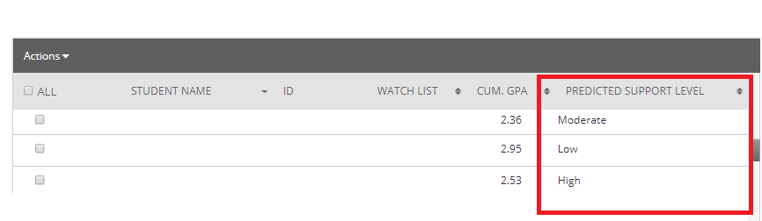
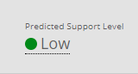
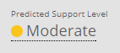
The predicted risk level is displayed with different colors. Red suggests that some type of intervention is needed for the student. Yellow suggests they are likely to complete their major, but there are challenges ahead. Green indicates the student has a high probability of completing their major with few challenges.
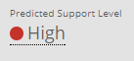

The recommended majors are displayed in the Search for Majors and Careers drop down box, beginning with the highest match based on the existing risk(s). Students who have a high risk in one major may not have a low risk in a different major based on their GPA, number of credits, etc.

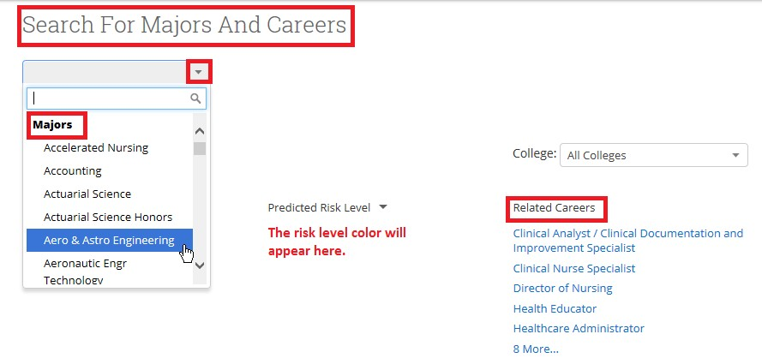
If you like, you can select a specific Purdue college to limit the selections based on that college.

All of the Major Options will appear below the Search For Majors and Careers drop down box. You can either scroll down the page to view each major, or select a major using the drop down box.

Clicking on Related Careers will display a page that describes information related to that major, and it also shows careers related to the major. For each major selected, the Major Explorer will display the Red, Yellow, and Green risk colors associated with that major.
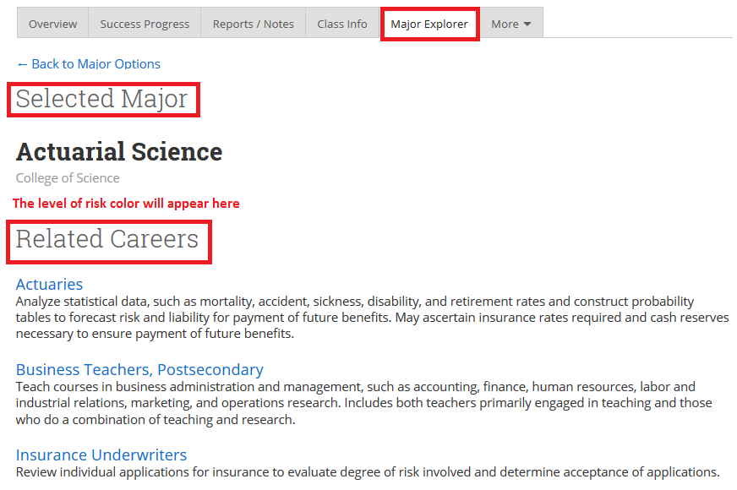

Breadcrumb: Advisor Home>Selected Student>More>Calendar
The More Tab Detail
The student’s calendar

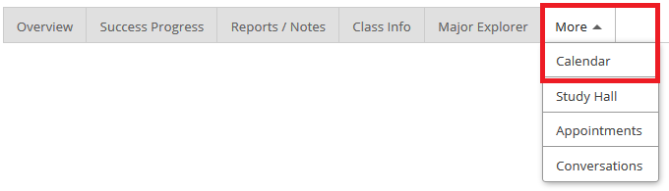

This function will appear under the More drop down box on the menu, and will allow you to view the student’s class calendar. This calendar would include any appointments that you have scheduled with them.

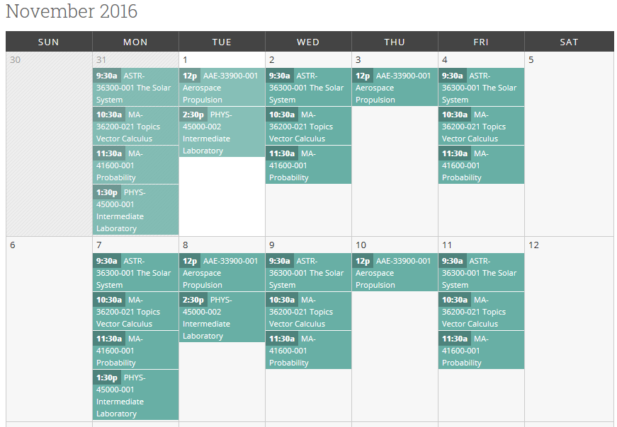

You have the ability to view their calendar by today, any day, week or month by clicking on the selection at the top of the calendar.

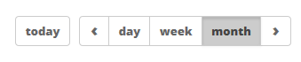

Breadcrumb: Advisor Home>Selected Student>More>Study Hall

Study Hall

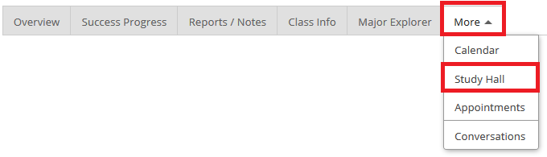

This function will relate to student athletes. Although it appears on the screen you may not see any students included in this grouping.

Breadcrumb: Advisor Home>Selected Student>More>Appointments
The Student Appointments
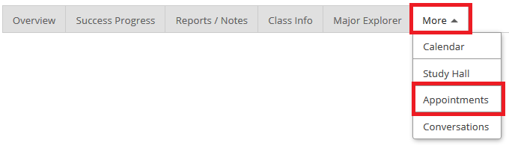

This function will display a list of all of the student’s upcoming and recent appointments, as well as any appointments they did not show up for:

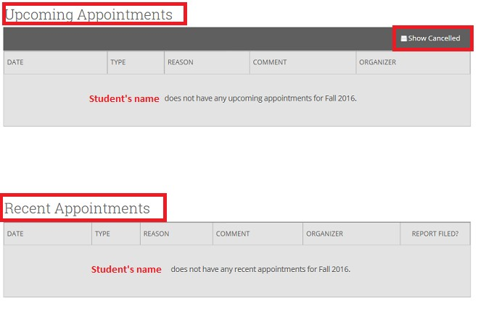

To display cancelled appointments, you will need to click on the Show Cancelled check box in the upper right corner of the black toolbar.

Breadcrumb: Advisor Home>Selected Student>More>Conversations

Viewing Conversations With a Specific Student

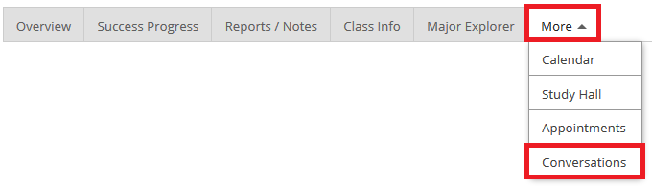

This function will allow you to view all contact that has been made with a student. It will give you the same screen as if you had clicked on the Conversations link in the Navigation Menu.

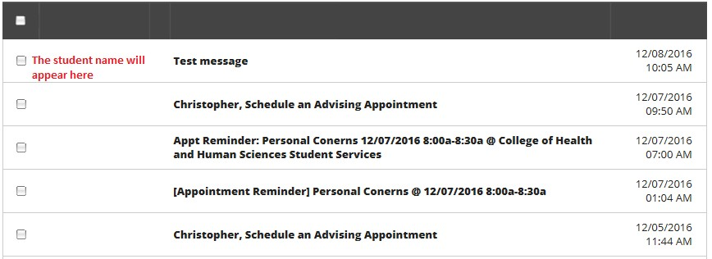

You will be able to click on any of the links and review the contact information.

Breadcrumb: Advisor Home>Navigation Menu>Conversations
Viewing Your Conversations With All Students

BoilerConnect pulls all of your emails and texts in to one location.

Notes and Advising Summaries are not considered as conversations with students. Only emails and texts will be viewable in using the Conversations icon.

- From the Navigation Menu click on the Envelope Icon. This will take you to the All Messages page.
Here, you will be able to view All of your conversations arranged by date.

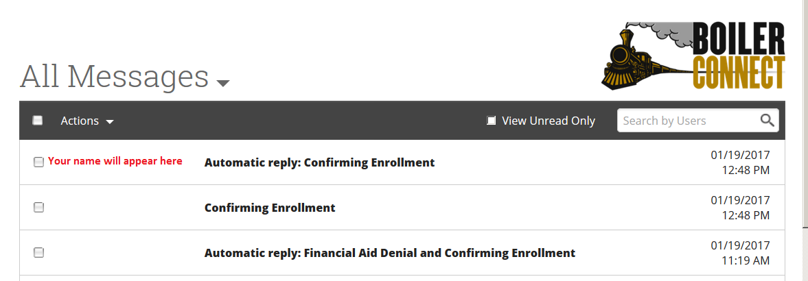

- You can filter viewing of them by clicking on the down arrow alongside All Messages and then clicking on Personal Message or Automated Messages.

