Manufacturing Volunteering Activities
Ver: Jan. 21, 2026

Bechtel Innovation Design Center
Purdue University

Name: ______________________________________
Table of Contents

Introduction 2
Part I: Introductory Exercises 3
Activity 1: Speeds, Feeds, and Cutting Parameters 4
Activity 2: CAD 6
Activity 3: CAM 7
PART II: Basics and Milling 8
Activity 4: Waterjet 9
Activity 5: Saws 10
Activity 6: Manual Milling 11
Activity 7: CNC Mill: 3 Axis Milling 12
Part III: Lathe 13
Activity 8: CNC Lathe CAD & CAM 14
Activity 9: CNC Lathe 15

Introduction

These volunteering activities have been designed to teach you how to use most of the equipment in the Metal Shop at the Bechtel Center. While the activities will not make you an expert overnight, you will continue to gain skill as you use the tools and machines. The activities must be completed in the following order:

- Activity 1 must be completed first
- Activities 2, 3, 5, 6, and 7 must be completed in that order
- Activities 5, 8 and 9 must be completed in that order.

Make sure to ask plenty of questions along the way and get anything you are confused about cleared up. Do not move on to the next activity until you feel you could help someone else with the one you just completed. This will help you to become a better, more effective Peer Mentor for the members of the Bechtel Center. It is always a good idea to take notes as you will be presented with more information than you can retain just in memory.

Completion of the volunteering program does not constitute a guarantee of employment.

Part I: Introductory Exercises

These activities are focused on fundamental principles of design and manufacturing processes. These activities are intended to give you a theoretical understanding which you will be able to apply later. You do not need direct supervision but are free to ask for help. Print this packet out and when you complete an activity, be sure to have a Peer Mentor sign each activity page to track your progress.

Activity 1: Speeds, Feeds, and Cutting Parameters


This activity is intended to teach you about the parameters required for metal cutting tools such as drills, end mills, and inserted carbide tooling.

Watch the listed Haas Tip of the Day video to learn how to find and determine tool Surface Speed (Surface Feet per Minute, SFM) and Feed per Tooth/Revolution (Inches, IPT/IPR), and use them with formulas listed below to determine a machine’s settings for Spindle Speed (Revolutions per Minute, RPM) and Feed Rate (Inches per Minute, IPM).
Haas Tip of the Day: How to Calculate Speeds and Feeds (14m)

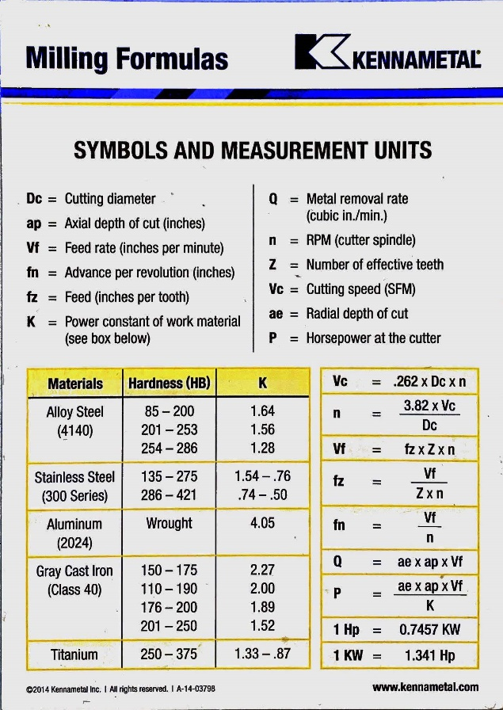

At the Bechtel Center, we use Kennametal carbide tooling for almost all applications. All of our custom CAM tool libraries are already tested and optimized for these tools. However, on many occasions, we refer to the Kennametal Speeds and Feeds app or Kennametal Novo for looking up more oddball cutters or to correct mistakes in our CAM tool libraries. You will need to create an account.

In the app, type the product number of the insert and tool you are using. Select the specific tool from the table, then look for the feeds and speeds button. The sliders are then used to determine feeds and speeds. These values are modifiable but generally more conservative values are preferred to prolong tool life. Higher Surface Speed creates heat which can damage tools, which is why we use smaller values. Sometimes, usually to preserve machine limits, a value outside the range allowed by the sliders can be manually entered. The values input with the sliders are combined with the properties of the tool itself to give the output values on the right.
If necessary, gently increase feed per tooth first for more performance and increase surface speed only if you still need more. In rare cases, these values can be adjusted on the fly with spindle speed and federate overrides on the machines.
Additionally, different materials can be converted into their ISO grades using this chart. This will be necessary to determine your feeds and speeds.
To complete this activity, please answer the following questions and bring the answers to a peer mentor. You are welcome and encouraged to use Novo to assist with your calculations.
- Endmill cutting
  - Given:
    - Material: 6061 Aluminum
    - Tool: Quarter inch endmill 3660401
    - Cutting type: Side Cutting
  - Calculate:
    - RPM –
    - Feed Rate -
    - Material Removal Rate -
- Endmill cutting, RPM limited
  - Given:
    - Material: 6061 Aluminum
    - Tool: Quarter inch endmill 3660401
    - Cutting type: side cutting
    - Machine RPM limit: 15,000
  - Calculate:
    - RPM –
    - Feed Rate -
    - Material Removal Rate -
- Drilling
  - Given:
    - Material: Ti6 Al-4V
    - Tool: Half inch drill 4149323
  - Calculate:
    - RPM -
    - Feed (penetration) rate -
    - Max depth of hole –

You will get this badge when a peer mentor verifies that your answers are correct.

Activity 2: CAD

To become familiar with the manual and CNC mills, you will be making a BIDC-1. The first step for any CNC project at the Bechtel Center is to create the part in CAD. Autodesk Fusion 360 is our primary CAD software. Please make your part inside the BIDC fusion team. Talk to the front desk if you aren’t already a member.
A technical drawing of the BIDC-1 is available below.
Please review the BIDC CAD training videos. Even if you already know how to CAD, please skim these videos and make sure that you aren’t missing any information.
Once you have completed your part in Fusion 360, show it to a Peer Mentor and have them answer any questions that you have about CAD and Fusion 360. It is very important that your part is designed correctly in CAD because it will be used later with the CNC mill.
You will get this badge when a peer mentor has approved your CAD model.

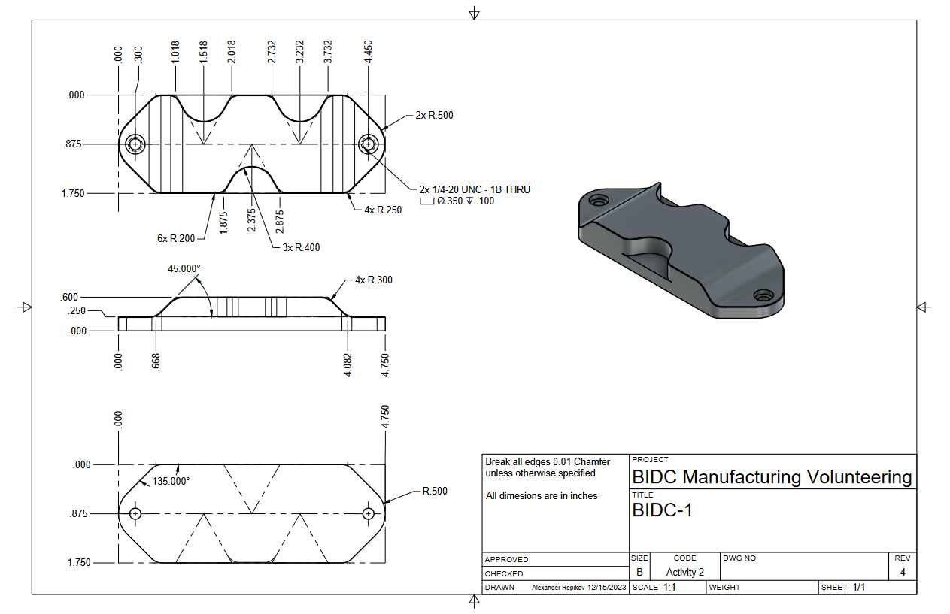

Activity 3: CAM

After you make a CAD model, you will need to make a CAM (computer aided machining) program in order to make it on the CNC mills. Using the BIDC Milling Toolpath Guide and the BIDC videos on milling, make your own CAM and show it to a peer mentor for approval.
Your stock size will be roughly 1 inch by 2 inches by 5 inches.
In Fusion 360, use the tools in the Bechtel Center tool library to create a program to mill your BIDC-1 part. You may need to have multiple operations.

Please note that you will have to hand-thread your holes after you finish making them.

Once you have completed your CAM have a Peer Mentor look over it and check for any errors.

You will get this badge once a peer mentor has approved your CAM.

PART II: Basics and Milling

These activities are focused on introducing you to the tools and machines available in the Bechtel Center and walking you through completing a small project using this equipment. An experienced Peer Mentor will work with you at all times to help you gain familiarity with the machines and to maintain the Bechtel Center’s high level of safety for both its users and equipment. If you are ever stuck or unsure about something, ASK. We are here to help you succeed and be safe. When you complete an activity, be sure to have a Peer Mentor sign this page. Additionally, if you don’t have the machine specific safety badge, make sure you have a Peer Mentor give that to you too.

3

Activity 4: Waterjet


The waterjet is one of the most used machines at the Bechtel Center with very unique capabilities and quirks. To get accustomed to the machine’s workflow, please first watch the following playlist:
BIDC Waterjet CAM Playlist

For this activity, you will be using the waterjet to cut out any shape you like out of polycarbonate plastic. If you don’t have any ideas, you may consider a star, a hook, or gear.
Make sure you get your CAM approved before setting up a reservation.

Before you come into the center for your reservation, please make sure that you read the Waterjet SOP, currently located on the Bechtel website under metal shop resources.

You will get this badge upon completion of your waterjet reservation.

Activity 5: Saws

The horizontal bandsaw is one of the most useful machines in the center. To complete this activity, you will need to cut pieces that will be used for manufacturing later (in activity 7 and 9). Schedule a reservation with a peer mentor. You will cut 5 inches of both the 1” by 2” flat bar and the 2” round bar.
Before you come in for your reservation, please read the Horizontal Bandsaw SOP, currently located on the Bechtel website under metal shop resources.
You will get your badge after you have your stock cut to size.


Activity 6: Manual Milling
In this activity, you will use the manual mill to square your stock. Please watch this NYC CNC video if you are unfamiliar with how a manual (or CNC) mills work and operate:

Squaring stock is a machining process when you mill all 6 sides of your workpiece so that they are flat, parallel, and perpendicular. If you are unfamiliar with the concept of squaring stock, or want to learn more about it, enjoy the accompanying This Old Tony video:
NYC CNC Beginner’s Guide (14m)

Once you understand the squaring process, have a Peer Mentor teach you how to use the manual mill to square your stock. They will get you the stock from the volunteering drawer. You will use a shell mill at its calculated speed (hint: manual machines have lower max spindle speed), feed, depth of cut, and stepover in the mill.
To make this process easier, go back to your CAD model and take note of the dimensions you will need to meet before CNC milling.

Before you come into the center for your reservation, please make sure that you read the Manual Mill SOP, currently located on the Bechtel website under metal shop resources.

You will receive this badge after you have finished squaring your stock and are ready to CNC machine your part.
This Old Tony: Squaring Stock (25m)

Activity 7: CNC Mill: 3 Axis Milling

In this activity, you will make a reservation and cut out your BIDC-1. You must have your CAM approved and stock selected in order to make this reservation.

Before you come into the center for your reservation, please make sure that you read the CNC Mill SOP, currently located on the Bechtel website under metal shop resources.

You will get this badge after you complete your reservation and have your completed BIDC-1 in hand.

Part III: Lathe

Now that you have completed a milling project, it is time to learn the lathe, which is fundamentally different. Mills spin the cutting tool; lathes spin the work. You will use the ST-20Y lathe to make a small part.

Activity 8: CNC Lathe CAD & CAM

To become familiar with the Bechtel Center’s lathes, you will be making a small part. A drawing of the BIDC-2 is below.
Like the mill, you will use the Bechtel Center Lathe Toolpath Guide to program your part. Additionally, take a look at the BIDC Lathe videos. They provide many details about CAM setup.
Your stock size will be roughly 2 inches in diameter and 5 inches long.
Be sure to ask a Peer Mentor if you have any questions!
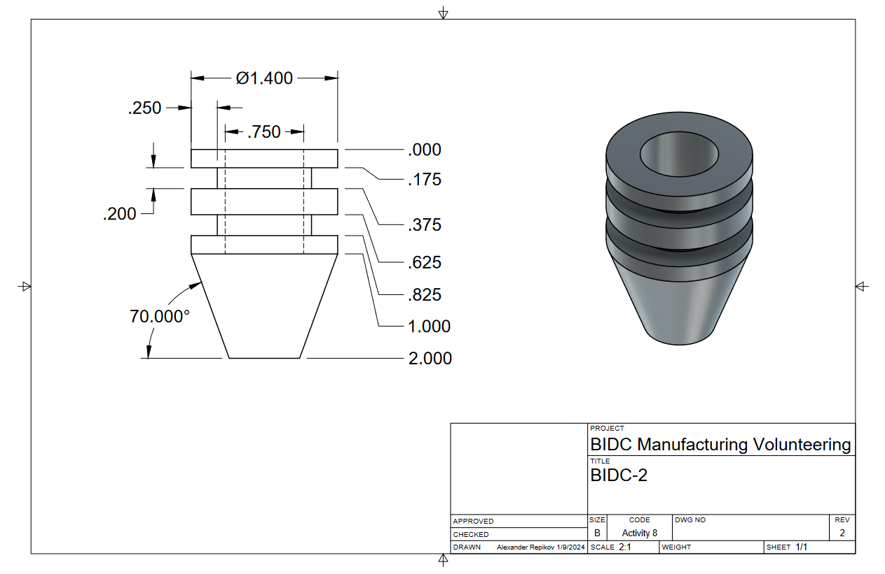

Activity 9: CNC Lathe

In this activity, you will make the BIDC-2 that you designed in the previous activity. Same as the mill, you will need to make a reservation.
Please make sure you read the CNC Lathe SOP before your reservation, currently located on the Bechtel website under metal shop resources.
You will get this badge after you complete your reservation and have the BIDC-2 in hand.

