

Purdue Tableau Server

Fundamentals

February 2024

Copyright © 2024 by Purdue University. All rights reserved. Some topics of this manual reference Tableau proprietary materials.
Permission to print or copy this material is granted to Purdue University faculty and staff for Purdue business purposes. Any other reproduction or use requires written permission of Purdue IT Business Intelligence Competency Center, Purdue University.

CONTENTS

Tableau Server What is Tableau Server? 3
How Do I Use Tableau Server? 3
How Do I Connect to Tableau Server? 3
How Do I Access Tableau Server Projects? 4
How Do I Publish My Data Sources to Tableau Server? 4
Where Can I Find Purdue Tableau Resources? 4
Project Leaders What Is a Tableau Project Leader? 5
How do I Manage Department Folder Access and Content? 5
Tableau Desktop Where Can I Get Tableau Desktop Training? 5
How Do I Publish My Tableau Desktop Workbook To Tableau Server 6
What Are the Purdue Tableau Authoring Standards 6
Can I Connect Tableau Desktop To Other Servers? 7
How do I Make My Tableau Dashboards Run Faster? 8

This manual is designed to help navigate and answer questions for users consuming the Purdue Tableau Server. Additional information can be found on the Tableau corporate site at https://www.tableau.com/products/server.

- Previous knowledge of Tableau Desktop and its uses is expected.
- See below for additional information regarding Tableau Desktop training.
- If Tableau Desktop licensing is required, send a request to BICC@purdue.edu.
o Tableau Server does NOT require a separate user license.

For additional help or questions about the Purdue Tableau Server not contained in this document, please contact the BICC Tableau Server Administrators at BICC@purdue.edu.

TABLEAU SERVER What Is Tableau Server?

Tableau Server is an online platform that allows users to connect to hosted data sources, create and publish workbooks, reports, and dashboards. Tableau Server is a platform that shares housed workbooks, reports, and dashboards with other users publicly (Tableau Public) or privately (Tableau Private). Tableau Server is maintained by the Business Intelligence Competency Center.

- Tableau Server Public is an environment in which assigned users can grant access to all internal (Purdue University) and external (public) viewers. If a project is needed on the Public site for new public content or to migrate content that needs to be accessible to the public, please send an email to bicc@purdue.edu.

- Tableau Server Private is an environment in which users can only share content internally throughout Purdue University.

- Tableau Desktop is used to connect data and publish worksheets and dashboards from and to Tableau Server.

How Do I Use Tableau Server?
Navigating through the Tableau Server users will see the content page, projects, workbooks, views, and data sources. Below are quick guides that provide the basics of getting started in Tableau.

Get Started
Connect to and Prepare Data
Create a New Workbook on the Web from a Published Data Source
Create Views and Dashboards
Manage Permissions with Projects

How Do I Connect to Tableau Server?
Tableau Server is available for Purdue users to store data sources and Tableau Workbooks. Websites can be linked to the content and dashboards stored in the server for shared use internally and/or externally. All faculty and staff members can log into Tableau Server by using the URLs listed below.

There are three server instances:

TABLEAU SERVER INSTANCE | PURPOSE | USES
https://tableau.it.purdue.edu | Database and Tableau upgrades and testing | Purdue IT Use Only
https://qa.tableau.it.purdue.edu/ | Develop and store dashboards and PROD dataset testing | All Tableau developers
https://dev.tableau.it.purdue.edu/ | Final storage solution for dashboards and  PROD data sets | All users with access to data and dashboards

How Do I Access Tableau Server Projects?

Tableau Server Project Leaders oversee the use of Tableau for their specific area. This includes acting as a first point of contact for publishing workbooks and data sources, licensing, and permissions. New users can contact their project leaders for access to Tableau Server. BICC Administrators set up project folders, usually by department, and assign two project leaders.

Users can check for current project folders and leaders by department. If there is no project folder and/or project leader for your department, contact the BICC to request an account be created. Please provide a project leader’s name and alternate name, if available.

How Do I Publish My Data Sources to Tableau Server?

Data sources can be published to the server to:

- Allow other users consuming the dashboards to connect to the data
- Allow other users to use the data source to create their own visualizations
- Allow the updates made to the published data source to be captured and flow to the workbooks consuming it

Review Publish a Data Source to Tableau Server to discover how the process works. If you need further assistance with data sources for Tableau server, contact BICC@purdue.edu.


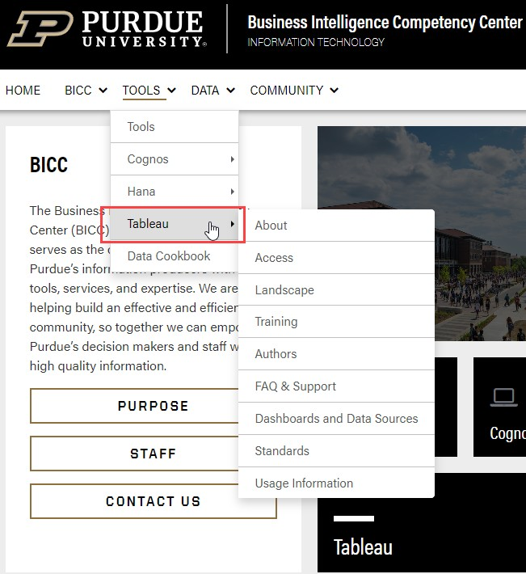
Where Can I Find Purdue Tableau Resources?

Additional documentation about Tableau software at Purdue is located on the Purdue BICC website. Select the Tools dropdown for information on Tableau including training, author links and resources, FAQ & support, and project access to Tableau Server.

Check www.tableau.com as a great resource in finding additional documentation.

PROJECT LEADERS What Is A Tableau Project Leader?

If designated as a project leader, users have a unique set of responsibilities for the project/department folder. Project leaders are responsible for maintaining the content and user security within the department folder and work with the BICC on upgrades and any changes related to Tableau Server.

Please review the training information included below on how to administer content and assist co-workers with Tableau Server usage.

How Do I Manage Department Folder Access And Content?

Create Projects to Organize Content
Content Access and Ownership
Manage Data
View or Edit permission Rules and User Permissions
Manage Content Ownership
Create Project-Based Permissions
Set Permissions for a Project
Set Permissions for a Data Source
Set Permissions for Workbooks and Views
Grant Web Edit, Save, and Download Permissions
Set a Site’s Web Authoring Access

TABLEAU DESKTOP Where Can I Get Tableau Desktop Training?
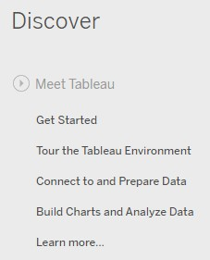
Tableau Server uses workbooks and worksheets created within the Tableau Desktop software.

On-line training for Tableau Desktop can be found at https://www.tableau.com/learn/training.

Users can also access Tableau Desktop training within Tableau Desktop by using the Discover links on the home page of Tableau Desktop. Use the links found in the upper right corner.

Some editing within Tableau Server (generally done in Tableau Desktop) is available on the server and has been activated for use.

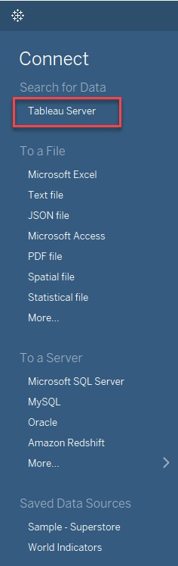
How Do I Publish My Tableau Desktop Workbook To
Tableau Server?

Below are informative links on publishing workbooks from Tableau Desktop to the
Tableau server for sharing information. Dashboards can be displayed or embedded on
websites and in other tools like SharePoint (Note: You must have access to publish to the departmental folder. Project leaders provide the access.

Contact bicc@purdue.edu if you do not have a Project leader for your department).

Prepare for Publishing a Workbook
Publish a Workbook
Set Permissions as You Publish a Workbook

What Are the Purdue Tableau Authoring Standards?

The Management Dashboards will provide a single source of useful data in a dashboard format for Deans, Directors, Department Heads, and Executives of the university. To ensure that the appropriate information is placed on the site, Purdue has set up a governance committee to oversee content, security, and access.

Additionally, to ensure the content maintains a consistent and high-quality look and feel, the standards committee oversees the development of the dashboards held on the site. Any individual wishing to publish a dashboard to the site must gain approval of the standards committee.

It is highly recommended any content planning to be consumed via Tableau, be approved by the standards committee.

The Standards and Best Practices page contains an overview of the process flow for dashboard production and publication as well as a user guide for dashboard standards. A template has been stored on the tableau production server for use as a guide https://tableau.it.purdue.edu/#/projects/61.

If you are interested in publishing a dashboard to the site or have questions about your own dashboards, please contact a member of the standards committee for more information.
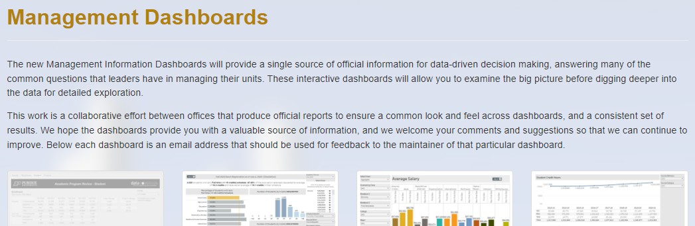

Can I Connect Tableau Desktop to Other Servers?

Tableau Desktop can be connected directly to servers like MySQL, Oracle, Google Sheets, etc. Connection instructions for the specific servers can be found on the home page of Tableau Desktop. Click on the desired server type name and complete the required information. Contact bicc@purdue.edu if you experience any issues with connecting to specific servers.
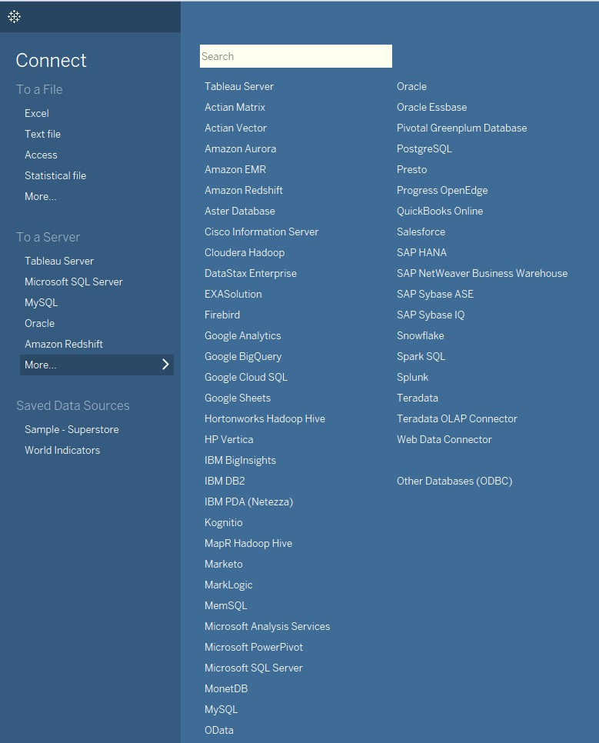

How Do I Make My Tableau Dashboards Run Faster?

Below are recommendations from Tableau on best practices for keeping your workbooks efficient.

- There are no silver bullets for inefficient workbooks. Start by looking at the performance recorder to understand where the time is going. Long-running queries? Lots of queries? Slow calculations? Complex rendering? Use this insight to focus your efforts in the right direction.

- The recommendations in this document are just that – recommendations. While they represent a level of best practice, you need to test if they will improve performance in your specific case. Many of them can be dependent on the structure of your data, and the data source you are using (e.g. flat file vs. RDBMS vs. data extract).

- Extracts are a quick and easy way to make most workbooks run faster.

- The cleaner your data is and the better it matches the structure of your questions (i.e. the less preparation and manipulation required), the faster your workbooks will run.

- Most slow dashboards are caused by poor design – in particular, too many charts on a single dashboard, or trying to show too much data at once. Keep it simple. Allow your users to incrementally drill down to details, rather than trying to show everything and then filter.

- Work with the data you need and no more – both in terms of the fields you reference as well as the granularity of the records you return. It allows Tableau to generate fewer, better, and faster queries and reduces the amount of data that needs to be moved from the data source to Tableau’s engine. It also reduces the size of your workbooks, so they are easier to share and open faster.

- While reducing the data, make sure you use filters efficiently.

- Strings and dates are slow, numbers and Booleans are fast.

