

Cognos Analytics
Navigation

COG 101

Cognos Version 12.1.0
APR 2026

Business Intelligence Competency Center



Copyright © 2026 by Purdue University. All rights reserved. Some topics of this manual reference IBM Cognos proprietary materials.
Permission to print or copy this material is granted to Purdue University faculty and staff for Purdue business purposes. Any other reproduction or use requires written permission of Purdue IT Business Intelligence Competency Center, Purdue University.

Table of Contents
Security 4
Data Classification & Handling 4
Accessing Cognos Analytics 5
Cognos Data Sources 6
Main Portal Page Content 8
Application Bar 9
Personal Menu 12
Navigation Menu 15
Navigating Cognos Analytics Folders and Objects 16
Icons in My Content and Team Content 16
Breadcrumb Trail 18
Folder Features 19
Filtering Folder Content 20
Report Output Format Options 22
Running Reports 23
Prompts 25
Drill Through Reports 26
Creating Report Views 27
Report View Options 29
View and Manage Saved Report Output 31
Creating Subscriptions 33
Server Response Considerations 36
Best Practice for Email Report Output 37
Logging Off 38
Troubleshooting 39
Feedback on this Document 39
APPENDIX A – Run Report in Background – If you HAVE WRITE access to the folder where the report is housed 40
APPENDIX B – Run Report in Background – If you do NOT have WRITE access to the folder where the report is housed 44

Security
Keeping data safe and secure is now a part of Indiana law. Cognos is designed as a secure environment for viewing data. If data must be extracted, take proper precautions to secure it. DO NOT save sensitive data on your PC (usually C: drive). If you must save the output, be sure to save it to a LAN drive or other secure location.
Review the link below for protection of data and for your own safety.

Data Classification & Handling
https://www.purdue.edu/securepurdue/data-handling/index.php

Accessing Cognos Analytics
- All users access Cognos by using their Purdue career account login and password.
- Google Chrome, Mozilla Firefox, and Edge can be used with Cognos Analytics. We do not suggest using Internet Explorer with Cognos.

- The standard Cognos Maintenance window is Saturdays from 3:45PM to Midnight. Additional outages will be communicated.

Cognos Data Sources
Data for Cognos reports usually comes from these sources.
Purdue Data Warehouse (PDW) - Boiler Insight - Business Data
Finance and HR Data | GM AIMS | Admin. Operations
- The data in these reports comes from SAP.  - Contains Human Resources (HR) and Financial (FI) data.  - Data is typically one business day old, depending on the Star. | - The data in these reports comes from SAP.  - Contains Human Resources (HR) and Financial (FI) data.  - Data is typically one business day old, depending on the Star. | - The data in these reports comes from SAP.  - Data is typically one day old.

Student Data
Banner Operational Data Store (ODS) | Banner Enterprise Data Warehouse (EDW)
- Base data from the Banner systems.  - Data is loaded into the ODS nightly.  - Data is one day old. | - Base data from the Banner systems.  - Transformed data from ODS for freeze files.  - Data can come from multiple freeze dates.

General Use URL (PROD)

The URL for Cognos is https://reporting.purdue.edu
(NOTE: For future use, you may want to add the URL to your favorites.)

Training URL

We will be using a test environment for training.
- Go to https://qa.reporting.purdue.edu
- Enter your network credentials.
Career Account Username: on the first line and Password: on the second.
- Click the Log in button to continue.
Log on Page  Use your Purdue Career Account Username and Password | Welcome Page
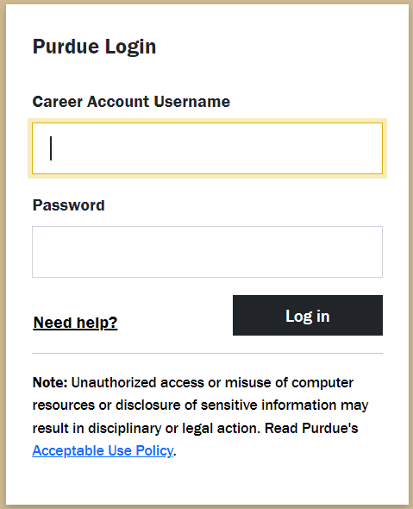 | 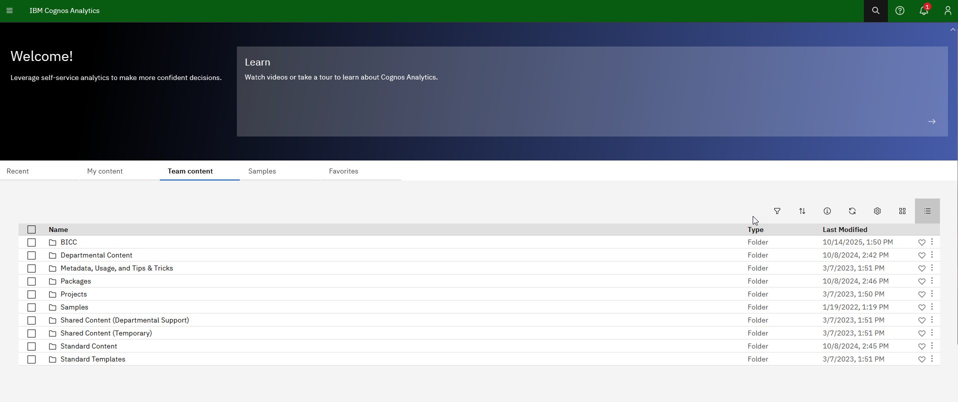

- When authentication is complete, you will see the Welcome main page.

Main Portal Page Content
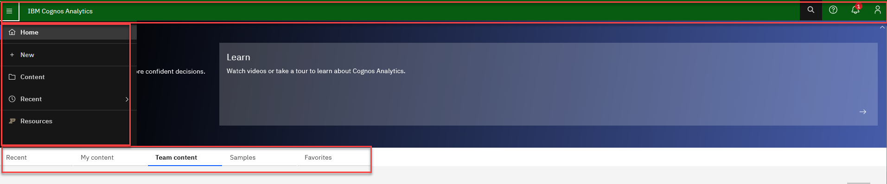
Note: The Navigation Menu is expanded when the user clicks on the hamburger (stacked horizontal lines), located on the far-left corner of the Application Bar. Otherwise, the Navigation Menu is hidden.

Application Bar
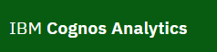 | Home  - Clicking on IBM Cognos Analytics will take you to the main Home Page.
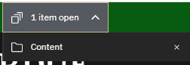 | Open Items  - Toggle between opened reports.  - Click to close objects in the window.
 | Search  - Search for items by keywords and select the Enter key.  - Searches can be saved
  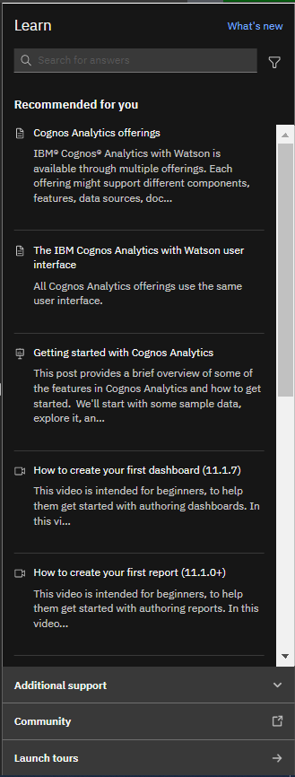 | Learn  - Provides the user with additional information as it relates to IBM Cognos Analytics  - Allows the user to search for help, suggestions, and answers to questions  - Explains What’s new with IBM Cognos Analytics  - Provides recommended articles to read  - Provides videos to watch on demand
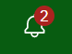 | Notification Indicator  - Alerts user when subscribed reports have finished executing.
 | Personal Menu  - Settings related to you as the user.  - Includes preference settings and schedule & subscription maintenance.  - Used to sign out of Cognos.

Personal Menu
The personal menu is everything that pertains to you as a user.
This includes your security settings and personal preference settings within the portal. 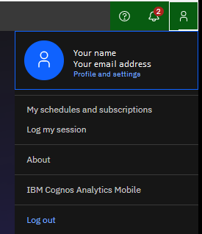

My Settings
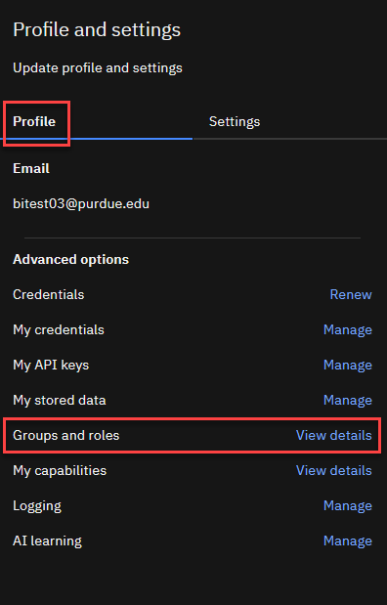
- Click on the Person Icon 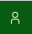
located on the Application Bar
and select Profile and Settings.
- Groups and roles: Provides a list of groups and roles you have access to.

Additional settings are not typically changed.

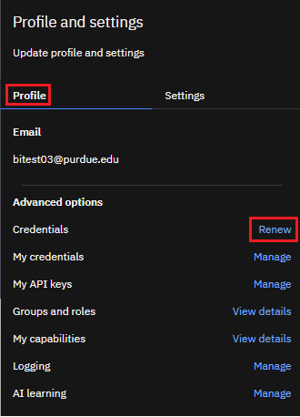
Renew Credentials
- Click on the Person Icon
located on the Application Bar
and select Profile and Settings
then select Profile.

- Renew Credentials: After changing your password to log into your computer, you will need to renew your credentials in Cognos.

- Click Renew after password changes for Subscriptions and Schedules to continue running.

Additional settings under Profile are not typically changed.

My schedules and subscriptions

Users can subscribe to a report they use often or on a regular basis. When you subscribe to a report, the subscription includes all your prompt and parameter values. My schedules and subscriptions display user subscriptions as well as schedules. It can be used to research failed report schedules, delete schedules/subscriptions, and modify schedule/subscription rules.
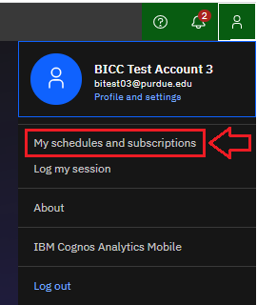

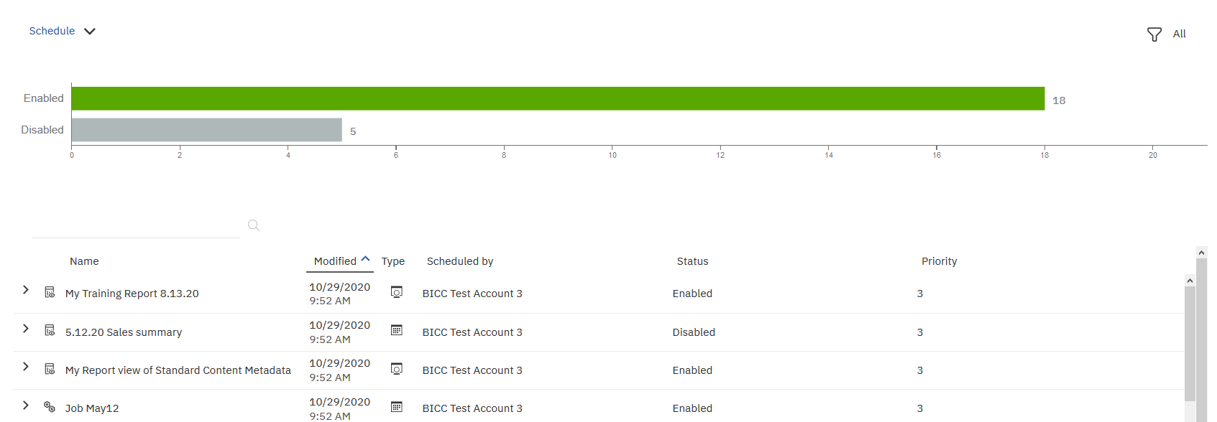

NOTE: More details and steps for creating subscriptions are found on page 33. COG 111 training includes how to schedule report runs.

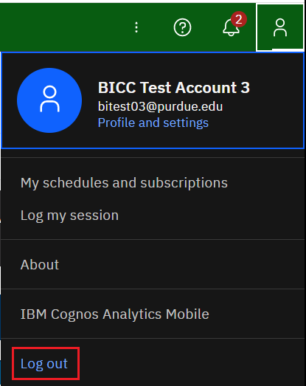
Log Out

- Click Log Out to leave Cognos
Analytics.

- Close the browser.

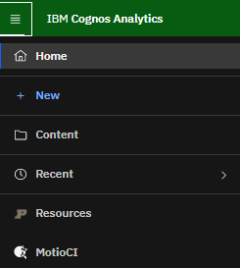
Navigation Menu
Note: Icon text descriptions only display if monitor size is wide enough. If you only see icons, hover over the icons objects to display descriptions.

Note: The Navigation Menu is expanded when the user clicks on the hamburger (stacked horizontal lines), located on the far-left corner of the Application Bar. Otherwise, the Navigation Menu is hidden.

 | Home | Takes the user to the home page
 | New | To create a new job or a new report (authors only)
 | Content | Gives the option to go to Team Content or My Content
 | Recent | Recently viewed report type objects and dashboards
 | Resources | Click to find links to additional information on Cognos, Authoring, and other documentation related to reporting at Purdue University
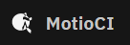 | MotioCI | Provides a direct connection to MotioCI. For more information on MotioCI, you can watch the MotioCI videos at https://www.purdue.edu/bicc/tools/cognos/training/cognos-videos.php

Navigating Cognos Analytics Folders and Objects
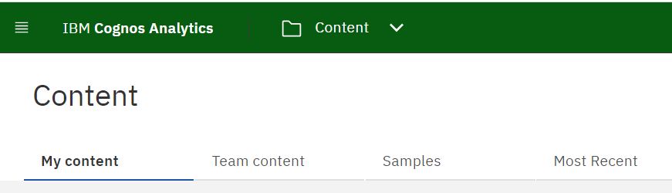
Recent | My Content | Team Content | Samples | Favorites
- Contains the most recent folders and reports accessed by the user | - Contains objects only viewable by the user  - Users can copy reports from Team Content folders and save them to My Content for personal use | - Contains standard and departmental folders and reports  - Users view items based on security roles | - Contains sample reports that can be used for training purposes | - Add items to your Favorites by clicking the heart icon next to them on the Content or Home pages, or by using the context menu

Icons in My Content and Team Content
Users can hover over items for a description.

Folder | 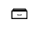  Package |  “Authoring” Report |   “Query Studio” Report |   Report View | Dashboard | Shortcut

Note: Users may or may not see some of these options as they are based on access and Cognos license capabilities.

- Click on Team Content to open a windowpane.
- The first pane generally contains folder icons. Clicking a folder name will open another pane.

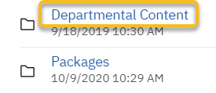
Click on the name of the folder to open folders and see additional objects.
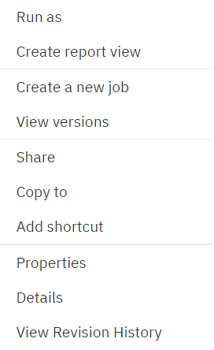

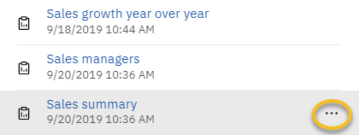
Right-click the report name link to select Run as and see additional options for the report.
OR
Click the ellipsis for the same list of options.

Note: Users may not see some of these options as they are based on access and Cognos license capabilities.

Breadcrumb Trail
The breadcrumb trail tracks where a user has been clicking through the folder structure. In Cognos Analytics, as users click through the folders, the breadcrumb path expands as more folders are selected. This makes it easier for a user to know where they are in Cognos Analytics.

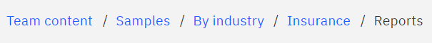

- Navigate to Team Content, Samples, By industry, Insurance, and click the Reports folder.

- The breadcrumb trail (path) is displayed on the user’s screen for reference.

- The user can go to any part of the breadcrumb trail that is in blue to get back to that previous folder.

Folder Features
- Navigate to Team Content, Samples, By industry, Insurance.
- Navigate to Reports and click the Action menu (3 vertical dots) to the right of the name.
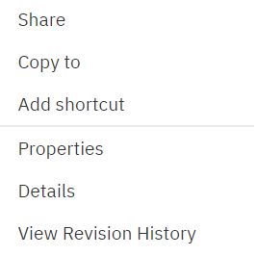
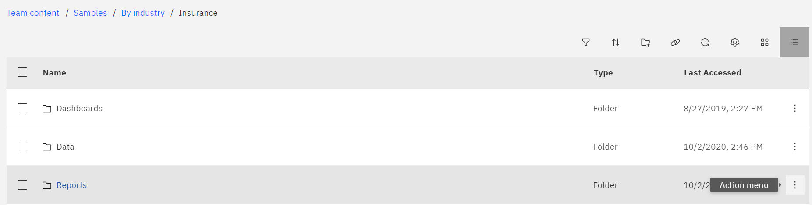
- The options list for folders opens.

Note: Users may not see some of these options as they are based on access and Cognos license capabilities.

Share | Copy link to share content with other users.
Copy to | Copy the folder object to another destination in Cognos. The Move option is based on the user’s access.
Add shortcut | Used to create a shortcut version of the folder.
Properties | Provides general information about the folder. Displays the folder name, description, permissions, and location.
Details | Displays folder owner, shows folder creation and modification dates, folder location, and link to folder properties.
View Revision History | Directs the user to MotioCI to review any changes to the folder.

Filtering Folder Content
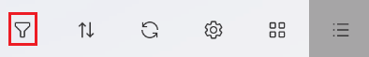
- Click on the Funnel icon to open filtering options.
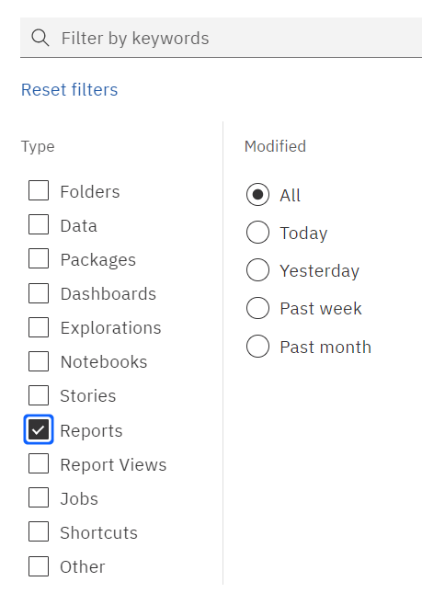
Default is set to “All Content”. To only see reports that are contained in this folder, check “Reports”. This will filter out all other objects except report objects.

- Use the folder with the plus icon to create new folders. Available to all users in the My Content folder. (Note: Some users will not see it in Team Content as it is based on folder security.)
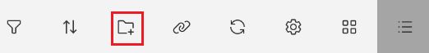

- Navigate to the Customer lifetime value analysis report (Team Content, Samples, By industry, Insurance, Reports) and click the Action menu (3 vertical dots) to the far right of the report name. Notice the row is highlighted and an options menu appears.

Note: Users may not see all of these options as they are based on access and Cognos license capabilities.

Run as | Allows selection of report output type and Run in background mode.
Create report view | Creates a report view, usually used to create a copy for scheduling.
Create a new job | A collection of reports. A job allows a user to set the same schedule for multiple reports, report views, and other jobs.
View versions | Displays any previously saved report output and previous run history.
Share | Copy link to share content with other users.
Copy or move to | Copy or move a report object to another destination in Cognos. Must have write access to the selected destination.
Add shortcut | Used to create a shortcut version of the report. Not generally recommended.
Edit name and description | Allows the report name and description to be changed.
Properties | Provides general information about the folder. Displays the folder name, description, permissions, and location.
Details | Displays the folder owner, shows the folder's creation and modification dates, the folder's location, and a link to the folder's properties. Also allows the user to open the report, run as or create a report view or new job.
Delete | Used to delete the report object.
View Revision History | Directs the user to MotioCI to review any changes to the report.

Report Output Format Options
This document provides information on the Cognos output options and behaviors when exporting Cognos reports.
HTML | - This is a report’s usual default.  - Web-based and designed for viewing report output on-screen.  - If the report contains tabbed layouts, all pages will be displayed and accessible.
CSV | - Export data which is tab-delimited and can be imported to (or read by) other software.  - Strings are not enclosed in quotation marks.  - CSV exports show only the results of the report query.  - Page layout items, such as titles, images, totals, and subtotals, etc., do not appear.  - Only the first page of tabbed layouts will appear.  - If the first page of the report contains more than one report object (list or crosstab), only the first object is displayed.
Excel | - Previously named Excel 2007 Format  - Supports lists, crosstabs, icons, titles, subtotals, totals, and charts.  - Preferred over Excel 2002.  - Each page of a tabbed layout will render as its own worksheet in Excel.  NOTE: Authoring Users: If Rows per Page in the Report Page Properties is populated with a value, this Excel version will page break into separate worksheets based on the number of rows per page.
Excel Data | - Report formatting (titles, charts, icons, subtotals, totals, etc.) is dropped, and data is returned in spreadsheet format (like CSV file).  - Only the first page of tabbed layouts will appear.  - If the first page of the report contains more than one report object (list or crosstab), only the first object is displayed.
PDF | - Used for printing and distributing output in Adobe Acrobat Reader.  - You must have administrator privileges to specify the advanced PDF options.  - Each page in a tabbed layout report will render its own page.  NOTE: Authoring Users: To modify the PDF default settings for the report, open the Authoring tool and open the properties for Page, then PDF Page Setup.
XML | - XML report outputs save the report data in a format that conforms to an internal schema, xmldata.xsd.  - Is useful if you want to use a report as a data source for another report.  - NOTE: For reports that have more than one query defined in the report, unless the additional queries are used for prompts, the following is true: if the report contains more than one data container, such as a crosstab and a list, and both containers use the same query, only the output for the list is produced. If the report contains multiple lists, only the output for the first list is produced. If the report contains multiple crosstabs and multiple lists, only the output for the first list is produced.

Running Reports
Consumers use IBM Cognos Analytics to run pre-written reports. You can subscribe, schedule, view, download, or print report output information based on the report logic. The results can be exported into these formats:
- Excel
- Excel data
- CSV (for mail merge or import into other systems)
- Adobe Acrobat (PDF) for printing
- XML
- Web-based HTML format for viewing

- Select Team Content, Samples, By industry, Insurance, Reports.
- Right-click the report link Customer lifetime value analysis or click the Action Menu (3 vertical dots).
- Select Run as, then click Run.

The report will run and display output within the same window.
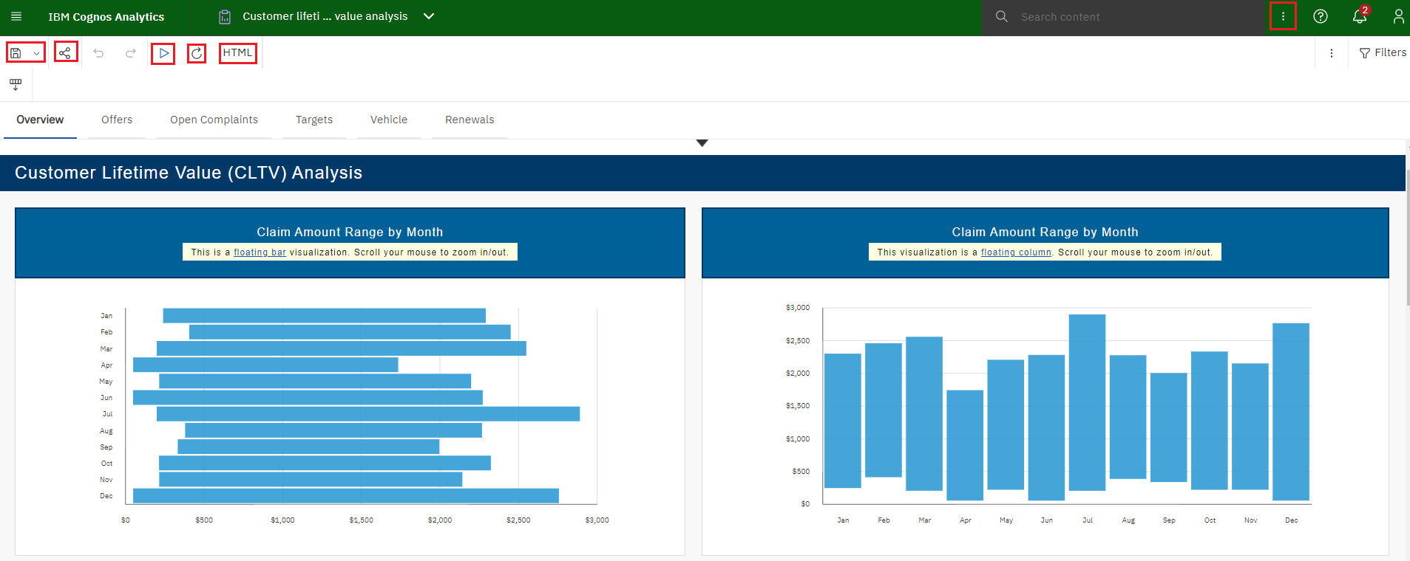
New options appear on the Application bar.

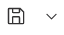 | Save | Save as: Save the open report to another folder within Cognos.  Save as report view: Used to create a Report view version of the report for scheduling reports.
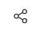 | Share | Copy link to share content with other users. (Note: recipients of the link must have a Cognos license to open and view the report).
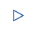 | Run | Users can select to rerun the report in the current default setting.
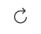 | Refresh | Refreshes the current report.
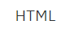 | HTML | Allows the user to rerun the report in a different output, rather than the current default setting. (See page 22 of this manual)
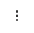 | More (left of the filter) | Allows the user to clear the parameter values used to generate the report.
 | More (right of the search bar) | The More options change when a report is open. It allows a user to create a Subscription to the report.
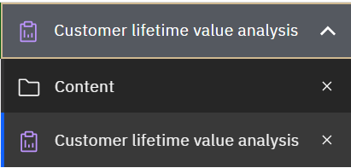 | Recent | The Recent section changes to show what you currently have open. In this example, Customer lifetime value analysis and Content are currently open.  - Click to view open windows, close windows, or toggle between open windows.  - Click the to close the object/report.
- Close the Customer lifetime value analysis report window.

Prompts
Most reports will display a prompt page once you send the request. This helps make reports more versatile for more users. It also helps the report process to become faster by limiting the amount of data coming back from the database.
- Prompts can be single select or multi select.
- Prompts can be required or optional. A red asterisk * indicates this prompt is mandatory.
- Finish or Submit buttons are grayed out until a mandatory prompt is selected.
- Some prompts only allow you to choose one value.
- Use the Ctrl key and/or Shift key with the mouse to select multiple values within the prompt box.
- Some prompts have Select all and De-select all links below the prompt.
- All prompt pages contain a Cancel, Submit, Finish, or OK button to cancel or execute the report.
- If prompts are optional and none are selected, the report may take longer to complete.

Not all prompt pages look the same. Report authors have the ability to create different designs and layouts based on the best use of the data and report.

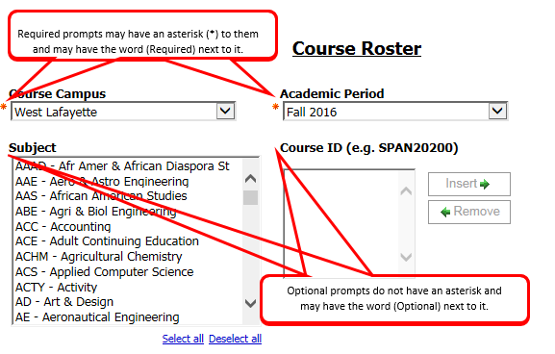

Drill Through Reports
Some reports may contain drill through links that allow users to view more details by opening a second report.

- Drill Throughs can only be used when processing the report in HTML or PDF format
- This feature is not found in all reports

Drill Through reports are indicated by the blue text color and underline, which links to a more detailed report. In this example, the hyperlink is for the Account Summary report details.

In the example below, users would click the blue report link, Account Summary, to drill down into the data.

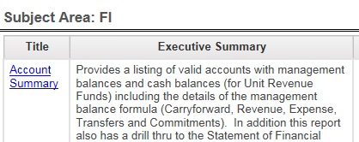

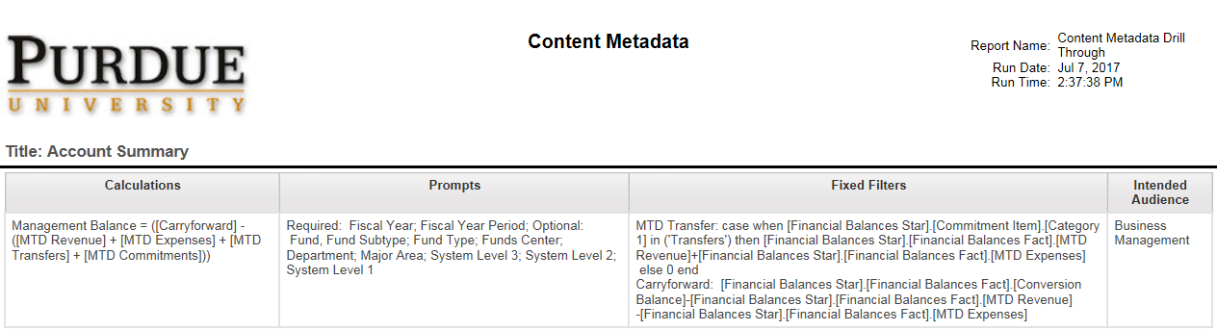
A new browser window opens for the drill through (child) report. The report displays details about the report, including calculations, prompts, and filters.

- Close the browser tab to return to the original report, Account Summary output.
- Close the report using the Switcher drop-down.

Creating Report Views
Report content, created by report authors and stored in available folders, may be saved as report views in your own My content or departmental folders. This allows you to save your favorite reports in a location that is easily accessible.

NOTE: The steps below would be used to create a Report View for scheduled reports or general use of the report to save selected prompts.
- Report views are a combination of a shortcut and a dynamic copy of the original report.
- If the source report is moved to another location, the report view link is not broken.
- If the source report is deleted, the report view link to the source report is removed, and the report view will have to be re-created.

- Navigate to Team Content, Samples, By industry, Insurance, Reports.
- Right-click on the report name Customer lifetime value analysis or click the Action Menu (3 vertical dots) and select Create report view.

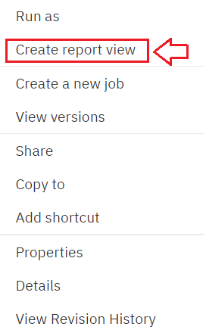

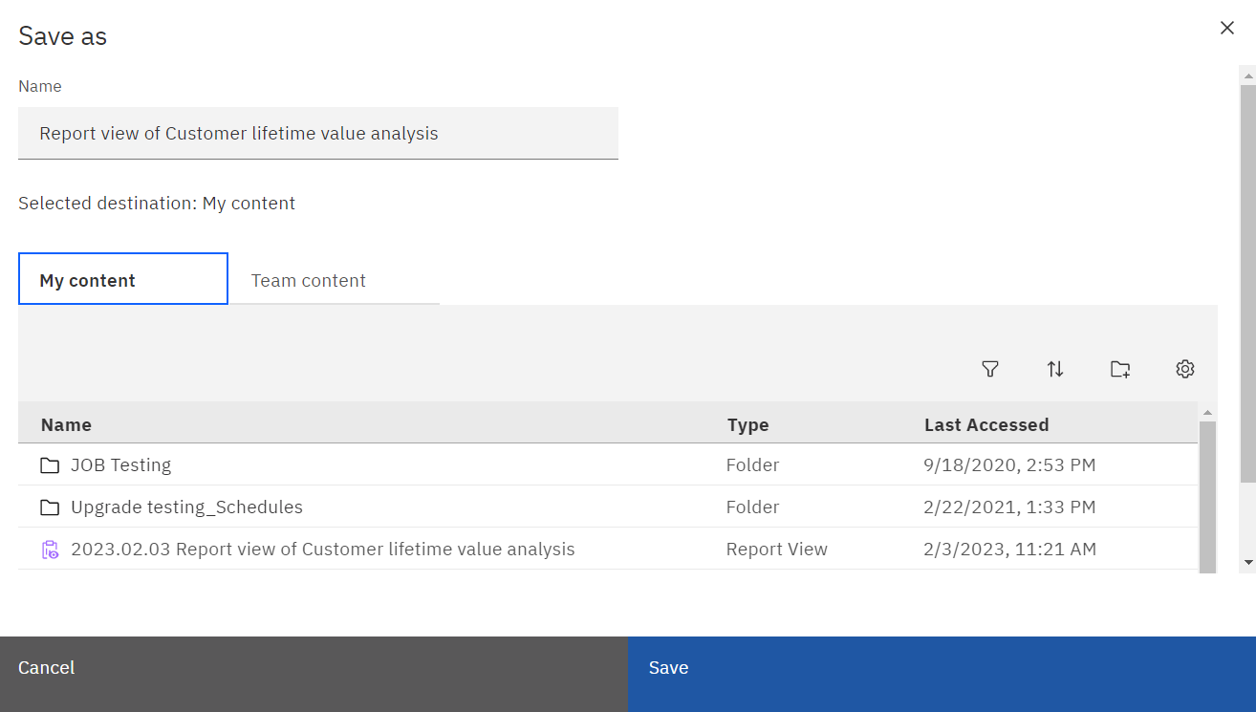
- Select My content and then Save.

Notice the report name has been changed to Report view
of Customer lifetime value analysis. Cognos defaults to the

NOTE: Users will only be able to save the report in their My content folder or departmental folder in Team content. In this example we saved it to My content.

original name of the report and adds Report view of at the
beginning.

- Close the original report.
- Navigate to your My content to find the new report
view just saved. The report will be alphabetized within the list.

Notice the report icon has changed (to a clipboard with an eye).

- It is highly recommended you create a subfolder in My content titled “Schedules” and save the report view in it if you plan to use the report view as a scheduled report.
- If the scheduled report is to be used by others in your department, create a “Schedules” folder in your departmental folder and store the report view there.

- Right-click on the report name or click the Action menu.
- Click Edit Name and Description
- Click inside the Name block and remove
Report View from the title. NOTE: This step is optional.
Users may wish to keep the reference in the title).
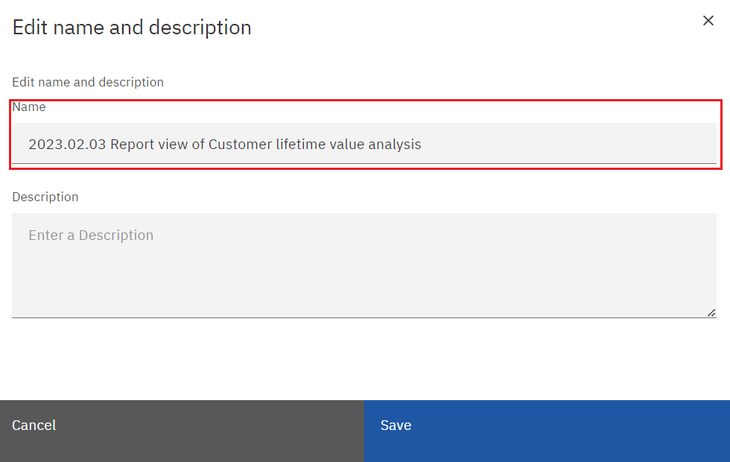

Report View Options
- Using the new Report View just created, click on the Action Menu, and select Edit Name and Description.

- Click in the Description field to add or modify the description.
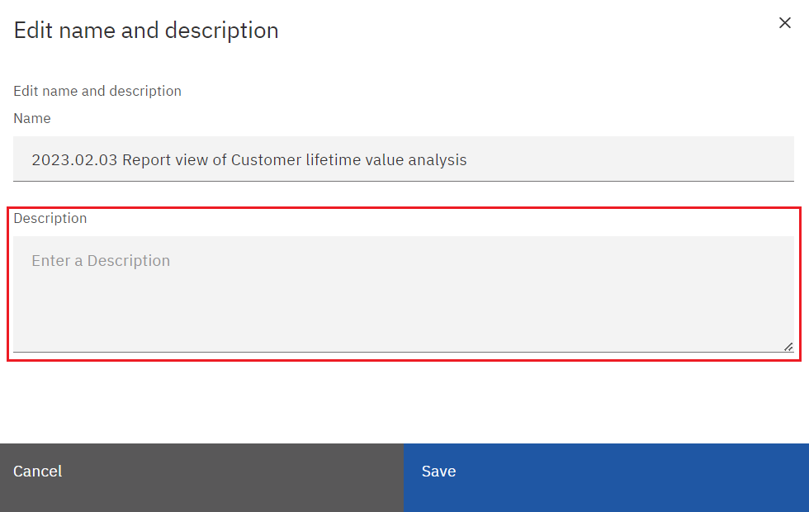

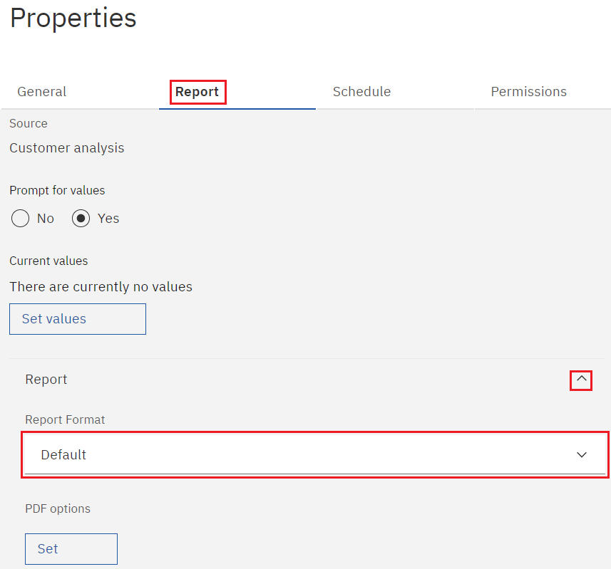

- Select Properties from the Action menu, then Report.
- Use the drop-down arrow next to Report to change the format to HTML.

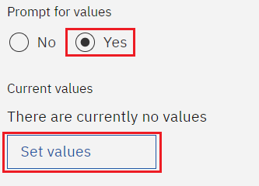
- Make sure the Prompt for values box is checked.
- Under Current values, select Set values.

- When the prompt page opens, select the desired option(s):
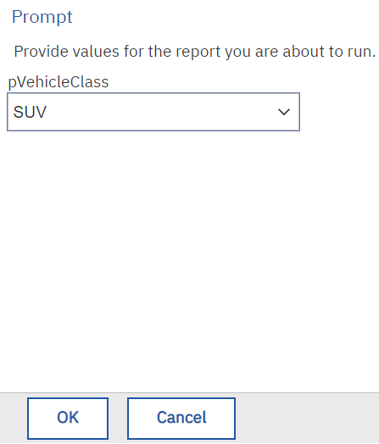

- Click the OK button on the top or bottom of the prompt page.

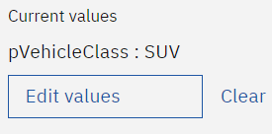
The prompt values selected will
appear on the right side. Prompt
names appear on the left.

Click Edit values if you desire to edit the prompts.

Click Clear if you desire to remove the prompts.

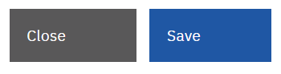
- Click the Save, then Close button to return
to the Content page.

- Return to the Properties by selecting the Action Menu (3 vertical dots) then Properties.

- Select Schedule from the menu if you wish to create scheduled output. (Note: Scheduling report runs is covered in the COG 111 training).

- The Permissions option is rarely used as it is tied to security. It’s generally only used by Cognos Administrators or selected Cognos department managers.

View and Manage Saved Report Output
Users may view saved report output and manage previous saved output versions.
- Navigate to Team Content, Samples, By industry, Insurance, Reports, then Customer lifetime value analysis report.
- Click the Action Menu to open report options.
- Select View versions in the options pane that opens.
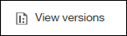
(NOTE: User must have access to the report).

- Click the Show all history box to see the entire list of saved output.
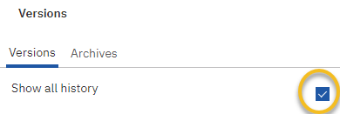

A list will appear. Two types of content are stored here: Saved Report Output Versions and Run History.

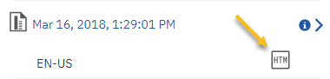
Saved Report Output
- Saved report output will appear as a link and, if clicked, will open saved output options.
- Click the attachment to open the saved report
output in the format indicated.
- Saved output can be deleted by selecting Delete report version.

Cognos will default to only 1 saved output file at a time.
Only the most recent output will have the saved report output available.
(Default settings can be changed in the Report Properties section of the report).

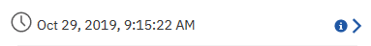
Run History

- A saved output run history appears in blue or red text and will also generate a record of the report run.

Cognos will default to 5 report run records before deleting the first one. Users cannot delete these records. (Default settings can be changed in the Report Properties section of the report).

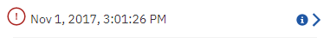
In this example, notice the red exclamation icon. This indicates the report failed to run.

Click on the blue arrow across from the report to see the failing message.

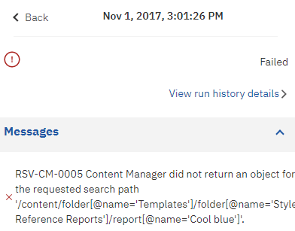
- Close the open report by selecting the
Back button in the top left corner.

Creating Subscriptions
- If you use a report regularly, you can set up a subscription to be delivered to you on a preset schedule. You can pick the time, date, format, output types, and how you want it delivered.

- The subscription set-up option is available ONLY when you run and view report output, but not when you are in editing mode or when you view saved output. If you edit a report, you must save it before you can subscribe.

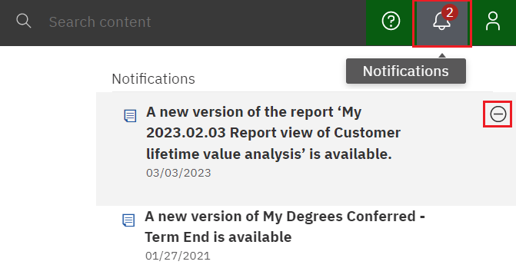
- After you subscribe, each time your report is delivered, you are notified via a Notification indicator on the Application Bar.

Click on the icon to see the message.

Hover and click Θ to delete the message.

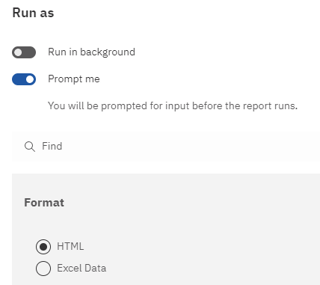
Go to Team Content, Samples, By industry, Insurance, Reports, Customer lifetime value analysis.

- Right-click on the Customer lifetime value analysis report and select Run As.

- Make sure HTML is selected then click Run at the bottom of the pane.

(NOTE: This step must be done to avoid using any previously saved output for this report)

- Select the prompts you would like.
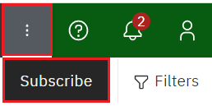
- Once the output is generated, select the More icon on the Application Bar and click Subscribe.

The subscription options pane opens with personalized options for how and when to run the report.

Daily | Days and Time
Weekly | Week, Day of the Week, and Time
Monthly | Day by Week, Date, Month and Time
Yearly | Day by Week, Date, Month and Time
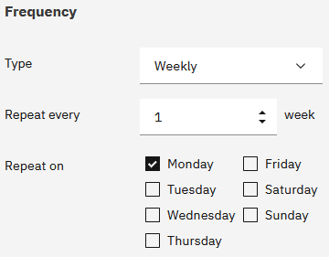
- Select one or more days for the report to run.
- Time the report will run for selected day(s).
- Defaults to current time.

- Click on the Time box to open time and AM/PM selection.
Adjust how you would like.
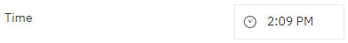

- Click on Options
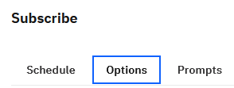

- On the Format line, select output format(s).
- Multiple selection is available.
- Defaults is HTML.
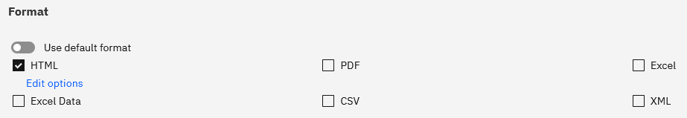

- Scroll down to the Delivery line to set delivery options.

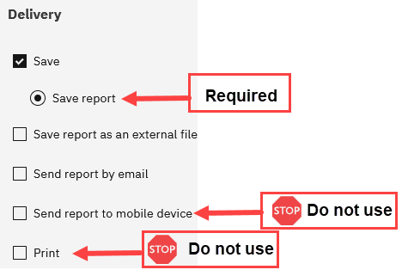
- Delivery: Save report is required!

- Save report as an external file - This requires a special setup. You must have made previous arrangements for this delivery type with the BICC.
- Send report by email - Email options are used to add additional users, update the subject and body, and verify report output delivery. Use the information below to build your scheduled report email.
- Send report to mobile device – This feature is not available.
- Print – This feature is not available.

- If you select Send report by email, select Edit details to add additional recipients, update the subject line, and add a message to the email. Scroll down to Attach the report if desired and/or Include a link.

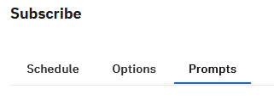
- Prompts can be changed at this level. The display indicates the current value of the saved prompts.
- The subscription saves the prompts from the initial run.
- Users can update or change the prompts that were initially selected.
- Users can also open their My schedules and subscriptions on the Personal Menu tab to change the subscriptions (which was discussed on page 13 of this manual).
  - My Schedules and Subscriptions is also the section to go to for other changes, maintenance, and deletions for your subscriptions.
- Cognos will save the selected values unless you change them.

- Select the Create button to create the new Subscription. You will receive a message at the top of the page that the Subscription was submitted successfully.

- Close the report.

Server Response Considerations
When a report is initiated, the server generates the final report. Depending upon the amount of data being returned and the design of the layout, some response times are longer than others. While the server is gathering the necessary data, this message appears:
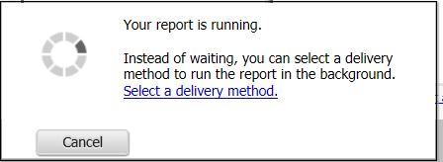

- When the server has gathered the requested data, the report will appear in the window in the format you requested (PDF, HTML, etc.).

If you need to cancel a report run:
- Do not close your browser (Chrome, Firefox, etc.) without letting the report complete OR cancelling it. If you neglect to do one of these actions, the server continues to gather data.
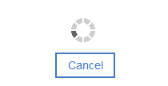
- If you need to cancel the report, use the Cancel button displayed when the report is running. This will properly stop the data gathering and clear the server.

Best Practice for Email Report Output
If using the email options for report distribution, please consider the following:

- report content (FERPA, HIPPA or other security restrictions)
- output type and size selected (Excel, PDF, HTML, etc.)
- report recipients’ access to Cognos

- The intended user does have a Cognos license, and the report contains sensitive or restricted information.

Suggested use for all users with a Cognos license
Include a link to the report | Use this option if you need the report to stay within Cognos for security reasons. Recipients receive the link and log into Cognos to review the output. Recipients must have access to Cognos to use this feature.
Include a link to the report | All output types can be used.
Include a link to the report | This is the most secure option for report delivery.

- The report does not contain sensitive or restricted information, and the user does not have a Cognos license.

Only use when data does not contain sensitive information
Attach the report | Use this if you want the output as an email attachment.
Attach the report | All output types can be attached. Cognos stores all types.
Attach the report | This option is less secure. Consider any sensitive report output before using this feature.

Logging Off
- Click the Personal Menu and Log out to log out of Cognos Analytics.
- Close the browser to end the session.

Troubleshooting
Please contact the BICC at bicc@purdue.edu with questions specific to this manual and any other Cognos questions or issues.

Feedback on this Document
Questions and feedback specific to this document are welcome. Please email your comments to bicc@purdue.edu.

APPENDIX A – Run Report in Background – If you HAVE WRITE access to the folder where the report is housed
Users can run reports in the background, allowing Cognos to process them asynchronously and notify the user by email once processing is complete. This approach typically reduces perceived runtime and enables users to continue working on other tasks instead of waiting for the report to render on their desktop.

Rules for using this feature:
- The user must have write access to the folder where the report is saved, commonly - My content or departmental folders.
- Users can include other recipients in the email.
- Using report links (default) is the optimal use for security purposes. Consider the report content before using the Attach the report output option.

Creating a Background Run Option

- Navigate to a report within a folder you have write access to save objects.
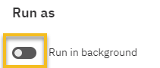
- background Right-click on the report and Select Run as.
- Select Run in background
- Click on the white circle in the gray cylinder.

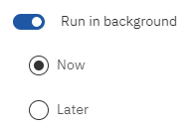
As Run in background is selected, the gray cylinder turns blue.

Selecting Later will open an option for date and one for time to set a future run.

- For this exercise, select Now, then
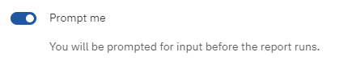
- Ensure Prompt me is checked.
- Select report output formats as desired (HTML, PDF, Excel, Excel Data, CSV, XML)

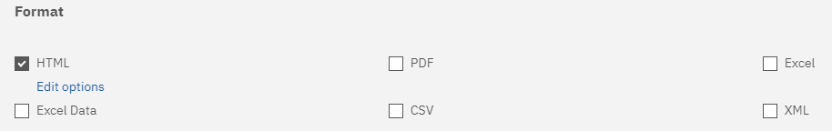

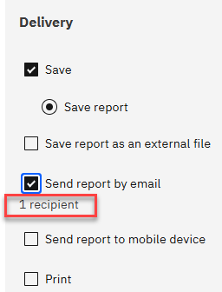
- Scroll down to the Delivery section.
- Click Send the report by email.

Notice there is currently 1 recipient.

- Click Edit details to the right
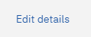

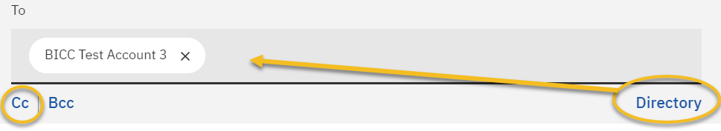
- As you can see, your email automatically appears in the To: block.
- To add other recipients within Purdue University, you can use the Directory to the right of your ID.

- Or begin typing another user’s FULL PURDUE EMAIL address in the Cc line. Note: User emails must be used here. Be sure to look them up before adding them to the list.
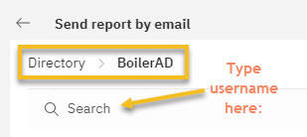
- To use the Directory, select BoilerAD and search for the recipient(s) username. Then hit Enter.

- Select the recipient(s) then click Add.

- After you receive your confirmation message, click Close to get back to the Delivery section.

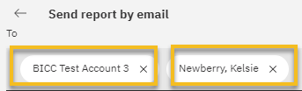
- Notice there are now two recipients.

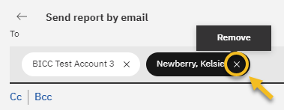
Click the to remove users from the To: block.

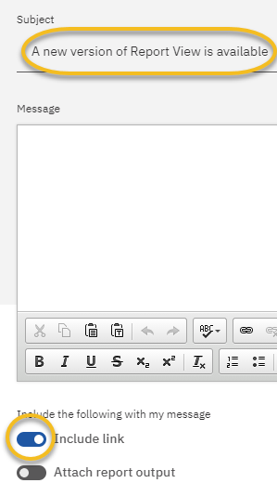
- You can edit the Subject line as well as add a message to the email, if desired.

- Scroll down and select Attach the report if you want the version included as an attachment to the email.

- (Please consider report content and security when using this feature). For this example, we are going to leave this box unchecked.

- Including a link is the most secure delivery option. Leave this box checked. Recipients must have a Cognos license to open the link in the email.

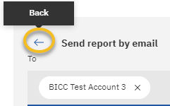

- Click on the arrow to get back to the Run as screen.

Users may see the Print report option checked. It MUST be unchecked for the report to run! Confirm the Print report is not checked (not a working feature).

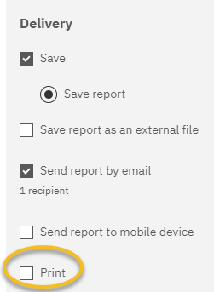
DO NOT CHECK Save report as an external file as this requires a special set up. You must have made previous arrangements for this delivery type with the BICC.

- Click RUN to return to the Run as form.

- Select your prompts
- Then select the Finish or Submit button.

APPENDIX B – Run Report in Background – If you do NOT have WRITE access to the folder where the report is housed
Users can run reports in the background, allowing Cognos to process them asynchronously and notify the user by email once processing is complete. This approach typically reduces perceived runtime and enables users to continue working on other tasks instead of waiting for the report to render on their desktop.

Rules for using this feature:
- Users do not have write access to the folder where the report is saved, commonly Standard Report folders, reports not in My content or departmental folders.
- Users can include other recipients in the email.
- Consider the report content before using this feature.

Follow the steps listed above in Appendix A

