Last Updated: 01/18/2023
This QRG outlines the steps on how to request a Cognos License for a position.
- Requests are initiated by the employee’s supervisor or business office. An employee cannot make the request for themselves.

- A position number is needed when completing the request. Position numbers are included in the employee’s profile or the Position Org Chart under My Company Info. https://performancemanager8.successfactors.com/sf/orgchart

- Student system such as Cognos can be requested here. However, other student system (i.e. Banner, Slate, etc.) roles are not requested through IDM. Steps on student system role requests are available here: https://www.purdue.edu/bicc/data/student/access.php

- The requestor must be on a VPN to connect to the SuccessFactors Employee Launchpad. For help setting up a VPN, contact the Purdue IT Customer Service Center (West Lafayette Campus), Information Services (PNW Campus), or Technology Services (PFW Campus).

Access Role Request via SuccessFactors
From the OneCampus portal (https://one.purdue.edu/), launch Employee Launchpad – SuccessFactors.  Log in using Career Account and BoilerKey. | 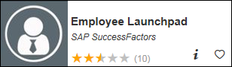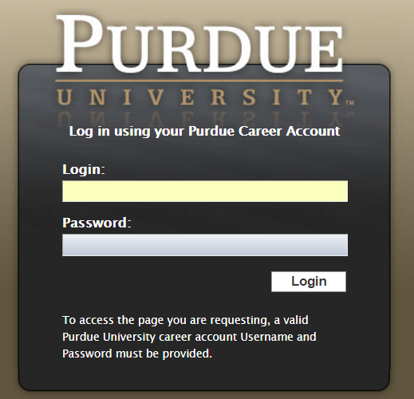
Under Organizational Updates on the SuccessFactors Home screen, click the Role Requests tile.
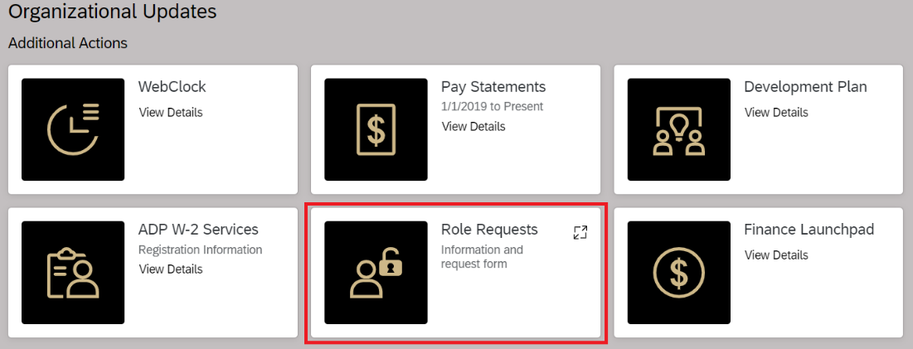

Click the IDM Role Request Form on the Role Requests pop up screen.
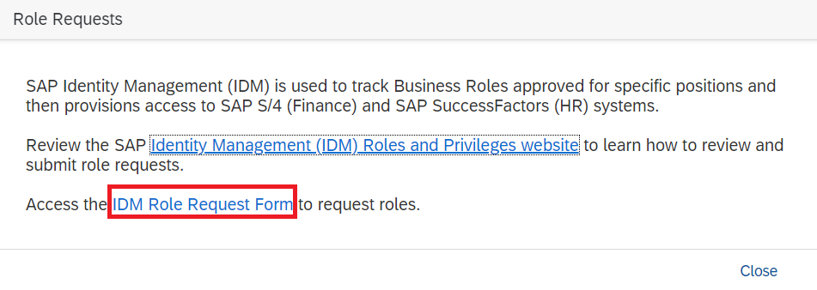
The request is displayed.  - Click Select (next to Position) to search for employee’s position.  To find the position number, see 2nd bullet above.  - Enter position number in the Find text entry.  When searching, use an asterisk (*) before and after the term to perform a more accurate search.  - Click Search | 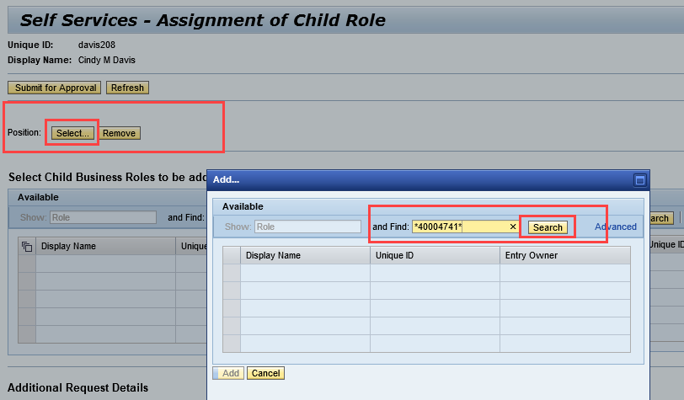
Click to select the desired position and click Add. If the position does not highlight, click the gray box to the left. | 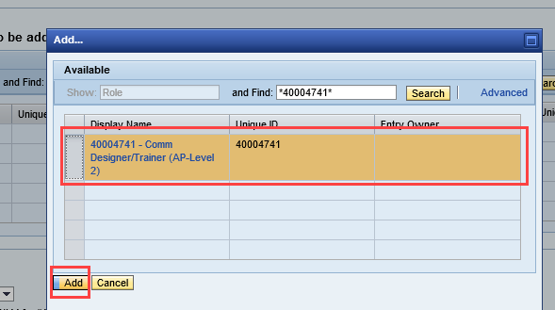
Select Add Role (or Remove Role, when applicable) from the Add or Remove menu under Additional Requests Details.  If restricting access to the role for a specific period of time, or delaying access to the role, enter Valid From and Valid To dates.  NOTE: The dates will apply to all roles on the request, so if one role should be limited, it should be requested separately. | 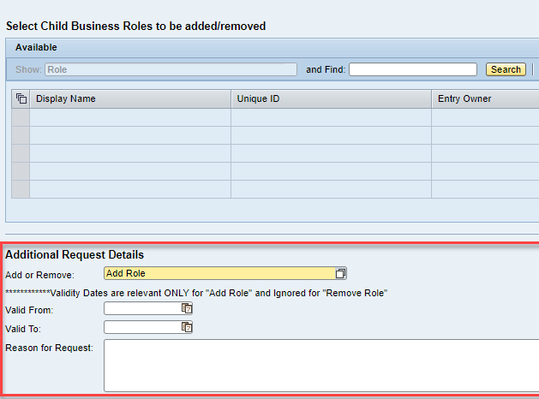
A Reason for Request should include:  - Name of the holder of the Position if applicable.  - Department  - If the position is grouped, note that here | 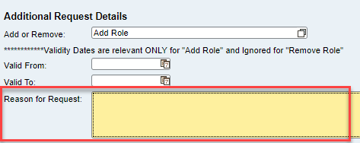
Locate business role by entering all or a portion of the business role display name in the search information in the Find text entry field.

When searching, use an asterisk (*) before and after the term to perform a more accurate search.

Cognos License:
*PWL Cognos License*

Cognos License with Authoring Capabilities (must request both):
*PWL Cognos License*
*PWL Cognos Author Capability*

Click Search.

- Click to select desired role from search results within the Available table.
- Click Add to move to Assigned table.
- Click Submit for Approval.

A message appears confirming the Child Role Assignment Request was Submitted. | 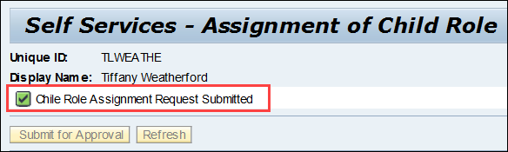

Who to Contact

If you have any questions regarding the Cognos License Request process, please contact bicc@purdue.edu.

Visit https://www.purdue.edu/bicc/tools/cognos/index.php for more information regarding Cognos

Email Notifications
If approved, the requester receives an email that the selected role has been added to the selected position. | 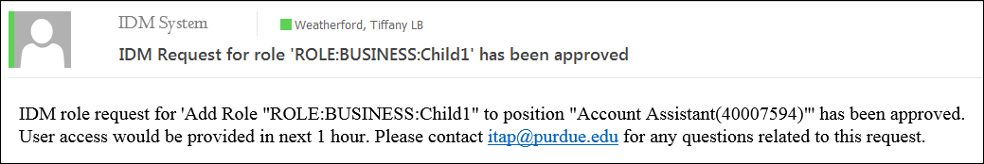
If denied, the requester receives an email that the selected role was denied | 