Network Analysis
Typically Taught in Fall

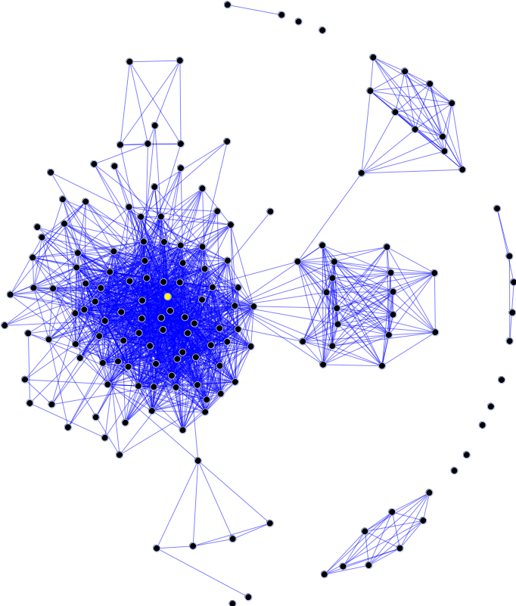

Natalie Lambert, Ph.D.
Brian Lamb School of Communication
Email: njlambert@purdue.edu
Office: BRNG 2160

Network Analysis
Syllabus

Course Description

Network analysis is a computational method focused on uncovering the patterns of relationships that arise from the interactions of people, groups, organizations, information entities, or any other social entity. Network analysis is an in-demand approach to data analysis because it identifies underlying structures within relational data, enabling scholars to, for example:

- Identify patterns of relationships within large-scale social media data
- Reveal power structures within a group or society
- Predict diffusion of information within a population
- Identify structural weaknesses within an information network
- Determine how the structure and functioning of an organization changes during a crisis
- Target a health campaign at influential individuals within an at-risk population
- Model the dynamic structuring of communication networks

The purpose of this course is to introduce students to basic network characteristics and analytic approaches. I will assign weekly readings so that you become familiar with seminal network science scholarship across many disciplines, including: communication, health sciences, sociology, political science, business, information sciences, and advertising. Students will learn how to analyze real-world datasets using social network analysis software, and will practice data analysis and interpretation in homework assignments. This seminar will culminate in a research paper in which students design and execute a small-scale network analysis study related to their individual research interests. No programming skills are required, and this course is structured to be applicable to students of any disciplinary background who have an interest in relational data. By the end of the semester you will have learned how to: 1) properly collect relational data, 2) analyze relational data using network analysis software, and 3) interpret network graphs within a data context.

Required Readings (Provided on Blackboard)

- Borgatti, S. P., Everett, M. G., & Johnson, J. C. (2013). Analyzing social networks. SAGE Publications Limited.

- Easley, D., & Kleinberg, J. (2010). Networks, crowds, and markets: Reasoning about a highly connected world. Cambridge University Press.
Available at: http://www.cs.cornell.edu/home/kleinber/networks-book/

- Articles and chapters that I make available to you on Blackboard.

Software Tools Introduced in this Course

AutoMap: Carley, K. (20001). AutoMap (version 3.0.10.41) [Computer software]. Pittsburg, PA: CASOS, Carnegie Mellon University. Available from http://www.casos.cs.cmu.edu/projects/automap/index.php

NetLogo: Wilensky, U. (1999). NetLogo. http://ccl.northwestern.edu/netlogo/. Center for Connected Learning and Computer-Based Modeling, Northwestern University, Evanston, IL.

NodeXL: Smith, M., Milic-Frayling, N., Shneiderman, B., Capone, T., Mendes Rodrigues, E., Leskovec, J., Dunne, C. (2012) Network Overview, Discovery and Exploration Add-In for Microsoft Excel. http://nodexl.codeplex.com

UCINET: Borgatti, S., Everett, M., & Freeman, L. (2012) UCINET 6.415 for Windows software for social network analysis. Harvard, MA: Analytic Technologies. http://www.analytictech.com, http://sites.google.com/site/ucinetsoftware

Grade Breakdown

Preparation (10%) and Participation (10%): 20%
Homework Assignments: 30%
Term Paper: 50%

Preparation and Participation: Students should attend and participate in every class meeting. Students are responsible for completing weekly readings (posted on Blackboard) prior to class. Prior to each class meeting you should also navigate to the class discussion board on Blackboard and post three discussion questions that are informed by the readings assigned for the class period. The questions should show that you have read the material and are engaging with network analysis concepts. Your questions MUST be posted prior to the start of class for you to receive credit. We will use these questions to spark discussion during class. Participation in class discussions is essential for learning how to apply and debate network principles. You should participate in class discussions frequently enough that I and your classmates know your name and your perspective about network analysis. I will notify students by September 30th if their level of in-class participation is insufficient for full credit.

Homework Assignments: You will be assigned three homework assignments over the semester. They are designed to give you experience applying network concepts and analyzing real-world data. You may work with one partner on these assignments, but both partners must write their names at the top of the assignment before turning it in. Turn in assignments to me via Blackboard by the due dates. Assignments turned in late will be penalized 33% off the graded score for every 24 hours they are late.

Term Paper: You will write a term paper for this class wherein you collect and analyze relational data using network or text analysis. The paper need not be more than 15 pages, but must detail and justify the choices you made during data collection, analysis, and interpretation of results. If you are collecting human subject data or wish to publish the results of this paper, you must secure IRB approval prior to data collection. You must receive written approval from me prior to data collection. Further instructions for the term paper will be provided.

Class Policies

You can expect me to give you feedback on any assignment, to respond to your emails within 24 hours except over the weekend and during holidays, and I will provide you with further learning resources when you are interested.

I expect all students to adhere to Purdue University’s academic code of conduct. As Purdue states:

Purdue University values intellectual integrity and the highest standards of academic conduct. To be prepared to meet societal needs as leaders and role models, students must be educated in an ethical learning environment that promotes a high standard of honor in scholastic work. Academic dishonesty undermines institutional integrity and threatens the academic fabric of Purdue University. Dishonesty is not an acceptable avenue to success. It diminishes the quality of a Purdue education, which is valued because of Purdue's high academic standards.

Purdue’s Academic Integrity Policy can be found here: https://www.purdue.edu/odos/academic-integrity/

The Purdue Student Conduct Statement can be found here:
http://www.purdue.edu/studentregulations/student_conduct/

Additionally, I expect students to be respectful of each other’s opinions during class discussions. This class is comprised of students from different departments and disciplines, which creates an exciting opportunity for us to learn about the different contexts in which network analysis can be applied. I expect students to listen to each other during discussion without interjection or interruption, and to make time during conversation for quieter students to contribute to the conversation.

Emergency Preparedness

- If the fire alarm sounds, we will immediately exit the building via a stairwell and gather together in the courtyard between UNIV and BRNG for a head count. We will not use the elevators.

- During a tornado or other storm event, we will shelter in place in the basement of BRNG.

- During a shooter event or other dangerous event, we will shelter in place in our classroom unless otherwise directed by campus authorities. You may wish to sign up for the campus emergent text alert system.

- For more information about emergencies, visit: www.purdue.edu/emergency_preparedness/

Class Schedule

The class schedule contains each class meeting topic and the due dates for homework and seminar paper deliverables. Be sure to remember that three discussion questions are due prior to each class meeting, and must be posted in the Blackboard discussion forum. The required readings are posted on Blackboard. I reserve the right to make changes to the schedule but will always notify you in advance of changes. No change will reduce the time allotted to you to complete an assignment.

I’m looking forward to a great semester!

Meeting | Topic | Deliverables
1 | Introduction to the class
2 | Introduction to network analysis
3 | The network analysis process; Basic network metrics: Node level, Part 1
4 | The network analysis process; Basic network metrics: Node level, Part 2
5 | Basic network metrics: Graph level, Part 1
6 | Basic network metrics: Graph level, Part 2
7 | LAB: UCInet, Part 1 | HW1 Out
8 | LAB: UCInet, Part 2
9 | Network Analysis Research: Design and Data Collection
10 | Network Analysis Research: Data Management and Visualization
11 | LAB: NodeXL, Part 1 | HW1 Due, HW 2 Out
12 | LAB: NodeXL, Part 2
13 | Models of Network Evolution
14 | Text Analysis
15 | LAB: Data Mining and Semantic Networks, Part 1
 | OCTOBER BREAK | HW 3 Out
16 | LAB: Data Mining and Semantic Networks, Part 2 | HW 2 Due
17 | Network Typologies
18 | LAB: Networks and Agent-based Modeling
19 | Grouping | Paper Proposal Due
20 | Network Roles and Diffusion | HW 3 Due
21 | Embedding, Part 1
22 | Embedding, Part 2
23 | Data Collection Practice
24 | Social Media Networks
25 | Networks as Social Entities (Communities and Organizations) | Data Collection Due
 | THANKSGIVING VACATION
26 | Network Theory | Draft of Paper Due
27 | Advanced Network Analysis
28 | Class Presentations
29 | Class Presentations
 |  | FINAL PAPER DUE

