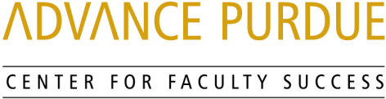

Faculty Advancement, Success and Tenure (FAST)

Agenda

September 10, 2019

9:00 – 9:10 Welcome, Introductions, and Orientation to FAST
9:10 – 9:50 “Things I wish I knew when I started”
Panel of Assistant Professors
Jason Cutter, Polytechnic Institute
Isaac Harris, College of Science
Adrie Koehler-Blair, College of Education
Sa Liu, College of Health and Human Sciences
Darcy Telenko, College of Agriculture
David Warsinger, College of Engineering
9:50 – 10:00 Questions and Answers
10:00 – 10:10 Small Group Discussion
10:10 – 10:15 Wrap- Up

Upcoming Events

October 15, 2019 Promotion and Tenure
STEW 278 Peter Hollenbeck, Vice Provost for Faculty Affairs and Professor of Biological Sciences, College of Science

Wei Hong, Associate Dean for Faculty Affairs and Professor of Languages and Cultures, College of Liberal Arts

www.purdue.edu/advance-purdue/center-for-faculty-success/fast.html

