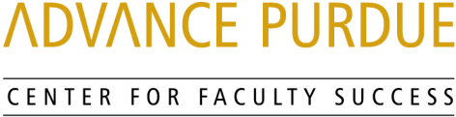

Faculty Advancement, Success and Tenure (FAST)

Agenda

January 24, 2017

9:00 Welcome, Introductions, and Orientation to FAST
9:00 – 9:50 Grant Writing
Sally Bond, Assistant Director, Research Development Services, Proposal Coordination, Office of the Executive Vice President for Research and Partnerships

Shelley MacDermid Wadsworth, Professor, Human Development and Family Studies, College of Health and Human Sciences and Director, Military Family Research Institute and Purdue’s Center for Families

9:50 – 10:00 Questions and Answers
10:00 – 10:10 Small Group Discussion
10:10 – 10:15 Wrap- Up

Upcoming Events

February 21, 2017 Purdue Work/Life Integration
STEW 202
Teresa Schnarr, Associate Director Human Resources Benefit Services and Paula Cheatham, Leave of Absence Coordinator, VP for Human Resources

Clint Chapple, Distinguished Professor Biochemistry, Agriculture

Lauren Ratcliff and Laura Farkas, Recruitment and Retention Consultants, VP for Human Resources, Michelle Jansen, Director of Concierge Program, College of Engineering, and Pam Nesbitt, Director Academic Human Resources, VP for Human Resources

http://www.purdue.edu/discoverypark/advance/cfs/FAST.php

