PURDUE UNIVERSITY APA THESIS HANDBOOK
This handbook is meant to accompany the official Purdue APA Thesis Template. Thoroughly read and follow the instructions, requirements, and examples within this formatting handbook prior to writing your thesis/dissertation.
When you are ready to write your thesis/dissertation, download the official Purdue APA Thesis Template from our website at https://www.purdue.edu/academics/ogsps/thesis/templates/. Please do not use a non-official template or attempt to recreate a template. You must use and work directly within the official template, use existing styles and settings in the template, and be careful not to override template format settings.
IMPORTANT NOTICE: Students interested in a obtaining a thesis/dissertation format review by the Thesis & Dissertation Office during the semester in which they intend to deposit should email grm@purdue.edu for more information. Format review deadlines vary for CAND 99200 (Degree Only) and CAND 99100 registrants, and students will need to ensure that they adhere to the correct format review deadline based on their candidacy registration. Please review the Graduation Dates and Deadlines calendar to locate semester format review deadlines. Please note that only one format review will be conducted per student each semester and it must occur prior to the designated format review deadline. Format review assistance will not be available after the candidate’s designated format review deadline has passed.
Theses/dissertations that DO NOT contain Export Administration Regulations (EAR), International Traffic in Arms Regulations (ITAR), Nuclear Regulatory Commission (NRC), Department of Energy (DOE), Covered Defense Information (CDI), and/or other controlled unclassified information (CUI) content should be emailed as an attachment to grm@purdue.edu for format review.
However, theses/dissertations that DO contain Export Administration Regulations (EAR), International Traffic in Arms Regulations (ITAR), Nuclear Regulatory Commission (NRC), Department of Energy (DOE), Covered Defense Information (CDI), and/or other controlled unclassified information (CUI) content cannot be shared electronically or virtually, and an in-person format review must be scheduled with the Thesis & Dissertation Office. If you have questions, please feel free to contact the Thesis & Dissertation Office at grm@purdue.edu.

TITLE OF THESIS
by
Your Name
A Choose Thesis Type
Submitted to the Faculty of Purdue University
In Partial Fulfillment of the Requirements for the degree of
Choose Degree

Choose Department
Choose Campus Location, Indiana
Choose Graduation Term
Formatting is already set on this page, so please do not change formatting. You will need to select the appropriate answer for the following dropdown boxes: Thesis (for Masters) or Dissertation (for PhD), Choose Degree, Choose Department, Choose Campus Location, and Choose Graduation Term. Note that on the template the Title page will not have a page number, so please do not add a page number to the title page.

THE PURDUE UNIVERSITY GRADUATE SCHOOL
STATEMENT OF COMMITTEE APPROVAL
Prof. John Doe, Choose committee member type
Choose Department
Prof. Jane Doe, Choose committee member type
Choose Department
Prof. James Doe, Member
Choose Department
Prof. Add or Delete Committee Member, Member
Choose Department
Prof. Add or Delete Committee Member, Member
Choose Department
Approved by:
Dr. Type the FORM 9 (ETAF) Thesis Form Head name here
The Statement of Committee Approval page comes after the cover Title page, and it must be page 2 of the document. You will need to complete thesis committee information on this page. Please list only your committee members’ primary department (do not include multiple departments). The name after “Approved by:” should match the name of the Thesis Form Head that is listed in your Form 9 ETAF (do not include a title and department name).

This page is OPTIONAL and is used for personal dedications, which should be very brief. This page is formatted using italicized font, 1.5 line spacing, and both centered horizontal and vertical alignment. If you do not intend to personally dedicate this document to anyone, delete this page.

ACKNOWLEDGMENTS
This page is OPTIONAL. The acknowledgements section is typically reserved for educational and professional dedication(s). You may also include funding information or any other copyright acknowledgments.
If you do not intend to professionally dedicate this document to anyone, delete this page.

TABLE OF CONTENTS
ACKNOWLEDGMENTS 3
TABLE OF CONTENTS 4
LIST OF TABLES 7
LIST OF FIGURES 8
LIST OF SCHEMES 9
LIST OF ABBREVIATIONS 10
LIST OF SYMBOLS 11
GLOSSARY 12
ABSTRACT 13
PURDUE APA THESIS FORMATTING HANDBOOK 14
Thesis/Dissertation styles 15
Controlled vs. Non-Controlled thesis or dissertation 16
Format review requirements 16
ADA Compliance 17
Table of Contents 17
Page Size 18
Page Layout 18
Page Margins 18
Page Breaks and Section Breaks 18
Paragraph Spaces 19
Page Numbers 19
Portrait Page Orientation Page Numbers 19
Landscape Page Orientation Page Numbers 19
Inserting Landscape Layout Page Numbers 20
Font and Line Spacing 22
Paragraph Indentations 22
Paragraph Alignment 22
Headings and Subheadings 22
Headings 22
Subheadings 23
Block quotes 24
Captions, Figures, and Tables 24
Captions 24
Figures and Schemes 26
Tables 28
Wide or Lengthy Figures and Tables 29
Figures, Tables, and Schemes on Pages by Themselves 30
Examples of formatted Figures, Tables, and Captions 32
Cross-References 39
Inserting a Cross-Reference 39
Broken Cross-References 40
Footnotes 40
Equations 42
Citation publication references 43
Permission to reuse content 44
References 44
Document Accessibility Statement 45
TYPE YOUR CHAPTER TITLE 46
First level subheading 46
Second level subheading 46
Third level subheading 46
Fourth level subheading 46
TYPE YOUR CHAPTER TITLE 47
First level subheading 47
Second level subheading 47
Third level subheading 47
Fourth level subheading 47
APPENDIX A. TYPE YOUR APPENDIX TITLE DESCRIPTION 48
Appendix equation information 48
Appendix figures, tables, caption information 48
APPENDIX B. TYPE YOUR APPENDIX TITLE DESCRIPTION 50
Appendix figures, tables, caption information 50
REFERENCES 52
PUBLICATIONS 54
VITA 55
This existing Table of Contents is already formatted for your use. Do not delete or manually modify this Table of Contents, and do not insert your own Table of Contents. After you have added your headings and subheadings throughout your document, right-click on the Table of Contents and select “update field,” then click “update entire field” and the entire table will update to reflect all your major headings, chapter title headings, subheadings, and page numbers. All major headings and chapter title headings should appear in all caps. All subheadings should appear in sentence case.

LIST OF TABLES
Table 1. This is an example of a formatted chapter table and caption with a note located underneath the table. 33
Table 2. This is an example of a wide formatted table and caption on a landscape-oriented page. 34
Table 3. This is an example of a formatted table and caption with a paragraph that immediately follows after the table. 35
Table 4. This is an example of a Purdue formatted table caption. 36
Table 5. This is an example of a Purdue formatted table caption. 38
This existing List of Tables is already formatted for your use (do not manually modify or delete the contents). After you have properly inserted captions for all tables throughout your chapters, right-click on the list above and select “update field”, then click “update entire field” and the entire list will update to reflect all your table captions. Please note that captions from an appendix at the back of your document will not populate in this list. If your document does not include any tables, delete this page.

LIST OF FIGURES
Figure 1. This is an example of a formatted chapter figure and caption. 32
Figure 2. This is an example of a formatted chapter figure and caption. 33
This existing List of Figures is already formatted for your use (do not manually modify or delete the contents). After you have properly inserted captions for all figures throughout your chapters, right-click on the list above and select “update field”, then click “update entire field” and the entire list will update to reflect all your figure captions. Please note that captions from an appendix at the back of your document will not populate in this list. If your document does not include any figures, delete this page.

LIST OF SCHEMES
Scheme 1. This is an example of a formatted chapter scheme and caption. 33
This existing List of Schemes is already formatted for your use (do not manually modify or delete the contents). After you have properly inserted captions for all schemes throughout your chapters, right-click on the list above and select “update field”, then click “update entire field” and the entire list will update to reflect all your scheme captions. Please note that captions from an appendix at the back of your document will not populate in this list. If your document does not include any schemes, delete this page.

LIST OF ABBREVIATIONS
3-D | Three dimensional
AI | Artificial intelligence
BIM | Building information modeling
CGA | Common Ground Alliance
DIRT | Damage Information Reporting Tool
EM | Electromagnetic
GNSS | Global Navigation Satellite System
LOL | Laugh out loud
PMU | Purdue Memorial Union
TBD | To be determined
The List of Abbreviations is formatted as a two-column table (with table borders turned off) using single line spacing, and both 4-point Before and 4-point After spacing. Contents must be sorted in alphabetical order. If you will not be including a List of Abbreviations, delete this page

LIST OF SYMBOLS
α | Alpha
β | Beta
$Σ$ | Sigma
Fe | Iron
H₂O | Water
k_{B} | Boltzmann constant
T_{½} | Half life
ω | Omega
The List of Symbols is formatted as a two-column table (with table borders turned off) using single line spacing, and both 4-point Before and 4-point After spacing. Contents must be sorted in alphabetical order. If you will not be including a List of Symbols, delete this page.

GLOSSARY
Academic Calendar - The calendar is the key dates and deadlines for Purdue. The academic year consist of two 16-week semesters. Summer session(s) may be one 4-week and one 8-week or two 6-week or other configurations as approved by the Provost's Office.
Bursar - The Bursar's Office is your one-stop shop for finding information on student tuition, viewing invoices, making payments and ensuring timely refunds. You can find valuable information regarding tuition, fees, rates and remissions, as well as our tuition calculator.
Commencement - A ceremony at which academic degrees or diplomas are awarded. Degrees are conferred three times a year.
Full-time Student - A student enrolled in 12 or more semester hours per semester. Students must be enrolled full-time to receive most type of institutionally funded financial assistance.
Registrar - The college or university official who is responsible for registering students and keeping their academic records, such as transcripts.
Transcript - An official record of courses completed, and grades earned by an individual student.
The Glossary is formatted as separate paragraphs with a 0.5” hanging indentation, 1.5- line spacing, justified alignment, and 12-point After spacing. Contents should be sorted in alphabetical order. If you will not be including a Glossary, delete this page.

ABSTRACT
An abstract is a concise summary of your thesis, which is REQUIRED to be included in this document. APA 7th edition guidelines state that an abstract should be limited to 250 words. Please summarize your research concisely and efficiently when writing the abstract.

PURDUE APA THESIS FORMATTING HANDBOOK
Students must follow the formatting noted in this handbook when writing their thesis or dissertation. This handbook provides formatting information and requirements. Please thoroughly read this handbook as it contains important formatting information and instructions.
The official Purdue APA Thesis Template you will use to write your thesis or dissertation within must be downloaded from our Templates website: https://www.purdue.edu/academics/ogsps/thesis/templates/. We suggest that you keep the Show/Hide tool (¶) found on the Home ribbon turned on when typing your thesis or dissertation so that you can see formatting within your document (spacing, page breaks, section breaks, etc.) You must use and work directly within the official Purdue APA Thesis Template and be careful not to override template format settings. Please do not try to copy or recreate the template as the format settings will not copy over. Use styles and settings in the template. Do not override template format settings, and do not import your own Table of Contents, lists, headings/subheadings, etc.
IMPORTANT NOTICE: Students are required to have the formatting in their dissertation or thesis reviewed by the Thesis & Dissertation Office during the semester in which the student intends to deposit. Format review deadlines vary for CAND 99100 and CAND 99200 registrants. Please review the Graduation Dates and Deadlines calendar to locate semester format review deadlines. We do not accept format review requests after the format review deadline passes, and we do not conduct secondary or subsequent reviews (only one format review per student each semester). Theses/dissertations that do not contain Export-Controlled/CUI content should be emailed to grm@purdue.edu for format review. However, if you have ITAR/Export-Controlled, Classified Unclassified Information (CUI), and/or Covered Defense Information (CDI) content in your thesis/dissertation, do not email or share your draft electronically. Instead, email grm@purdue.edu to notify the Thesis & Dissertation Office and to schedule an in-person format review.
If you have questions regarding information in this handbook, the template, or about formatting, feel free to contact us for help at grm@purdue.edu.

Thesis/Dissertation styles
Three types of thesis/dissertation styles are accepted by the Graduate School:
- Traditional.
- Article-Based
- Creative Work
Both an introduction chapter (which must be the first chapter) and a conclusion chapter (which must be the last chapter) are required in a thesis or dissertation.
A Creative Work style proposal must be submitted to the Thesis & Dissertation office for case-by-case approval review and must be approved before the student proceeds with using that style. If the proposal is not approved, the student will need to use either a Traditional or Article-Based style.
For information on thesis styles and requirements, please see section VII. Administering Graduate Degree Programs, subsection C. Thesis and Dissertation Policies, and subsection 6. Thesis and Dissertation Structures and Formatting in the Purdue University Catalog for Policies and Procedures for Administering Graduate Student Programs .

Controlled vs. Non-Controlled thesis or dissertation
Theses/dissertations containing content and data subject to Export Administration Regulations (EAR), International Traffic in Arms Regulations (ITAR), Nuclear Regulatory Commission (NRC), Department of Energy (DOE), Covered Defense Information (CDI), and/or other controlled unclassified information (CUI) must meet specific federal security requirements and cannot be handled or stored in standard university systems. Theses with these security designations and requirements must be specially handled and cannot be submitted to the Hammer Research Repository, cannot be submitted through iThenticate (or any other plagiarism checker), cannot be submitted through any type of AI tool, and cannot be shared electronically or virtually. We cannot determine whether you have controlled data in your document. It is up to you, your sponsors, sources, and/or committee to determine whether you have controlled content in your document.
If your thesis or dissertation does not contain or is not subject to any of the information mentioned above, then it will be treated as non-controlled.

Format review requirements
To help students better prepare for their final deposit submission, students planning to graduate with a doctoral degree or a thesis-option master’s degree may opt to have the formatting in their dissertation or thesis reviewed by the Thesis & Dissertation Office during the semester in which the student intends to deposit. Format review deadlines vary for CAND 99100 and CAND 99200 registrants. Please review the Graduation Dates and Deadlines calendar to locate semester format review deadlines based on your registered candidacy. We do not accept format review requests after the format review deadline passes, and we do not conduct secondary or subsequent reviews (only one format review per student each semester).
The formatting review method is based on whether the thesis or dissertation is controlled or non-controlled. Please see below:
- Non-controlled thesis/dissertation – Students with non-controlled theses/dissertations must email their draft as an attachment (not a link) to grm@purdue.edu. Students that used an official Purdue Standard Thesis Template or Purdue APA Thesis Template must send their draft as a Word document. Students that used the official Purdue Latex/Overleaf Thesis Template must send their draft as a PDF document.
- Controlled thesis/dissertation - DO NOT email your draft or share it electronically or virtually. Instead, an in-person format review is required to ensure that your document remains confidential and secure. To schedule an in-person controlled format review, please contact us at grm@purdue.edu.

ADA Compliance
For information and resources, please see all information found in the Accessibility Requirements for Theses and Dissertations section of the Thesis Requirements website.

Table of Contents
DO NOT delete or manually modify the existing Table of Contents, and DO NOT import your own Table of Contents. Instead, use the existing Table of Contents. Follow the instructions included at the end of the Table of Contents in this handbook on how to update its contents.

Page Size
An 8.5” x 11” page size must be used for the thesis or dissertation. The only exception to this page size requirement is for wide or lengthy tables/figures as described and shown in this handbook.

Page Layout
Portrait page orientation must be used for the thesis or dissertation. However, landscape page orientation can be used on certain pages that contain wide or lengthy tables/figures. Please refer to the Wide or Lengthy Figures and Tables section if this handbook for more information.

Page Margins
Both the Title Cover Page and the Statement of Committee Approval page both require a 1.5” top margin and 1.0” for the left, right, and bottom page margins. All other pages require 1.0” margins on all sides.

Page Breaks and Section Breaks
- Use “page breaks” (instead of paragraph spaces) at the end of a page when you need to start a new chapter or major section on the next page. DO NOT press Enter to move content to the next page.
- Use “section break (next page)” only if you need to put tables and figures on pages by themselves.
- DO NOT USE “section break (continuous)” as it can cause formatting issues.

Paragraph Spaces
To comply with ADA Accessibility requirements, DO NOT include extra paragraph spaces above/below headings, subheadings, figures, tables, schemes, captions, and equations; within tables, charts, or graphs; or to move content to a new page. Please turn on the “Show/Hide” tool found in the Paragraph section of the Home tool ribbon (see screenshot below) in your document so that you can clearly see any extra paragraph spaces that need removed.
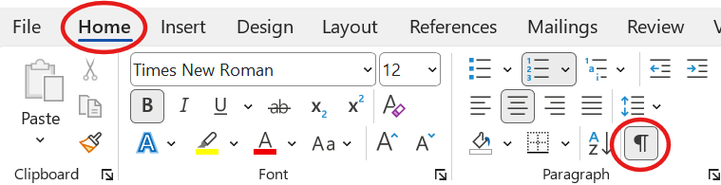

Page Numbers
Page numbers are already set up and formatted in this template. The title cover page should not be numbered. Page numbering begins on page 2 (the Statement of Committee Approval page). Page numbers must be numerical and in sequential order.

Portrait Page Orientation Page Numbers
Page numbers on portrait-oriented pages are located in the center of the page footer.

Landscape Page Orientation Page Numbers
Page numbers on landscape-oriented pages should be inserted in the center of the left page margin. Please see the next section for instructions on how to properly insert a page number in the left page margin.

Inserting Landscape Layout Page Numbers
Follow the steps listed below to properly insert a page number in the left page margin for landscape-oriented pages:
- On the landscape-oriented page, place the cursor in the page header, then click the “Link to Previous” button in the Navigation section of the Header and Footer tool ribbon to unlink the header. Repeat this process in the page footer.
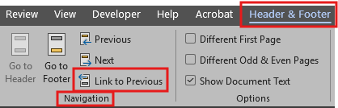
- Repeat the first step above in both the header and footer of the first portrait-oriented page that follows after the landscape-oriented page.
- Go back to the landscape-oriented page, place the cursor in the footer, click the Page Number drop-down in the Header and Footer tool ribbon, select Page Margins from the drop-down, and then select “Border, Left”. You may have to scroll down to find “Border, Left”. See the screenshots below. This will insert the page number in the center of the left page margin of the landscape page.
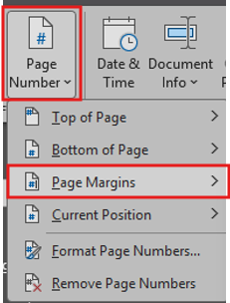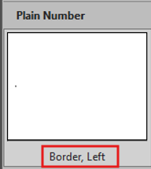
- While still in the footer, click on the page number that is now located in the left margin, then go to the Home tool ribbon and select center alignment, single line spacing, and “no border” from Paragraph tools. Next, click on Shape Format tool ribbon, click the Text Direction drop-down and select “Rotate all text 90º”.
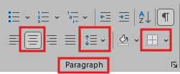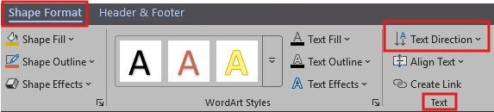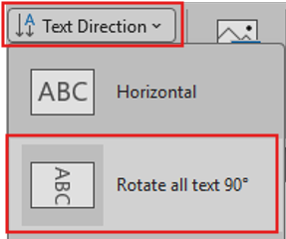
- Finally, delete the original existing page number located in the page footer. This page reflects a properly formatted landscape page number after all steps were completed.

Font and Line Spacing
The font style and size for sentences and paragraphs throughout your document should be Times New Roman with 12-point font size. Line spacing should be double line spacing.

Paragraph Indentations
Paragraphs must be indented to a 0.5” depth. To easily indent your paragraphs, use the “Indented Paragraph” style in the Styles section of the Home tool ribbon (see snapshot below).


Paragraph Alignment
All sentences, paragraphs, and lists should use left paragraph alignment.

Headings and Subheadings
Heading and subheading styles are set up, formatted, and included in the Styles section of the Home tool ribbon for you to use (see the snapshot below). Clicking on the drop-down button in Styles will expand the available list of styles for selection. DO NOT modify style settings.
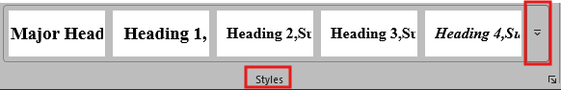

Headings
Headings should not be numbered, and they must be typed in ALL CAPS. Heading styles should be applied to your headings as described below and shown in this handbook.
- Major headings – The following major headings should use the “Major Headings” style from the Styles section of the Home tool ribbon (see the screenshot below): ACKNOWLEDGMENTS, TABLE OF CONTENTS, LIST OF TABLES, LIST OF FIGURES, LIST OF SCHEMES, LIST OF ABBREVIATIONS, LIST OF SYMBOLS, GLOSSARY, ABSTRACT, REFERENCES, and PUBLICATIONS.

- Chapter and Appendix title headings – All chapter and appendix title headings should use the “Heading 1” style from the Home tool ribbon (see the screenshot below).
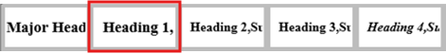

Subheadings
Subheadings should not be numbered, and they must be typed in sentence case. Subheading styles should not be skipped, and they must be used in sequential order. Subheading styles should be applied to your subheadings as described below and shown in this handbook.
- Chapter and Appendix subheadings – Chapter and appendix subheading styles in sequential order are “Heading 2, Subheading 1”, “Heading 3, Subheading 2”, “Heading 4, Subheading 3”, and “Heading 5, Subheading 4” as shown in the Styles section of the Home tool ribbon (see the screenshots below).
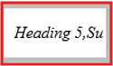

Block quotes
Block quotes are long quotes consisting of either 40 words or more, or 3 lines of text or more. Please see the block quote example below:
This is an example of a formatted block quote. The Block Quote style is set up to use a 0.5” left indentation, left alignment, and 0-point Before and 6-point After spacing. To easily format a block quote, put your cursor in the block quote and then click on the “Block Quote” style in the Styles gallery in the Home tool ribbon (see screenshot below). Do not use quotation marks for your block quote. The parenthetical citation should come after the closing punctuation mark.


Captions, Figures, and Tables

Captions
Captions must adhere to the following requirements:
- DO NOT insert captions into text boxes or within tables, figures, schemes, shapes, or graphics.
- Chapter captions: Captions for figures, tables, and schemes that are located within chapters (including supplemental content) must be properly inserted. Caption numbering should consist of only one number and be in sequential numerical order. For example, Figure 1, Figure 2, Figure 3, etc. To insert a caption, use the “Insert Caption” function in the References tool ribbon to properly insert figure, table, or scheme captions (you would select the caption type from the Label drop-down options) and ensure that the “include chapter number” box is unchecked in the “Numbering” section (see screenshots below). DO NOT manually modify caption labels/numbers after they are inserted. DO NOT add extra letters, numbers, or characters to caption numbers.
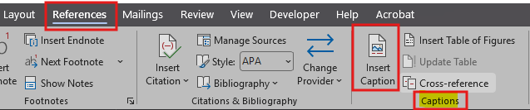
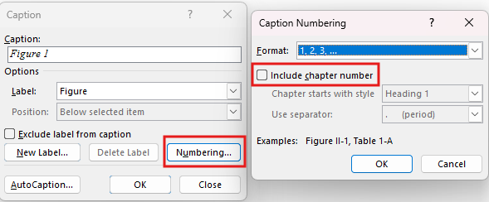
- Appendix captions: Appendix captions should only be used when they are when they are located in an appendix at the back of the document. Captions for appendix figures, tables, and schemes must be manually typed and NOT inserted. Caption numbering should consist of only two digits. The first digit represents the appendix letter, and the number represents its numerical sequence in the appendix. For example, Figure A1, Figure A2, Figure A3, etc. DO NOT add extra letters, numbers, or characters to caption numbers. See APPENDIX A. and APPENDIX B. for appendix caption examples.
- Caption formatting: See all steps listed below:
  - Apply the “Caption” style from the Styles gallery in the Home tool ribbon to all captions (see screenshots below).
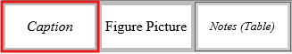
- To format a caption using a soft return after the “Caption” style is applied:
- Place the cursor immediately after the caption number, hold down the “Shift” button, and then press the “Enter” button.
- Next, highlight the caption label/number using the mouse cursor and manually change the font to bold and remove the italics. The caption description should remain in italicized text. See examples of formatted captions in this document.

Figures and Schemes
All figures and schemes (including shapes and graphics) must adhere to the following requirements:
- Figures, schemes, shapes, and graphics should not exceed the 1” page margins.
- Figures, schemes, shapes, charts, and graphics should appear either before or after sentences, paragraphs, lists, equations, etc. (they should not interrupt or break them up).
- “Wrap Text” settings for figure pictures, schemes, shapes, and graphics must be “In Line with Text” (see screenshot below).
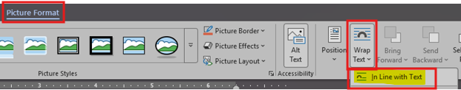
- To reduce document file size, compress figure pictures by clicking on the Compress Pictures button in Picture Format tools, which will open a pop-up box of resolution options for you to select from (see the screenshot below).
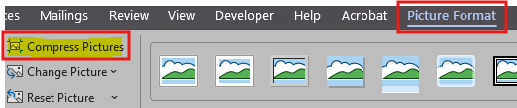
- Single line spacing, center paragraph alignment, and 24-point Before spacing must be applied to each figure picture, shape, and graphic. To easily format spacing and alignment for figure pictures, shapes, and graphics, please apply the “Figure Picture” style to each of them from the Styles section of the Home tool ribbon (see screenshot below).
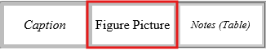
- For ADA compliance, Alt Text must be included for each figure picture, scheme, shape, chart, and graphic. To add Alt Text, put your cursor on each item and then click on the Alt Text button in Picture Format tools (see screenshot below), which will open a description box for you to type a detailed brief description within (approximately 1-2 sentences).
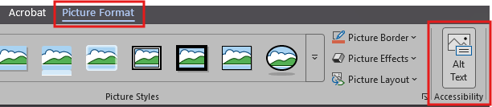

Tables
All tables must adhere to the following requirements:
- Tables should not exceed the 1” page margins.
- Tables should appear either before or after sentences, paragraphs, lists, equations, etc. (they should not interrupt or break them up).
- Font size for table contents may be 8-point, 9-point, or 10-point (no more, no less).
- Single line spacing must be used for contents inside of tables.
- Table notes: To easily format notes located underneath figure pictures, apply the “Notes (Table)” style from the Styles section of the Home tool ribbon (see screenshot below).
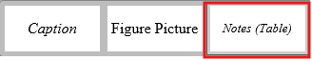
- There should be 24-point spacing after a table when a sentence, paragraph, list, or equation immediately follows a table. DO NOT use paragraph spaces to achieve this. Instead, apply 24-point Before spacing to the sentence, paragraph, list, or equation to space it away from the table. Spacing can be adjusted in the Paragraph section of the Layout tool ribbon. For an example, see the paragraph immediately following Table 3 in this handbook.
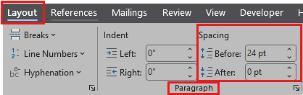
- Each table should use “Center” alignment and text wrapping set to “None” in the Properties section of Table Layout tools (see both screenshots below).
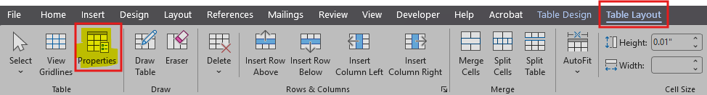
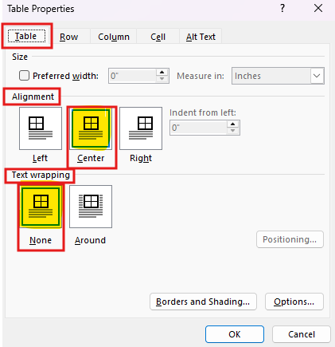

Wide or Lengthy Figures and Tables
Figures, tables, and schemes (with captions and notes) that are too wide or too lengthy to fit entirely on the same page should be placed on a page by themselves so that they do fit on the same page without carrying over to another page. To accommodate length and/or width on those pages, you may increase the page size to either 8.5” x 14” or 11” x 17” and use either portrait or landscape page orientation. Refer to the Figures, Tables, and Schemes on Pages by Themselves section for additional information and instruction steps.
If wide and/or lengthy tables, figures, and schemes (with captions and notes) still do not fit on the same page even after using the page size options mentioned in the previous paragraph, then content will then be allowed to carry over to the next page. A manually typed caption leader must be included above the carryover content to indicate continuance (for example: Table 4. continued).

Figures, Tables, and Schemes on Pages by Themselves
Figures, tables, and schemes on pages by themselves (without any headings, subheadings, or paragraph text) must be centered vertically on the page. Do not use paragraph spaces to achieve this result. Instead, follow the steps below:
- Add a “section break (next page)” at the end of the page that precedes the page to be centered.
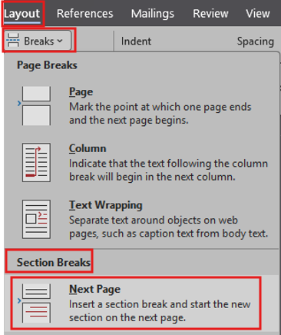
- Add a “section break (next page)” at the end of the page that will be centered vertically.
- After both section breaks are in place, put your cursor in the page to be centered and then click the corner carrot to open Page Setup in the Layout tool ribbon. Next, click on the Layout tab of the pop-up box and change the Vertical Alignment dropdown selection to “Center” (see both screenshots below).
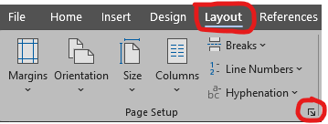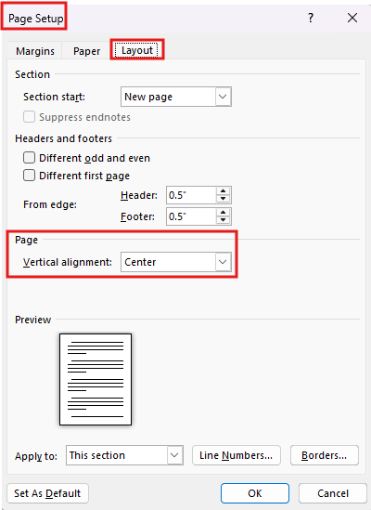
- If you need to use landscape page orientation for wide or lengthy tables/figures located on pages by themselves, you can select “Landscape” from the “Orientation” dropdown located in the Page Setup section of the Layout tool ribbon (see screenshots below).
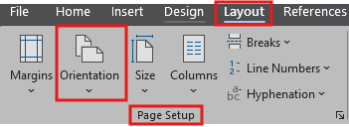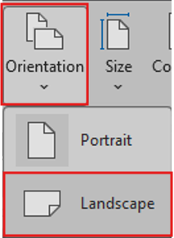

Examples of formatted Figures, Tables, and Captions
Figure 1.
This is an example of a formatted chapter figure and caption.
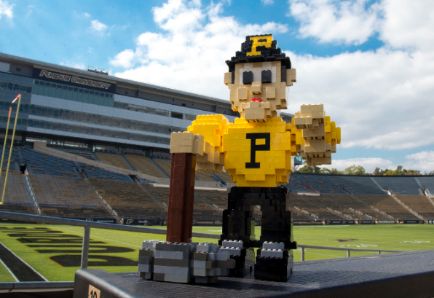

Scheme 1.
This is an example of a formatted chapter scheme and caption.
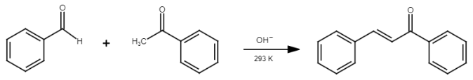
Figure 2.
This is an example of a formatted chapter figure and caption.

Table 1.
This is an example of a formatted chapter table and caption with a note located underneath the table.
Purdue University Colors and Mascots
Gold and Black | Purdue’s colors
Purdue Pete | Purdue’s sports mascot
Boilermaker Special | Purdue’s official mascot – a locomotive
Big Bass Drum | Drum used by Purdue’s band members.
NOTE: This is an example of a table that includes a note underneath it.

Table 2.
This is an example of a wide formatted table and caption on a landscape-oriented page.
Example | Example | Example | Example
Example | Example text | Example text | Example text, example text, example text, example text, example text, example text, example text, example text, example text, example text, example text, example text, example text, example text, example text, example text, example text, example text, example text.
Example | Example text | Example text | Example text, example text, example text, example text, example text, example text, example text, example text, example text, example text, example text, example text, example text, example text, example text, example text, example text, example text, example text.
Example | Example text | Example text | Example text, example text, example text, example text, example text, example text, example text, example text, example text, example text, example text, example text, example text, example text, example text, example text, example text, example text, example text.
Example | Example text | Example text | Example text, example text, example text, example text, example text, example text, example text, example text, example text, example text, example text, example text, example text, example text, example text, example text, example text, example text, example text.
Example | Example text | Example text | Example text, example text, example text, example text, example text, example text, example text, example text, example text, example text, example text, example text, example text, example text, example text, example text, example text, example text, example text.
Example | Example text | Example text | Example text, example text, example text, example text, example text, example text, example text, example text, example text, example text, example text, example text, example text, example text, example text, example text, example text, example text, example text.
Example | Example text | Example text | Example text, example text, example text, example text, example text, example text, example text, example text, example text, example text, example text, example text, example text, example text, example text, example text, example text, example text, example text.

Table 3.
This is an example of a formatted table and caption with a paragraph that immediately follows after the table.
Examples of Graduate Degree Programs at Purdue University
Aeronautics and Astronautics | Health Sciences | Mechanical Engineering | Sociology
Computer Science | Industrial Engineering | Nuclear Engineering | Statistics
Economics | Linguistics | Physics | Technology
Forestry and Natural Resources | Management | Psychological Sciences | Veterinary Clinical Sciences
There should be 24-point spacing after a table when a sentence, paragraph, list, or equation immediately follows a table. DO NOT use paragraph spaces to achieve this. Instead, apply 24-point Before spacing to the sentence, paragraph, list, or equation to space it away from the table above it. You’ll also notice that content on this page is not centered vertically, which is because this paragraph is on this page. Tables, figures, and schemes should only be centered vertically when they are on pages by themselves without headings, subheadings, sentences, paragraphs, or other types of text.

Table 4.
This is an example of a Purdue formatted table caption.
Example | Example | Example | Example
Example | Example text | Example text | Example text, example text, example text, example text, example text, example text, example text, example text, example text, example text, example text, example text, example text, example text, example text, example text, example text, example text, example text.
Example | Example text | Example text | Example text, example text, example text, example text, example text, example text, example text, example text, example text, example text, example text, example text, example text, example text, example text, example text, example text, example text, example text.
Example | Example text | Example text | Example text, example text, example text, example text, example text, example text, example text, example text, example text, example text, example text, example text, example text, example text, example text, example text, example text, example text, example text.
Example | Example text | Example text | Example text, example text, example text, example text, example text, example text, example text, example text, example text, example text, example text, example text, example text, example text, example text, example text, example text, example text, example text.
Example | Example text | Example text | Example text, example text, example text, example text, example text, example text, example text, example text, example text, example text, example text, example text, example text, example text, example text, example text, example text, example text, example text.
Example | Example text | Example text | Example text, example text, example text, example text, example text, example text, example text, example text, example text, example text, example text, example text, example text, example text, example text, example text, example text, example text, example text.
Example | Example text | Example text | Example text, example text, example text, example text, example text, example text, example text, example text, example text, example text, example text, example text, example text, example text, example text, example text, example text, example text, example text.
Example | Example text | Example text | Example text, example text, example text, example text, example text, example text, example text, example text, example text, example text, example text, example text, example text, example text, example text, example text, example text, example text, example text.
Example | Example text | Example text | Example text, example text, example text, example text, example text, example text, example text, example text, example text, example text, example text, example text, example text, example text, example text, example text, example text, example text, example text.
Example | Example text | Example text | Example text, example text, example text, example text, example text, example text, example text, example text, example text, example text, example text, example text, example text, example text, example text, example text, example text, example text, example text.
Example | Example text | Example text | Example text, example text, example text, example text, example text, example text, example text, example text, example text, example text, example text, example text, example text, example text, example text, example text, example text, example text, example text.

Table 4. continued
Example | Example | Example | Example
Example | Example text | Example text | Example text, example text, example text, example text, example text, example text, example text, example text, example text, example text, example text, example text, example text, example text, example text, example text, example text, example text, example text.
Example | Example text | Example text | Example text, example text, example text, example text, example text, example text, example text, example text, example text, example text, example text, example text, example text, example text, example text, example text, example text, example text, example text.
Example | Example text | Example text | Example text, example text, example text, example text, example text, example text, example text, example text, example text, example text, example text, example text, example text, example text, example text, example text, example text, example text, example text.
Example | Example text | Example text | Example text, example text, example text, example text, example text, example text, example text, example text, example text, example text, example text, example text, example text, example text, example text, example text, example text, example text, example text.
Example | Example text | Example text | Example text, example text, example text, example text, example text, example text, example text, example text, example text, example text, example text, example text, example text, example text, example text, example text, example text, example text, example text.
Example | Example text | Example text | Example text, example text, example text, example text, example text, example text, example text, example text, example text, example text, example text, example text, example text, example text, example text, example text, example text, example text, example text.
Example | Example text | Example text | Example text, example text, example text, example text, example text, example text, example text, example text, example text, example text, example text, example text, example text, example text, example text, example text, example text, example text, example text.
Example | Example text | Example text | Example text, example text, example text, example text, example text, example text, example text, example text, example text, example text, example text, example text, example text, example text, example text, example text, example text, example text, example text.
Example | Example text | Example text | Example text, example text, example text, example text, example text, example text, example text, example text, example text, example text, example text, example text, example text, example text, example text, example text, example text, example text, example text.
Example | Example text | Example text | Example text, example text, example text, example text, example text, example text, example text, example text, example text, example text, example text, example text, example text, example text, example text, example text, example text, example text, example text.
Example | Example text | Example text | Example text, example text, example text, example text, example text, example text, example text, example text, example text, example text, example text, example text, example text, example text, example text, example text, example text, example text, example text.

Table 5.
This is an example of a Purdue formatted table caption.
Example | Example | Example | Example
Example | Example text, example text, example text, example text, example text, example text, example text, example text, example text, example text, example text, example text, example text, example text, example text, example text, example text, example text, example text. | Example text | Example text, example text, example text, example text, example text, example text, example text, example text, example text, example text, example text, example text, example text, example text, example text, example text, example text, example text, example text.
Example | Example text, example text, example text, example text, example text, example text, example text, example text, example text, example text, example text, example text, example text, example text, example text, example text, example text, example text, example text. | Example text | Example text, example text, example text, example text, example text, example text, example text, example text, example text, example text, example text, example text, example text, example text, example text, example text, example text, example text, example text.
Example | Example text, example text, example text, example text, example text, example text, example text, example text, example text, example text, example text, example text, example text, example text, example text, example text, example text, example text, example text. | Example text | Example text, example text, example text, example text, example text, example text, example text, example text, example text, example text, example text, example text, example text, example text, example text, example text, example text, example text, example text.
Example | Example text, example text, example text, example text, example text, example text, example text, example text, example text, example text, example text, example text, example text, example text, example text, example text, example text, example text, example text. | Example text | Example text, example text, example text, example text, example text, example text, example text, example text, example text, example text, example text, example text, example text, example text, example text, example text, example text, example text, example text.
Example | Example text, example text, example text, example text, example text, example text, example text, example text, example text, example text, example text, example text, example text, example text, example text, example text, example text, example text, example text. | Example text | Example text, example text, example text, example text, example text, example text, example text, example text, example text, example text, example text, example text, example text, example text, example text, example text, example text, example text, example text.
Example | Example text, example text, example text, example text, example text, example text, example text, example text, example text, example text, example text, example text, example text, example text, example text, example text, example text, example text, example text. | Example text | Example text, example text, example text, example text, example text, example text, example text, example text, example text, example text, example text, example text, example text, example text, example text, example text, example text, example text, example text.
Example | Example text, example text, example text, example text, example text, example text, example text, example text, example text, example text, example text, example text, example text, example text, example text, example text, example text, example text, example text. | Example text | Example text, example text, example text, example text, example text, example text, example text, example text, example text, example text, example text, example text, example text, example text, example text, example text, example text, example text, example text.
Example | Example text, example text, example text, example text, example text, example text, example text, example text, example text, example text, example text, example text, example text, example text, example text, example text, example text, example text, example text. | Example text | Example text, example text, example text, example text, example text, example text, example text, example text, example text, example text, example text, example text, example text, example text, example text, example text, example text, example text, example text.
Example | Example text, example text, example text, example text, example text, example text, example text, example text, example text, example text, example text, example text, example text, example text, example text, example text, example text, example text, example text. | Example text | Example text, example text, example text, example text, example text, example text, example text, example text, example text, example text, example text, example text, example text, example text, example text, example text, example text, example text, example text.
Example | Example text, example text, example text, example text, example text, example text, example text, example text, example text, example text, example text, example text, example text, example text, example text, example text, example text, example text, example text. | Example text | Example text, example text, example text, example text, example text, example text, example text, example text, example text, example text, example text, example text, example text, example text, example text, example text, example text, example text, example text.
Example | Example text, example text, example text, example text, example text, example text, example text, example text, example text, example text, example text, example text, example text, example text, example text, example text, example text, example text, example text. | Example text | Example text, example text, example text, example text, example text, example text, example text, example text, example text, example text, example text, example text, example text, example text, example text, example text, example text, example text, example text.
Notes should be located underneath the table using a 10-point font size, italicized font, single line spacing, left alignment, 6-point Before spacing, and 24-point After spacing.

Cross-References
Cross-references for tables, figures, schemes, and references may either be manually typed or inserted within your paragraph text.

Inserting a Cross-Reference
To insert a caption cross-reference:
- Put your cursor in the text where you want to insert a cross-reference, click on the References tool ribbon, click on “Cross-Reference” (located in the Captions section), and then a box will open for you to select your cross-reference options.
- Select the correct “Reference Type” (figure, table, scheme, or numbered item), select the correct “Insert Reference To” option (“only label and number” or “page number”), select the correct caption from the “For which caption” section, click the “Insert” button, and then click the “Cancel” button when done.
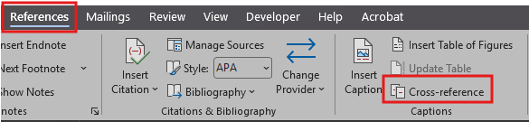
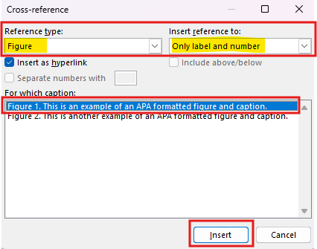

Broken Cross-References
If you do insert cross-references, you must ensure that they do not “break.” Cross-references usually break if you make changes to the source (such as captions or references) after the cross-reference was inserted. Microsoft Word does not identify broken cross-references until after you save a document to PDF. Broken cross-references will appear in the PDF document but may not be visible in the Word document. For this reason, you should save your Word document to PDF and then carefully comb through the PDF to locate broken cross-references so that you know where to fix them in the Word document.
Broken cross-references appear in different ways. For example, it may convert the cross-reference to appear as Error! Reference source not found. and/or broken cross-references may appear as formatting issues at the location of the broken cross-reference (such as automatically added section breaks or page breaks, added hard returns, false new paragraphs, insertion of tables/figures at the location of the broken cross-reference, altered paragraph formatting, etc.). To fix broken cross-references, first delete them and then either re-insert them or manually type them.

Footnotes
Footnotes may be used for brief, concise explanatory and/or bibliographic notes. Do not use footnotes for extensive or digressive notes, block quotes, or lengthy explanations or clarifications. Do not use footnotes in headings or subheadings. To insert a footnote, use the following steps:
- Place the cursor in the paragraph sentence where you wish to insert the footnote reference and click on the Insert Footnote function in the References tool ribbon (see snapshot below).
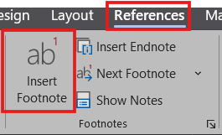
- Click on the corner arrow in the Footnotes section of the References tool ribbon to open the footnote formatting options box. Footnotes must be located at the bottom of the page, be numerical (do not use Roman numerals, symbols, etc.), and they must be continuous throughout your document. Footnote numbering should not start over at “1” in each chapter or section (see the settings snapshot below).
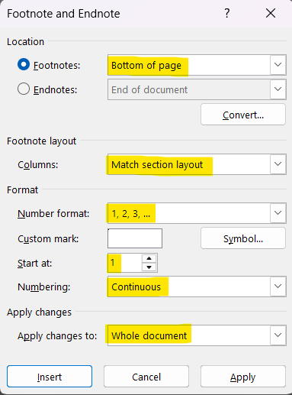
- Footnotes should be formatted using Times New Roman 10-point font, justified alignment, a 0.5” paragraph indentation, 0-point Before, 3-point After spacing, and paragraph settings of both “widow/orphan control” and “keep lines together”. Footnotes begin and end on the same page and should never carry over from one page to the next. To easily format footnotes, apply the “Footnotes” style to them from the Styles gallery in the Home tool ribbon (see snapshot below).


Equations
- Chapter equations: Chapter equations should be numbered using one numerical digit and be in sequential order. The first digit of the equation number represents the chapter number, and the second digit represents the equation number in the chapter. Equation numbers should be encased in parentheses.
- Appendix equations: Equations located in an appendix at the back of the document should be numbered using two digits consisting of one letter and one number and be in sequential order. The first digit of the equation number is the appendix letter, and the second digit represents the equation number in the appendix. Equation numbers should be encased in parentheses.
To format an equation, place the cursor on the outside of the left parenthesis, apply the “Equation” style from the Styles gallery in the Home tool ribbon (see snapshot below), and then press the Tab key until the equation is centered on the page (the equation number will remain aligned to the right margin).

An example of a formatted chapter equation is shown below:
$f\left(x\right)=a_{0}+\sum_{n=1}^{∞}{\left(a_{n}\cos{\frac{nπx}{L}}+b_{n}\sin{\frac{nπx}{L}}\right)}$ (1)
An example of a formatted appendix equation (using appendix A. at the back of this document as an example) is shown below:
[-b ± √(b² - 4ac)]/2a (A1)

Citation publication references
See below for clarification on the information that must be included when reusing your published content (as an author or co-author) in your document:
              - If your chapter has been submitted to a publisher for review, but it is not published yet, then you will need to include an unindented publication citation reference (using single line spacing) underneath the chapter title heading. An example of this is shown underneath the chapter 2 heading in this handbook.
              - If part or all of your chapter consists of published information, then you must include 1) an unindented publication citation reference (using single line spacing) underneath the chapter title heading, 2) short cross-references in the areas where publication information was used, and 3) you will need also need to include the published article as a full reference in the references section of your document. A publication citation reference example can be found underneath the chapter 3 heading in this handbook.
              - When you are reusing only a few items (such as a table, figure, and/or paragraph) from a published journal article, a publication citation reference underneath the chapter title heading is not required. Instead, you should include a short cross-reference in the caption(s) and/or paragraph(s), and you will need also need to include the published article as a full reference in the references section of your document.

Permission to reuse content
When you are using content in your document that you have authored or co-authored (whether submitted for publication or already published), you need to make sure that you have documented the following below:
- Published article – You must obtain written permission from the publisher to reuse your published article content and retain the written permission for your records. Some publishers also require specific language to be included in your thesis/dissertation.
- Submitted article – You must find out from the publisher whether they require you to obtain written permission from them to reuse your article while it is in review or pending status.
- Unpublished article – If you co-authored an article that has not been published or submitted for publication, you must obtain written permission from the co-authors to reuse content and retain the written permission for your records.

References
You can either include a reference section as a subchapter at the end of each chapter, OR you can list all references in the separate reference section at the back of the document. Please use only ONE method; do not use both methods.
References should not be numbered, and they must be listed in alphabetical order. References should be formatted using double line spacing, left alignment, a 0.5” hanging indentation, 0-point Before spacing, 0-point After spacing, and both “widow/orphan control” and “keep lines together” from paragraph settings. A website hyperlink must be included in all references. To easily format references, apply the “References” style to them from the Styles gallery in the Home tool ribbon (see snapshot below).
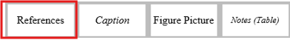
See the REFERENCES section in the back matter of this document for formatted examples.

Document Accessibility Statement
This section is for your information only. According to Purdue University Policy, Electronic Information, Communication and Technology Accessibility (S-5): As a public university and federal contractor, Purdue University is required to adhere to Sections 504 and 508 of the Rehabilitation Act of 1973 and Title II of the Americans with Disabilities Act. This standard specifies the means by which the University ensures compliance with these laws.
Please read all the information pertaining to Accessibility Requirements for Theses and Dissertations found in the Thesis and Dissertation Policies and Practices website, which includes helpful resources. You may also use Microsoft’s accessibility guide to help create an accessible document. Please note that your thesis/dissertation must be ADA compliant before you deposit.
When you initiate Form 9 Electronic Thesis Acceptance Form from your online Plan of Study, you will need to certify that in the preparation of this thesis/dissertation, you have to the best of your ability, created an accessible document that is in compliance with sections 504 and 508 of the Rehabilitation Act of 1973 and Title II of the Americans with Disabilities Act.

TYPE YOUR CHAPTER TITLE
Content in this chapter has been submitted for review and is pending publication with Psychology of Popular Media Culture:
Grady, J. S., Her, M., Moreno, G., Perez, C., & Yelinek, J. (2024). Emotions in storybooks: A comparison of storybooks that represent ethnic and racial groups in the United States. Psychology of Popular Media Culture. Manuscript submitted for publication (in review, pending).
All four subheading style levels are listed below in sequential order.

First level subheading
Paragraph starts here.

Second level subheading
Paragraph starts here.

Third level subheading
Paragraph starts here.

Fourth level subheading
Paragraph starts here.

TYPE YOUR CHAPTER TITLE
Content in this chapter is published in Psychology of Popular Media Culture and is reprinted with permission:
Grady, J. S., Her, M., Moreno, G., Perez, C., & Yelinek, J. (2019). Emotions in storybooks: A comparison of storybooks that represent ethnic and racial groups in the United States. Psychology of Popular Media Culture, 8(3), 207–217. https://doi.org/10.1037/ppm0000185

First level subheading
Paragraph begins here.

Second level subheading
Paragraph begins here.

Third level subheading
Paragraph begins here.

Fourth level subheading
Paragraph begins here.

APPENDIX A. TYPE YOUR APPENDIX TITLE DESCRIPTION
An appendix section is OPTIONAL and is not required. If your document will not include an appendix, delete this page. Some students use an appendix for survey information, data collection information, supplemental data, etc.

Appendix equation information
As previously mentioned in the Equations section of this handbook, equations located in an appendix at the back of the document should be numbered using two digits consisting of one letter and one number and be in sequential order. The first digit of the equation number is the appendix letter, and the second digit represents the equation number in the appendix. See the formatted appendix equation below:
[-b ± √(b² - 4ac)]/2a (A1)

Appendix figures, tables, caption information
Please note that if figures, tables, schemes, and equations are included in an appendix section at the back of your document, the caption numbering and equation numbering is different than those located in chapters. In an appendix in the back of your document, the caption number must begin with the appendix letter. Additionally, captions must be manually typed instead of inserted. For this reason, appendix figures, tables, and schemes will not be included in the List of Figures, List of Tables, and List of Schemes sections.
Refer to the Captions, Figures, and Tables section of this handbook for formatting information and requirements. Please see the examples on the next page.

Figure A1.
This is an example of a formatted appendix figure and caption.

Figure A2.
This is an example of a formatted appendix figure and caption.

Table A1.
This is an example of a formatted appendix table and caption.
Year | Fun Facts
1886 | Purdue University Band established
1891 | Boilermakers nickname adopted
1912 | The Purdue fight song, “Hail Purdue,” is written
1975 | Purdue alum, Ruth Siems, invents and patents Stove Top Stuffing

APPENDIX B. TYPE YOUR APPENDIX TITLE DESCRIPTION
An appendix section is OPTIONAL and is not required. If your document will not include an appendix, delete this page. Some students use an appendix for survey information, data collection information, supplemental data, etc.

Appendix figures, tables, caption information
Please note that if figures, tables, schemes, and equations are included in an appendix section at the back of your document, the caption numbering and equation numbering is different than those located in chapters. In an appendix in the back of your document, the caption number must begin with the appendix letter. Additionally, captions must be manually typed instead of inserted. For this reason, appendix figures, tables, and schemes will not be included in the List of Figures, List of Tables, and List of Schemes sections.
Refer to the Captions, Figures, and Tables section of this handbook for formatting information and requirements. Please see the examples below and on the next page.
Table B1.
This is an example of a formatted appendix table and caption.
Famous Purdue Alumni
Neil Armstrong | Mike Alstott
Gus Grissom | Jim Gaffigan
Drew Brees | David Boudia

Scheme B1.
This is an example of a formatted appendix scheme and caption.
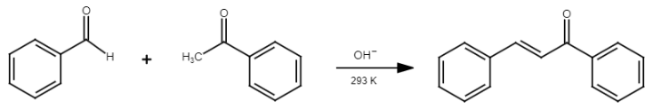

REFERENCES
American Psychiatric Association. (2022). Diagnostic and statistical manual of mental disorders (5th ed., text rev.). American Psychiatric Association Publishing. https://doi.org/10.1176/appi.books.978089042578.
Grady, J. S., Her, M., Moreno, G., Perez, C., and Yelinek, J. (2019). Emotions in storybooks: A comparison of storybooks that represent ethnic and racial groups in the United States. Psychology of Popular Media Culture, 8(3), 207–217. https://doi.org/10.1037/ppm0000185.
Jackson, L. M. (2019). The psychology of prejudice: From attitudes to social action (2nd ed.). American Psychological Association. https://doi.org/10.1037/0000168-000.
Miranda, C. (2019). Exploring the lived experiences of foster youth who obtained graduate level degrees: Self-efficacy, resilience, and the impact on identity development (Publication No. 27542827) [Doctoral dissertation, Pepperdine University]. PQDT Open. PQDT Open ProQuest doc 2309521814.
National Cancer Institute. (2019). Taking time: Support for people with cancer (NIH Publication No. 18-2059). U.S. Department of Health and Human Services, National Institutes of Health. https://www.cancer.gov/publications/patient-education/takingtime.pdf.
Ouellette, J. (2019, November 15). Physicists capture first footage of quantum knots unraveling in superfluid. Ars Technica. https://arstechnica.com/science/2019/11/study-you-can-tie-a-quantum-knot-in-a-superfluid-but-it-will-soon-untie-itself/.
Sapolsky, R. M. (2017). Behave: The biology of humans at our best and worst. Penguin Books. https://www.penguinrandomhouse.com/books/311787/behave-by-robert-m-sapolsky/
Svendsen, S., and Løber, L. (2020). The big picture/Academic writing: The one-hour guide (3rd digital ed.). Hans Reitzel Forlag. https://thebigpicture-academicwriting.digi.hansreitzel.dk/.
Zambrano-Vazquez, L. (2016). The interaction of state and trait worry on response monitoring in those with worry and obsessive-compulsive symptoms [Doctoral dissertation, University of Arizona]. UA Campus Repository. https://repository.arizona.edu/handle/10150/620615.
NOTE: See the References section in this handbook for formatting requirements and information.

PUBLICATIONS
Pete, P. (2025). The Boilermaker Special: Powered for Success. Engineering Monthly, 12(5), 135–151. https://doi.org/example/hyperlink/
Pete, P., & Dye, P. B. (2026). The Beauty and Challenge of Purdue Golf Courses. International Journal of Golf Science. (submitted, under review).
If you are an author or co-author of a publication or publications (both published or submitted/pending publications), publication references should be included in this section. If you have only one publication, the heading cannot be plural and must be revised to show as PUBLICATION. Publications should be formatted the same way as references are formatted. If you do not have any publications, delete this page.

VITA
A VITA section is OPTIONAL and is not required. This section is meant to include professional and educational achievements, which can either be written as a narrative or in Curriculum VITA (CV) form. DO NOT include any personal, private, or confidential information such as your home address, personal email address, personal phone number, date of birth, Social Security number, family member names and addresses, photos, etc.
If your document will not include a VITA, delete this page.

Footnotes should be brief and concise. If your footnotes are lengthy, reduce the size of your footnote by integrating some of the information within your paragraph text instead of including it in your footnotes.
This is another footnote example.

