STUDENT INSTRUCTIONS FOR INITIATING THE
FORM 9: ELECTRONIC THESIS ACCEPTANCE FORM (ETAF)
This document contains instructions to assist students with the submission of the Form 9 Electronic Thesis Acceptance Form (also known as the ETAF).
NOTE: You must have an approved Form 8 (to schedule the final defense/exam) before you will have access to initiate the Form 9 ETAF. Students should submit a Form 9 ETAF after they have passed their final defense/exam.

TO INITIATE THE FORM 9: ELECTRONIC THESIS ACCEPTANCE FORM:
- Log into myPurdue (https://mypurdue.purdue.edu) using your Purdue Career Account Credentials.
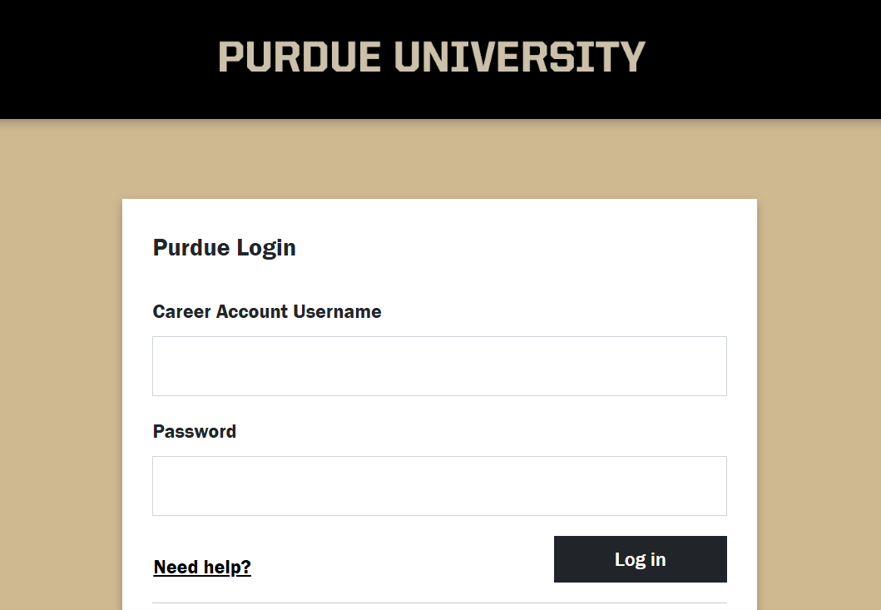
- Search for the Graduate Students card.
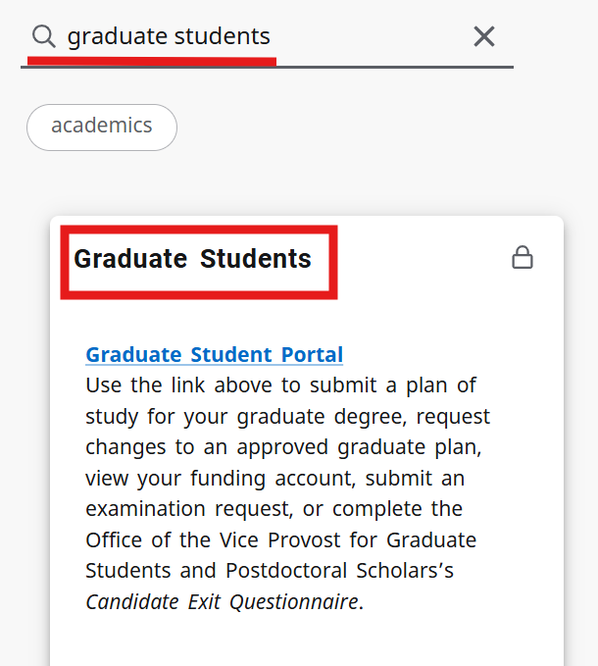
- Click the Graduate Student Portal link.
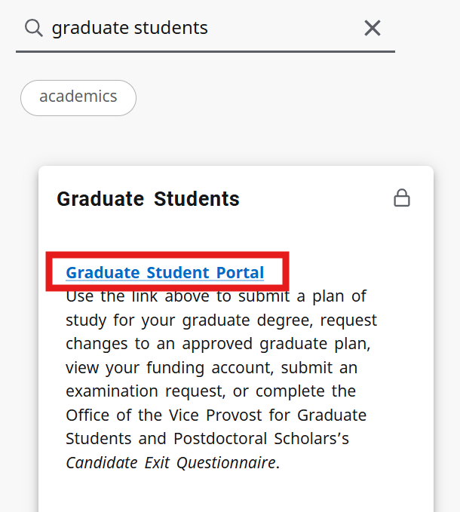
- If prompted, log into the Graduate Student Database. Your login is your Purdue career account credentials.
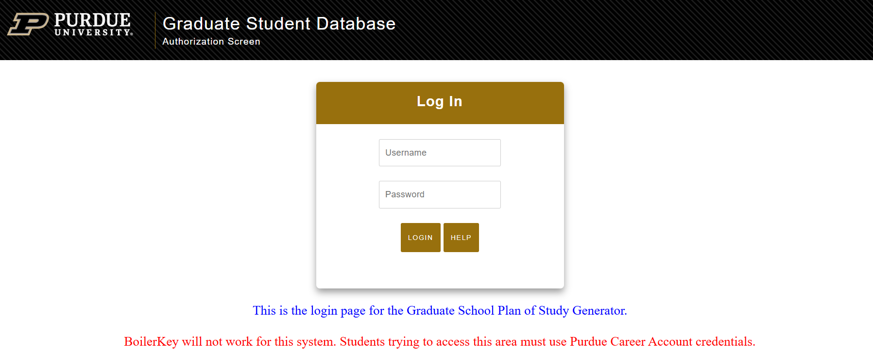

- Scroll down until you see Form 9: Electronic Thesis Acceptance Form (ETAF). Click on the link.
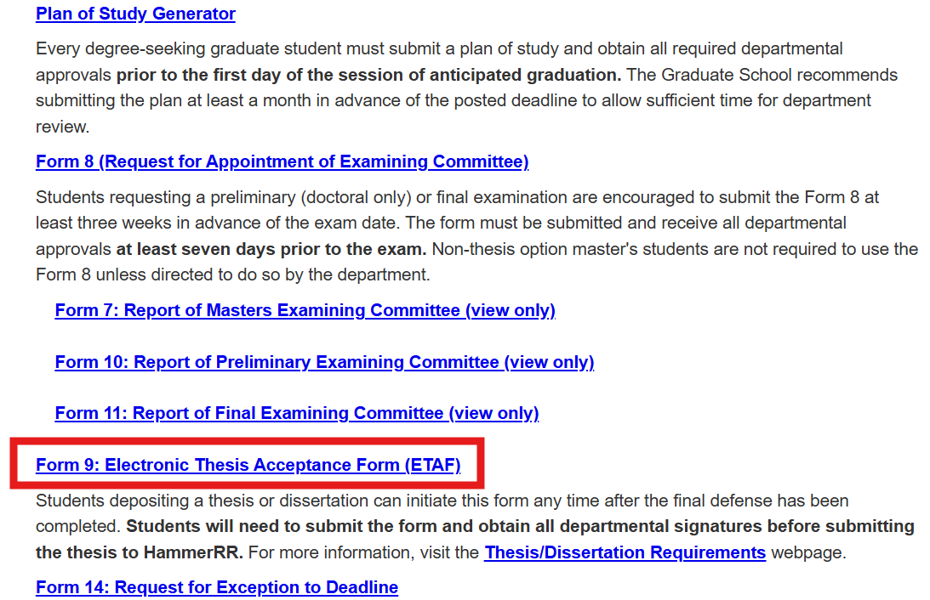
Note: If you have not submitted the Form 8 for the final exam, you will not see the Form 9. You will need to submit your Form 8 and get all required signatures before the Form 9 link displays.
- Click the Initiate Thesis/Dissertation Acceptance Form link.
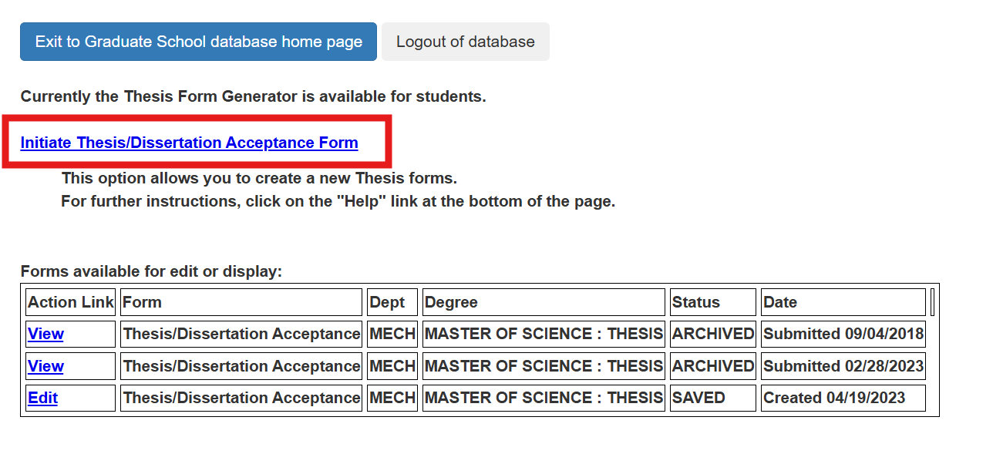
- If you have submitted a Form 8 for multiple graduate degrees, click on the radio button next to the degree that pertains to the thesis or dissertation you are currently depositing. At the bottom of the page, put your personal email address in the Permanent Email Address box, and click the Continue button.
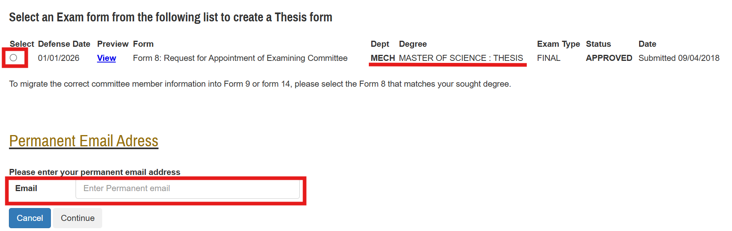
- Review your personal information, update your thesis or dissertation title if necessary, and then click Save and Continue.
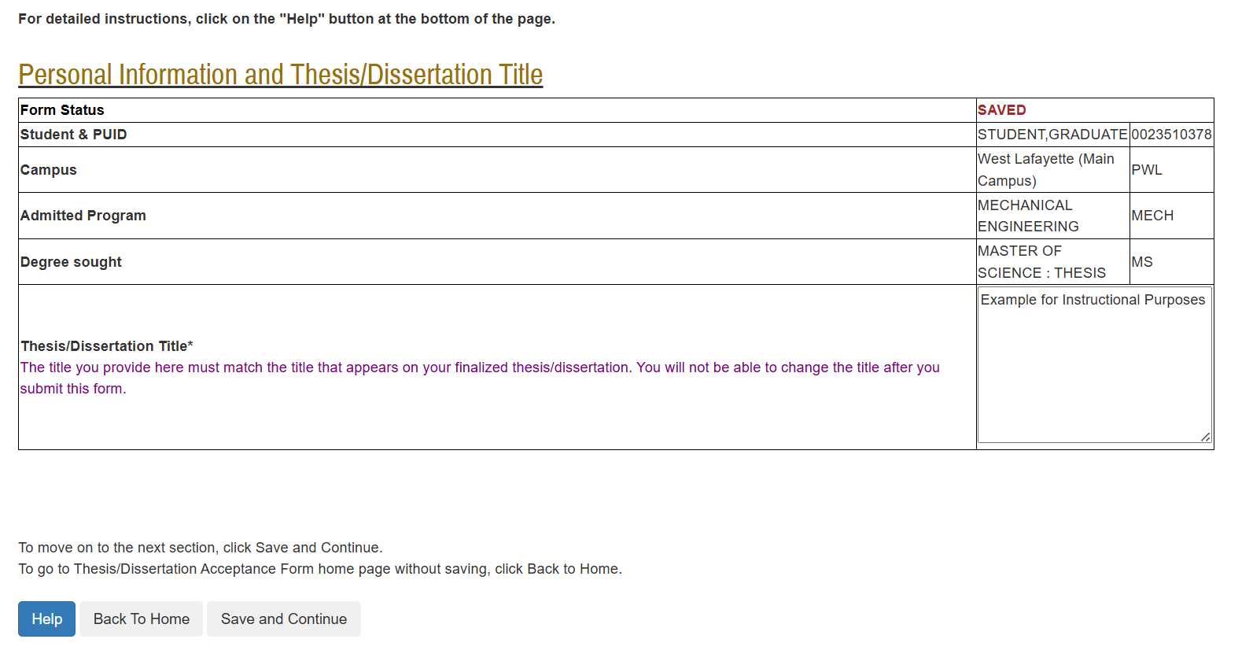

- Review your Thesis/Dissertation Committee. The committee must match the final exam committee listed on your Form 8. If the list is correct, click Save and Continue.
If you need to make a change to the list, click Save without submitting, log out of the Graduate School Database, and contact your department’s Plan of Study Coordinator and ask them to email grm@purdue.edu. After you receive a confirmation email that your Form 9 ETAF committee is corrected, log back in to the Graduate School Database and continue submitting the form.
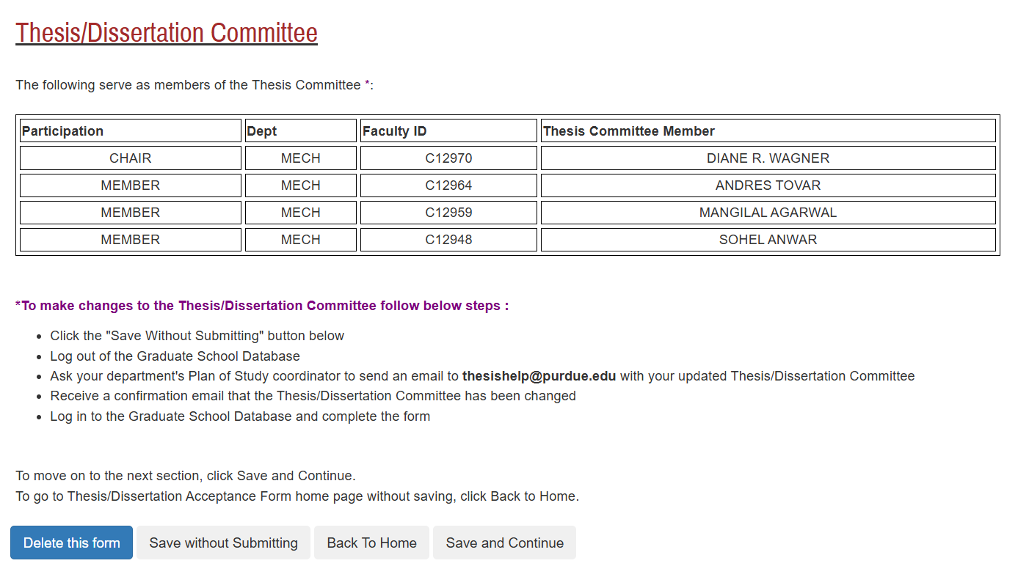
- Carefully read all material on the Thesis/Dissertation Agreement page, check the box indicating you acknowledge the terms of the agreement, and then click Save and Continue.
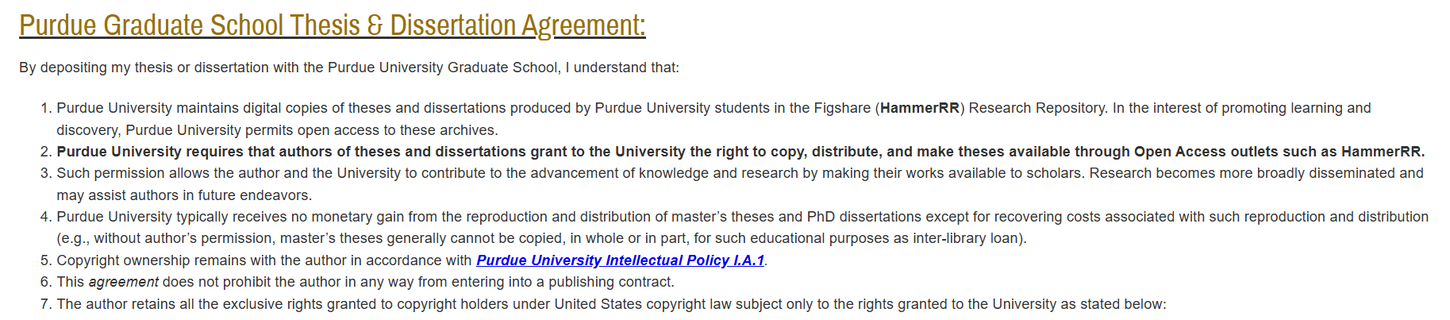
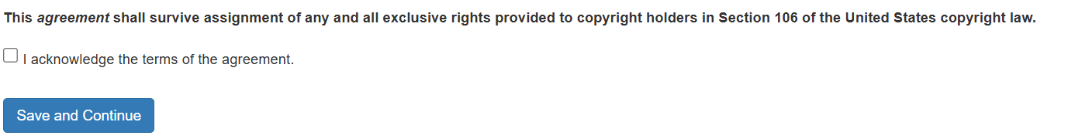
- Carefully read all material on the Embargo and Confidentiality Agreements page, discuss your options with your major professor, make your selection(s), and then click Save and Continue.
NOTE: Students may select either an embargo period or a confidentiality period, but not both. For more information about embargo and confidentiality periods, please review the Required Form 9: Electronic Thesis Acceptance Form (ETAF) section of the Thesis and Dissertation Policies and Practices website. The duration of an embargo or confidentiality period depends on whether or not the thesis or dissertation content is subject to EAR, ITAR, DFARS Clause 252.204-7012, Controlled Unclassified Information (CUI), Covered Defense Information (CDI), or other controlled data, and/or have certain contracts on file with Sponsored Program Services (SPS):
- Non-controlled theses/dissertations allow 6 months, 1 year, or a maximum of 2 years.
- Controlled theses/dissertations require an indefinite confidentiality period.
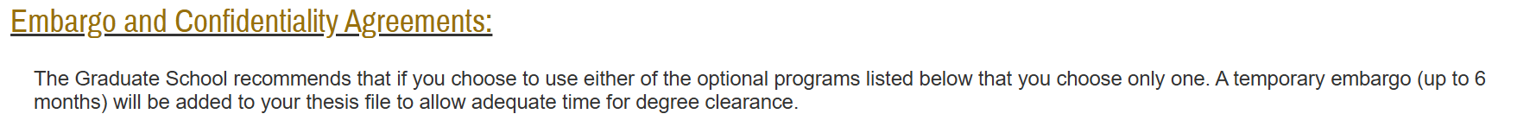

NOTE: Although the Embargo and Confidentiality Agreements section indicates that a temporary embargo of 6 months will be added to your thesis deposit, that is no longer provided as part of the deposit process. Students must make a selection if they need one.
- Carefully read all material on the Research Integrity and Copyright Disclaimer page. To proceed with this form and deposit your thesis or dissertation, you must check the box next to “Yes, I certify”. After you have made your selection, click Save and Continue.
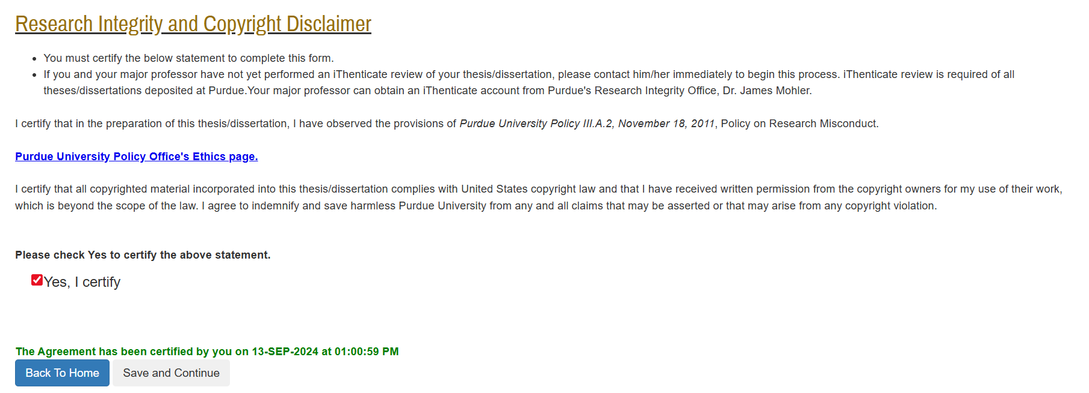

- Carefully read all material on the ADA Accessible Document Statement page. To proceed with this form and deposit your thesis or dissertation, you must check the box next to “Yes, I certify”. After you have made your selection, click Save and Continue.
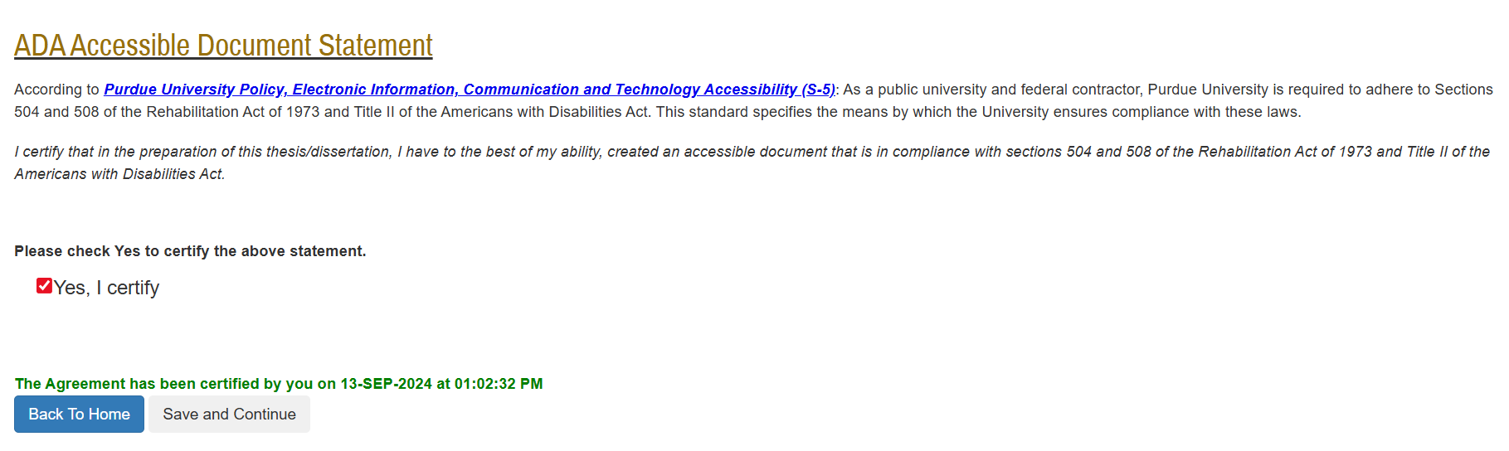
- Confirm that you have completed all sections (completed sections are marked with a check), and then click Preview Thesis/Dissertation Form.
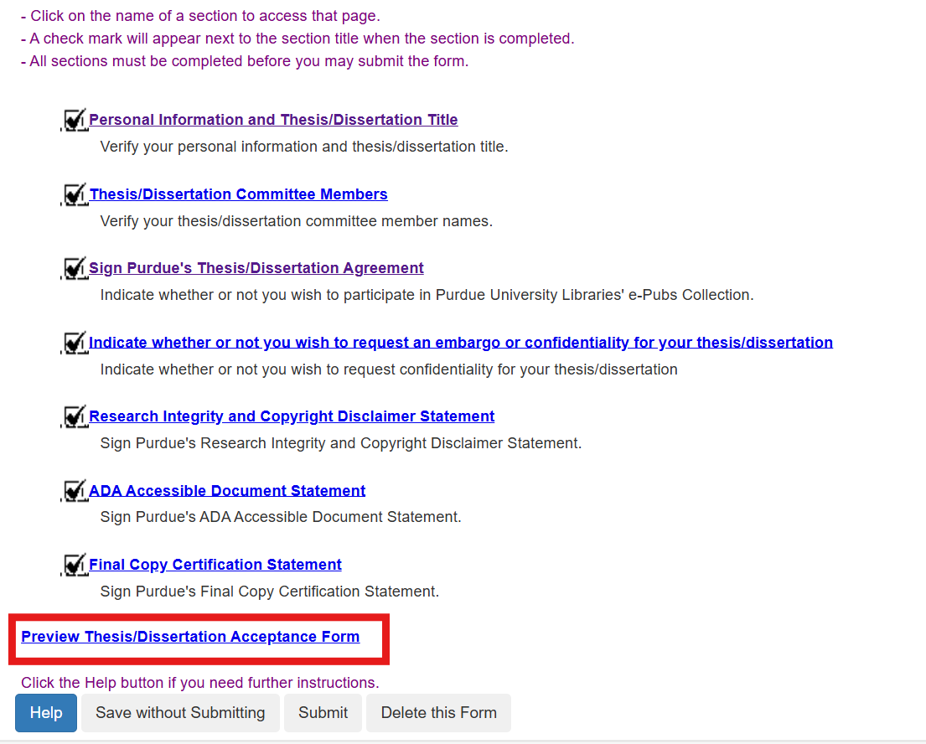

- Confirm that all your information and responses are correct, and then click Submit. If your form has been successfully submitted, you will see your decision has been successfully submitted in red at the top of the screen.
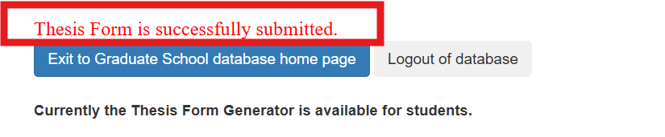
The form will now proceed to the members of your thesis or dissertation committee for signature review.
If you do not receive the “Thesis Form is successfully submitted” message, please check that you have completed all sections and resubmit. If after resubmitting you still do not receive the message, please contact us at grm@purdue.edu.

