Instructions for ordering insurance for study abroad/away programs.
All departmental programs must order the insurance for students through Risk Management.
#1. Download the student list from your program leader page under “Program Forms” and then “Insurance”:
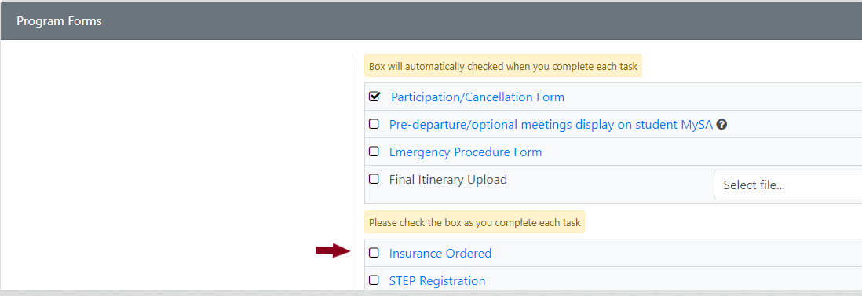
#2. Open the list of students and save to your computer.
#3. Open the appropriate form: RM23 (international) or RM 05 (domestic) located on the Risk Management forms site.
#4. Complete the top section of the form entering the program/department/account information.
#5. Click the “Submit” button. You will receive a notification that an incident has been submitted and you will need to “attach a file”. Please attach the list of participants that you saved to your computer.
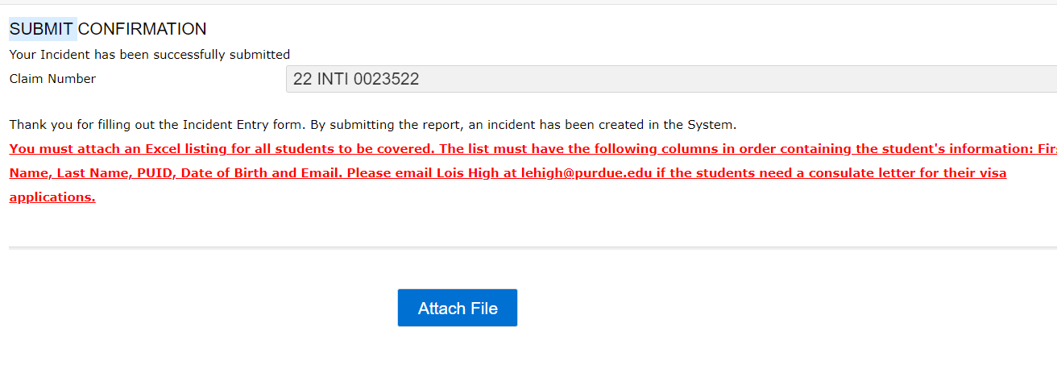
#7. The person listed in the “Send ID Card To” section will receive an email once the students have been entered into Risk Management system.
#8. Notify PL leader or students that the insurance has been ordered and students should carry the Insurance ID card with them during their travels.

