Appointments Module – Current Student Perspective (Condensed)

Step 1: Login to your DRC Student Portal using BoilerKey
Step 2: Click Request for Appointment in Home menu
Step 3: Click the Request for Appointment button.
Step 4: Choose the Who You Would Like to Meet. NOTE: Schedule your appointment with your assigned Access Consultant. Scheduling with a different Access Consultant could result in having your appointment cancelled.
Step 5: Choose the Appointment Location (In-person)
Step 6: Provide any specific questions or concerns you wish to address in this appointment in the Additional Comments text box. Please also specify if you need accommodations or assistive technology to access your appointment.
Step 7: Choose the Appointment Purpose (Initial Meetings, Check-in, etc.) If you do not select an appointment purpose, the system will default to a 30 minute meeting.
Step 8: Click Find Availability
Step 9: Choose a specific appointment time and date.
- By default, you will see 5 business days at a time. If no times where in the first set of dates/times, click Next Available to show more dates/times.
Step 10: Click Schedule Appointment

Appointments Module – Current Student Perspective (With Screenshots)

Step 1: Login to your DRC Student Portal using BoilerKey
Step 2: Click Request for Appointment in Home menu
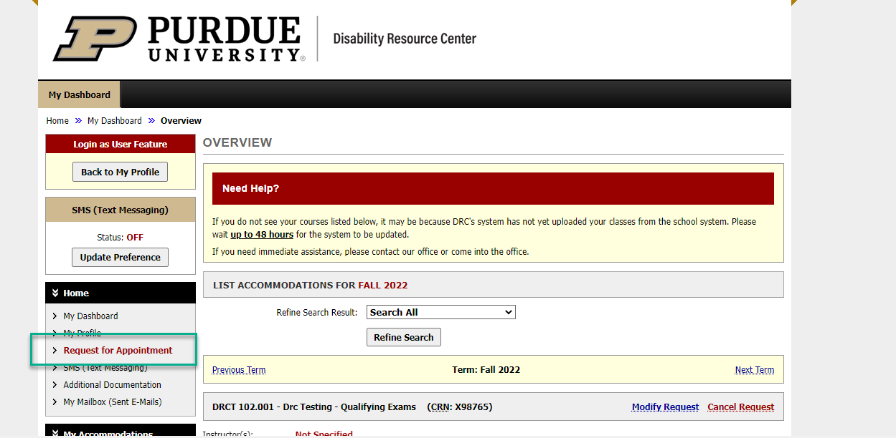o

Step 3: Click the Request for Appointment button.
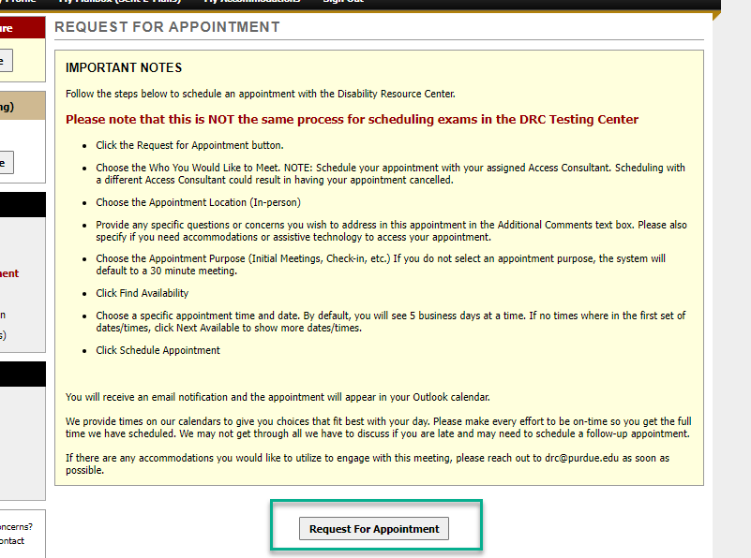

Step 4: Choose the Who You Would Like to Meet. NOTE: Schedule your appointment with your assigned Access Consultant. Scheduling with a different Access Consultant could result in having your appointment cancelled.
Step 5: Choose the Appointment Location (In-person)
Step 6: Provide any specific questions or concerns you wish to address in this appointment in the Additional Comments text box. Please also specify if you need accommodations or assistive technology to access your appointment.
Step 7: Choose the Appointment Purpose (Initial Meetings, Check-in, etc.) If you do not select an appointment purpose, the system will default to a 30 minute meeting.
Step 8: Click Find Availability
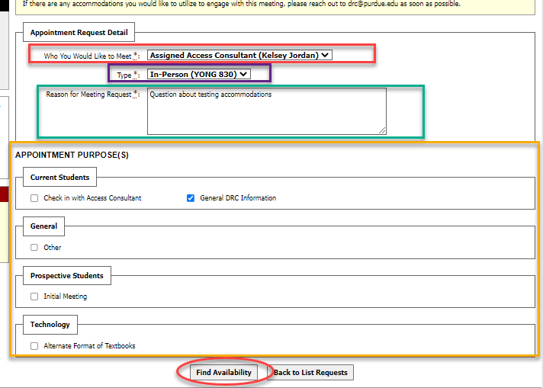o

Step 9: Choose a specific appointment time and date.
- By default, you will see 5 business days at a time. If no times where in the first set of dates/times, click Next Available to show more dates/times.
Step 10: Click Schedule Appointment
