Finding Accessible Books

Search Accessible Textbook Finder
- Select ISBN or Title from drop down menu
- Enter information
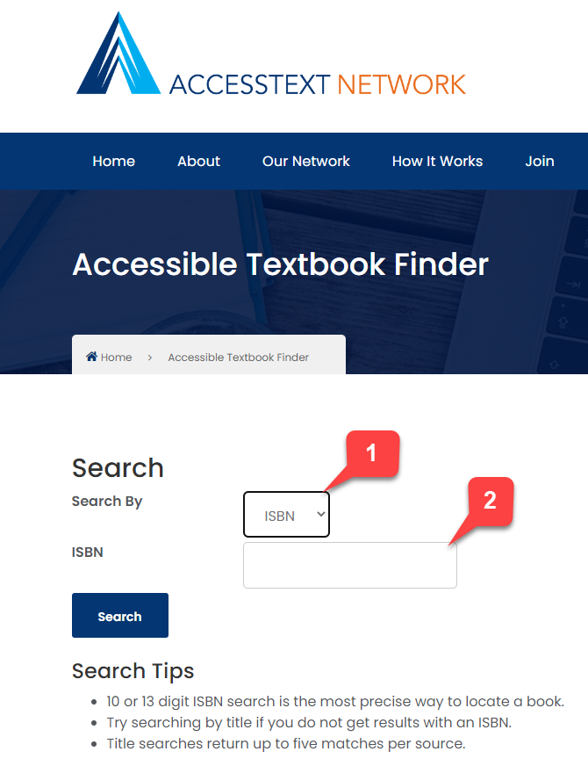

- Enter information
- Results where you can find your book
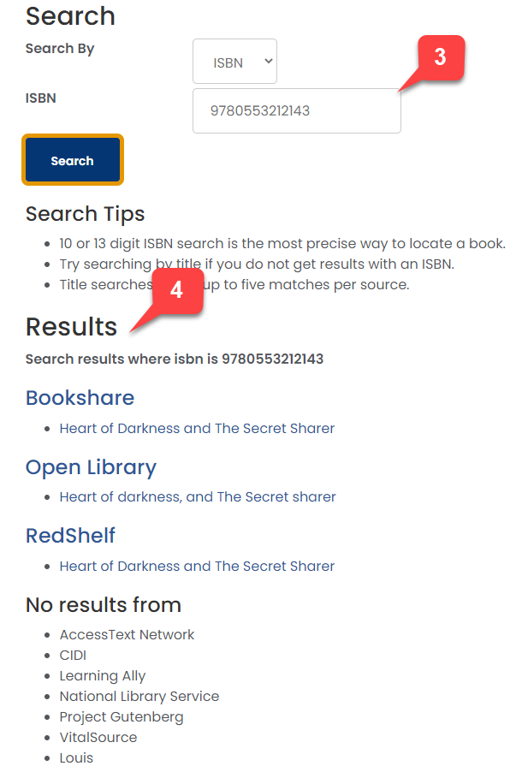

Purdue Library
- Search by Title, ISBN, Author, etc.
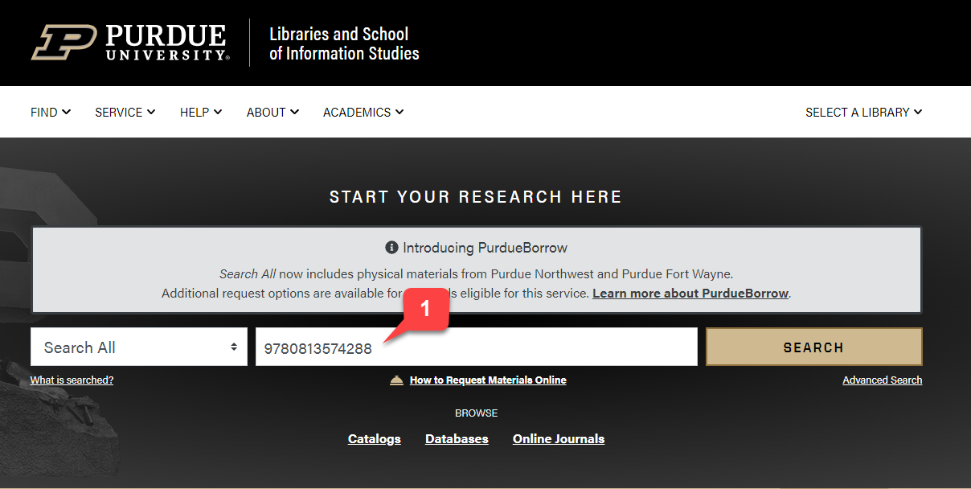

- Result
- Click on Online access available (Not every search will be successful) 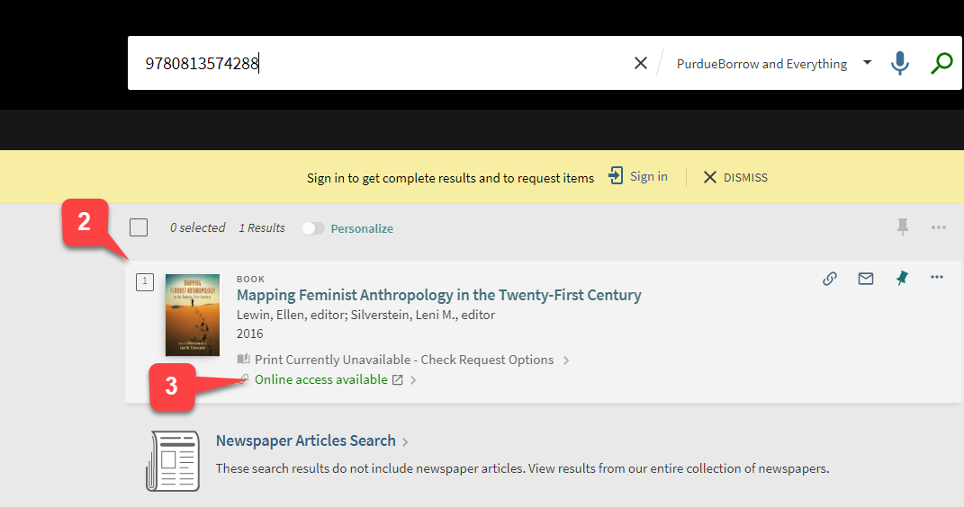
- Click on the blue “link” to download the file (this will vary depending on the various webites, you may need to contact library staff for assistance)
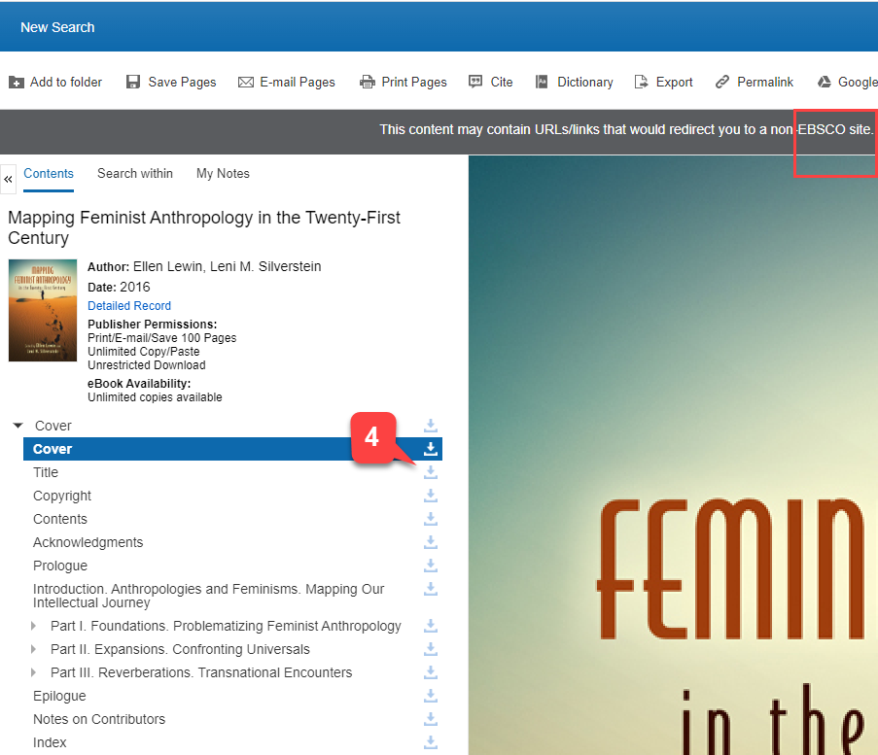

Internet Title Search via Google
Search title with PDF at the end of your search. (NOTE: the PDFs below may not be the exact version of the book or it may be a book review)
