PURDUE UNIVERSITY CENTRAL
SHIPPING OFFICE

700 Ahlers Dr. 765.494.7103
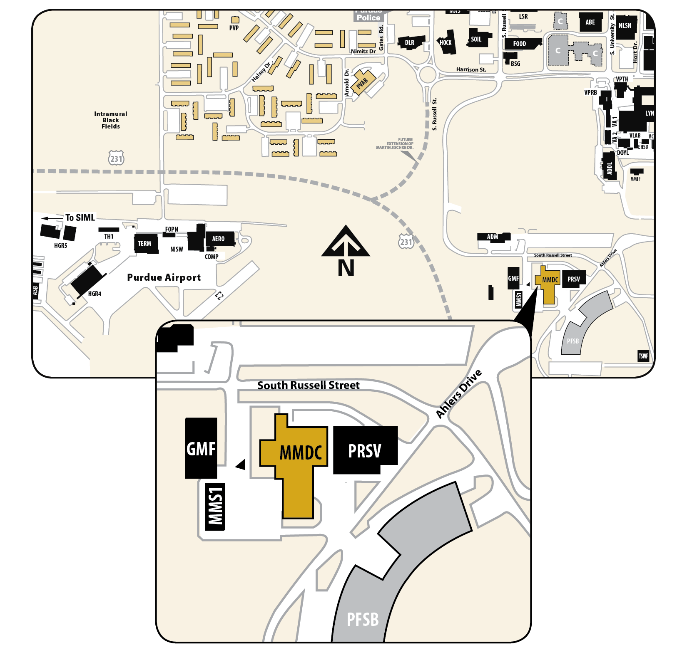

Purdue University Central Shipping Office
Materials Management Distribution Center MMDC
700 Ahlers Dr.
West Lafayette, IN 47907

