Instructions for Obtaining a Researcher Account on Sona

If you are working in a research lab and need a researcher account on the Sona website used for the PSY 120 research participant pool, please follow these instructions.

1. Complete online CITI training

You must complete online CITI training for Social Behavioral Research and for Responsible Conduct of Research before you will be eligible for a researcher account. If you are already certified at Purdue (and your past certification has not expired), then you do not need to repeat this process. However, you still need to email your completion certificates to the Sona Coordinator. If you are not already certified, then please follow these instructions.

(a) Go to https://www.irb.purdue.edu, “Training and Tools” tab, then “Online CITI Training.”
(b) Read the “CITI Registration Instruction Sheet” that is available on the IRB website.
(c) The “CITI Human Subjects Research Basic Course” link takes you to the CITI website.
(d) Complete the training that leads to the following two certifications:

Social Behavioral Research:
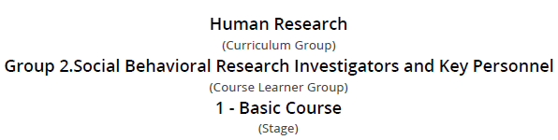

Responsible Conduct of Research (different options exist for undergraduate students vs. faculty, postdocs, and graduate students—choose the option relevant for you):

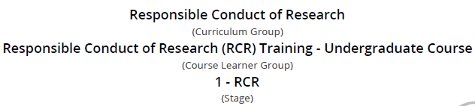

or

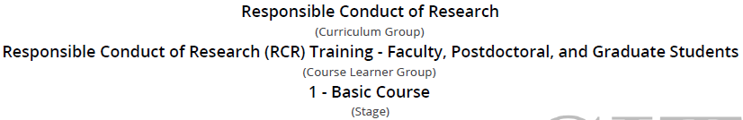

(e) After the training, download PDFs of your completion certificates.

2. Request a researcher account: Send an email with your name, email address, name of your faculty mentor, and attached PDFs of your CITI certificates to the Sona Coordinator, Darryl Schneider (dws@purdue.edu).

