TITLE OF THESIS
by
Your Name

A Choose Thesis Type
Submitted to the Faculty of Purdue University
In Partial Fulfillment of the Requirements for the degree of

Choose Degree

Department of Psychological Sciences
Choose Campus Location, Indiana
Choose Graduation Term

THE PURDUE UNIVERSITY GRADUATE SCHOOL
STATEMENT OF COMMITTEE APPROVAL
Dr. John Doe, Chair
Department of Psychological Sciences
Dr. Jane Doe
Department of Psychological Sciences
Dr. Jim Doe
Department of Psychological Sciences
Add or Delete Committee Member
Add or Delete Department
Add or Delete Committee Member
Add or Delete Department

Approved by:
Dr. David Rollock

Head of the Graduate Program

Dedication
ACKNOWLEDGMENTS
This page is optional.

To copy & paste your work on this page, please highlight this text and replace it.

If you are not including acknowledgements, delete this page.

If you are acknowledging only one person, change the title to ACKNOWLEDGMENT.

TABLE OF CONTENTS
LIST OF TABLES 6
LIST OF FIGURES 7
EXTRA HEADINGS 8
ABSTRACT 9
INTRODUCTION 10
The Basics 10
Margins 10
Heading Styles 10
Purdue Heading 1 11
Purdue Heading 2 11
Purdue Heading 3 11
Purdue Heading 4 11
Purdue Heading 5 11
Purdue Heading 6 12
Inserting a Table of Contents 12
Notes 12
Page Numbers 13
Issues with Pagination 13
TIPS 14
Before You Submit 14
Inserting Internal Links (Bookmarks) 14
Sample Pages and Formatting Checklist 14
Landscape Page 22
REFERENCES 23
APPENDIX A. SURVEYS 24
APPENDIX B. FORMS 25
VITA 26
PUBLICATIONS 27

LIST OF TABLES
Table 1. Suggested Line Spacing 15
Table 2. Oversized Table 17

In order to generate a List of Tables easily, you will need to assign a caption to all of the tables in your document. After this has happened, click on the References Ribbon, select Insert Table of Figures, under general select Table from drop down box, select OK. Be sure to indent subsequent lines of captions.

If you use landscape pages, make sure the landscape page numbers match what is listed in your List of Tables.

LIST OF FIGURES
Figure 1. Styles Box 16
Figure 2. Purdue Fountains 19
Figure 3. Oversized Figures 21
Figure 4. Snowy Hovde Hall 22

In order to generate a List of Figures easily, you will need to assign a caption to all of the tables in your document. After this has happened, click on the References Ribbon, select Insert Table of Figures, under general select Figures from drop down box, select OK. Be sure to indent subsequent lines of captions.

If you use landscape pages, make sure the landscape page numbers match what is listed in your List of Figures.

EXTRA HEADINGS
OPTIONAL SECTION

If you do not have a Glossary, List of Abbreviations, List of Symbols, or Nomenclature section, delete this page.

If you are using this page, choose one of the headings above.

Entries should be spaced consistently (single line spacing, 1.5 line spacing or double line spacing are all acceptable when applied consistently). If you wish, you can use 2 columns to fit nomenclature, definitions, terms, etc. onto one page.

To copy & paste your work here, please highlight the paragraphs to replace the text.

If this section is more than 2 pages, it can be placed at the back of the thesis, following the VITA. Consult with your department.

ABSTRACT
Author: LastName, FirstName, Middle Initial. Choose Degree
Institution: Purdue University
Degree Received: Choose Graduation Term
Title: Type Your Thesis Capitalizing the First Letter of Major Words: Do Not Use All Caps. Be sure to indent subsequent lines of your title.
Committee Chair: FirstName LastName

REQUIRED SECTION

Two different kinds of paragraph spacing will be used on this page. The first three lines, where your personal information is included, make up the introduction block or introduction paragraph. Use only single space and set Before/After space setting to zero (in Paragraph setting box).

In the main body of the abstract, use the same spacing you use throughout the rest of your document (either double spacing or 1.5 line spacing).

To copy & paste your work here, please highlight the paragraphs to replace the text.

Keep the section break below to allow Chapter 1 to start page 1.

INTRODUCTION

The Basics
This template is best used with MS Office 2013 on a PC or MS Word 2016 on a Mac. It is suggested to turn on the Show/Hide tool (¶) that can be found on the Home ribbon so you can track you spacing and section breaks.

Review the Template Guide before you begin. Use it for troubleshooting. If you can’t find a solution there, try Microsoft’s extensive help pages.

Margins
Margin requirements are 1” left, bottom, right, and top margins. 1.5” top margins are required on Title and Statement of Approval pages.

1.5” left margin is recommended by Boiler Copy Maker for screw & post bindings – if you wish to have a hard bound copy made. Hard bound copies are not required for submission to the Graduate School, we will work solely with the PDF copy you upload to ProQuest, requiring 1” left margins.

Heading Styles
There are many heading styles that have been added to the Styles Ribbon. There are Purdue Headings 1-6 above. You will have to manually change the text back to normal style after you apply the heading. You will want to use these styles so you can generate a table of contents without any issues. If you open the navigation toolbar [Ctrl + F] and under the search document bar you choose “Browse headings in your document” you will be able to easily track which headings will go in your table of contents. It is also common for students to center ALL of their headings on the page. If you wish to use this method, simply right click on the heading style > Modify > choose the center alignment > OK. You can also use the same method to remove the italicizing if you do not want your subheadings to be italicized.
If after you apply a Style to a heading and you receive Error! Bookmark not defined in your Table of Contents after updating the page number, go back to your heading that is causing the issue and make sure there is still a style applied to it. You can update the entire table to resolve the issue – if you had previously formatted the Table of Contents, you may have to re-format.

Purdue Heading 1
This heading will be your normal Major/Chapter heading. It will be bolded, centered on page, you will not want to use this heading for any title before the table of contents – these titles do not belong in the table. You will use this heading for anything after the table. This heading is formatted for 3 single spaces after the heading and before the text – do not reformat this as it is a University requirement. Example:
INTRODUCTION

Purdue Heading 2
This heading will be a secondary heading. It will be bolded, centered on page, but will not be typed in all caps. Example:
Introduction

Purdue Heading 3
This heading is a level 3 heading. It will be bolded and aligned with the 1” left margin. Example:
Introduction

Purdue Heading 4
This heading is a level 4 heading. It is indented, bold, and followed by a period. Example:
Introduction.

Purdue Heading 5
This is a level 5 heading. It is indented, bold, italicized, and followed by a period. Example:
Introduction.

Purdue Heading 6
This is a level 6 heading. It is indented, italicized, and followed by a period. This level is very rarely used. Example:
Introduction.

Inserting a Table of Contents
In order to insert an automatic table of contents, you will have needed to apply styles to your headings (as shown above). Once your headings have been assigned a style, you can then insert a table of contents that will automatically populate with the correct heading level indentations, leader dots, and page numbers. This will also create an embedded link from your table of contents to the section in your thesis in both a MS Word doc and in a PDF file.

To insert the table, follow these instructions:
- In Ribbon above, click References
- Click ‘Table of Contents’ on the left hand side of the ribbon
- Choose ‘Custom Table of Contents’ below the built-in tables
- After a Table of Contents box pops up, click “OK”, without making any changes within the box

Typically, inserting a table of contents, list of figures, and list of figures should be the last step in the formatting practice. If you’ve made changes to content that moves a heading to a different page number, all you’ll need to do is go back to your inserted table of contents, right click, select ‘Update Field’, and select “Update page numbers only”. This will make changes to your page numbers and won’t affect the headings.

Notes
If you are planning to include List of Figures and List of Tables, we recommend you using the following method to insert your captions:
- In Ribbon above, click References
- In Captions section, click on Insert Caption
- Next to Label, chose Table or Figure
- Click OK
- Type your caption next to the table/figure number.
To create a table of contents you will need to assign a heading style to each heading in your entire document then follow the steps below:
- Locate your Table of Contents page above
- In the Ribbon above, click References
- In the Table of Contents section, click Table of Contents
- Look past the built-in Table of Contents and select Insert Table of Contents
- Under the General section in the Show Levels box, select the number of headings you want to show in the Table of contents – 3 levels are common, but it can incorporate all levels, if you wish.

Page Numbers
Page numbers will go in the upper right hand corner of each portrait page. If you are using any landscape orientation pages, the page number will go in the lower right hand corner with vertical text (see page 11 for example). Page number font and font size needs to be the same as the main body text.

Issues with Pagination
Occasionally, page numbers will overlap due to section breaks. To fix this issue, simply click on the page number and locate the Design ribbon at the top of the page. Click the drop down arrow on page number > Format page numbers > under the Page numbering section choose Continue from previous section.

TIPS

Before You Submit
Before you convert to PDF, carefully review our Formatting Checklist, then double check the formatting of your entire document, page-by-page.

Inserting Internal Links (Bookmarks)
If you would like to click on a title in the Table of Contents and it take you straight to that page (or figures/tables/equations), follow the steps below: (click on Publications in TOC for example)
- In the table you’ve created, highlight the text you want to link
- Click the Insert Ribbon
- Click Bookmarks
- Click on or create the appropriate bookmark in the list and click OK
- Click OK again and your bookmark will be created.
You can use this option to create external hyperlinks as well using the Hyperlink option in the Insert Ribbon (Sample Thesis Pages above is an example of an external hyperlink)

Sample Pages and Formatting Checklist
The sample pages and Formatting Checklist are available on our website.

Please follow your department’s requirements for placement of captions for tables and figures. The default placement of captions in MS Word is Tables above and Figures below – this can be changed to match your department’s discipline.

If only one table (or figure) is desired on one page, center the table (or figure) on the page.

Table 1.
Suggested Line Spacing
After Space Setting | Where to Use It
12 (equal to single line spacing) | After lowest level subheadings
18 (equal to1.5 line spacing) | After higher level subheadings
24 (equal to double spacing) | After figure captions or table captions
36 (equal to 3 single spaced blank lines; equal to 1 inch) | After title page blocks, major headings and chapter headings

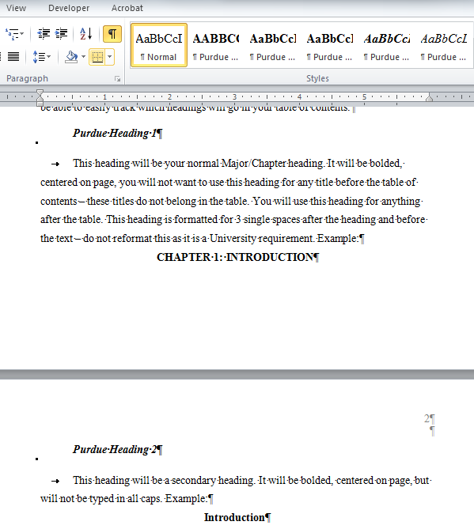
Do not work on TABLE OF CONTENTS, LIST OF FIGURES, or LIST OF TABLES until you finish the last page of your thesis and pagination.
Figure 1. Styles Box
Table 2.
Oversized Table
(table continues)

In order to add the table continuation above the table, you’ll need to split the table. You can achieve this by selecting the table, choose Layout ribbon, find the Merge section, and click Split Table. You will want to place the cursor on the line that you’d like to move to the next page before selecting Split Table.

OR

Add a new row above the table and merge the cells to form one cell above the table so you can type the continuation. This row should not have any borders outside of a bottom border to begin the continuation of the table.

Do you have a figure that goes on for 2 or more pages?
Add the caption to the first page and add (figure continues) below the figure on the first page.
Example:
A)
B)
(figure continues)
Figure 2. Purdue Fountains

C)
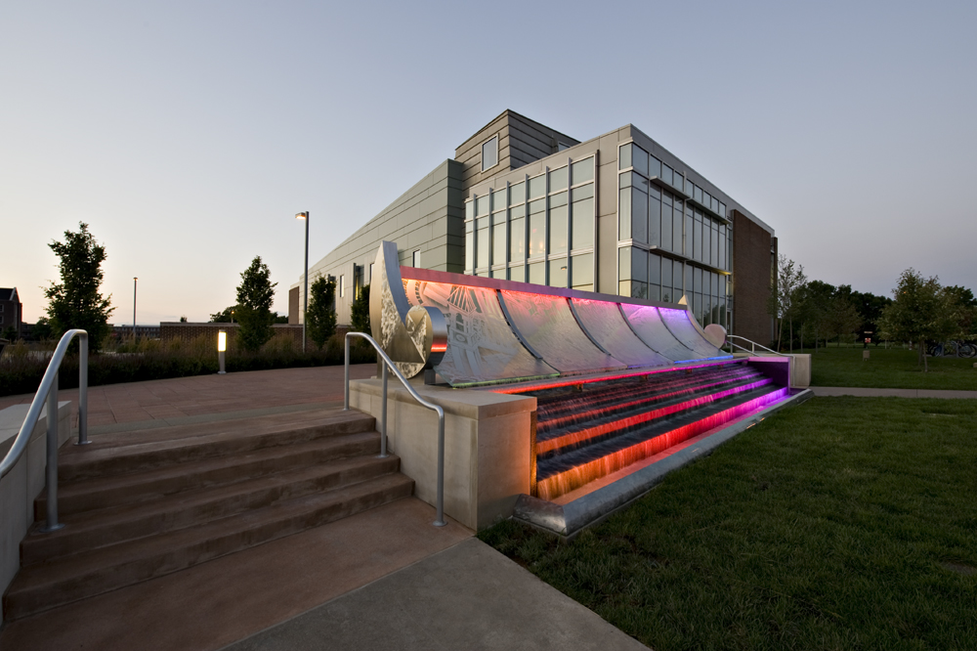

Do you have a figure or a table that is too large to add a caption to the same page as the figure or table?
Add the caption to the page before the figure or table. The caption should be centered on the page vertically.
Example:
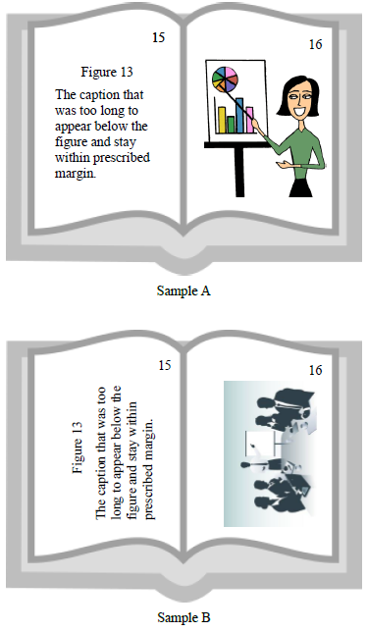
Figure 3. Oversized Figures

Landscape Page
You may use landscaped pages for large tables or figures that normally will not fit within left and right margins. Note that page numbers will need to be added manually with a text box (that is in place in the bottom right hand corner). A normal page number will show up in the upper right hand corner when adding pagination. You will need to unlink this page and the next page’s pagination to previous in order to keep the pagination in the correct place. Use the page number text box in the lower right corner of this page for additional landscape pages.

To achieve adding a landscape page, you will need to add a Next Page section break on the previous page. You will also need to add a Next Page section break to the end of this page to convert back to a portriat orientation. It is beneficial to open the Show/Hide control on the Home Ribbon in the Paragraph section so you can see where all extra spacing is and where section and page breaks are.

Captions may be no smaller than size 10 font. Make every effort to allow the text to stay on same page as figure or table; if needed, the text may overflow to the next page. Oversized pages (11x14 or 11x17) may be used to accommodate larger tables.

22
Figure 4. Snowy Hovde Hall

REFERENCES
Include reference entries here using the style preferred by your department.
References may either be a separate section (like shown in this template) or they may be listed after each chapter. If references are placed at the end of the chapters, they will need to begin on a new page.

References and Appendix placement may be changed to fit the needs of the author.

Examples:

(APA style in Alphabetical order)
Applewood, John (2015, December 17). How to Format a Purdue Thesis. Retrieved from http://www.purdue.edu/gradschool/research/thesis/index.html
Brownstone, Daniel (2015, January 24). Sample Thesis Pages. Retrieved from http://www.purdue.edu/gradschool/research/thesis/index.html

-OR-

(APA style in Endnote referenced order)
[1] Brownstone, Daniel (2015, January 24). Sample Thesis Pages. Retrieved from http://www.purdue.edu/gradschool/research/thesis/index.html
[2] Applewood, John (2015, December 17). How to Format a Purdue Thesis. Retrieved from http://www.purdue.edu/gradschool/research/thesis/index.html

Follow your department’s style for your References section.

To copy & paste your work on this page, please highlight this text and replace it.

APPENDIX A. SURVEYS
OPTIONAL SECTION

If you only have one appendix the title should read APPENDIX, do not include any other information in the title.

Use secondary headings for Appendix titles. You will need to manually type the heading in ALL CAPS, or you can highlight the text and use the Shift + F3 function and it will automatically change the text to ALL CAPS. These headings will be indented in your table of contents, but you will add APPENDICES to the table so they will be indented under a major heading. If you are only using one Appendix, list it as a level 1 heading and do not include APPENDICES in the table of contents.

APPENDIX B. FORMS
If you have large tables or figures to include we ask that you use landscape pages and place the Appendix Title above the figure/table.

VITA
OPTIONAL SECTION

We strongly recommend you not include any private data like your home address, email address, or phone number.

If you are unsure about what to include in your vita, consult with your department and/or major professor. The vita can be written as a narrative or in curriculum vita (CV) form. Please keep vita format identical to the format used in thesis (margins, spacing, and text font).

PUBLICATIONS
OPTIONAL SECTION

This is where you can place a list of publication or alternately, you can include a PDF of a published article. This article may either be in color or black and white.

Steps to insert a PDF into a document without having to screenshot:
- Select Insert ribbon.
- Select Object in the Text section.
- Choose the first Adobe Acrobat Document.
- Locate your file and click Open (after saving each page of your PDF as a separate file).
- Your file will open, close the file – it will automatically show up in your document and fit within the required margins.
- Repeat this method for each page of your PDF.

If you have questions or need any guidance inserting a PDF into your document, contact our office.

All pages of publications need page numbers sequential to the number in the rest of your thesis. You may need to block out original page numbers to prevent confusion. You may use the landscape text box and rotate it to fit in the upper right hand corner of the page. You will need to ensure the page number is horizontal when using the text box.

If you have only one publication, list the title as PUBLICATION.

