Standard Operating Procedure
Zirconium Powder
This is an SOP template and is not complete until: 1) lab specific information is entered into the box below 2) lab specific protocol/procedure is added to the protocol/procedure section and
3) SOP has been signed and dated by the PI and relevant lab personnel.
Print a copy and insert into your Lab-Specific Chemical Hygiene Plan.
Section 1 – Lab-Specific Information
Building/Room(s) covered by this SOP: | Click here to enter text.
Department: | Click here to enter a date.
Principal Investigator Name: | Click here to enter text.
Principal Investigator Signature: | Click here to enter text.
Section 2 – Hazards
Zirconium is a self-heating substance and may catch fire spontaneously if exposed to air. Work with zirconium powder should only be conducted in a glove box with an inert atmosphere. It is considered a flammable solid. Zirconium powder is an irritant to the skin, eyes, and mucous membranes. It may be harmful by inhalation, ingestion, or skin absorption and can cause eye and skin irritation. Zirconium may also cause inflammation of the skin on contact and accentuate any pre-existing dermatitis condition. Inhalation of zirconium compounds may cause pulmonary granulomas. The inhalation of small particles of metal oxides results in sudden thirst, a sweet, metallic foul taste, throat irritation, cough, dry mucous membranes and tiredness.
Exposure Limit:
OSHA PEL (8-Hour Time Weighted Average): 5 mg/m³
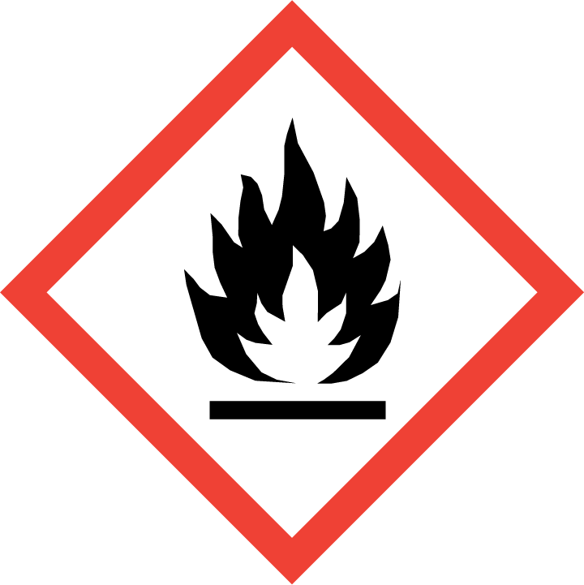
Section 3 – Engineering Controls and Personal Protective Equipment (PPE)
Engineering Controls: Use of zirconium powder should be conducted in a glove box with an inert atmosphere.
Hygiene Measures: Avoid contact with skin, eyes, and clothing. Wash hands before breaks and immediately after handling the product.
Hand Protection: Chemical-resistant gloves must be worn, nitrile gloves are recommended for low volume applications. Wearing two pairs of nitrile gloves is recommended. NOTE: Consult with your preferred glove manufacturer to ensure that the gloves you plan on using are compatible with the specific chemical being used.
Eye Protection: ANSI approved properly fitting safety glasses or chemical splash goggles are required. A face shield may also recommended
Skin and Body Protection: Flame resistant lab coats must be worn and be appropriately sized for the individual and buttoned to their full length. Laboratory coat sleeves must be of sufficient length to prevent skin exposure while wearing gloves. Personnel should also wear full length pants, or equivalent, and close-toed shoes. Full length pants and close-toed shoes must be worn at all times by all individuals that are occupying the laboratory area. The area of skin between the shoe and ankle should not be exposed.
Respiratory Protection: If chemical is being used outside of a chemical fume hood, respiratory protection may be required. If this activity is necessary, contact REM (4-6371) so a respiratory protection analysis can be performed.
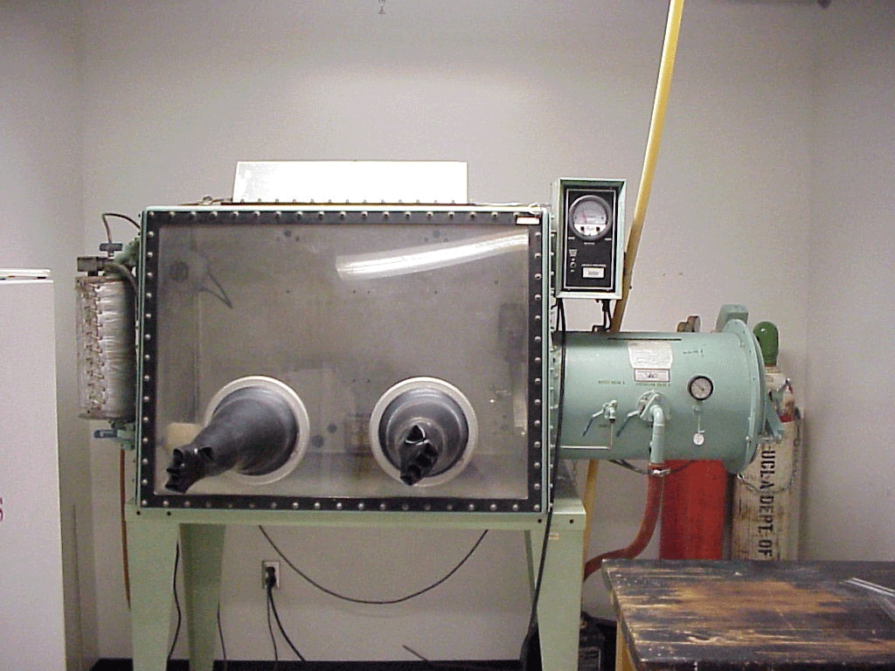
Section 4 – Special Handling and Storage Requirements
- Avoid contact with skin, eyes, and clothing.
- Avoid inhalation and ingestion.
- Keep cool and protect from sunlight.
- Keep away from heat, shock, friction, and sources of ignition. Prevent build-up of electrostatic charge.
- The use of zirconium powder should only occur in a glove box with an inert atmosphere such as argon gas as shown in Figure 1.
Figure 1: Glove Box
- Handle and open container with care. Never work with zirconium powder alone, use the buddy system.
- Zirconium powder should be stored in a sealed container and in a flammable cabinet or under an inert atmosphere such as a glove box away from incompatible chemicals. Incompatibles include water, strong acids, strong oxidizing agents, hydrogen fluoride, phosphorus, and oxygen.
- If received wetted, only dry what is necessary to perform the experiment; do not dry all of the contents of the container.
- Zirconium powder creates a Class D metal fire. Therefore, only a D-powder extinguisher or dry sand or clay is acceptable as an extinguishing agent. Hazardous decomposition products, carbon oxides and zirconium oxides are formed under fire conditions.
- All chemicals should be clearly labeled with the original manufacturer’s label, which should have the chemical name, hazard labels, and pictograms. The label should not be defaced in any way.
- Do not over purchase. Any expired or unnecessary reactive materials should be properly disposed of as hazardous waste.
Section 5 – Spill and Accident Procedures
Immediately evacuate area and ensure others are aware of the spill. If there is an imminent threat of a fire, pull the nearest fire alarm station to evacuate the building and dial 911. If personnel have become exposed and need medical assistance, dial 911. If the spill is minor and does not pose a threat to personnel, contact REM at 49-40121 during normal business hours (Monday – Friday, 7 AM – 4 PM) for spill cleanup assistance (dial 911 if spill occurs after hours and assistance is needed).
Section 6 – Waste Disposal Procedures
Store hazardous waste in closed containers, and in a designated area (flammable cabinet is recommended). Zirconium waste should be segregated from all incompatible chemicals and sources of ignition. Complete a Chemical Waste Pickup Request Form to arrange for disposal by REM; detailed instructions are provided at the following link: http://www.purdue.edu/ehps/rem/hmm/chemwaste.htm.
Section 7 – Protocol (Add lab specific Protocol/Procedure here)
Click here to enter text.
NOTE: Any deviation from this SOP requires approval from PI.
Section 8 – Documentation of Training (signature of all users is required)
Prior to conducting any work zirconium powder, the Principal Investigator must ensure that all laboratory personnel receive training on the content of this SOP.
I have read and understand the content of this SOP:
Name | Signature | Date
Click here to enter text. |  | Click here to enter a date.
Click here to enter text. |  | Click here to enter a date.
Click here to enter text. |  | Click here to enter a date.
Click here to enter text. |  | Click here to enter a date.
Click here to enter text. |  | Click here to enter a date.
Click here to enter text. |  | Click here to enter a date.
Click here to enter text. |  | Click here to enter a date.
Click here to enter text. |  | Click here to enter a date.
Click here to enter text. |  | Click here to enter a date.

