Standard Operating Procedure
Sulfuric acid, concentrated
This is an SOP template and is not complete until: 1) lab specific information is entered into the box below 2) lab specific protocol/procedure is added to the protocol/procedure section and
3) SOP has been signed and dated by the PI and relevant lab personnel.
Print a copy and insert into your Lab-Specific Chemical Hygiene Plan.

Section 1 – Lab-Specific Information
Building/Room(s) covered by this SOP: | Click here to enter text.
Department: | Click here to enter a date.
Principal Investigator Name: | Click here to enter text.
Principal Investigator Signature: | Click here to enter text.

Section 2 – Hazards
Sulfuric acid is a highly corrosive mineral acid. The historical name of this acid is oil of vitriol. Sulfuric acid is harmful if inhaled, ingested, or absorbed through the skin. Inhalation may cause irritation to the respiratory tract with burning pain in the nose and throat, coughing, wheezing, shortness of breath, and pulmonary edema. Contact with skin causes burns and irritation. Eye contact causes burns, irritation, and may cause blindness. Ingestion may cause permanent damage to the digestive tract. It is destructive to the tissue of the mucous membranes and upper respiratory tract.
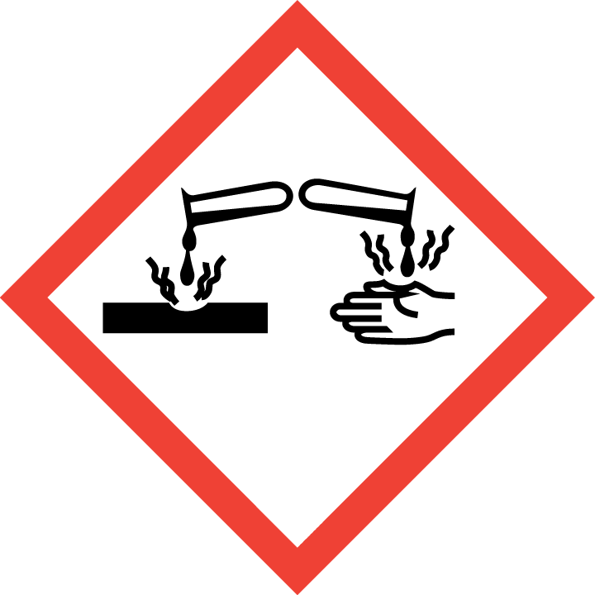
Section 3 – Engineering Controls and Personal Protective Equipment (PPE)
Engineering Controls: Use of sulfuric acid should be conducted in a properly functioning chemical fume hood whenever possible. Avoid inhalation of vapor or mist. The chemical fume hood must be approved and certified by REM and have a face velocity between 80 – 125 feet per minute.
Hygiene Measures: Avoid contact with skin, eyes, and clothing. Wash hands before breaks and immediately after handling the product.
Hand Protection: Chemical-resistant gloves must be worn, nitrile gloves are recommended for low volume applications. Viton gloves are recommended for full contact exposure. NOTE: Consult with your preferred glove manufacturer to ensure that the gloves you plan on using are compatible with the specific chemical being used.
Eye Protection: ANSI approved properly fitting safety glasses or chemical splash goggles are required. A face shield may also be appropriate depending on the specific application.
Skin and Body Protection: Laboratory coats must be worn and be appropriately sized for the individual and buttoned to their full length. Personnel must also wear full length pants, or equivalent, and close-toed shoes. Full length pants and close-toed shoes must be worn at all times by all individuals that are occupying the laboratory area. The area of skin between the shoe and ankle must not be exposed.
Respiratory Protection: If sulfuric acid is being used outside of a chemical fume hood, respiratory protection may be required. If this activity is necessary, contact REM (4-6371) so a respiratory protection analysis can be performed.

Section 4 – Special Handling and Storage Requirements
- Do not over purchase; only purchase what can be safely stored in the laboratory.
- Avoid contact with skin and eyes. Avoid inhalation of vapor or mist.
- Always use inside a chemical fume hood.
- Do not allow water to get into the container because of violent reaction.
- Note: In case you need to dilute the concentration of Sulfuric acid, always add the acid to water.
- Do not use with metal spatula or other metal items.
- Use in the smallest practical quantities for the experiment being performed.
- Keep container upright & tightly closed in a dry and well-ventilated place.
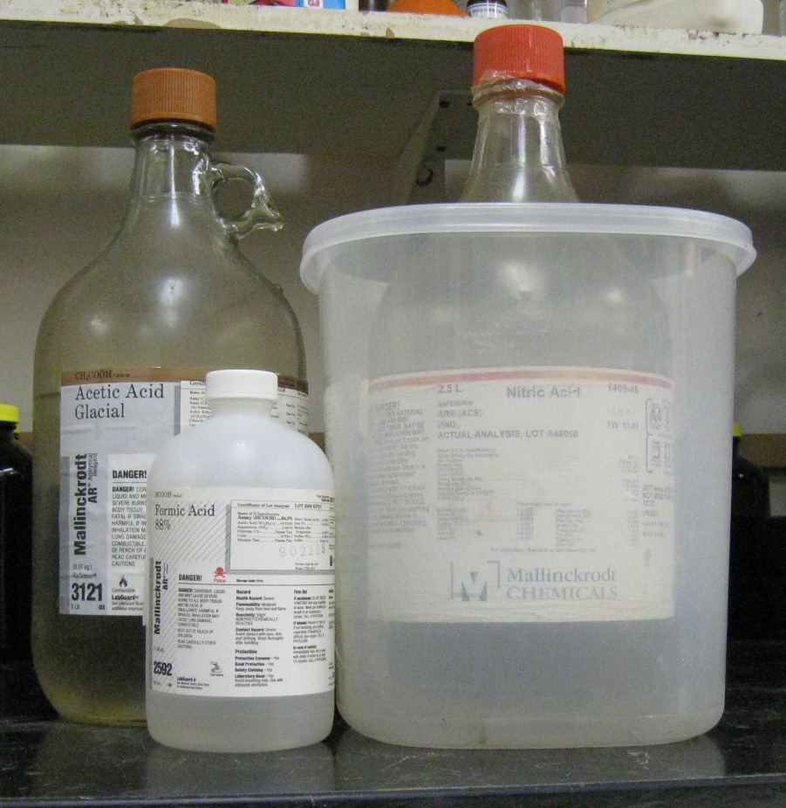
- Containers which are opened must be carefully resealed and kept upright to prevent leakage.
- Store in original container. Do not store Sulfuric acid in metal containers.
- Sulfuric acid must be segregated from incompatible materials. Sulfuric acid is incompatible with metals, oxidizing agents, reducing agents, bases, Acrylonitrile, azides, cyanides, chlorates, finely powdered metals, nitrates, perchlorates, permanganates, epichlorohydrin, aniline, carbides, fulminates, halides, picrates, organic materials, zinc salts, and flammable liquids.
Organic acid
Oxidizing acid
- Containers should be labeled appropriately; the original manufacturer’s label is acceptable. Label should indicate the name of the chemical(s) in the container. Avoid using chemical abbreviations (acceptable if a legend is present in the lab) and formulae.
- Transport all corrosives in secondary containment, such as polyethylene or other non-reactive acid/solvent bottle carrier.
Section 5 – Spill and Accident Procedures
Immediately evacuate area and ensure others are aware of the spill. If there is an imminent threat of a fire, pull the nearest fire alarm station to evacuate the building and dial 911. If personnel have become exposed and need medical assistance, dial 911. If the spill is minor and does not pose a threat to personnel, contact REM at 49-40121 during normal business hours (Monday – Friday, 7 AM – 4 PM) for spill cleanup assistance (dial 911 if spill occurs after hours and assistance is needed).

Section 6 – Waste Disposal Procedures
When possible, do not mix acidic and basic waste streams. Store hazardous waste in closed containers that are properly labeled, and in a designated area (flammable cabinet is recommended) away from incompatible chemicals. Complete a Chemical Waste Pickup Request Form to arrange for disposal by REM; detailed instructions are provided at the following link: http://www.purdue.edu/ehps/rem/hmm/chemwaste.htm.

Section 7 – Protocol (Additional lab protocol may be added here)
Click here to enter text.
NOTE: Any deviation from this SOP requires approval from PI.

Section 8 – Documentation of Training (signature of all users is required)
Prior to conducting any work with sulfuric acid, the Principal Investigator must ensure that all laboratory personnel receive training on the content of this SOP.
I have read and understand the content of this SOP:
Name | Signature | Date
Click here to enter text. |  | Click here to enter a date.
Click here to enter text. |  | Click here to enter a date.
Click here to enter text. |  | Click here to enter a date.
Click here to enter text. |  | Click here to enter a date.
Click here to enter text. |  | Click here to enter a date.
Click here to enter text. |  | Click here to enter a date.
Click here to enter text. |  | Click here to enter a date.

