Standard Operating Procedure
Pyrophoric Materials
This is an SOP template and is not complete until: 1) lab specific information is entered into the box below 2) lab specific protocol is added to the protocol section and
3) SOP has been signed and dated by the PI and relevant lab personnel.
Print a copy and insert into your Lab-Specific Chemical Hygiene Plan.
Section 1 – Lab-Specific Information
Building/Room(s) covered by this SOP: | Click here to enter text.
Department: | Click here to enter a date.
Principal Investigator Name: | Click here to enter text.
Principal Investigator Signature: | Click here to enter text.
Section 2 – Hazards
Pyrophoric materials are classified as pyrophoric; and typically also classified as flammable liquids/solids, water reactive, and corrosives. Many are often toxic. They react violently with water liberating extremely flammable gas and are spontaneously flammable in air and causes burns. They pose a danger of serious damage to health by prolonged exposure through inhalation. Extreme caution is advised. Keep away from heat and sources of ignition. While it is often possible to work with these compounds using cannula transfer, traces of these compounds at the tip of the needle or cannula may catch fire and clog the cannula with lithium salts. Some workers prefer to enclose the needle tip or cannula in a short glass tube which is flushed with an inert gas and sealed via two septa. Examples include tert-butyllithium and triethylaluminum.
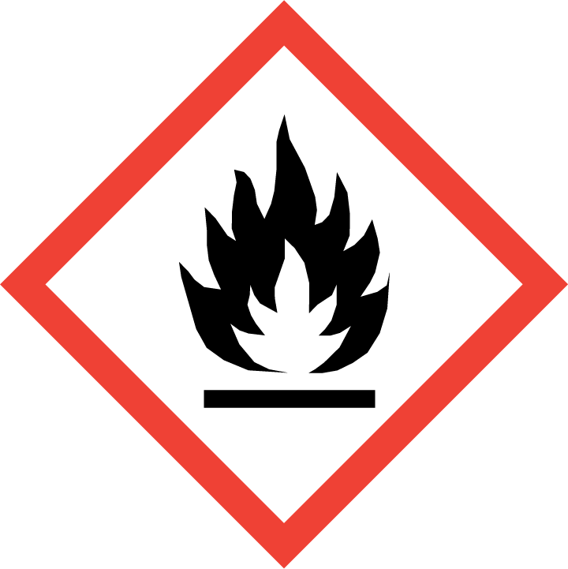
Section 3 – Personal Protective Equipment (PPE) and Engineering Controls
Engineering Controls: Use of pyrophoric material must be conducted in an inert atmosphere; use of a glove box is recommended. Chemical fume hoods must be approved and certified by REM and have a face velocity between 80 – 125 feet per minute.
Hygiene Measures: Avoid contact with skin, eyes, and clothing. Wash hands before breaks and immediately after handling the product.
Hand Protection: Chemical-resistant gloves must be worn, nitrile gloves are recommended. Wearing two pairs of nitrile gloves is recommended. NOTE: Consult with your preferred glove manufacturer to ensure that the gloves you plan on using are compatible with the specific chemical being used.
Eye Protection: ANSI approved properly fitting safety glasses or chemical splash goggles are required. A face shield may also be appropriate depending on the specific application.
Skin and Body Protection: Flame resistant laboratory coats must be worn and be appropriately sized for the individual and buttoned to their full length. Personnel must also wear full length pants, or equivalent, and close-toed shoes. Full length pants and close-toed shoes must be worn at all times by all individuals that are occupying the laboratory area. The area of skin between the shoe and ankle must not be exposed.
Respiratory Protection: Pyrophoric material should never be used outside of a chemical fume hood or glove box; therefore respiratory protection should not be required.
Section 4 – Special Handling and Storage Requirements
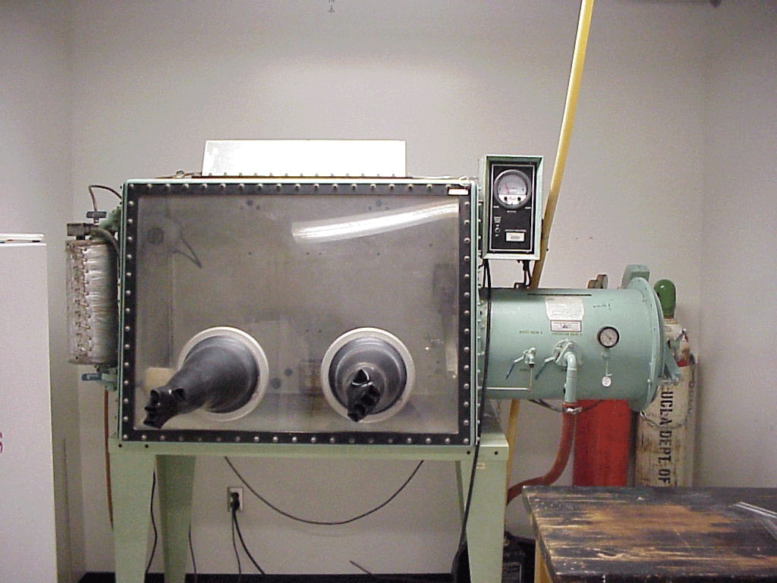
- Precautions for safe handling: Pyrophoric, use extreme care when handling.
- Only handle under inert gas; use a glove box if possible. Do not expose to air.
- Avoid contact with skin and eyes and inhalation.
- A “dry-run” of the experiment should be performed using low-hazard materials such as water or an organic solvent.
- Never work with pyrophoric materials alone.
- Conduct the procedure only after a supervisor has observed the user performing the proper technique unassisted.
- A current copy of the SDS for the specific pyrophoric compound being used must be made available to all lab personnel at all times.
- All glassware used for pyrophoric materials should be oven-dried and free of moisture.
- Keep away from sources of ignition. Avoid heat and shock or friction when handling.
- Secure all pyrophoric material containers to a stand.
- Keep containers tightly closed. Store in a cool, dry and well-ventilated area away from incompatible substances.
- The amount of pyrophoric materials stored should be kept at a minimum.
- Any expired or unnecessary reactive materials should be properly disposed of as hazardous waste.
- All pyrophoric materials should be clearly labeled with the original manufacturer’s label, which should have the chemical name, hazard labels, and pictograms. The label should not be defaced in any way.
- All pyrophoric material should be placed into secondary containment as a precautionary measure.
- Suitable storage locations include inert gas-filled desiccators or glove boxes, flammable storage cabinets that do not contain aqueous or other incompatible chemicals, or intrinsically safe refrigerators or freezers that also do not contain aqueous or other incompatible chemicals.
- If pyrophoric materials are received in a specially designed shipping, storage, or dispensing container (such as the Aldrich Sure-Seal packaging system), ensure that the integrity of that container is maintained. Ensure that sufficient protective solvent, oil, kerosene, or inert gas remains in the container while pyrophoric materials are stored.
Section 5 – Spill and Accident Procedures
Immediately evacuate area and ensure others are aware of the spill. If there is an imminent threat of a fire, pull the nearest fire alarm station to evacuate the building and dial 911. If personnel have become exposed and need medical assistance, dial 911.
Section 6 – Waste Disposal Procedures
Store hazardous waste in closed containers that are properly labeled, and in a designated area (flammable cabinet is recommended) away from incompatible chemicals such as aqueous solutions. Complete a Chemical Waste Pickup Request Form to arrange for disposal by REM; detailed instructions are provided at the following link: http://www.purdue.edu/ehps/rem/hmm/chemwaste.htm.
Section 7 – Protocol (Add lab specific Protocol here)
Click here to enter text.
NOTE: Any deviation from this SOP requires approval from Principal Investigator.
Section 8 – Documentation of Training (signature of all users is required)
Prior to conducting any work with pyrophoric material, the Principal Investigator must ensure that all laboratory personnel receive training on the content of this SOP.
I have read and understand the content of this SOP:
Name | Signature | Date
Click here to enter text. |  | Click here to enter a date.
Click here to enter text. |  | Click here to enter a date.
Click here to enter text. |  | Click here to enter a date.
Click here to enter text. |  | Click here to enter a date.
Click here to enter text. |  | Click here to enter a date.
Click here to enter text. |  | Click here to enter a date.

