Standard Operating Procedure
Hydrogen Sulfide
This is an SOP template and is not complete until: 1) lab specific information is entered into the box below 2) lab specific protocol/procedure is added to the protocol/procedure section and
3) SOP has been signed and dated by the PI and relevant lab personnel.
Print a copy and insert into your Lab-Specific Chemical Hygiene Plan.
Section 1 – Lab-Specific Information
Building/Room(s) covered by this SOP: | Click here to enter text.
Department: | Click here to enter a date.
Principal Investigator Name: | Click here to enter text.
Principal Investigator Signature: | Click here to enter text.
Section 2 – Hazards
Hydrogen sulfide is a compressed gas that is extremely flammable and toxic and can be fatal if inhaled. Avoid exposure to incompatible chemicals such as oxidizing agents and bases. Hydrogen sulfide has a very distinctive rotten eggs odor. Hydrogen sulfide can be fatal if inhaled; avoid breathing vapors or fumes. It may cause irritation or burns to the eyes and skin.
Exposure Limits:
OSHA PEL (8 HR. TWA): 20 ppm
NIOSH REL (10 minute): 10 ppm
IDLH: 100 ppm
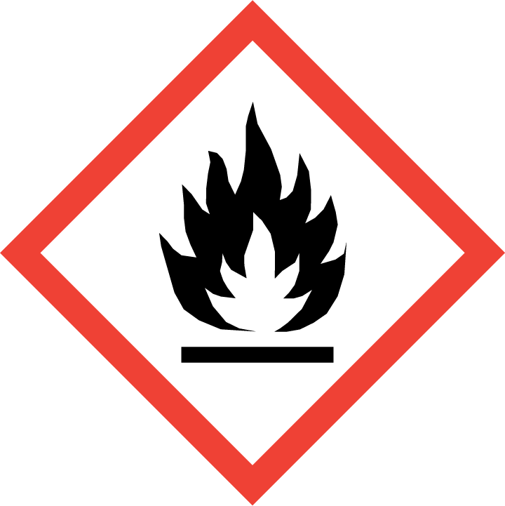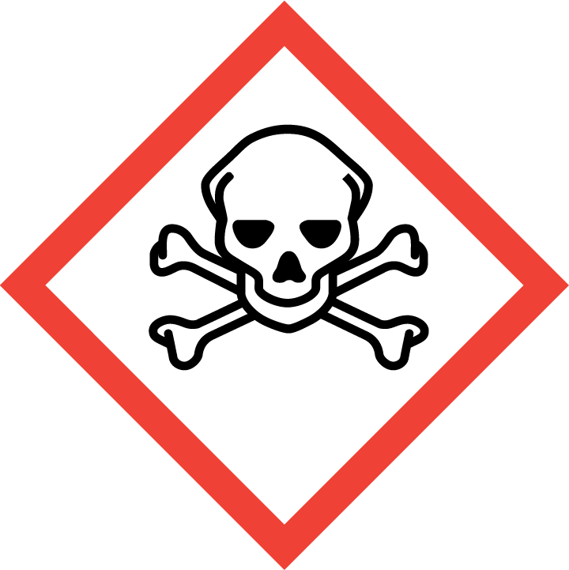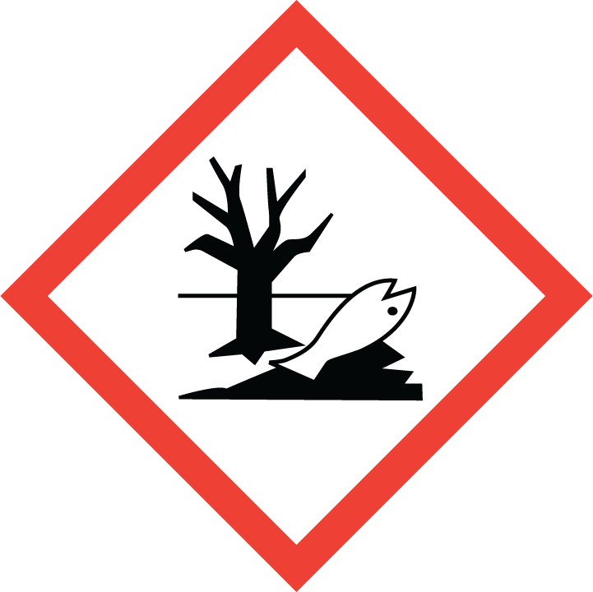
Section 3 – Engineering Controls and Personal Protective Equipment (PPE)
Engineering Controls: The use of hydrogen sulfide must be conducted in a properly-functioning chemical fume hood. The chemical fume hood must be approved and certified by REM and have a face velocity between 80 – 125 feet per minute.
Hygiene Measures: Wash thoroughly and immediately after handling. Remove any contaminated clothing and wash before reuse.
Hand Protection: Gloves must be worn. Nitrile gloves are recommended for low volume applications. Butyl rubber gloves are recommended for high volume applications. NOTE: Consult with your preferred glove manufacturer to ensure that the gloves you plan on using are compatible with the specific dangerous when wet material being handled.
Eye Protection: ANSI approved properly fitting safety glasses or chemical splash goggles.
Skin and Body Protection: Flame resistant lab coats must be worn and be appropriately sized for the individual and buttoned to their full length. Laboratory coat sleeves must be of sufficient length to prevent skin exposure while wearing gloves. Personnel should also wear full length pants, or equivalent, and close-toed shoes. Full length pants and close-toed shoes must be worn at all times by all individuals that are occupying the laboratory area. The area of skin between the shoe and ankle should not be exposed.
Respiratory Protection: If hydrogen sulfide is being used outside of a chemical fume hood, respiratory protection may be required. If this activity is necessary, contact REM (49-46371) so a respiratory protection analysis can be performed.
Section 4 – Special Handling and Storage Requirements
- Always wear appropriate PPE when handling. Avoid contact with skin, eyes, and clothing. Avoid inhalation.
- Keep containers tightly closed. Store in a cool, dry and well-ventilated area.
- Incompatible with the following materials: oxidizing materials, bases.
- Contents under pressure
- Cylinders should be stored and upright and secure
Section 5 – Spill and Accident Procedures
Immediately evacuate area and ensure others are aware of the spill. If there is an imminent threat building occupants, pull the nearest fire alarm station to evacuate the building and dial 911. If personnel have become exposed and need medical assistance, dial 911.
Section 6 – Waste Disposal Procedures
Store hazardous waste in closed containers that are properly labeled, and in a designated area. Complete a Chemical Waste Pickup Request Form to arrange for disposal by REM; detailed instructions are provided at the following link: http://www.purdue.edu/ehps/rem/hmm/chemwaste.htm.
Section 7 – Protocol/Procedure (Add lab specific Protocol/Procedure here)
Click here to enter text.
NOTE: Any deviation from this SOP requires approval from PI.
Section 8 – Documentation of Training (signature of all users is required)
Prior to conducting any work with hydrogen sulfide, the Principal Investigator must ensure that all laboratory personnel receive training on the content of this SOP.
I have read and understand the content of this SOP:
Name | Signature | Date
Click here to enter text. |  | Click here to enter a date.
Click here to enter text. |  | Click here to enter a date.
Click here to enter text. |  | Click here to enter a date.
Click here to enter text. |  | Click here to enter a date.
Click here to enter text. |  | Click here to enter a date.
Click here to enter text. |  | Click here to enter a date.
Click here to enter text. |  | Click here to enter a date.
Click here to enter text. |  | Click here to enter a date.
Click here to enter text. |  | Click here to enter a date.
Click here to enter text. |  | Click here to enter a date.
Click here to enter text. |  | Click here to enter a date.
Click here to enter text. |  | Click here to enter a date.

