Standard Operating Procedure
Hydrogen Peroxide
This is an SOP template and is not complete until: 1) lab specific information is entered into the box below 2) lab specific protocol/procedure is added to the protocol/procedure section and
3) SOP has been signed and dated by the PI and relevant lab personnel.
Print a copy and insert into your Lab-Specific Chemical Hygiene Plan.
Section 1 – Lab-Specific Information
Building/Room(s) covered by this SOP: | Click here to enter text.
Department: | Click here to enter a date.
Principal Investigator Name: | Click here to enter a date.
Principal Investigator Signature: | Click here to enter text.
Section 2 – Hazards
Hydrogen peroxide is a strong oxidizer that has a potential to cause a fire or explosion in contact with incompatible materials such as combustibles (e.g., wood, paper, organic solvents). It is corrosive and light-sensitive. It is toxic if swallowed and corrosive to the eyes and skin. Prolonged exposure may cause dermatitis.
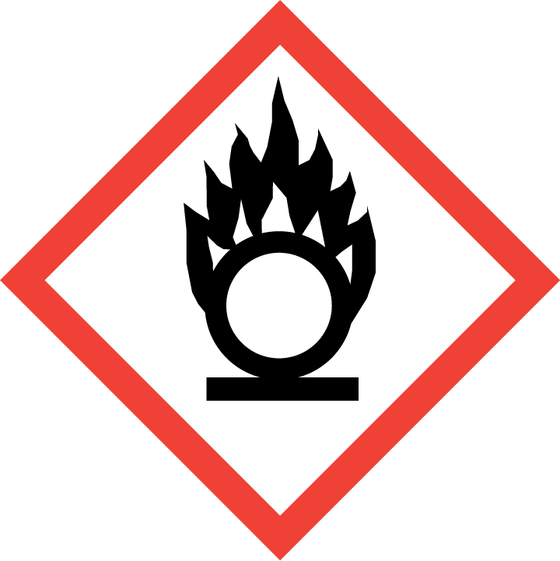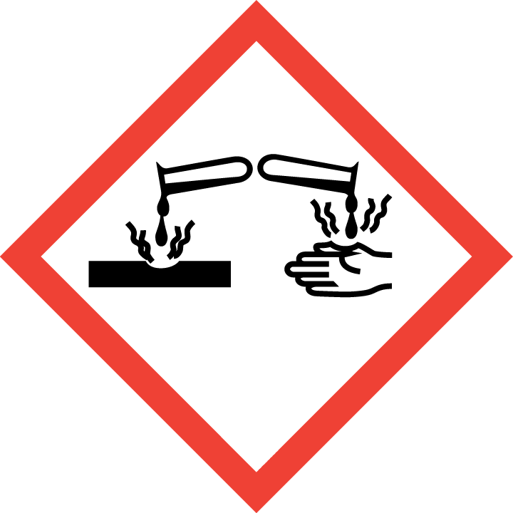
Section 3 – Engineering Controls and Personal Protective Equipment (PPE)
Engineering Controls: Use of hydrogen peroxide should be conducted in a properly functioning chemical fume hood whenever possible. The chemical fume hood must be approved and certified by REM and have a face velocity between 80 – 125 feet per minute.
Hygiene Measures: Avoid contact with skin, eyes, and clothing. Wash hands before breaks and immediately after handling the product.
Hand Protection: Chemical-resistant gloves must be worn, nitrile gloves are recommended for low volume applications. Wearing two pairs of nitrile gloves is recommended. NOTE: Consult with your preferred glove manufacturer to ensure that the gloves you plan on using are compatible with the specific chemical being used.
Eye Protection: ANSI approved properly fitting safety glasses or chemical splash goggles are required. A face shield may also be appropriate depending on the specific application.
Skin and Body Protection: Laboratory coats must be worn and be appropriately sized for the individual and buttoned to their full length. Personnel must also wear full length pants, or equivalent, and close-toed shoes. Full length pants and close-toed shoes must be worn at all times by all individuals that are occupying the laboratory area. The area of skin between the shoe and ankle must not be exposed.
Respiratory Protection: If hydrogen peroxide solution is being used outside of a chemical fume hood, respiratory protection may be required. If this activity is necessary, contact REM (49-46371) so a respiratory protection analysis can be performed.
Vent
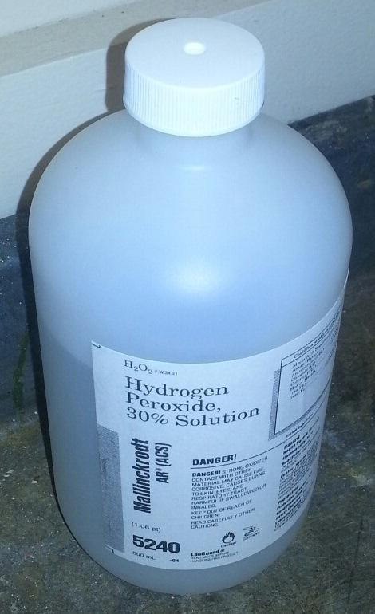
Section 4 – Special Handling and Storage Requirements
- Avoid contact with skin, eyes, and clothing. Avoid inhalation or ingestion.
- Hydrogen peroxide solutions greater than 10% should be kept in their original container with the manufacturer cap that allows the container to vent oxygen while in storage as shown in the picture to the right.
- Do not store hydrogen peroxide solutions greater than 10% in glass containers; only plastic containers should be used for storage.
- Keep container tightly closed in a dry and well-ventilated area. Opened containers must be carefully resealed and kept upright to prevent leakage. Recommended storage temperature is 2 – 8 ºC.
- Store away from combustible materials. Do not store on wooden shelves. Store away from all organic compounds, including organic solvents.
- Avoid contact with powdered metals, zinc, iron, copper, nickel, and brass.
Section 5 – Spill and Accident Procedures
Immediately evacuate area and ensure others are aware of the spill. If there is an imminent threat of a fire, pull the nearest fire alarm station to evacuate the building and dial 911. If personnel have become exposed and need medical assistance, dial 911. If the spill is minor and does not pose a threat to personnel, contact REM at 49-40121 during normal business hours (Monday – Friday, 7 AM – 4 PM) for spill cleanup assistance (dial 911 if spill occurs after hours and assistance is needed).
Section 6 – Waste Disposal Procedures
Store hazardous waste in closed containers that are properly labeled, and in a designated area (flammable cabinet is recommended). No oxidizers are permitted to be poured down the drain. Complete a Chemical Waste Pickup Request Form to arrange for disposal by REM; detailed instructions are provided at the following link: http://www.purdue.edu/ehps/rem/hmm/chemwaste.htm.
Section 7 – Protocol/Procedure (Additional lab protocol may be added here)
Click here to enter text.
NOTE: Any deviation from this SOP requires approval from Principal Investigator.
Section 8 – Documentation of Training (signature of all users is required)
Prior to conducting any work with hydrogen peroxide, the Principal Investigator must ensure that all laboratory personnel receive training on the content of this SOP.
I have read and understand the content of this SOP:
Name | Signature | Date
Click here to enter text. |  | Click here to enter a date.
Click here to enter text. |  | Click here to enter a date.
Click here to enter text. |  | Click here to enter a date.
Click here to enter text. |  | Click here to enter a date.
Click here to enter text. |  | Click here to enter a date.
Click here to enter text. |  | Click here to enter a date.
Click here to enter text. |  | Click here to enter a date.
Click here to enter text. |  | Click here to enter a date.
Click here to enter text. |  | Click here to enter a date.
Click here to enter text. |  | Click here to enter a date.
Click here to enter text. |  | Click here to enter a date.
Click here to enter text. |  | Click here to enter a date.

