Standard Operating Procedure
Flammable Solids
This is an SOP template and is not complete until: 1) lab specific information is entered into the box below 2) lab specific protocol is added to the protocol section and
3) SOP has been signed and dated by the PI and relevant lab personnel.
Print a copy and insert into your Lab-Specific Chemical Hygiene Plan.

Section 1 – Lab-Specific Information
Building/Room(s) covered by this SOP: | Click here to enter text.
Department: | Click here to enter a date.
Principal Investigator Name: | Click here to enter text.
Principal Investigator Signature: | Click here to enter text.
Section 2 – Hazards
A flammable solid is a solid which is readily combustible, or may cause or contribute to a fire through friction. Readily combustible solids are powdered, granular, or pasty substances which are dangerous if they can be easily ignited by brief contact with an ignition source. Flammable solids are more hazardous when widely dispersed in a confined space (e.g., finely divided metal powders). Heating may cause a fire. There is a risk of fire by shock, friction, or other sources of ignition. A flammable solid may be harmful if ingested, inhaled, or absorbed through the skin. They may cause irritation to the gastrointestinal tract, respiratory tract, skin, and eyes.
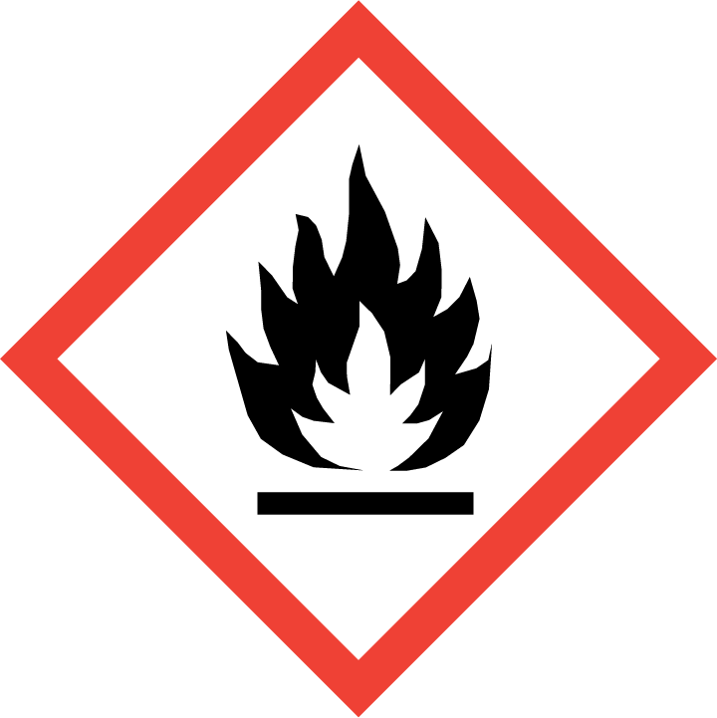
Section 3 – Engineering Controls and Personal Protective Equipment (PPE)
Engineering Controls: Use of flammable solids should be conducted in a glove box or properly functioning chemical fume hood whenever possible. The chemical fume hood must be approved and certified by REM and have a face velocity between 80 – 125 feet per minute. Properly engineered ventilation is extremely important when handling larger quantities of flammable solids. Therefore, consultation with REM (4-6371) should be made prior to working with large volumes of flammable solids.
Hygiene Measures: Avoid contact with skin, eyes, and clothing. Wash hands before breaks and immediately after handling the product.
Hand Protection: Gloves must be worn. Use proper glove removal technique to avoid any skin contact. Nitrile gloves are recommended. Wearing two pairs of nitrile gloves is recommended. NOTE: Consult with your preferred glove manufacturer to ensure that the gloves you plan on using are compatible with the specific chemical being used.
Eye Protection: ANSI approved properly fitting safety glasses or chemical splash goggles are required. A face shield may also be appropriate depending on the specific application.
Skin and Body Protection: Flame resistant lab coats must be worn and be appropriately sized for the individual and buttoned to their full length. Laboratory coat sleeves must be of sufficient length to prevent skin exposure while wearing gloves. Personnel should also wear full length pants, or equivalent, and close-toed shoes. Full length pants and close-toed shoes must be worn at all times by all individuals that are occupying the laboratory area. The area of skin between the shoe and ankle should not be exposed.
Respiratory Protection: If flammable solids are being used outside of a chemical fume hood, respiratory protection may be required. If this activity is necessary, contact REM (4-6371) so a respiratory protection analysis can be performed.
Section 4 – Special Handling and Storage Requirements
- Avoid contact with skin, eyes, and clothing.
- Avoid inhalation and ingestion.
- Avoid formation and accumulation of dust. Use only in a well-ventilated area.
- Keep away from heat, shock, friction, and sources of ignition- No smoking. Prevent build-up of electrostatic charge. Use spark-proof tools and explosion-proof equipment.
- Handle and open container with care. Never work with flammable solid materials alone.
- Flammable materials should be stored in a separate safety storage cabinet or room.
- Keep containers tightly closed. Store in a cool, dry and well-ventilated area away from incompatible substances.
- Any expired or unnecessary reactive materials should be properly disposed of as hazardous waste.
- All flammable solids should be clearly labeled with the original manufacturer’s label, which should have the chemical name, hazard labels, and pictograms. The label should not be defaced in any way.
Section 5 – Spill and Accident Procedures
Immediately evacuate area and ensure others are aware of the spill. If there is an imminent threat of a fire, pull the nearest fire alarm station to evacuate the building and dial 911. If personnel have become exposed and need medical assistance, dial 911. If the spill is minor and does not pose a threat to personnel, contact REM at 49-40121 during normal business hours (Monday – Friday, 7 AM – 4 PM) for spill cleanup assistance (dial 911 if spill occurs after hours and assistance is needed).
Section 6 – Waste Disposal Procedures
Store hazardous waste in closed containers that are properly labeled, and in a designated area (flammable cabinet is recommended). Flammable and combustible liquid waste should be segregated from all incompatibles such as oxidizers. No flammable or combustible liquids (including alcohols) are permitted to be poured down the drain. Complete a Chemical Waste Pickup Request Form to arrange for disposal by REM; detailed instructions are provided at the following link: http://www.purdue.edu/ehps/rem/hmm/chemwaste.htm.
Section 7 – Protocol (Additional lab protocol may be added here)
Click here to enter text.
NOTE: Any deviation from this SOP requires approval from the Principal Investigator.
Section 8 – Documentation of Training (signature of all users is required)
Prior to conducting any work with flammable solids, the Principal Investigator must ensure that all laboratory personnel receive training on the content of this SOP.
I have read and understand the content of this SOP:
Name | Signature | Date
Click here to enter text. |  | Click here to enter a date.
Click here to enter text. |  | Click here to enter a date.
Click here to enter text. |  | Click here to enter a date.
Click here to enter text. |  | Click here to enter a date.
Click here to enter text. |  | Click here to enter a date.
Click here to enter text. |  | Click here to enter a date.
Click here to enter text. |  | Click here to enter a date.
Click here to enter text. |  | Click here to enter a date.
Click here to enter text. |  | Click here to enter a date.

