Standard Operating Procedure
Ethidium Bromide
This is an SOP template and is not complete until: 1) lab specific information is entered into the box below 2) lab specific protocol is added to the protocol section and
3) SOP has been signed and dated by the PI and relevant lab personnel.
Print a copy and insert into your Lab-Specific Chemical Hygiene Plan.
Section 1 – Lab-Specific Information
Building/Room(s) covered by this SOP: | Click here to enter text.
Department: | Click here to enter a date.
Principal Investigator Name: | Click here to enter text.
Principal Investigator Signature: | Click here to enter text.
Section 2 –Hazards
Ethidium bromide is classified by OSHA as highly toxic by inhalation, harmful by ingestion, and a mutagen. Avoid breathing dust, fumes, gas, vapor, mist, or spray. Toxic if inhaled. Ethidium bromide is suspected of causing genetic defects.
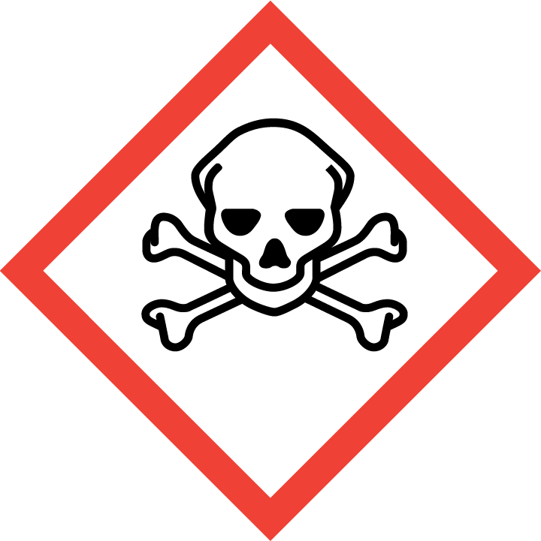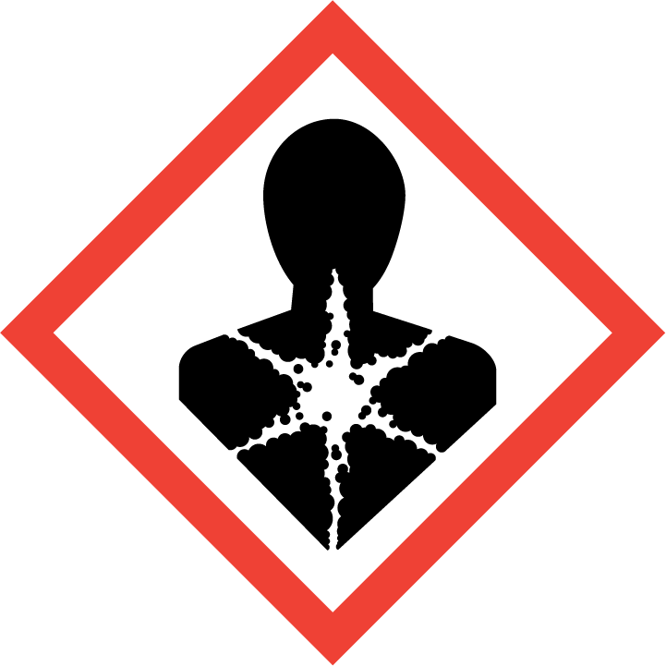
Section 3 – Engineering Controls and Personal Protective Equipment (PPE)
Engineering Controls: Under normal working conditions where ethidium bromide is in very low concentrations in agarose gel or in an aqueous solution, use in chemical fume hood is not required, but recommended. However, all ethidium bromide powder (pure product) must be handled in a properly functioning chemical fume hood. The chemical fume hood must be approved and certified by REM and have a face velocity between 80 – 125 feet per minute.
Hygiene Measures: Avoid contact with skin, eyes, and clothing. Wash hands before breaks and immediately after handling the product.
Hand Protection: Chemical-resistant gloves must be worn, nitrile gloves are recommended. Wearing two pairs of nitrile gloves is recommended. NOTE: Consult with your preferred glove manufacturer to ensure that the gloves you plan on using are compatible with the specific chemical being used.
Eye Protection: ANSI approved properly fitting safety glasses or chemical splash goggles are required. A face shield may also be appropriate depending on the specific application.
Skin and Body Protection: Laboratory coats must be worn and be appropriately sized for the individual and buttoned to their full length. Personnel must also wear full length pants, or equivalent, and close-toed shoes. Full length pants and close-toed shoes must be worn at all times by all individuals that are occupying the laboratory area. The area of skin between the shoe and ankle must not be exposed.
Respiratory Protection: Under normal working conditions where ethidium bromide is in very low concentrations in agarose gel or in an aqueous solution, respiratory protection is not required. However, all ethidium bromide powder (pure product) must be handled in a properly functioning chemical fume hood.
Section 4 – Special Handling and Storage Requirements
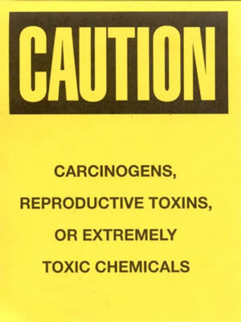
- Designate an area where ethidium bromide work is going to occur and only handle it in this area (i.e. chemical fume hood, bench top). The area should be posted with a “Caution, Carcinogen, Reproductive Toxins, or Extremely Toxic Chemicals” label provided by REM (as shown to the right).
- A current copy of the SDS for the specific ethidium bromide powder or solution and concentration must be made available to all personnel working in the laboratory at all times.
- It is recommended that the surfaces of the designated area be covered with an appropriate liner (i.e. plastic, chemical resistant liner). If the liner becomes contaminated, it can be replaced and disposed of as ethidium bromide contaminated debris.
- If a liner cannot be used, then the surfaces of the work area should be decontaminated routinely. All spills or evidence of contamination should be cleaned immediately.
- Avoid contact with skin and eyes and inhalation.
- Keep containers tightly closed.
- Store in a cool, dry and well-ventilated area.
- Containers which are opened must be carefully resealed and kept upright to prevent leakage.
- Routinely decontaminate the area where ethidium bromide is used. Decontamination procedures are detailed below:
Decontamination Procedures:
- Prepare the following decontamination solution:
  - 4.2 grams of sodium nitrite (NaNO₂)
  - 20 milliliters of 50% hypophosphorous acid solution (H₃PO₂)
  - 300 milliliters of water
- Soak a paper towel in the decontamination solution and thoroughly wash the contaminated area.
- Once the contaminated area has been thoroughly washed with the decontamination solution, rinse the area 5 times with tap water using a clean paper towel for each rinse.
- Soak all spent paper towels in the decontamination solution for one hour. Gently wring out excess solution and dispose of as hazardous waste with contaminated gloves, pipette tips or any other solid ethidium bromide debris.
- Using a UV light, check to ensure all ethidium bromide has been removed.
- The decontamination solution should be collected in an appropriate container and labeled as hazardous waste (i.e. Water 95%, hypophosphorus acid 3%, Sodium Nitrite 1%, ethidium Bromide 1%).
Note: Hypophosphorous acid is a DEA List chemical. When purchasing this product, you and your PI will have to fill out and sign an “Authorized Purchaser” form. This is simply a company’s method of ensuring you will not misuse the material.
Section 5 – Spill and Accident Procedures
Immediately isolate the area and ensure others are aware of the spill. If there is an imminent threat of a fire, pull the nearest fire alarm station to evacuate the building and dial 911. If personnel have become exposed and need medical assistance, dial 911. If the spill is minor and does not pose a threat to personnel, contact REM at 49-40121 during normal business hours (Monday – Friday, 7 AM – 4 PM) for spill cleanup assistance (dial 911 if spill occurs after hours and assistance is needed). If lab personnel feel comfortable cleaning up the spill, then they can do so as long as proper training has been provided. The spilled material should be absorbed and/or collected and put in an appropriate container (e.g., bucket and/or bag) for proper disposal by REM. The decontamination procedures detailed in Section 4 of this SOP should be followed for decontaminating surfaces.
Section 6 – Waste Disposal Procedures
Ethidium bromide waste must be collected and managed as hazardous waste, not biological waste. PPE, absorbent materials, liners or other debris contaminated with ethidium bromide must also be collected as hazardous waste. All solid ethidium bromide waste, including debris and dry agarose gels, should be placed in an appropriate container and labeled accordingly. Please double-bag solid waste in two black trash bags. Do not use orange biohazard waste bags unless the waste is also infectious (biohazard). The buffers and solutions used with ethidium bromide gels can be submitted to REM as chemical waste or put down the drain only if a filter especially designed for removal of ethidium bromide is used. There are several commercially available filtering systems that can be purchased. One such product can be found at the following link: http://www.thomassci.com/Supplies/Filtering-Funnels/_/Extractor-EtBr-Waste-Reduction-System/. Complete a Chemical Waste Pickup Request Form to arrange for disposal by REM; detailed instructions are provided at the following link: http://www.purdue.edu/ehps/rem/hmm/chemwaste.htm.
Section 7 – Protocol (Add lab specific Protocol here)
Click here to enter text.
NOTE: Any deviation from this SOP requires approval from Principal Investigator.
Section 8 – Documentation of Training (signature of all users is required)
Prior to conducting any work with ethidium bromide, the Principal Investigator must ensure that all laboratory personnel receive training on the content of this SOP.
I have read and understand the content of this SOP:
Name | Signature | Date
Click here to enter text. |  | Click here to enter a date.
Click here to enter text. |  | Click here to enter a date.

