Standard Operating Procedure
Corrosives
This is an SOP template and is not complete until: 1) lab specific information is entered into the box below 2) lab specific protocol is added to the protocol section and
3) SOP has been signed and dated by the PI and relevant lab personnel.
Print a copy and insert into your Lab-Specific Chemical Hygiene Plan.

Section 1 – Lab-Specific Information
Building/Room(s) covered by this SOP: | Click here to enter text.
Department: | Click here to enter a date.
Principal Investigator Name: | Click here to enter a date.
Principal Investigator Signature: | Click here to enter text.

Section 2 – Important Definitions
- Acid: Any chemical compound which, when dissolved in water, gives a solution with a pH of less than 7.0.
- Mineral Acid: A compound having atoms of hydrogen, identifying nonmetal (typically chlorine, sulfur, or phosphorus), and maybe oxygen. Sulfuric acid (H₂SO₄) and hydrochloric acid (HCl) are examples of mineral acids.
- Organic Acid: An organic compound with acidic properties. Generally, organic acids are also flammable. Acetic acid (CH₃COOH) and Formic acid (HCOOH) are examples of organic acids.
- Base: Any chemical compound which, when dissolved in water, gives a solution with a pH of greater than 7.0.
Section 3 – Hazards
Corrosives may be harmful if inhaled, ingested, or absorbed through the skin. Inhalation may cause irritation to the respiratory tract with burning pain in the nose and throat, coughing, wheezing, shortness of breath and pulmonary edema. Contact with skin causes burns and irritation. Eye contact causes burns, irritation, a may cause blindness. Ingestion may cause permanent damage to the digestive tract. It is destructive to the tissue of the mucous membranes and upper respiratory tract. Acids and bases may have other hazards associated with them, such as flammability, oxidizer, or toxicity. Note: Refer to SOP of Hydrofluoric acid (HF) for specific hazards and safety information.
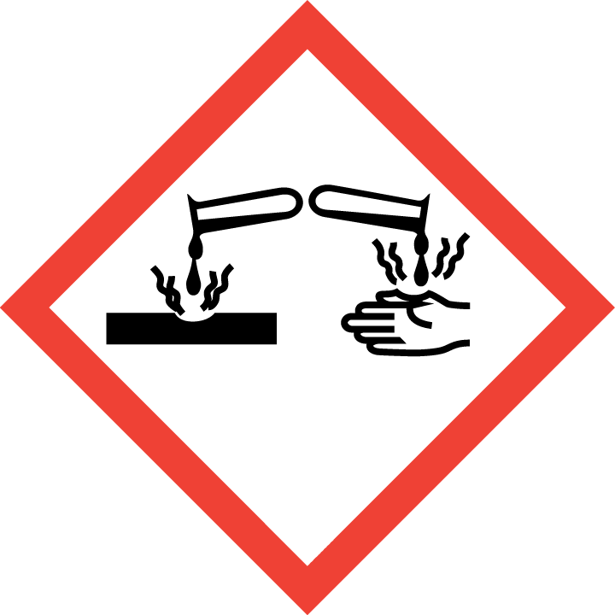

Section 4 – Engineering and Personal Protective Equipment (PPE)
Engineering Controls: Use of corrosive materials should be conducted in a properly functioning chemical fume hood whenever possible. The chemical fume hood must be approved and certified by REM and have a face velocity between 80 – 125 feet per minute.
Hygiene Measures: Avoid contact with skin, eyes, and clothing. Wash hands before breaks and immediately after handling the product.
Hand Protection: Chemical-resistant gloves must be worn, nitrile gloves are recommended for low volume applications. For high volume applications, disposable gloves are not appropriate; a heavy-duty glove is required such as butyl rubber, Viton, or equivalent. NOTE: Consult with your preferred glove manufacturer to ensure that the gloves you plan on using are compatible with the specific chemical being used.
Eye Protection: ANSI approved properly fitting safety glasses or chemical splash goggles are required. A face shield may be required for high volume applications.
Skin and Body Protection: Laboratory coats must be worn and be appropriately sized for the individual and buttoned to their full length. For high volume applications, additional PPE such as a chemical-resistant apron may be required. Personnel must also wear full length pants, or equivalent, and close-toed shoes. Full length pants and close-toed shoes must be worn at all times by all individuals that are occupying the laboratory area. The area of skin between the shoe and ankle must not be exposed.
Respiratory Protection: If corrosive materials are being used outside of a chemical fume hood, respiratory protection may be required. If this activity is necessary, contact REM (49-46371) so a respiratory protection analysis can be performed.

Section 5 – Special Handling and Storage Requirements
- Do not over purchase; only purchase what can be safely stored in the laboratory.
- Avoid contact with skin and eyes. Avoid inhalation of vapor or mist. Avoid formation of dust.
- Always use inside a properly functioning chemical fume hood.
- Note: In case you need to dilute the concentration of acids, always add acid to water.
- Keep container upright and tightly closed in a dry and well-ventilated place.
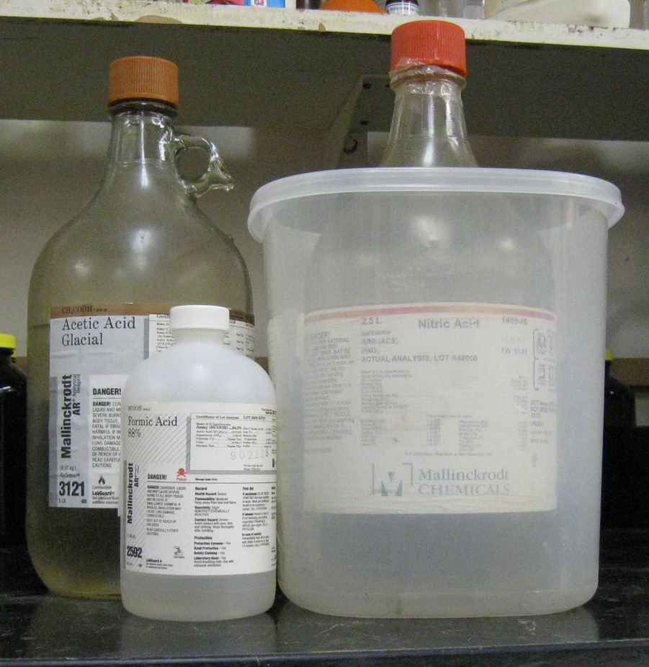
- Containers which are opened must be carefully resealed and kept upright to prevent leakage.
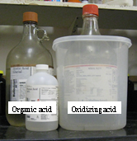
- Keep away from sources of ignition. Avoid heat and shock or friction when handling.
- Store in original container. Acids should not be stored in metal containers.
- Keep away from incompatible materials. Acids and bases should not be stored together. Organic acids and oxidizing acids must be stored separately or with proper secondary containment (see below).
Organic acid
Oxidizing acid
- Use in the smallest practical quantities for the experiment being performed.
- Work must be conducted in a chemical fume hood if the chemical is irritating to the eyes or respiratory system, and/or is toxic by inhalation.
- A current copy of the SDS for the specific toxic chemical being used must be made available to all personnel working in the laboratory at all times.
Demonstration of proper use of secondary containment with Organic and Oxidizing acids
- Containers should remain closed when not in use.
- Containers should be labeled appropriately. Label should indicate the name of the chemical(s) in the container. Avoid using chemical abbreviations (acceptable if a legend is present in the lab) and formulae.
- Containers should be in good condition and compatible with the material.
- Transport all corrosives in secondary containment, such as polyethylene or other non-reactive acid/solvent bottle carrier.
- Corrosives must be segregated from incompatible materials. Incompatibilities will be noted in Section 10 of the SDS, “Stability and Reactivity”.

Section 6 – Spill and Accident Procedures
Immediately evacuate area and ensure others are aware of the spill. If there is an imminent threat of a fire, pull the nearest fire alarm station to evacuate the building and dial 911. If personnel have become exposed and need medical assistance, dial 911. If the spill is minor and does not pose a threat to personnel, contact REM at 49-40121 during normal business hours (Monday – Friday, 7 AM – 4 PM) for spill cleanup assistance (dial 911 if spill occurs after hours and assistance is needed).

Section 7 – Waste Disposal Procedures
Store hazardous waste in closed containers that are properly labeled, and in a designated area. Corrosive waste should be segregated from all incompatibles (e.g., acids away from bases). No corrosive wastes are permitted to be poured down the drain. Complete a Chemical Waste Pickup Request Form to arrange for disposal by REM; detailed instructions are provided at the following link: http://www.purdue.edu/ehps/rem/hmm/chemwaste.htm.

Section 8 – Protocol (Additional lab protocol may be added here)
Click here to enter text.
NOTE: Any deviation from this SOP requires approval from Principal Investigator.

Section 9 – Documentation of Training (signature of all users is required)
Prior to conducting any work with corrosives, the Principal Investigator must ensure that all laboratory personnel receive training on the content of this SOP.
I have read and understand the content of this SOP:
Name | Signature | Date
Click here to enter text. |  | Click here to enter a date.
Click here to enter text. |  | Click here to enter a date.
Click here to enter text. |  | Click here to enter a date.

