Standard Operating Procedure
Boron Trifluoride
This is an SOP template and is not complete until: 1) lab specific information is entered into the box below 2) lab specific protocol/procedure is added to the protocol/procedure section and
3) SOP has been signed and dated by the PI and relevant lab personnel.
Print a copy and insert into your Lab-Specific Chemical Hygiene Plan.
Section 1 – Lab-Specific Information
Building/Room(s) covered by this SOP: | Click here to enter text.
Department: | Click here to enter a date.
Principal Investigator Name: | Click here to enter text.
Principal Investigator Signature: | Click here to enter text.
Section 2 – Hazards
Boron trifluoride is toxic and flammable reactive compressed gas. It reacts violently with water, and should avoid moisture and strong oxidizing agents. May cause respiratory tract burns, skin burns, eye burns, mucous membrane burns. Containers may rupture or explode if exposed to heat. It can release a toxic, corrosive, flammable or explosive gas. Boron trifluoride may be fatal if inhaled.
Boron trifluoride gas may cause severe skin irritation, chemical burns with ulceration, and scarring. With prolonged or widespread contact, the skin may absorb potentially harmful amounts of material. It may cause chemical burns of the mouth, throat, esophagus, and stomach, with severe abdominal and chest pain if swallowed. Eye exposure causes pain and irritation with tearing and can result in slight redness and irritation to blindness.
Prolonged or repeated exposure to vapor may discolor and erode the teeth, ulcerate the nasal mucosa, and cause nose and gum bleeds, and cause skin dermatitis.
Reacts with common substances including water, organics, hydrogen, ammonia, grease, oxygen, alcohols, nitrogen peroxide.
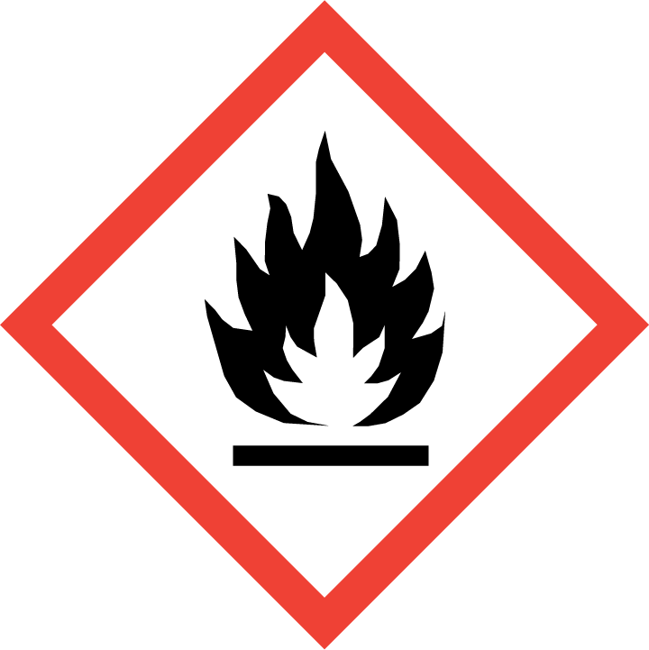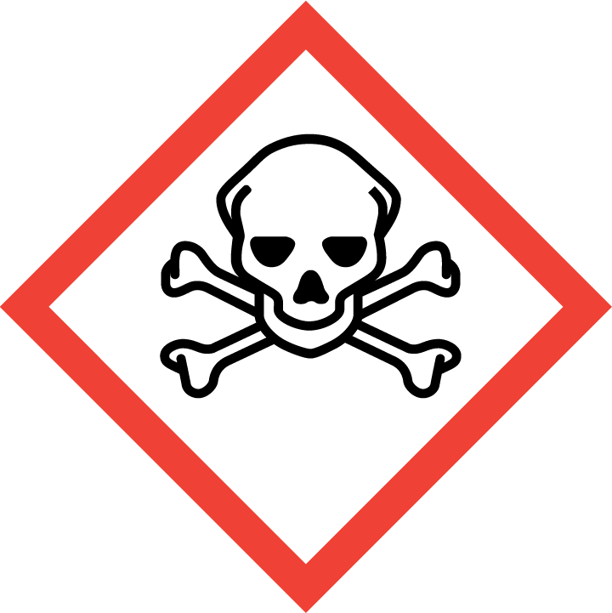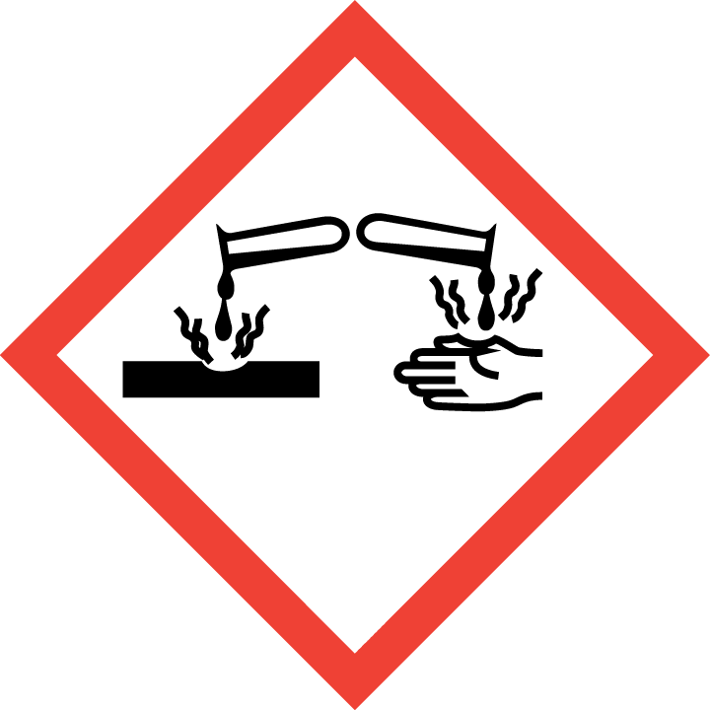
Section 3 – Engineering Controls and Personal Protective Equipment (PPE)
Engineering Controls: Boron trifluoride must be handled in a chemical fume hood or in an inert atmosphere, such as a glove box. Refer to the SDS of the specific material for handling recommendations. The chemical fume hood must be approved and certified by REM and have a face velocity between 80 – 125 feet per minute. Inside the fume hood, keep these materials away from oxidizing agents, acids, and moisture/water.
Hygiene Measures: Avoid contact with skin, eyes, and clothing. Wash hands before breaks and immediately after handling the product.
Hand Protection: Chemical-resistant gloves must be worn, nitrile gloves are recommended. Wearing two pairs of nitrile gloves is recommended. NOTE: Consult with your preferred glove manufacturer to ensure that the gloves you plan on using are compatible with the specific chemical being used.
Eye Protection: ANSI approved properly fitting safety glasses or chemical splash goggles are required. A face shield may also be appropriate depending on the specific application.
Skin and Body Protection: Flame resistant laboratory coats must be worn and be appropriately sized for the individual and buttoned to their full length. Personnel must also wear full length pants, or equivalent, and close-toed shoes. Full length pants and close-toed shoes must be worn at all times by all individuals that are occupying the laboratory area. The area of skin between the shoe and ankle must not be exposed.
Respiratory Protection: Pyrophoric material, such as boron trifluoride, should never be used outside of a chemical fume hood or glove box; therefore respiratory protection should not be required.
Section 4 – Special Handling and Storage Requirements
- Precautions for safe handling: water-reactive (W), use extreme care when handling.
- Avoid contact with skin and eyes and inhalation.
- Conduct the procedure only after a supervisor has observed the user performing the proper technique unassisted. Do not work with dangerous when wet materials alone.
- Keep away from sources of ignition.
- Keep away from water and aqueous solutions.
- Keep containers tightly closed. Store in a cool, dry and well-ventilated area away from incompatible substances such as aqueous solutions, strong bases, Potassium, oxidizers, alcohols and metals.
- Dangerous when wet materials should be stored in secondary containment.
- The amount of dangerous when wet materials stored should be kept at a minimum.
- Any expired or unnecessary reactive materials should be properly disposed of as hazardous waste.
- All dangerous when wet materials should be clearly labeled with the original manufacturer’s label, which should have the chemical name, hazard labels, and pictograms. The label should not be defaced in any way.
- Suitable storage locations include inert gas-filled desiccators or glove boxes, flammable storage cabinets that do not contain aqueous or other incompatible chemicals, or intrinsically safe refrigerators or freezers that also do not contain aqueous or other incompatible chemicals.
- A current copy of the boron trifluoride Safety Data Sheet (SDS) must be made available to all personnel working in the laboratory at all times.
Section 5 – Spill and Accident Procedures
Immediately evacuate area and ensure others are aware of the spill. If there is an imminent threat of a fire, pull the nearest fire alarm station to evacuate the building and dial 911. If personnel have become exposed and need medical assistance, dial 911.
Section 6 – Waste Disposal Procedures
Store hazardous waste in closed containers that are properly labeled, and in a designated area (flammable cabinet is recommended) away from incompatible chemicals such as aqueous solutions. Complete a Chemical Waste Pickup Request Form to arrange for disposal by REM; detailed instructions are provided at the following link: http://www.purdue.edu/ehps/rem/hmm/chemwaste.htm.
Section 7 – Protocol (Add lab specific Protocol here)
Click here to enter text.
NOTE: Any deviation from this SOP requires approval from Principal Investigator.
Section 8 – Documentation of Training (signature of all users is required)
Prior to conducting any work with boron trifluoride, the Principal Investigator must ensure that all laboratory personnel receive training on the content of this SOP.
I have read and understand the content of this SOP:
Name | Signature | Date
Click here to enter text. |  | Click here to enter a date.
Click here to enter text. |  | Click here to enter a date.
Click here to enter text. |  | Click here to enter a date.
Click here to enter text. |  | Click here to enter a date.
Click here to enter text. |  | Click here to enter a date.
Click here to enter text. |  | Click here to enter a date.
Click here to enter text. |  | Click here to enter a date.
Click here to enter text. |  | Click here to enter a date.

