Standard Operating Procedure
2-Mercaptoethanol
This is an SOP template and is not complete until: 1) lab specific information is entered into the box below 2) lab specific protocol/procedure is added to the protocol/procedure section and
3) SOP has been signed and dated by the PI and relevant lab personnel.
Print a copy and insert into your Lab-Specific Chemical Hygiene Plan.
Section 1 – Lab-Specific Information
Building/Room(s) covered by this SOP: | Click here to enter text.
Department: | Click here to enter a date.
Principal Investigator Name: | Click here to enter text.
Principal Investigator Signature: | Click here to enter text.
Section 2 – Hazards
2-Mercaptoethanol is extremely toxic if swallowed or inhaled and can be fatal if absorbed through the skin. It is corrosive and can cause severe burns to the skin and eyes. It is also a combustible liquid. This compound is extremely toxic to aquatic life and has long-lasting effects in the environment. Additionally, it has an extremely unpleasant odor that can be detected at very low concentrations (stench chemical).
Exposure Limits:
OSHA PEL (8 HR. TWA): 0.2 ppm
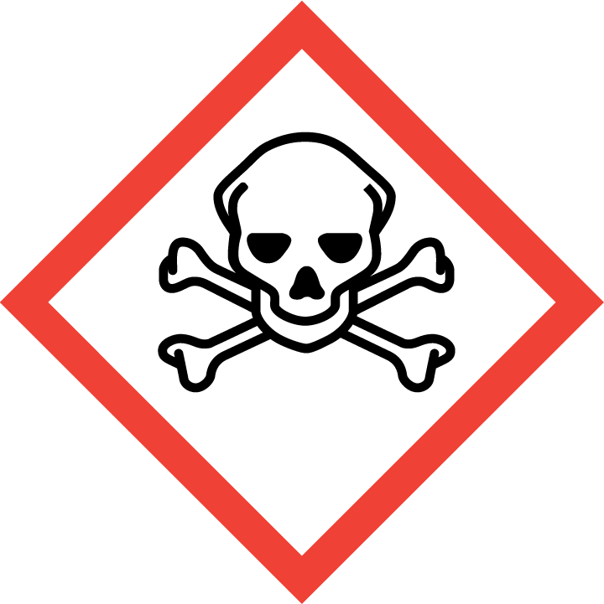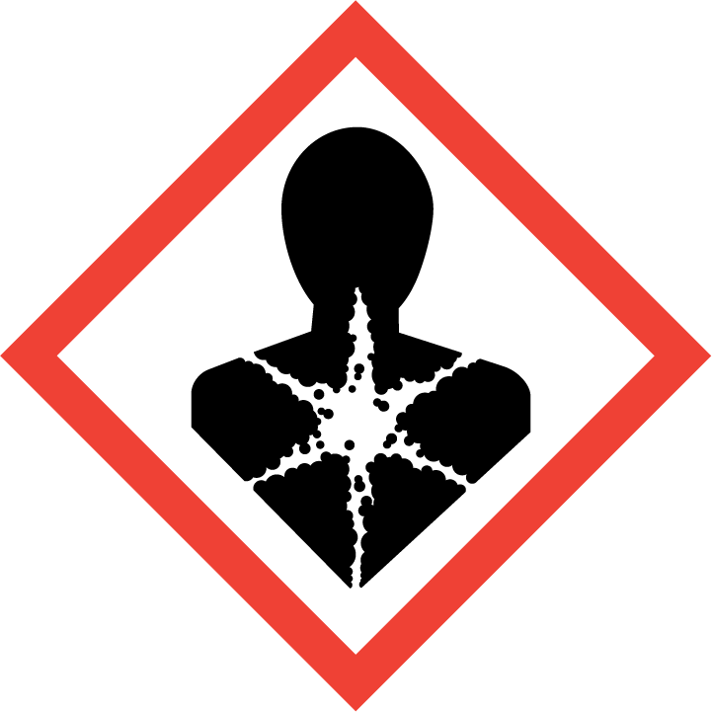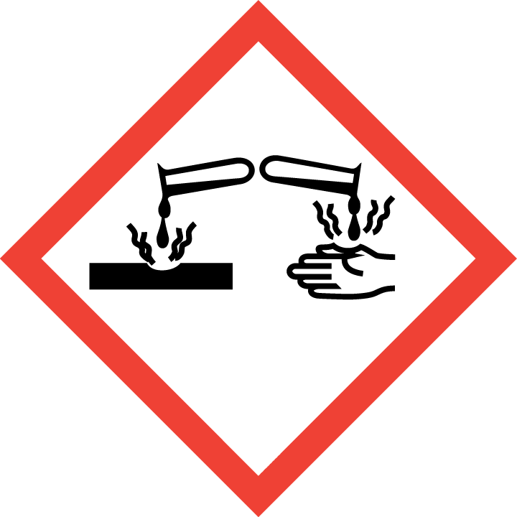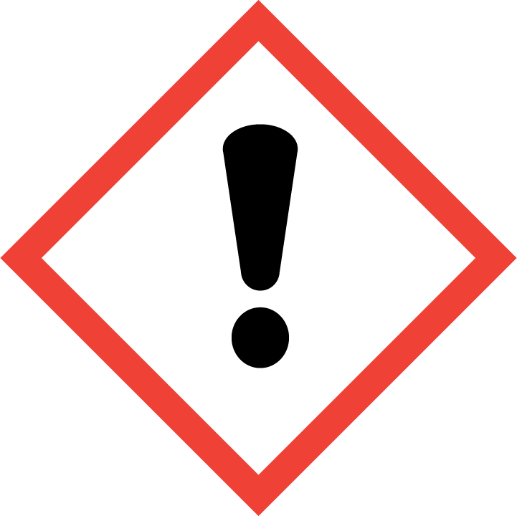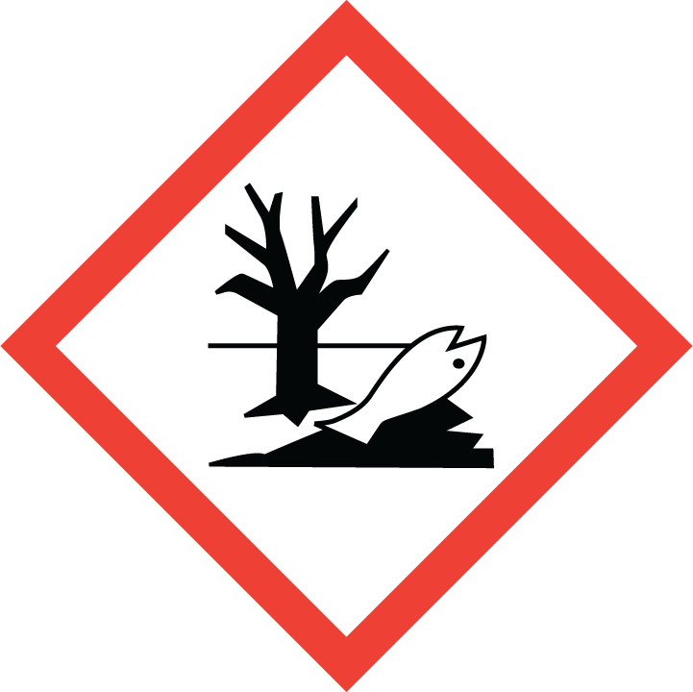
Section 3 – Engineering Controls and Personal Protective Equipment (PPE)
Engineering Controls: Use of 2-mercaptoethanol must be conducted in a properly functioning chemical fume hood. The chemical fume hood must be approved and certified by REM and have a face velocity between 80 – 125 feet per minute.
Hygiene Measures: Avoid contact with skin, eyes, and clothing. Wash hands before breaks and immediately after handling the product.
Hand Protection: Chemical-resistant gloves must be worn, nitrile gloves are recommended. Wearing two pairs of nitrile gloves is recommended. Contaminated gloves (even just a few drops) must be disposed of as hazardous waste (due to odor). NOTE: Consult with your preferred glove manufacturer to ensure that the gloves you plan on using are compatible with the specific chemical being used.
Eye Protection: ANSI approved properly fitting safety glasses or chemical splash goggles are required. A face shield may also be appropriate depending on the specific application.
Skin and Body Protection: Laboratory coats must be worn and be appropriately sized for the individual and buttoned to their full length. Personnel must also wear full length pants, or equivalent, and close-toed shoes. Full length pants and close-toed shoes must be worn at all times by all individuals that are occupying the laboratory area. The area of skin between the shoe and ankle must not be exposed.
Respiratory Protection: 2-Mercaptoethanol should never be used outside of a chemical fume hood or glove box; therefore respiratory protection should not be required.

Section 4 – Special Handling and Storage Requirements
- Do not over purchase; only purchase what can be safely stored in the laboratory.
- Avoid contact with skin, eyes, and clothing. Avoid inhalation of vapor or mist.
- Always use inside of a chemical fume hood. 2-Mercaptoethanol has an unpleasant odor at extremely low concentrations. Therefore, extreme care should be taken when handling; always work with under a chemical fume hood.
- Keep container upright and tightly closed in a dry and well-ventilated place. Containers should remain closed when not in use. A vented chemical cabinet or storage fume hood is recommended. Consider using a secondary sealed container (over pack) to minimize odors.
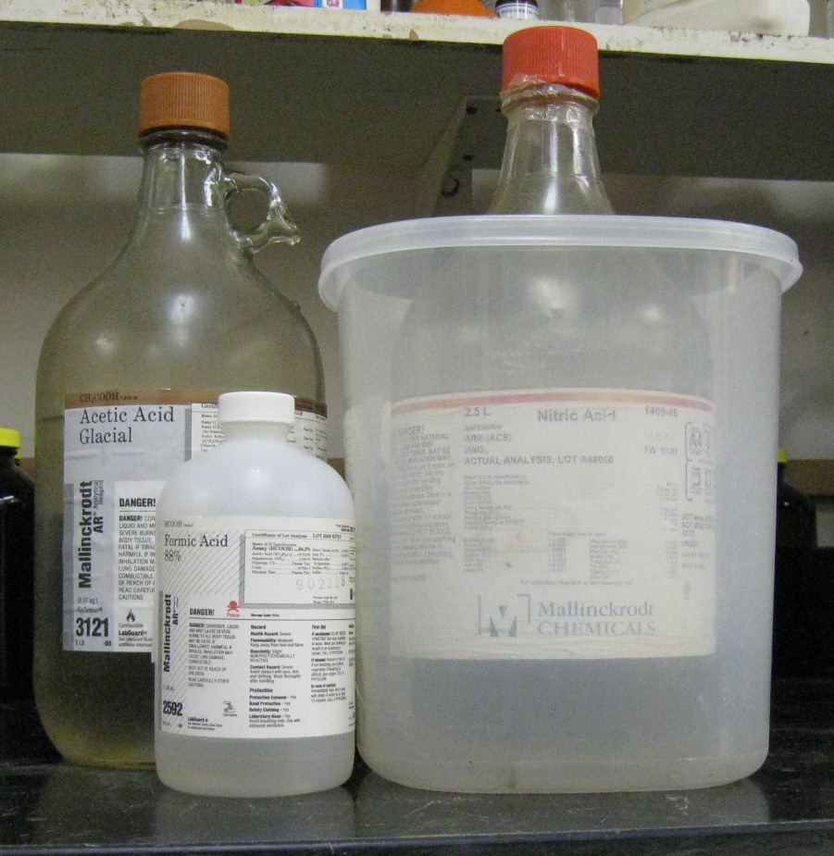
- Containers which are opened must be carefully resealed and kept upright to prevent leakage. If a spill occurs outside of a chemical fume hood, make sure that everyone is aware of the spill and that it is cleaned up immediately. 2-Mercaptoethanol is often mistaken for a natural gas leak, therefore it is extremely important that people are aware of the spill and that it is cleaned up immediately.
- Keep away from incompatible materials: oxidizing agents and metals, such as aluminum, stainless steel, iron and copper.
Organic acid
Oxidizing acid
- Use in the smallest practical quantities for the experiment being performed.
- Containers should be labeled appropriately. Label should indicate the name of the chemical(s) in the container. Avoid using chemical abbreviations (acceptable if a legend is present in the lab) and formulae.
Section 5 – Spill and Accident Procedures
Immediately evacuate area and ensure others are aware of the spill. If there is an imminent threat of a fire, pull the nearest fire alarm station to evacuate the building and dial 911. If personnel have become exposed and need medical assistance, dial 911. If the spill is minor and does not pose a threat to personnel, contact REM at 49-40121 during normal business hours (Monday – Friday, 7 AM – 4 PM) for spill cleanup assistance (dial 911 if spill occurs after hours and assistance is needed). 2-Mercaptoethanol has an unpleasant odor at extremely low concentrations, therefore can be a problem if even a small spill occurs outside of a chemical fume hood. If a small spill occurs that causes an odor issue, open the lab chemical fume hood sashes to maximize flow, leave the lab and make sure the exterior lab door remains closed (do not prop open) to allow proper negative pressure ventilation of the lab.
Section 6 – Waste Disposal Procedures
Store hazardous waste in closed containers that are properly labeled, and in a designated area (flammable cabinet is recommended) away from incompatible chemicals such as aqueous solutions. 2-Mercaptoethanol waste has a very unpleasant odor; care should be taken when handling waste solutions as well. If practicable, do not mix 2-mercaptoethanol waste with other organic waste, collect separately if possible. Contaminated debris (e.g., gloves, Kim wipes, etc.) generated while working with 2-mercaptoethanol must also be collected as hazardous waste (due to odor). Complete a Chemical Waste Pickup Request Form to arrange for disposal by REM; detailed instructions are provided at the following link: http://www.purdue.edu/ehps/rem/hmm/chemwaste.htm.
Section 7 – Protocol (Add lab specific Protocol here)
Click here to enter text.
NOTE: Any deviation from this SOP requires approval from Principal Investigator.
Section 8 – Documentation of Training (signature of all users is required)
Prior to conducting any work with 2-mercaptoethanol, the Principal Investigator must ensure that all laboratory personnel receive training on the content of this SOP.
I have read and understand the content of this SOP:
Name | Signature | Date
Click here to enter text. |  | Click here to enter a date.
Click here to enter text. |  | Click here to enter a date.
Click here to enter text. |  | Click here to enter a date.
Click here to enter text. |  | Click here to enter a date.
Click here to enter text. |  | Click here to enter a date.
Click here to enter text. |  | Click here to enter a date.
Click here to enter text. |  | Click here to enter a date.
Click here to enter text. |  | Click here to enter a date.

