This QRG outlines the process for creating standing substitutes (for a period of time or indefinitely) and delegating approval for “one off” items (ad hoc). Substitution is used to ensure coverage of time sensitive approvals during periods of absence and/or to provide an opportunity to request additional review by individuals more familiar with the transaction(s) under review.
In the event of an unexpected absence, Purdue’s Workflow Administrator is able to set up substitutions on behalf of the absent individual. The Workflow Administrator role is still being defined and this document will be updated when additional information is available.
Access SAP Finance Launchpad
Logging into the SAP Finance Launchpad requires two-factor authentication using BoilerKey. | BoilerKey is Purdue’s version of two-factor authentication, which is an extra layer of security that requires your login, a type of password or PIN, and something that can only be accessed by the user, such as a smartphone or physical token.  BoilerKey adds another layer of protection for employees and for the University’s data. For example, the employee portal contains sensitive information, such as bank account numbers, W-2s, and personal addresses. Should an employee’s password be compromised, all of that information could be stolen.  Go to www.purdue.edu/boilerkey to sign up today.
Access the OneCampus Portal (one.purdue.edu)  Click Finance Launchpad to launch SAP Fiori  Log in using your BoilerKey | 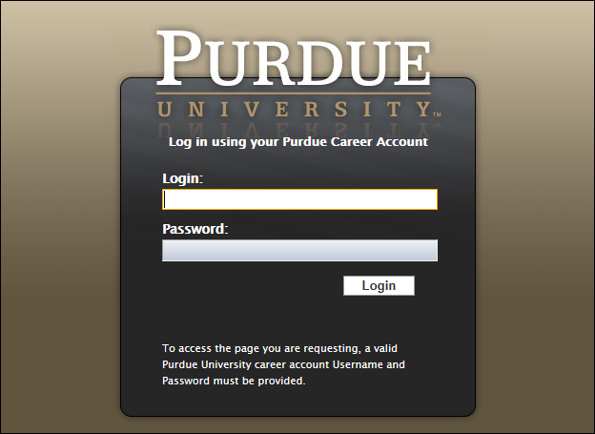
Create Standing Substitute
Standing substitutions are used to add additional individual(s) to the workflow, in advance, for a set duration of time. It is important to note that only individuals with fiscal authority to approve items for the original approver may be used as substitutes.
Immediately after being assigned, standing substitutes begin receiving all future approval requests routed to the original approver. Note: Setting a standing delegate does not prevent approvals from being routed to the delegator – approval requests will appear in both the delegate’s and delegator’s inboxes.
Click Purdue User Group > SAP GUI Launcher to launch SAP | 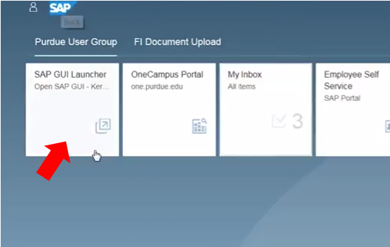
Click the SAP Business Workplace icon | 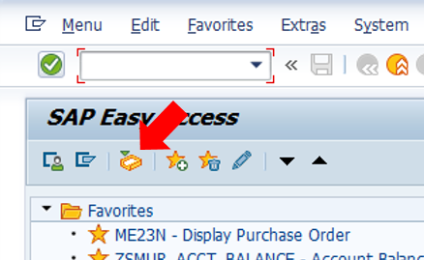
In the Settings drop down menu, choose Workflow Settings then choose Edit Substitute | 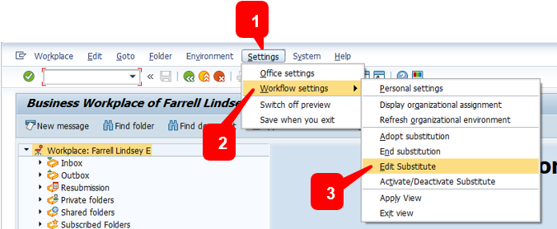
On the pop-up screen, click to select your username listed in the Name column.  Click the Create Substitute button  Note: Return to this screen to delimit or delete delegates using the buttons below, found near the Create Substitute button.  Delimit  Delete | 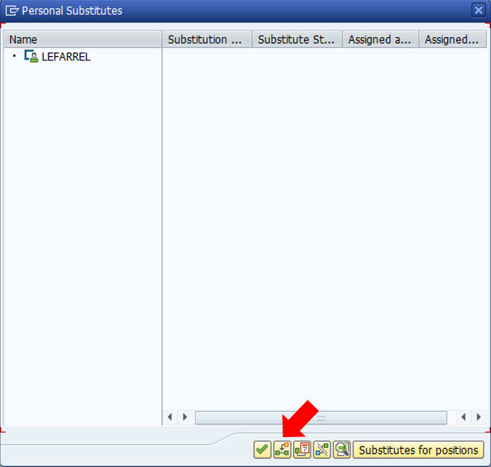
In the Search Term field, type the Purdue career account username of the individual to whom approvals are to be delegated.  Click Search | 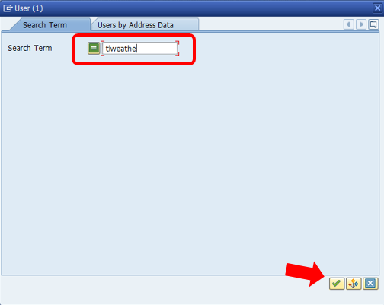
Select the appropriate user from the resulting list and click OK. | 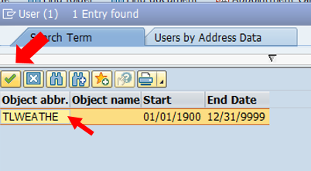
In the Validity fields, type the dates for which the substitution should be valid.  Mark the Substitution active checkbox.  Click Save | 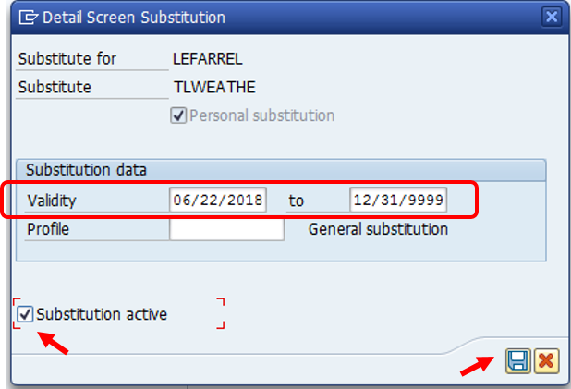
The substitute appears in the Personal Substitutes list.  Click Continue. | 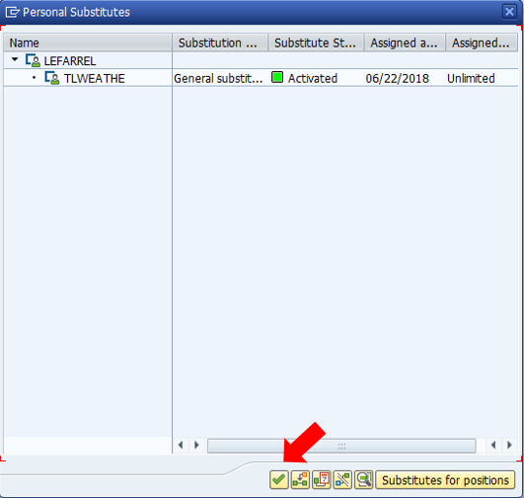
Create Ad Hoc Substitute
Ad hoc substitutions allow the original approver to forward a specific item to another individual for approval.
It is important to note that items can only be forwarded to individuals with fiscal authority to approve items for the original approver.
On the SAP Fiori Launchpad, click My Inbox. | 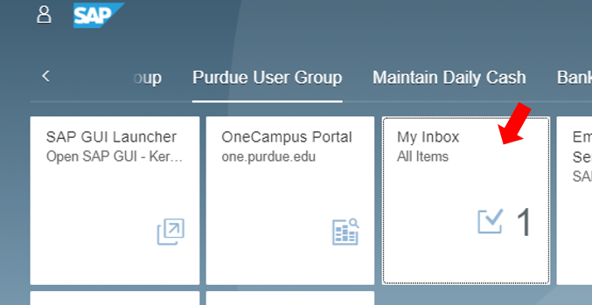
Open the inbox item to be provided to additional individual for approval.  Click Forward. | 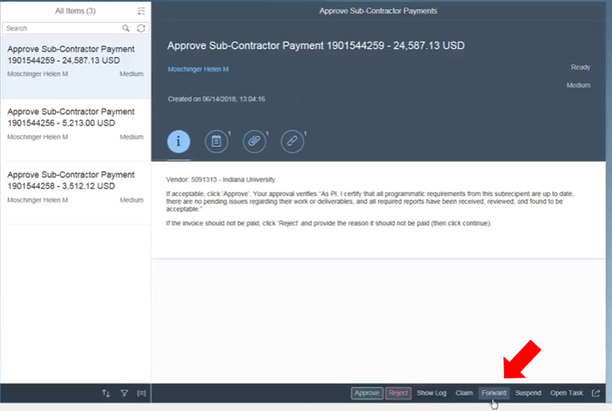
Use the search field to search for and select the individual to whom the item is to be forwarded.  After the individual is selected, add any applicable notes and click Forward. | 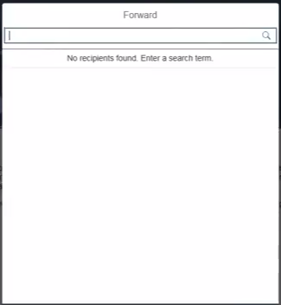
The item is forwarded to the individual for approval and is removed from the original approver’s inbox. | 