SPS Grant Closing Guide

Prelude to Closing - Identifying Expired Grants
On the fourth business day of each month the Expired/Expiring report is generated and delivered via e-mail to the respective areas. This report in conjunction with the expired report from Grant Master Data should be used to identify expired grants. Questions to ask: Are we expecting additional time or funding from the sponsor? Is an NTP appropriate? Is it ready to scrub for closeout?

Closing e-mail notifications should be sent to the responsible cost center at the grant level 15-45 days after expiration (based on due date of final financial/invoice).

Section A - To be completed prior to contacting Business Office

Does Grant Status = Award/Expired? - Verify that grant status flipped to Expired. If the status is still Approved Award, change to Expired. This will prevent new commitments from being placed on the grant.

Review FSSR’s –Review FSSR’s for the month of expiration and the month in which the account is being closed.

Compare Sponsor Award to Budget
- Does the grant value match the award documentation?
- Does the budget line items match the proposed/sponsor award budget line items?

Cost Sharing: If an account has a balance, the type of cost share commitment should be reviewed in order to take appropriate action.

Check Cost Sharing Requirement
  - Specific dollar amount?
    - This dollar amount must be met. The department needs to discuss the situation with the PI and SPS. There may be situations where a specific item (equipment, supplies, etc) was not purchased or the cost was less than budgeted. Exceptions will be reviewed by SPS on a case by case basis.
  - Percent of sponsor dollars awarded (one-to-one match, 25% of sponsor budget)?
    - Balance is acceptable as long as the commitment has been met.
  - Percent of effort for an individual?
    - Balance is acceptable as long as the commitment has been met.
  - Was it expensed as proposed?
  - Cost share must be zero at closing

Contributed F&A (IDC)
  - Contributed F&A should be checked to ensure it calculated properly on the FSSR.
Memo Match – departments are expected to send documentation of the memo match to SPS within 60 days after expiration.
  - Do we have proof that the memo match has been met?
    - Equipment from third party -> Gift and loan report from third party
    - SPS external account (state, industrial, PU/PRF fellowship/assistantship) -> AIMS/Line Item Display/FSSR
    - Other -> Letter from Donor/Company
    - Subcontract cost share documented on invoices (SPS gathers this information)
  - Work with the Business Office to obtain information, if necessary

Check GR55 –Run t-code GR55, use report group z500
Cash Balance, Other Assets (AR), and Liabilities should be zero

GR55 – Execute Group Report
SAP Easy Access | Enter the transaction code GR55  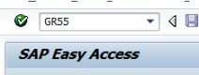
Execute Report Group | Report Group = Z500  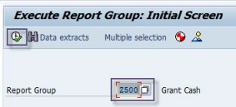  Click Execute
Grant Cash: Selection | Remove the 1 from the From Period AND Enter grant number in Or value(s) field  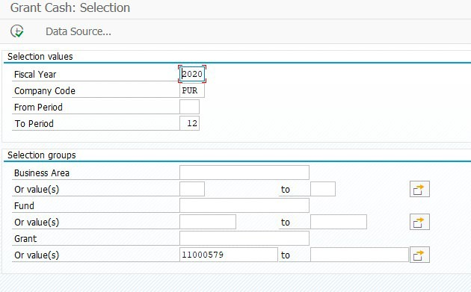  Click Execute

Check the Cash Balance in the Total column. This is the Balance of Cash on the Grant (FI – Statitistical entry which nets all activity posted to the grant on income, expense, asset, liability GLs).
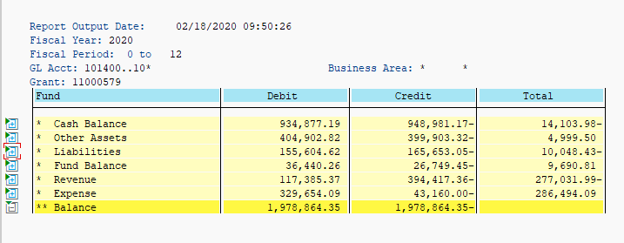
Click next to Liabilities to expand section.
- Review Vendor Pay – Recon: if there is a balance then Purdue has received an invoice that is due but not paid. This will be zero once receivable is reconcilled.
- Review Vendor Pay – GR/IR: if there is a balance then goods have been received and expensed to the grant but an invoice hasn’t been received or the invoice received had a difference from what was ordered and is unresolved. This will be zero once receivable is reconcilled.

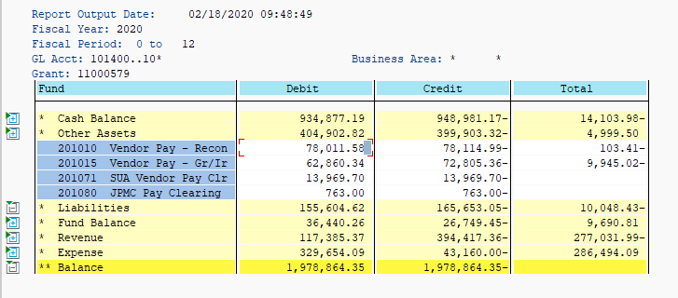
Click next to Other Assets to expand section.
- FI-AR Recon: This should be zero before changing grant to closed/closed. This reflects any outstanding accounts receivable on the grant. This will be zero once receivable is reconcilled.
- Other Equipment: There can be a balance in Other Equipment. No action needed

 | 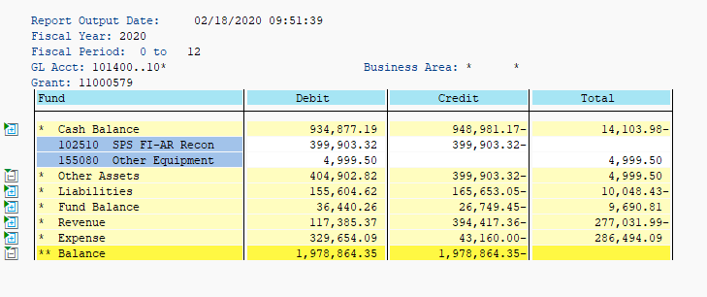
Additional Definitions | - Fund Balance - The life to date revenue – expense. Assets and liabilities are also included.  - Revenue - Amount of Income posted during the current Fiscal Year  - Expense - Amount of Expenses posted during the current Fiscal Year  Note: no action is needed for closeout
Scenario 1 | Grant: 11000579  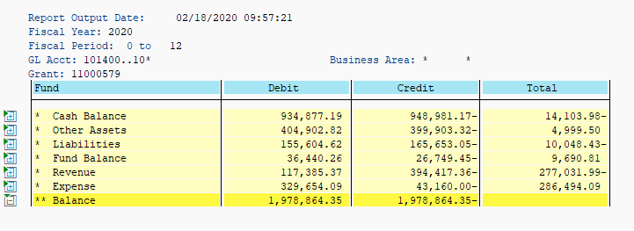  Cash Balance states the grant has a cash deficit of $14,103.98 but the FSSR states it is $24,152.41. The difference is the outstanding liability of $10,048.43, which is an outstanding vendor invoice to be paid.  SPS should contact the business office to resolve this liability issue. After the liability balance is zero, the Cash Balance in GR55 and FSSR should match. Once all expenses have posted, any excess income will need to be returned to the sponsor, and should resolve a Cash Balance issue.

Scenario 2 | Grant: 10001054  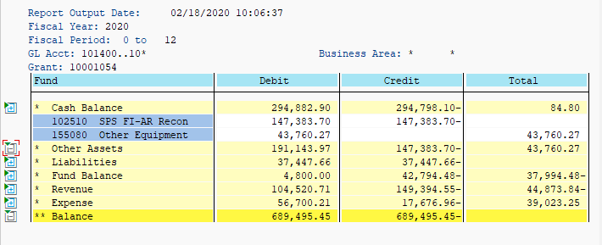  The Other Assets category is related to equipment and as a result does not need to be investigated. This leaves the $84.80 cash balance which matches the FSSR. If no additional expenses are to be incurred then revenue would need to be returned to the sponsor. After revenue is returned the total for Cash Balance  should become $0.00
Scenario 3 | Grant: 11000550  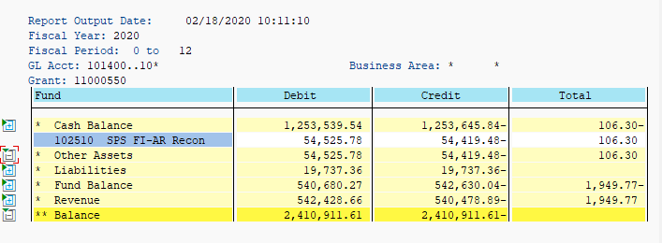  In this scenario it shows under Other Assets that there is a $106.30 outstanding receivable. This matches the FSSR through FY2020 Period 7. If this grant was closing this would need to be cleared before closing.
Scenario 4 (Cost Share) | Grant: 11000406/106898 – Select Fund under Variation: Characteristics and 21010000 under Variation: Fund  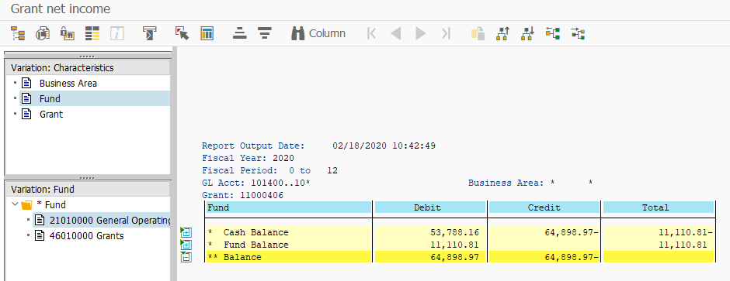  The example above shows a cash balance of $11,110.81 on the 21010000 fund. Remember that prior to 7/1/2016, SPS did not collect cash on the grant for cost share accounts. This scenario is one of those examples. To verify review when the budgets were entered using the budget validation layout in Line Item Display.

The budget dates (Entered On column) for all budget entries on the 21010000 fund were prior to 7/1/2016.
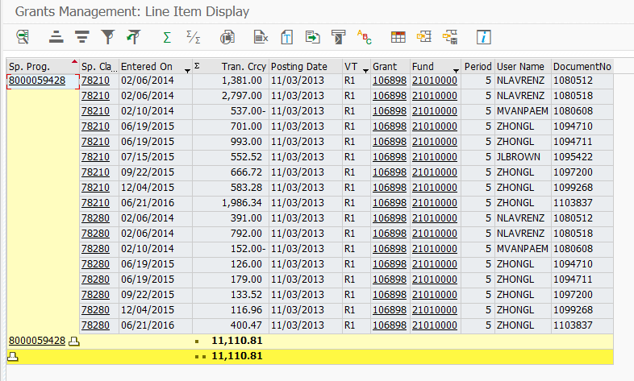

Check Questionable Transactions - Run QTR report to check questionable transactions – BI (Cognos) - > Boiler Insight > Departmental Content > West Lafayette > Office of the Treasurer (formerly Business Services) > SPS > Post Award
- Review charges for approvals and/or allowability
  - QTR – SPS Guidance https://www.purdue.edu/business/sps/doc/SPS_QTR_Guide.docx

Check Regulatory - Run BI – Cognos report > Boiler Insight > Departmental Content > West Lafayette > Office of the Treasurer (formerly Business Services) > SPS > Post Award
*If expenses posted to any of the above ensure proper regulatory approvals were in place.

Participant Support Costs
- Ensure participant support is expended appropriately
- Obtain confirmation from BO that all charges posted to the Participant Support account were truly for Participant Support
- Guidelines for Participant Support Costs https://www.purdue.edu/business/sps/pdf/Participant%20Support%20Guidelines.pdf

Check Pre-Award Charges
- Are pre-award charges allowable?
- Run a Payroll Transaction Report to confirm salary dates
- If project start date is after 1st of month, confirm with BO that salaries were pro-rated

Review Charges 90 days prior to Expiration – things to consider:
- What is the project?
- What items were purchased?
o Type/Volume/Amount?

Check Post-Expiration Charges
- Are the post-expiration charges allowable? Look at documents in WebNow to confirm dates. Run a Payroll Transaction Report in COGNOS to check salary dates

- If project end date is before last day of month, confirm with BO that salaries were pro-rated
- Have business office confirm any charges you are unable to confirm

Commitments/Reservations
- Run line item display (T-Code S_PLN_16000269), choose layout /COMMRESPRK (Commitments/Reservations/Parked Documents). If a balance appears, there is a commitment on the account.
- Include as part of final expenses or not? Verify with BO

Check Foreign Travel – if applicable
- Is foreign travel allowable? If not do we have documented approval?
- For converted grants you will need to run line item display (T-Code S_PLN_16000269), choose layout /Foreign Trv (Foreign Travel/SPS) on the old grant to see if any charges posted to a foreign travel GL prior to 7/1/18.

Check for Admin & Clerical salaries (Federal & Federal pass-thru)
If admin or clerical salaries were charged, are unlike circumstances documented?
- Guidance for checking Administrative & Clerical salaries
https://www.purdue.edu/business/sps/doc/AdminClericalSalaryCheck-updated%20May2019.docx

Clerical Salaries – roll up into sponsored class 78240. If any charges appear on the FSSR in this sponsored class, review the grant agreement and budget to see if unlike circumstances were documented. If documentation cannot be located, ask the Business Office to provide documentation as part of the closing email.
Administrative Salaries – roll up into sponsored class 78210. If any charges appear on the FSSR in this sponsored class, further investigation is required. Run BI – Cognos report Boiler Insight > Standard Content > HR and Payroll > Statement of Payroll Charges

Check F&A (IDC)
- Did F&A calculate properly?
- For MTDC base, utilize layout /GL Excl SPS (G/L’s Excluded p/MTDC base)

Subcontract Accounts
- Have we received a final invoice from the subcontractor?
- Has the subcontractor submitted any other required reports?
- Has the subcontractor’s cost share requirement been met (if applicable)?
- Have all payments to the subcontractor been processed? If not, be sure to include this amount in the final request for payment.

NSF 2 Months Rule (if applicable)
- Check that senior personnel have not exceeded 2 months. Confirm senior personnel by running a Payroll Transaction Report

NIH Salary Cap (if applicable)
- Confirm, based on grant number, all individuals who have exceeded the applicable salary cap limitation are in compliance. Verify for both ELI and ELII accounts.

Section B - Notification
Choose appropriate email template
- Email templates: S:\bs\common\users\SPS\POSTAWARD\Closing\
- Send email to the Generic BO email

o Obtain the generic email address from the following: https://www.purdue.edu/business/sps/general/boemail.html
- Identify any questionable charges and send spreadsheet of charges SPS can’t verify to the business office

Section C – Adjustments

F&A adjustment – utilize F&A Adjustment Guide
- Determine if F&A needs to be adjusted.
- Use templates provided for F&A Adjustments.

Budget reductions – utilize Budget Adjustment Guide
- Final expenses for each WBSE have been verified with lead cost center.
- All steps prior to budget adjustment in closing process have been completed.

Begin with adjusting external budgets
  - Adjust budget on each WBSE to match final expenses ensuring that the budget on adjusted sponsored class(es) are not less than zero after the adjustment.
  - Be aware of sponsor budget restrictions (ex. line item overages, use of direct costs for indirect or vice versa)
  - Do not adjust the grant value (general data tab) or information on the award data tab.

Adjusting Cost Share Budgets at Closing
  - Only adjust after it has been determined that the cost share commitment was met.
  - Adjusting Cost Share accounts with Balances:
    - Utilize the cost share budget template to reduce the budget to zero out the WBSE.
  - Adjusting Cost Share WBSE’s with overdrafts:
    - It is the department’s decision to increase budget.
    - Charges must be allowable & within the project period.
    - Adjustments to cost share budgets must be done using the cost share budget template.

Final Invoice
- Check grant to see if a final invoice is needed.
- Non-LOC – generate and send final invoice to sponsor
- LOC – generate and send final invoice to Funding Administrator, Cash Specialist

Excess Income/Overdraft
Grants must have a zero cash balance at closing. Excess income is handled as either a residual transfer or it is returned to the sponsor.

Residual transfer is an option when:
- The contract is fixed price (i.e. there is no provision for return of unexpended funds to the sponsor).
- All payments required under the contract have been received from Purdue.
- All required project work is complete, and all reports and other deliverables have been provided to the sponsor.
- All expenses related to the project have been properly charged to the account.

If the unexpended balance of the grant exceeds 15% of the award amount (25% for Industrial sponsors) the department MUST provide an explanation why the balance exists on the residual transfer form (instruction no.
- and have an academic signature.

If the balance is less than 15%, the use of the form is not mandatory; business office staff can email the residual account information to post-award.

Return Funds to the sponsor, verify via GR55 that the cash balance equals the amount being returned to the sponsor (see GR55 QRC).
  - Prepare a ZV60 to return excess funds on Non-LOC grants or LOC grants that require a check refund.
  - Send an email request to the Funding Administrator, Cash Specialist to return LOC funds

Clear Small Balance – Accounts that have a balance of less than $5.00, SPS will follow these guidelines for clearing the balance:
- The sponsor has removed the account from their letter of credit funds.
- There is no F&A or cost shown on the account to adjust in closing.
- Non letter of credit sponsors must be contacted to determine if they want the amount refunded. If yes, the balance must be refunded.
- If the sponsor does not want the balance refunded, the balance will be cleared via a Journal Voucher (FV50)

Clear Small Overdraft - Overdraft Grants with Compensation expenses only:
- Overdrafts in excess of $100.00 for Grants that have only Compensation charges will always be cleared by the academic department. Once the correcting documents are processed, see "b" to clear any remaining small Compensation balances.
- Grants that have small overdrafts ($100.00 or less) due only to salary issues (e.g., grants that have only Compensation expenses, fellowship accounts that have balances due to rounding) and have no funds remaining will be cleared via a Journal Voucher (FV50).

Section D - Reports

Reports
Check sponsor guidelines to see what reports are required. Required reports may include: financial reports, FCTRs, technical reports, property reports, invention reports, MBE/WBE reports, among others. Ensure all reports listed on the Reporting Requirements tab in GMGRANT have been submitted but also check the sponsor agreement; not all reporting requirements may have been listed in SAP.

The Post Award Funding Administrator will prepare the required financial report and send the report to the Post Award Senior Manager for review and signature. The report will be returned to the Post Award Funding Administrator for submission to the sponsor by the due date.

Note: All property, patent and financial reports must be submitted by SPS before a grant can be closed.

Section E - Grant Finale

- Check grant reporting requirements and update completion dates
- Verify FSSR – verify there are no outstanding account receivables and income should equal total sponsor expense which should equal budget. Confirm the FSSR reflects a zero grant
- Revenue Allocation - Verify all revenue has been allocated according to expenses on each WBSE account (excluding Cost Share WBSE’s). If not, allocate revenue as necessary by a JV document
- Cost Share Revenue – Verify all revenue has been allocated to the Cost Share accounts as part of the C/S budgeting entries

Section F – Grant Closeout

- Verify GR55 – Confirm the cash balance, other assets (AR), and Liabilities are zero
- Change all WBSE accounts to Closed/Locked status
- Enter Storage and destroy date on Additional Reference Tab in GMGRANT
  - Date to Storage = 4/1/xx or 10/1/xx
  - Date to Destroy = Date to Storage + 3 years
- Change status in SAP to Closed/Closed
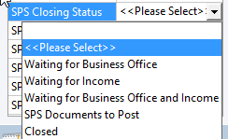
- Update Closing status in Perceptive Content on the Closing Checklist document type

Tips and Tricks

It is recommended that we will not need to image documents that can be replicated, such as the FSSR, JV’s and ZV60’s.

We will need to image all closing documents that cannot be replicated such as emails, copies of refund checks with letters and any other information gathered in the closing process. Final invoices will be imaged as all invoices are currently imaged. We recommend that you include a sticky note on your final invoice asking the Cash area to send the invoice back to you when it’s paid.

Final reports will be imaged using the SPS Reports document type.

Please do not upload the closing documents with the Closing Checklist as this is a routable document. Those types of documents should be merged and uploaded as SPS Closing Documents

Any updates completed after the Closing Checklist is uploaded can be documented using the sticky notes within Perceptive Content

