This job aid describes information regarding data fields of a Sponsored Program. This document can be referenced when trying to determine where data fields exist and what they are used for within grants management.

GMPROGRAM
SAP Easy Access | Enter the transaction code GMPROGRAM  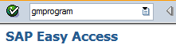
Display Sponsored Program | Type the sponsored program number into the Sponsored Program text field and click the view icon or press enter.
Display Sponsored Program – Basic Data | The name for the SP in the Program Description field should help identify the SP to the business office and faculty. This description should be meaningful to the use of the sponsored program. Generally the business office will provide this information. It is often the name of the Co-PI or project. However, additional identifying information which may be important can be added. This field appears in GM AIMS. Some examples include:  - “Main”  - “Smith – Travel”  - “Cost Share – Engineering”  - “Participant Support”  - "Michigan State Subcontract"  - “Stipends – TDC 25%” (This example is how we might name a sponsored program if the grant had multiple IDC bases. This would be the SP with the base different from the rest of the grant.)  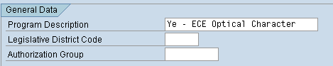
Display Sponsored Program – Budget Transfer | Click on the Budget Transfer tab.  - FM Area – Is ALWAYS PUR  - Funds Center – This is the Responsible Cost Center for the SP and is the same as the Responsible Cost Center entered on the Internal Order  - Functional Area - This is the Functional Area for the SP which indicates if it is Instruction & Departmental Research (1000), Sponsored Research (1200), Extension and Public Service (1500) or Student Aid – Fellowships (4000)  - Funded Program - Is ALWAYS grant relevant  - Default – This box MUST be checked  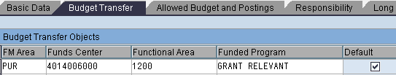
Display Sponsored Program – Responsibility | Click on the Responsibility Tab. Only one Co-Principal Investigator (CO-PI) can be entered on the SP. AIMS Access can be granted to any number of people that need access for this SP. (AIMS Access on the SP will not give them access to the entire grant – only this SP)  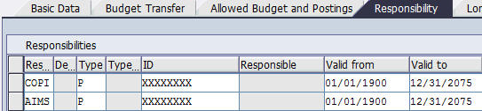
Display Sponsored Program – Additional Data | Click on the Additional Data Tab and then click the Additional Program Data.  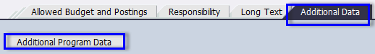
GM program data
GM program data – Multidisciplinary Report | This tab is where Discovery Park (DP) and other affiliated Cost Centers are identified for expenditure reporting purposes. This information should be provided by the business office. The proposal submission form will also include this information at the proposal level; however, multidisciplinary reporting could vary from one SP to the next. If DP is receiving credit in box(s) six through ten, an academic unit must be entered in box(s) one through five.  - All academic units (cost center numbers) receiving credit are entered in boxes One-Five. The corresponding percentage of credit for each unit should go in the percentage text box beside the academic unit. The percentages for boxes One-Five should always add up to 100%.  - All Discovery Park units (cost center numbers) receiving credit are entered in boxes Six-Ten. The corresponding percentage of credit for each unit should go in the percentage text box beside the Discovery Park unit. The percentages for boxes Six-Ten should always add up to 100%.  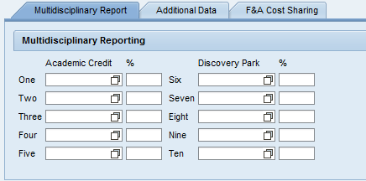
GM program data – Additional Data | Click on the Additional Data Tab.  - Valid From Date and Valid To Date - These date fields are for informational purposes only and do not control postings to the account. They can be used to capture dates which may differ from the grant validity dates. In most cases these dates are the same as the grant project period.  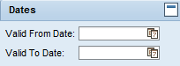  - Subrecipient (if applicable) –This is used if the SP is set up for a subcontract.  - Off Campus Flag – This is marked “Yes” if the SP is set up for Off Campus rates.  - Bowen Flag – This is marked “Yes” if the work is completed at the Bowen Lab.  - Participant Support – This is marked “Yes” if the SP is for participant support.  - Fund – The fund associated to this SP is entered. This will allow you to tell if this SP is a sponsor account or cost share account.
GM program data – F&A Cost Sharing | Cost Share F&A – The manner in which these fields are populated will depend on whether or not the grant has cost sharing and what type of cost sharing is being contributed. Either none or one of the following three fields should be marked yes and a rate entered:  - Cost Share of Full F&A Rate – This field should be marked yes and the appropriate negotiated rate entered in the F&A Rate field if the grant does not allow F&A be charged to the sponsor, but the F&A can be and is being counted as cost share.  - Cost Share of Unrecovered F&A - This field should be marked yes and the difference between Purdue’s negotiated rate and the rate negotiated with the sponsor entered in the F&A Rate field if the F&A rate to be charged to the sponsor differs from Purdue’s standard rate and the difference of F&A can be and is being counted as cost share.  - Cost Share of F&A on Internal Funds – This field should be marked yes if this SP is a cost sharing SP. If F&A on cost share expenditures is being counted as cost share, the appropriate rate should be entered in the F&A field. If not allowable, the rate should be left blank.  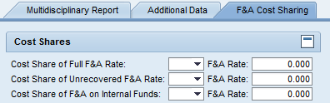
GM program data – Subrecipient  *This tab will only appear if a subrecipient is entered on the Additional Data Tab | The following information will appear on this tab:  - Subrecipient Create Date – This is the date the information was initially entered.  - Subrecipient Vendor # - The vendor number used for processing the ZV60.  - Subagreement # - This number is what is assigned to the subrecipient and is generally made up of the first four digits of the fund; dash; last five digits of the sponsored program.  - Amount Funded this Action – This is the amount funded to the subrecipient for this increment.  - Est. Project Total – The amount estimated to be funded to the subrecipient.  - Cost Sharing this Action – This is the cost share amount committed for this increment.  - Est. Cost Share Total – The total cost share committed amount.  - Total Award Amount – This is the total amount awarded to the subrecipient to date.  - High Risk – This flag will show if this subrecipient is considered high risk based on criteria outlined in the Subrecipient Monitoring Procedures.  - FFATA – This is “Yes” for all Federal funds. This notifies contracting that special language pertaining to FFATA requirements be added to the subagreement.  - Subrecipient FCOI Policy – This states whether the subrecipient has a FCOI policy in place.  - Contracting Language – This field tells contracting what language to use for FCOI. PHS or Non PHS  - Regulatory – Yes or No  - Regulatory Type – Applicable regulatory types are selected. 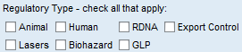  - Subcontractor Information – This is the subrecipient’s financial, contractual and PI contact information.  - Payment Schedule – This indicates the payment terms that contracting will place in the subagreement.  - Subrecipient Financial Report – This indicates the financial reporting terms that contracting will place in the subagreement.  - Subrecipient Technical Report – This indicates the technical reporting terms that contracting will place in the subagreement.  - Subrecipient Property Report – This indicates the Property reporting terms that contracting will place in the subagreement.  - This indicates the Invention/Patent reporting terms that contracting will place in the subagreement.  - Subrecipient Monitoring – These are a list of items SPS reviews before sending the subrecipient information to contracting for processing.  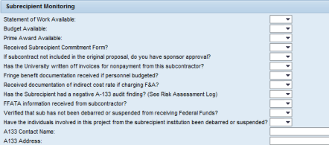  - Special Instructions – Provides specific notes for contracting.

