Using the Appointment Center

- Features in the Appointment Center
- Choosing Your Location
- The Calendar Appointment and Availability Display
- Scheduling an Appointment
- Using the Calendar to Schedule the Appointment
- Using the Scheduling Grid to Schedule the Appointment
- Moving an Appointment
- Cancelling an Appointment
- Appointment Check-in for Offices Without a Kiosk
- Appointment List
- Drop-in Appointment List
- Check-in Without Specific Staff Button

Features in the Appointment Center

A new Appointment Center has been introduced in BoilerConnect. With these new interactions, you will find a more efficient way to manage appointments at the front desk.

The purpose of these materials is to introduce you to these interactions.

Some of these capabilities include:

- Design for appointments/drop-ins and the calendar/availabilities grid

- Ability to change the x and y axis of the calendar grid

- “Create Appointment” dialog box

- Hover-over details when looking at appointment blocks

- Fewer clicks to override conflicts and move appointments

- Actions when checking students in for appointments

- Additional details on students when checking in

- “Drop-In Appointments” tab with actions for Drop-in appointments

- “Scheduled Appointment List” tab with actions for appointments

Choosing Your Location

The display of advisor locations has been revised. This is a cosmetic change to the display and will not change how a location is selected. Your location should show as the default location if you have only one advising location. If you have more than one, then the list of available locations would appear.

From This:

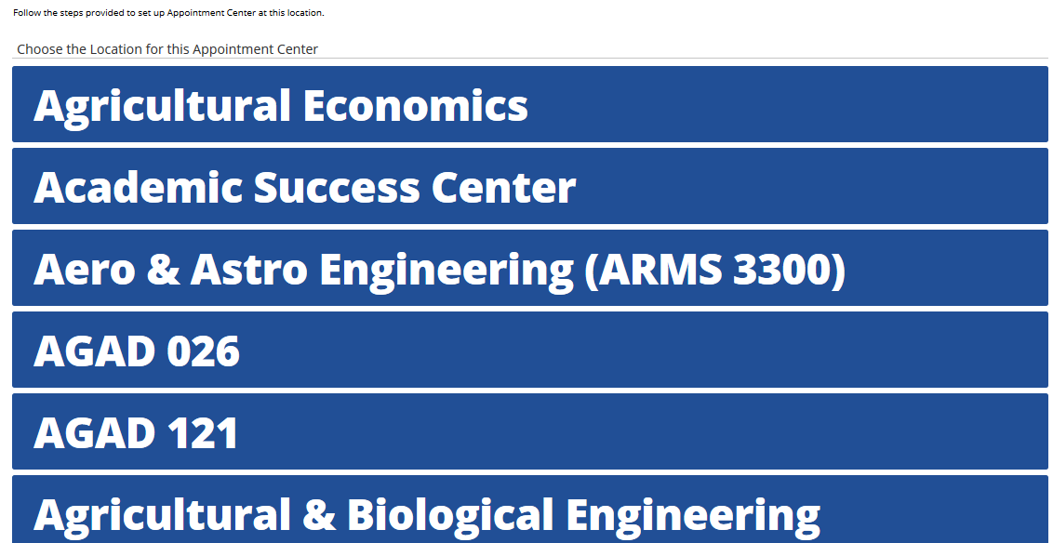

To This:

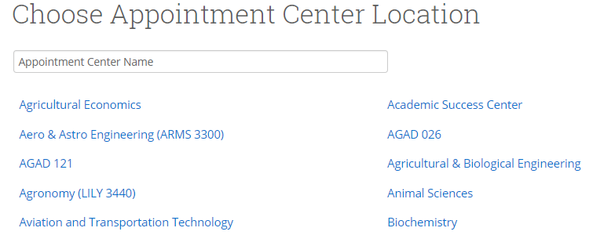

The Calendar Appointment and Availability Display

Perhaps the most significant difference, is how the Calendar grid display has changed. Previously you had a display that contained check boxes and text.
From This:

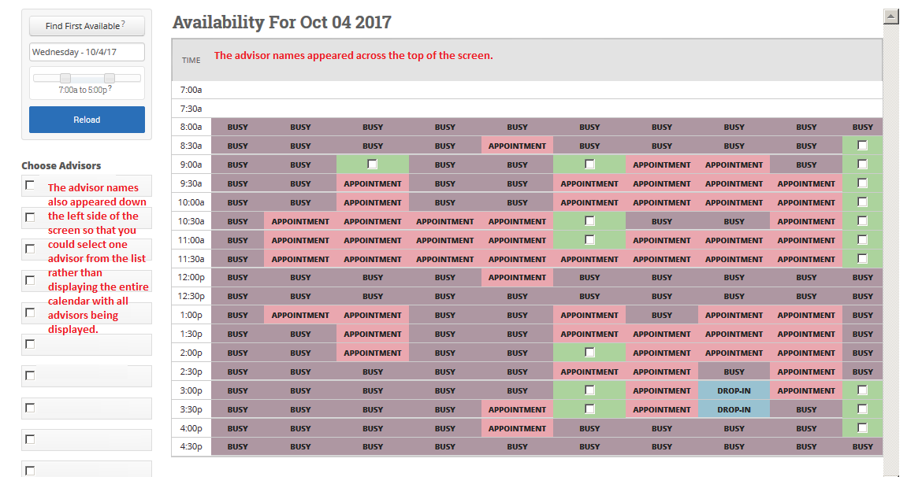

To This:
With the Appointment Center there are no more green check boxes used to select open appointment times. Your display will now have a more common Outlook calendar interface where available time for appointments are shown as white blocks and unavailable times as grey blocks. On the left side of the screen, the default time increment value for appointments for your unit will appear

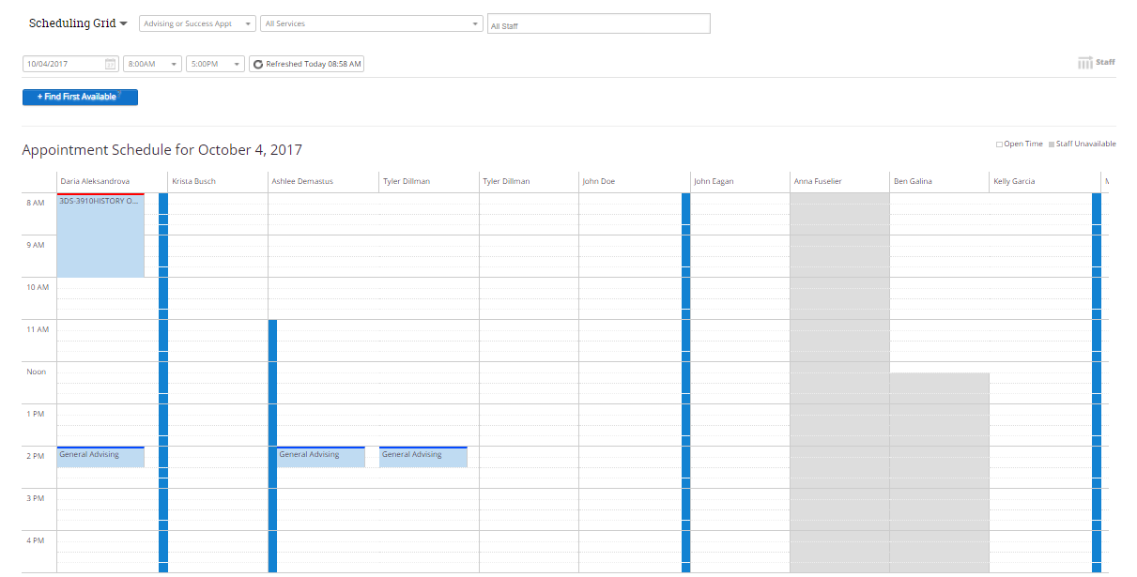

If you hover over the white or grey blocks, you will notice a pop -up that will display details about the selected block.

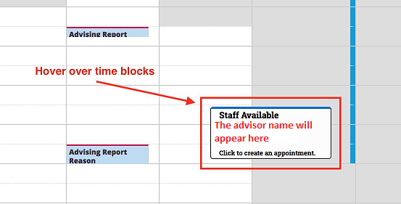

If you prefer to see the calendar in a different layout, click on the Staff icon on the right side of the screen, and the display will place the time across the top of the screen with the advisors down the left side of the screen.

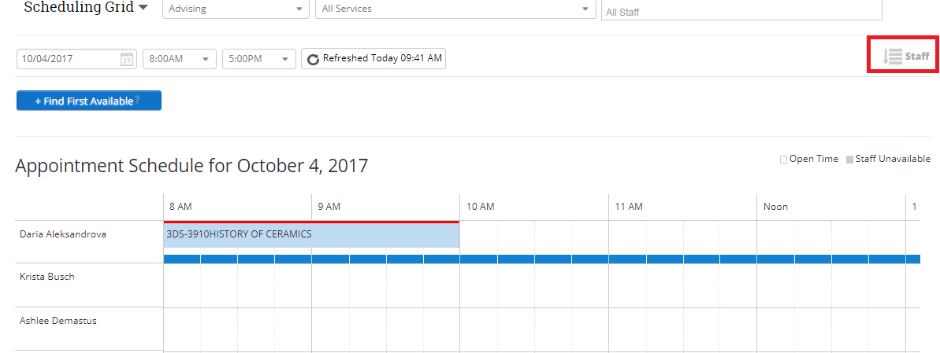

Note: Once you move away from the screen after setting it up for this display, it will return to the default display with advisors across the top and time down the left side.

Blue blocks will appear in the calendar and will indicate the Drop-in availability by advisor.

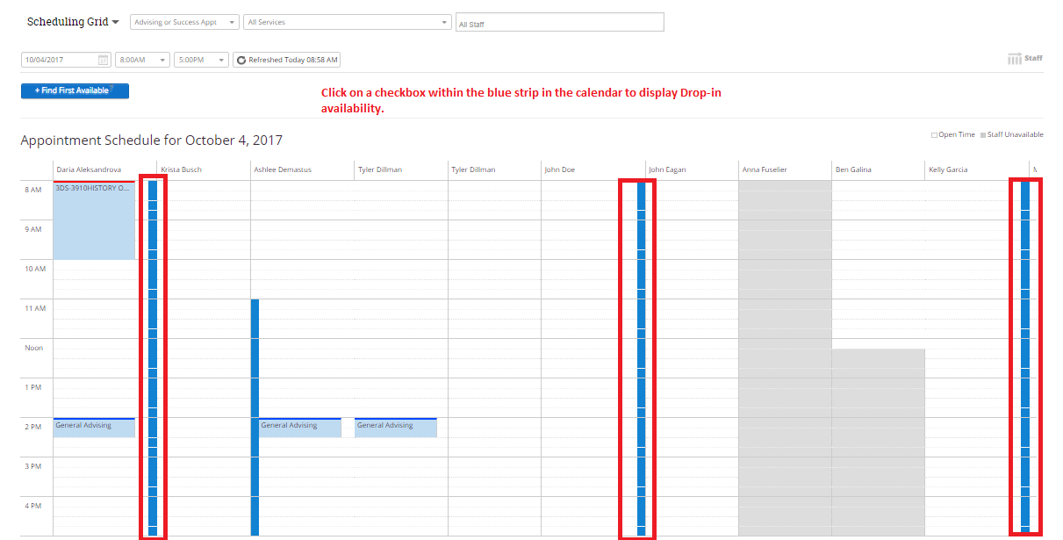

Scheduling and Checking in Drop-in Appointments
If you click a box that appears within the blue strip in the calendar at the time the student wants to meet, you will be able to create a Drop-in appointment.

- When the Create an Advising Appointment dialog box appears select the Service the student is there for from the drop down box. Services are specific to your area.
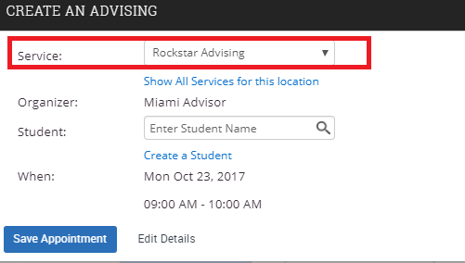

Then, enter the student’s name. DO NOT use the link to Create a Student.
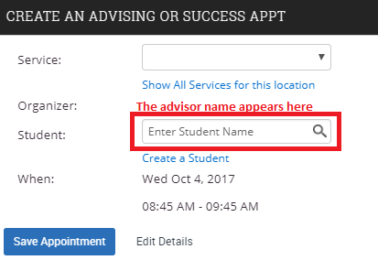

- Within this window, you will have the ability to edit the details of the appointment and adjust the Service type if needed. Clicking on the Edit Details link at the bottom of the pop-up screen will take you to a pop up where you can enter any Comments for the advisor to prepare for the appointment. You may also adjust the length of time scheduled for the drop-in.
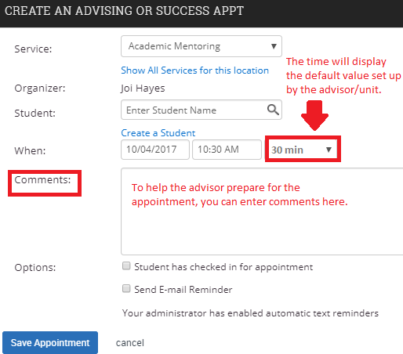
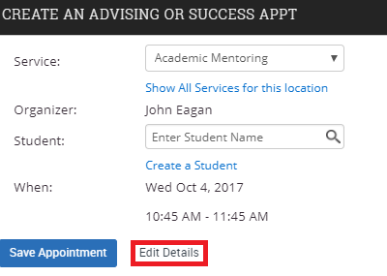

To schedule the appointment, click on the blue Save Appointment button at the bottom of the screen.

Scheduling an Advising Appointment

Scheduling an appointment with a student that does not currently have an appointment, can be done it in two ways.

Using the Calendar to Schedule an Appointment
Click in one of the white time blocks under the column for the advisor the student wants to meet with. It will then display the Create an Advising Appointment dialog box. Select the Service the student is there for from the drop down box.

Then, enter the student’s name.

If a chosen advisor is NOT available, you will see a yellow banner stating that they are not available because of a conflict. You would see one of the following displayed when you selected a time that was appearing as grey in the schedule, or you clicked the Drop-in check box in the blue stripe in the calendar.

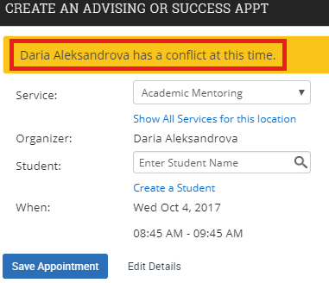
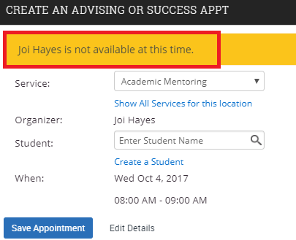

Note: If the advisor being selected is showing as NOT available, you still have the capability of scheduling an appointment during unavailable times.
You would still need to check with the advisor prior to scheduling the appointment during a time that is showing as unavailable.

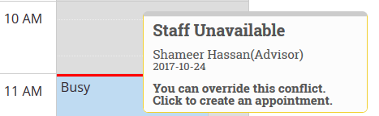

- After clicking in an unavailable time that the advisor has approved for meeting with a student, select the service the student has requested the meeting for from the Service drop down box. Enter the student’s name in the Student text box. Since the meeting was approved by the advisor during a normally unavailable time, click on the Edit Details link.
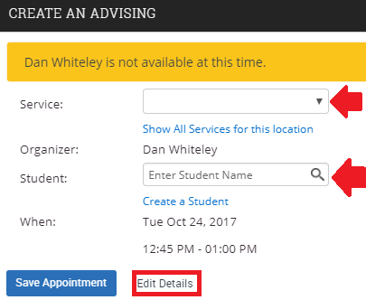

- Once the Details option displays the Comments box, enter a reminder for the academic advisor regarding their approval of scheduling an appointment during a normally unavailable time.

- If the student is meeting with the advisor at the same time the appointment is being scheduled for, click the Student has checked in for appointment box. If the appointment is in the future, you have the option of sending a reminder email and text reminder.

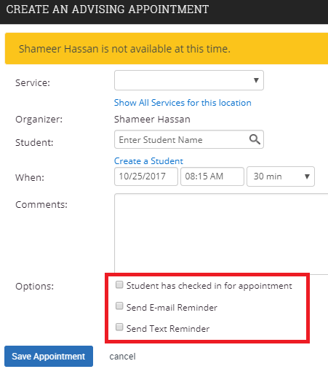

- Click the blue Save Appointment button to save the appointment.

If the advisor is available, then within this window, you will have the ability to edit the details of the appointment and change the length if needed by clicking on the Edit Details link at the bottom of the pop-up screen. This is where you will also be able to enter any Comments for the advisor to prepare for the appointment.

To schedule the appointment, click on the blue Save Appointment button at the bottom of the screen.

NOTE: You will no longer see that pink line that used to carry across all of the advisors calendars when you schedule an appointment using this approach. No more having to refresh the screen to get it to return to the display where the appointment would then show under the selected advisor only.

Using the Scheduling Grid to Schedule an Appointment
Do a search and enter the student’s name in the Enter Student Name box at the top of the Appointment Center screen.

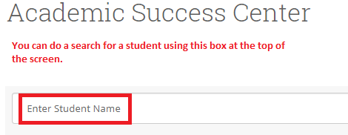

You will then see the student’s details appearing on the screen.

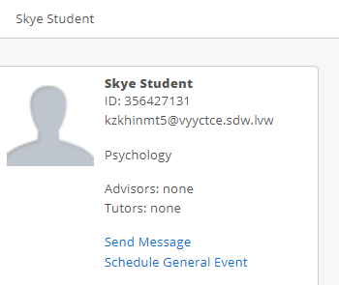

Once you begin scheduling using the Scheduling Grid drop down boxes, you will see the option to choose a service. The choices will default to the available services that the advisor has set up. Just click in the All Services box and select the service the student would like to meet with the advisor about from the list of available options.

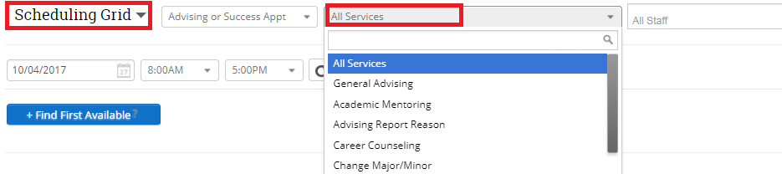

There is an option to select a specific advisor so that it will display their calendar only. Just click in the All Staff box and click on the name of the advisor the appointment is to be scheduled with.

This will then limit the display of the calendar to the selected advisor. Follow the instructions in the Using the Calendar to Schedule an Appointment to complete the process of scheduling an appointment.

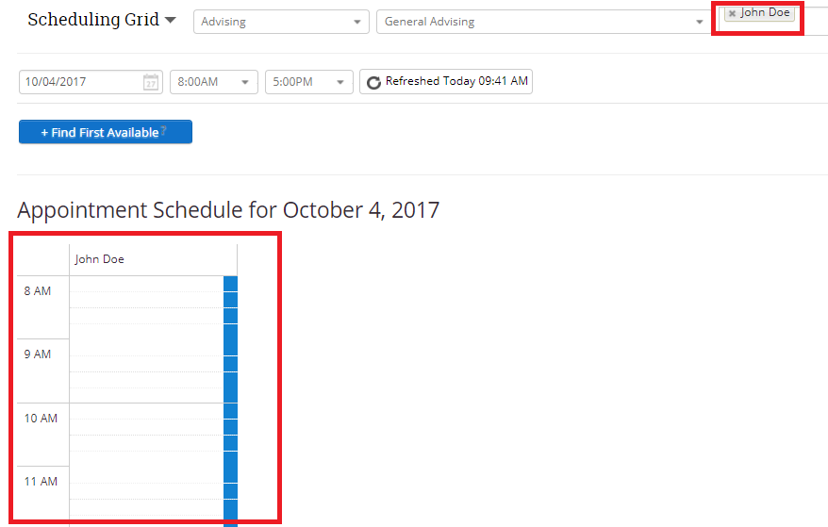

When you are done, just click on the “X” alongside the advisor name, and it will return you to the full calendar display.

Moving an Existing Appointment
In the previous version of the Appointment Center, you had to handle moving an appointment to a different time but the same day or the same time but a different advisor one way (previously done using edit), and moving an appointment to a different day a different way (previously done using move). In the Appointment Center you can handle both of these options the same way.

- Find the appointment on the calendar you would like to move, and click on it

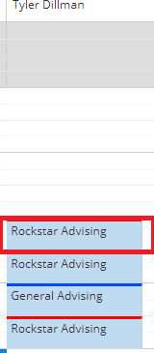

- On the Manage Appointment pop-up, click on Move (do not select edit)
Note: Selecting edit will take you to the old appointment center. This link will be removed at a later date.
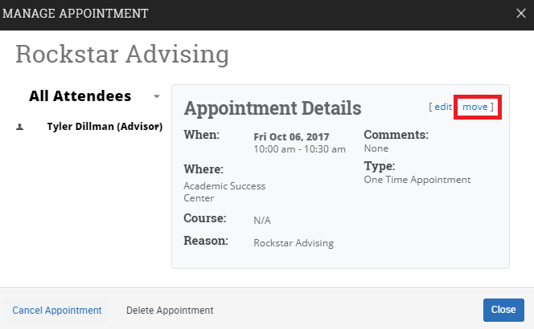

- You will see a display asking you to select the time and date that you want to move the appointment to
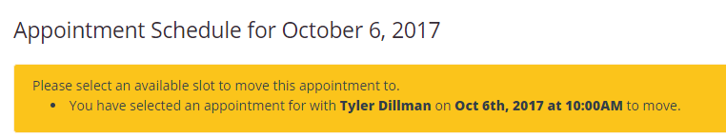

NOTE: Be careful when moving an appointment after you have selected Move. Any time you click on a new time/date within the calendar, the appointment will be immediately moved. There is no pop up asking if this is where you want to move the appointment to.

- If you are moving the appointment to the same day but a different advisor, just click on one of the white blocks under the advisor the appointment is being moved to.
- If you are moving the appointment to a different day, click on the date calendar in the Scheduling Grid area
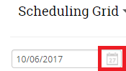

- Select the new day, and then click the Please Refresh button
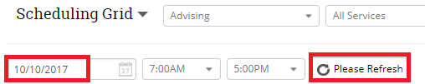

- The calendar will refresh with the new date display. Click in one of the white spaces under the advisor and time the appointment is to be moved to. You will see a yellow bar across the top of the screen indicating the appointment is being moved.
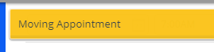

- The appointment will now appear on the calendar for the new date and time.

Cancelling an Appointment

- Find the appointment you would like to cancel, and click on it

- On the Manage Appointment pop-up, click on Cancel Appointment
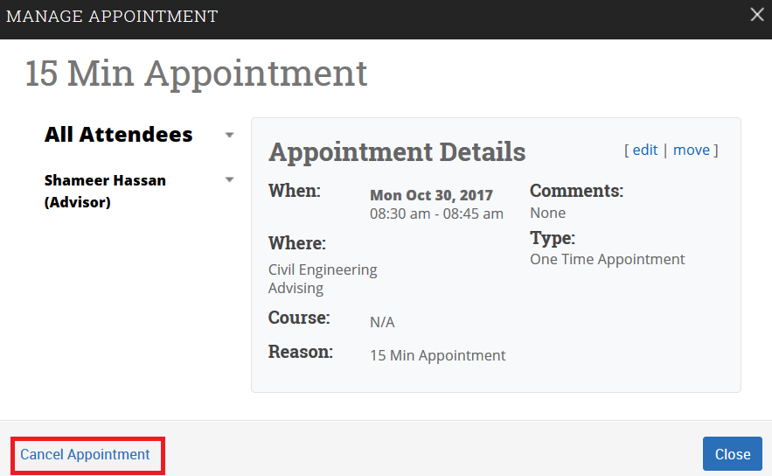

Appointment Check-in for Offices Without a Kiosk

For units that are not using a kiosk, when checking in a student with a scheduled appointment, the front desk will be able to see additional information and take additional actions from the display of student information on the selected student.

Additional information:

- Student PUID
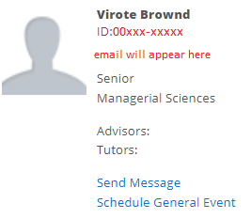

- Email Address

- Major

- Classification

- Assigned Advisor

Additional actions:

- Send Message to student
- Schedule an Appointment
- Send Message to Advisor

Do a search by entering a student’s name or ID from the top of the Appointment Center screen

- The following screen will display the student’s appointment information. If you want to send a message to the academic advisor, you can click the down arrow alongside Actions and select Message Organizer. Otherwise, click the blue Check-in button.

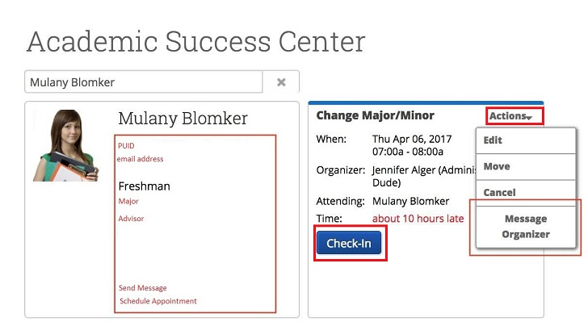

The student will then be put in to the appointment queue for the selected advisor.

Scheduled Appointment List

In some situations, the front desk may need to view all of the day’s appointments. With the Scheduled Appointment List tab, staff can view all of the appointments for the current day and take action from the list.

- Click on the down arrow alongside Scheduling Grid. This will give you a drop down box where you can click on Scheduled Appointments

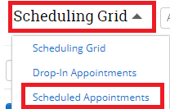

- The Scheduled Appointments for the day will appear at the bottom of the screen. Here you will be able to take additional actions.
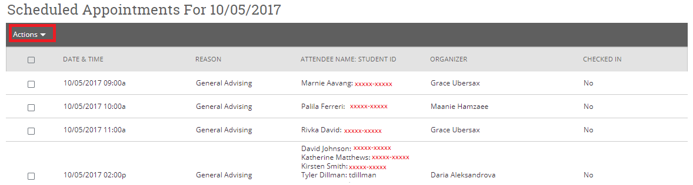

Additional actions include:
- Send message to Attendee (Student)

- Send message to organizer(s)

- View Appointment Details

- Check In

- Check Out

- Mark No-Show

- Cancel Appointments

When choosing multiple appointments, actions are limited to sending messages and canceling appointments. This gives you the ability to cancel all appointments for a given day in a particular location.

You also have the ability to view future dates and see appointments on the selected date.

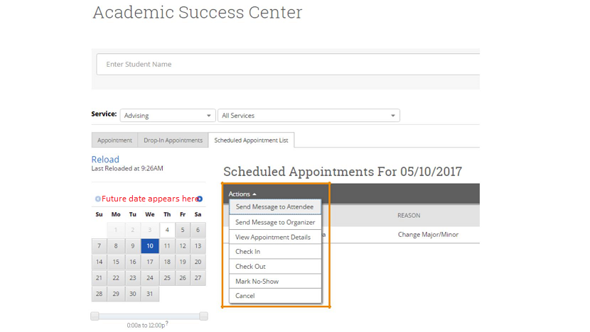

Drop-in Appointment List

In some situations, the front desk may need to view all of the day’s drop-in appointments. With the “Drop-in Appointments” tab, staff can view all of the appointments for the current day and take action from the list.

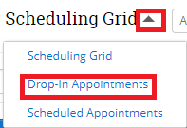

After clicking on the Drop-in Appointments link, you will see a summary page that lists the Students in the first available queue as well as students in the other drop-in advisor queues.

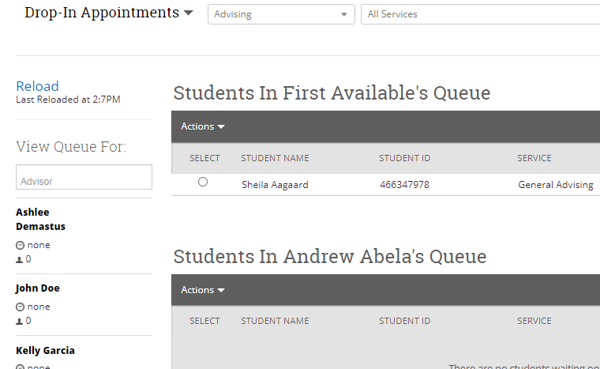

From here you can perform the following actions
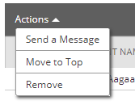

Check-in Without Specific Staff Button
(Formerly called the Record Visit button)
At the front desk, you will have a function available to you that will allow you to check in a student that didn’t need to see a specific advisor. This function would ONLY be used when you are not checking a student in with an advisor. For students that just want to ask a general question or pick up materials that have been left for them, you will now be able to check a student in and out so that their duration of their visit is recorded in BoilerConnect.

- Do a search by entering a student’s name or ID from the top of the Appointment Center screen

- Alongside the Scheduling Grid display, click on the down arrow and select the Drop-in Appointments link

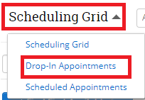

- From the left side of the screen, click on the blue Check in without specific Staff button
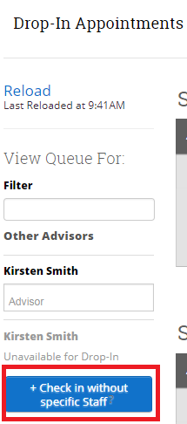

- From the list of services, click on the option that best matches what the student is looking for

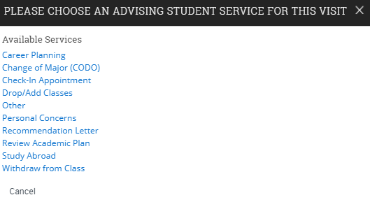

- The student’s visit will then appear at the top of the screen
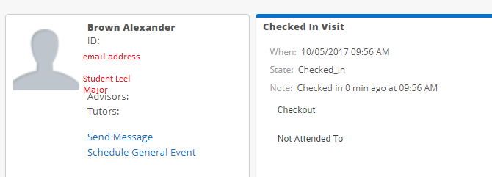

- Their visit also appears in the queue at the bottom of the page:
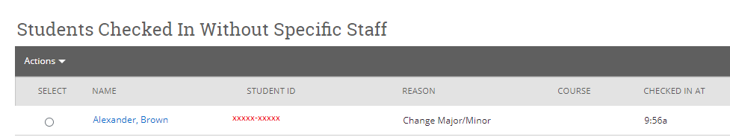

- You will be able to click on the Checkout link once the student leaves to record the visit in BoilerConnect (screen shot #1). You can also select the student from the queue, click on the down arrow alongside Actions, and then click on Check Out (screen shot #2).
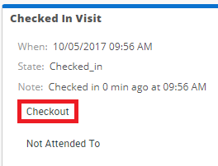
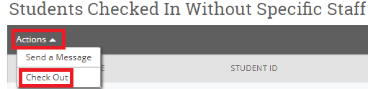

- Either way, you will receive a prompt to confirm the Check Out.
