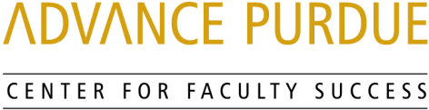

Faculty Advancement, Success and Tenure (FAST)

Agenda

October 15, 2019

9:00 – 9:05 Welcome, Introductions, and Orientation to FAST
9:05 – 9:50 Promotion and Tenure
Peter Hollenbeck, Vice Provost for Faculty Affairs and Professor, Biological Sciences, College of Science
Wei Hong, Associate Dean for Faculty Affairs and Professor, School of Languages and Cultures, College of Liberal Arts
9:50 – 10:00 Questions and Answers
10:00 – 10:10 Small Group Discussions
10:10 – 10:15 Wrap- Up

Upcoming Events

November 12, 2019 Grant Writing
STEW 278
Sally Bond, Assistant Director of Research Development Services, Proposal Coordination, Office of the Executive Vice President for Research and Partnerships

Peter Bermel, Associate Professor, Electrical and Computer Engineering, College of Engineering

www.purdue.edu/advance-purdue/center-for-faculty-success/fast.html

